SOFTWARE DESIGN DOCUMENT (SDD)
Vehicle Service Management System
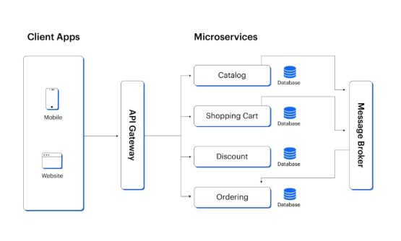

1.DOCUMENT CONTROL
Item | Details
Project Name | Vehicle Service Management System
Version | 1.0
Author | B Divya
Date | 29-12-2025
Status | Building

2. PURPOSE OF THE DOCUMENT
This document describes the system architecture, design decisions, component structure, APIs, data models, and non-functional aspects of the Smart Order Management System.
It is intended for:
- Developers
- Reviewers
- Interview discussions
- Maintenance & enhancement planning

3. SYSTEM OVERVIEW
Business Objective
Provide a scalable , secure, and maintainable system to:
- Manage Customer Vehicles
- Manage Inventory
- Place and track service requests
- Support growth through microservices
High-Level Features
- User registration & login
- Place service request for vehicle
- Track the request
- Role-based access (USER / ADMIN)

4. ARCHITECTURE OVERVIEW (HLD)

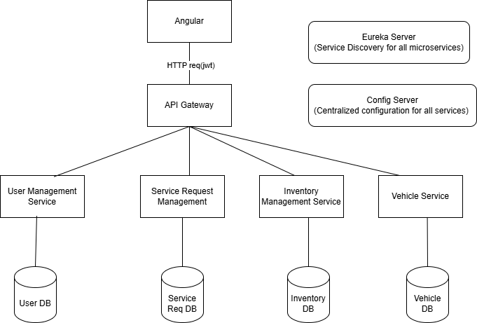

Architecture Style:
- Microservices Architecture
- REST-based communication
- Containerized deployment
Core Components:
1.Angular Frontend
2.API GATEWAY
3.User Management Service
4.Service Request
5.Inventory Managemnt
6.Vehicle Service
5. TECHNOLOGY STACK
Backend
- Java 17
- Spring Boot
- Spring Web
- Spring Data MongoDB
- Spring Validation
Frontend
- Angular
- Angular Material
- RxJS
Database
- MySQL (one DB per microservice)
DevOps
- Docker
- Docker Compose
- Jenkins
- SonarQube
Testing
- JUnit 5
- Mockito
- Spring Boot Test
- Jasmine / Karma

6.MICROSERICES DESIGN
6.1 User Management Service
Responsibilities

- User Registration
- Authentication
- Authorization

APIs
- Post /login
- Post /register/manager
- Post /register/technician
- Get /user/{id}
Database:
-users collection/manager collection
{
Id
Email
Password
Name
Phono
}
-Technician collection
{
Id
Name
Skillset
Phone
workAssigned
}

6.2 Inventory Service

Responsibilities:

- Inventory CRUD
- Low stock management

Apis

- Post /inventory
- Get-All /inventory
- Get /inventory/{id}
- Get /inventory/low-stock
- Post /inventory/{id}/update-quantity
- Delete /inventory/{itemId}

Database:

{
PartName
Description
Quantity
unitPrice
units
}

6.3 Service Request

Responsibilities:

- Manage Bay Details
- Manage Request
- Assign Managers
- Assign Technicians
- Generate Bill

Apis:

Post /service/request
Post /service/{id}/assign-technician
Post /service/{id}/assign-manager
Patch /service/{id}/status-update status
Patch /service/{id}/remarks

Database:

Bay Details:
{
bayNumber,
bayName,
isAvailable,
}

Bill Details:

{
billNumber,
laborCost,
partsCost,
tax,
totalAmount
}

Service Request:

{
serviced,
customerId,
vehicleId,
description,
managerId,
technicianId,
bayNumber,
remarks
}

6.4 Vehicle Service:

Responsibilities:

- Add Customer Vehicle
- Update Vehicle
- Book a service Request

Api’s

Get /vehicle/{id}
Post /vehicle
Put /vehicle/{id}
Delete /vehivle/{id}

Database:

{
customerId,
registrationNumber,
model,
yearOfManufacture,
color,
vin_number
}

7. DATA DESIGN (LLD)
User Document
{
"id": "u101",
"email": "manager1@example.com",
"password": "encrypted_password",
"name": "Ravi Kumar",
"phone": "9876543210",
"role": "MANAGER",
"active": true
}

Technician Document

{
"id": "t201",
"name": "Arjun Mehta",
"skillSet": "Engine Repair",
"phone": "9876501234",
"workAssigned": false
}

6.2 Inventory Service

Inventory Item Document
{
"id": "inv101",
"partName": "Brake Pad",
"description": "Front brake pad for sedan",
"quantity": 25,
"unitPrice": 1200,
"units": "pcs"
}

6.3 Service Management
Service Request Document
{
"serviceId": "SR1001",
"customerId": "C101",
"vehicleId": "V203",
"description": "Engine noise and oil leakage",
"status": "IN_PROGRESS",
"managerId": "M102",
"technicianId": "T305",
"bayNumber": "B2",
"remarks": "Engine inspection started"
}

Bay Details Document

{
"bayNumber": "B2",
"bayName": "Engine Repair Bay",
"isAvailable": false
}

Bill Document

{
"billId": "BIL101",
"serviceId": "SR1001",
"laborCost": 2500,
"partsCost": 1800,
"tax": 430,
"totalAmount": 4730
}

6.4 Vehicle Service

Vehicle Document
{
"vehicleId": "V203",
"customerId": "C101",
"registrationNumber": "TS09AB1234",
"model": "Hyundai i20",
"yearOfManufacture": 2020,
"color": "White",
"vinNumber": "1HGCM82633A123456"
}

8. API DESIGN & VALIDATION
- RESTful principles
- JSON request/response
- Bean Validation at DTO layer
- Service-level business rule enforcement
- Standard HTTP status codes

9. ERROR HANDLING STRATEGY

Global Exception Handling

- Centralized using @ControllerAdvice
- Standard error response format

{
"timestamp": "2025-01-01T10:00:00",
"status": 400,
"error": "Validation Error",
"message": "Price must be greater than zero"
}

10. SECURITY DESIGN

- Password encryption (BCrypt)
- Role-based access control
- JWT authentication (optional enhancement)
- Secure API access

11. NON-FUNCTIONAL REQUIREMENTS

Area | Design Decision
Scalability | Stateless services, Docker
Performance | Pagination, async calls
Availability | Independent services
Maintainability | POM-like layered backend
Security | Validation, encryption
Observability | Logging & monitoring

12. TESTING STRATEGY

Backend
- Unit tests (Service layer)
- Controller tests (MockMvc)
- Minimum 90% coverage
Frontend
- Component tests
- Service tests
Quality Gates
- SonarQube enforced
- Build fails on violations

13. CI/CD DESIGN

Pipeline Flow
- Git Commit
- Jenkins Build
- Unit Tests
- SonarQube Scan
- Quality Gate Check
- Docker Build
- Docker Compose Deploy

14. DEPLOYMENT DESIGN

- Docker image per microservice
- docker-compose for orchestration
- Environment-specific configs

15. ASSUMPTIONS & CONSTRAINTS

Assumptions
- Services communicate over REST
- MongoDB available
- Docker environment present
Constraints
- No distributed transactions
- Event-driven architecture out of scope

16. FUTURE ENHANCEMENTS

- Spring Cloud Gateway
- Kafka-based async communication
- Kubernetes deployment
- Centralized logging (ELK)

17. CONCLUSION

This design ensures:
✔ Clean separation of concerns
✔ Scalability & maintainability
✔ Testability & CI/CD readiness
✔ Interview-ready explanatio

SEQUENCE DIAGRAMS

