**Visdiff** - This function is used to compare two text files, MAT-Files, binary files, Zip files, or folders

This MATLAB function opens the Comparison Tool and presents the differences between the two files or folders.

MATLAB > Programming Scripts and Functions > Files and Folders > File Operations

**Syntax:**

Visdiff ('filename1 with path and extension', 'filename2 with path and extension'

visdiff('C:\Users\R.P.Vaghela\Documents\one.txt','C:\Users\R.P.Vaghela\Documents\two.txt')

output for identical files:

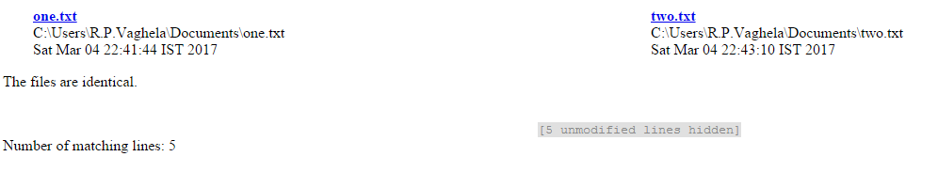

Output for different files:

