# Have Hall of Fame Player’s statistics changed by decade?

We looked at 4 key statistics to judge batting performance for Hall of Fame players: Slugging Percentage, OPS, Batting Average and Home Runs. To determine if these statistics differed by the decade, we used ANNOVA. We found no significant differences in Slugging Percentage and OPS across decades at the 5% level, both had p-values of 0.0683. We found significant differences in Batting Averages (p-value: 6.4768e-8) and Home Runs (p-value: 2.2474e-5). This result is not entirely surprising because Slugging Percentage and OPS are two of the best efficiency statistics to determine how good a batter truly is. Even though the way we view game has changed in recent time with the proliferation of data driving efficiency, the greatest players have been efficient all along. 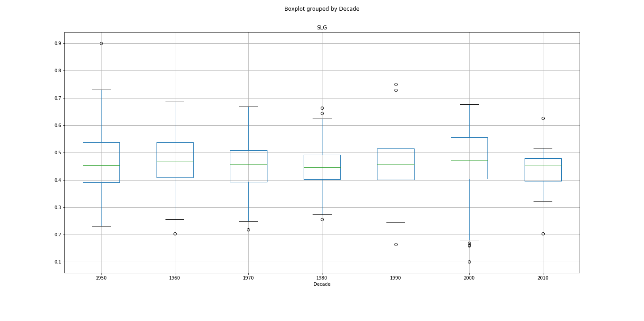

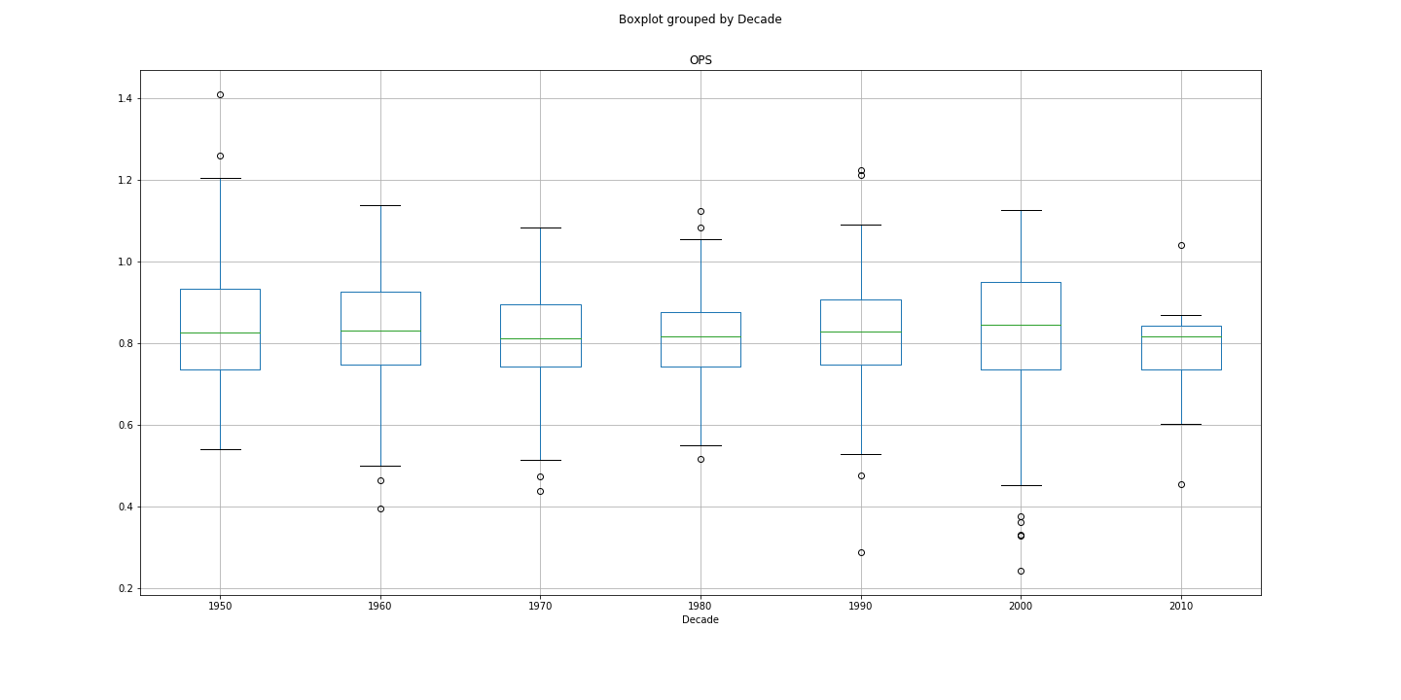

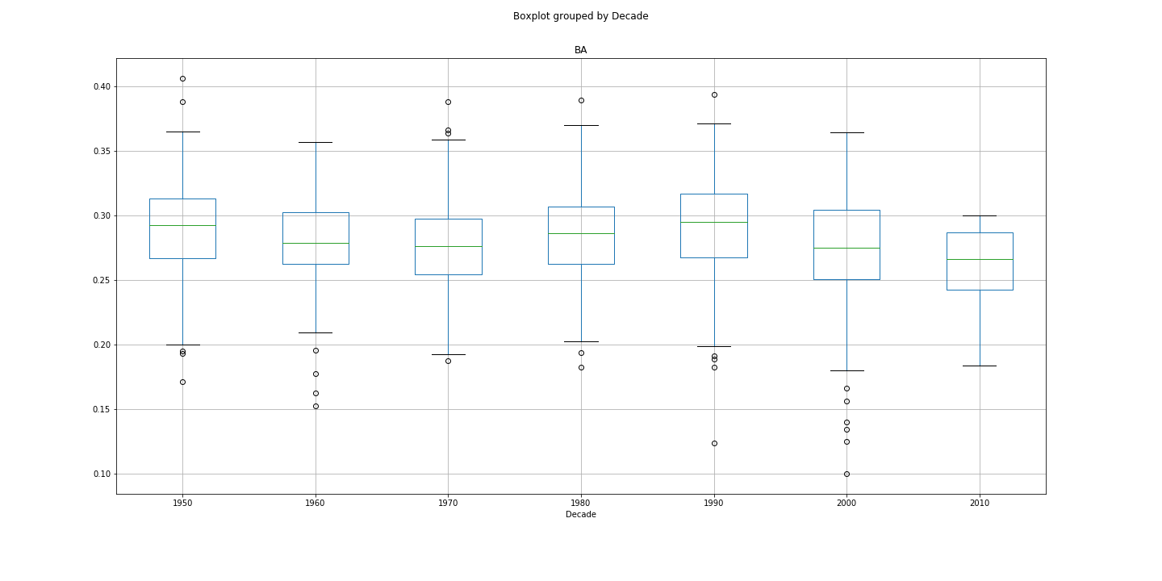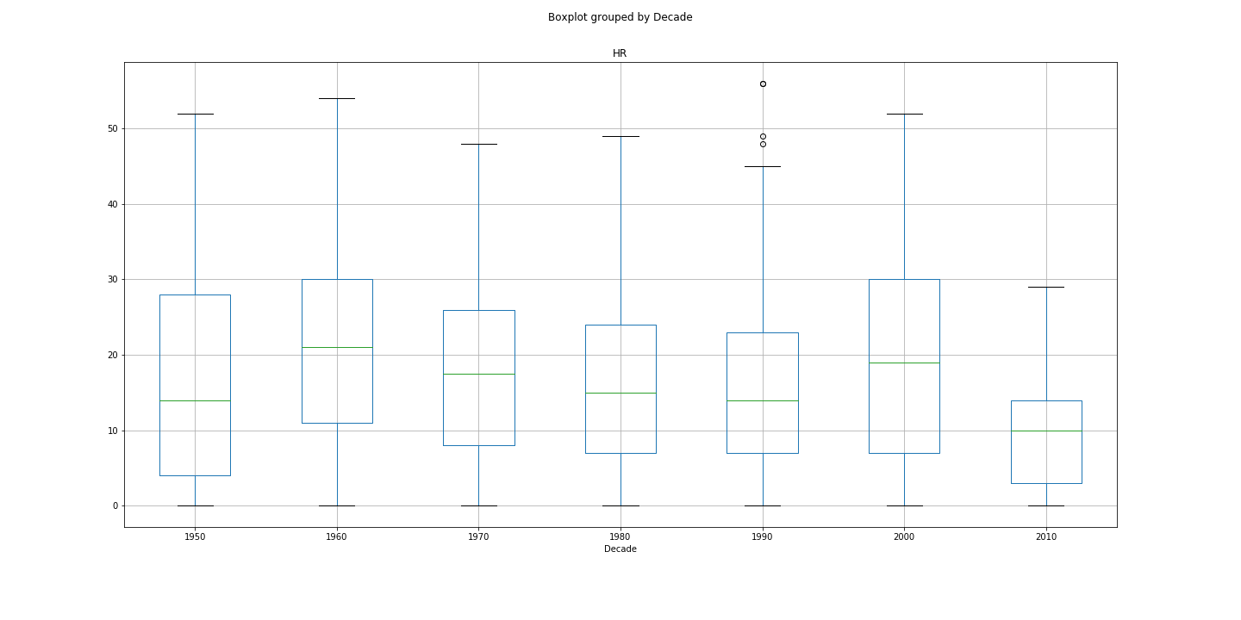

# Is each decade proportionately represented in the Hall of Fame?

To answer this question, we first had to exclude the 2000’s and 2010’s since many players that will be inducted have simply not made it through the long process of induction. To determine if the decades were equally represented, we used a Chi-Squared test. Most Hall of Fame players’ careers span multiple decades, so we are simply answering whether the number of Hall of Fame players that played in the decade is proportionate. The expectation is that 33 Hall of Fame players would play in each decade. Our calculated critical value was 9.4877 and the statistic from our Chi-Squared test was 1.3939, so there is no statistically significant difference in Hall of Fame representation by the decade. Interestingly, the 1950’s had the most players with 37 and the 1990’s had the fewest with 29. Many of the greatest players from the 1990’s were caught using performance enhancing drugs and will likely never make it to Cooperstown so this result is expected.

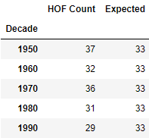

# Do Hall of Fame players increase their performance in the postseason?

Hall of Famer players are the leaders of their team and we expect that they step up their play when their team needs it the most. We also wanted to see how this compared to all players for context. To answer this question, we used students’ t-tests to see if there is a difference in play. We used Slugging Percentage and Batting Average as metrics for performance differences. The differences in performance were all significant for Hall of Fame Players and all players across both metrics comparing regular season statistics to Post-Season statistics at the 1% level. We then calculated the differences and then plotted them to see the direction of the differences in performance. Everyone performed worse in the playoffs across both metrics. Shockingly, Hall of Fame players’ Slugging Percentages decreased in the playoffs more than all players. Hall of Fame players’ Batting Averages decreased by less than all players. It is not surprising to see all these stats go down in the playoffs as the teams are better, but Hall of Fame players doing worse than everyone on the metric that best indicates performance is very surprising.

