**Project Volunteer Match**

**Software Requirements Specification**

**CEN 3031, Fall, 2017**

**Modification history:**

|  |  |  |  |
| --- | --- | --- | --- |
| Version | Date | Who | Comment |
| v1.0 | 10/01/2017 | Brandon Walters,  Brett Dube,  Daniel Scamardella,  Rachel Snyder, and  Chris Dreiser | Document created |
| v1.1 | 10/4/2017 | Daniel Scamardella | Added Use Case Diagram, UseCase Descriptions, and specific requirements 5-10 |
| v1.2 | 10/8/2017 | Chris Dreiser  Daniel Scamardella | Added requirements 1.1, 1.2, 1.3, 3.1, 4.1, and 5.1. Reorganized and renumbered several requirements. |

**Team Name:** The Gruntled

**Team Members:**

* Brandon Walters [btwalters8591@eagle.fgcu.edu](mailto:btwalters8591@eagle.fgcu.edu)
* Brett Dube [bwdube8586@eagle.fgcu.edu](mailto:bwdube8586@eagle.fgcu.edu)
* Daniel Scamardella [dcscamardella6157@eagle.fgcu.edu](mailto:dcscamardella6157@eagle.fgcu.edu) Daniels7009
* Rachel Snyder [resnyder2333@eagle.fgcu.edu](mailto:resnyder2333@eagle.fgcu.edu)
* Christopher Dreiser [cjdreiser1110@eagle.fgcu.edu](mailto:cjdreiser1110@eagle.fgcu.edu)

**Contents of this Document**

Introduction

* Software to be Produced
* Definition, Acronyms, and Abbreviations

Product Overview

* Assumptions
* Use Case Diagram
* Use Case Descriptions

Specific Requirements

**SECTION 1: Introduction**

Software to be Produced:

* Our program will allow volunteer organizations to easily get in touch with their volunteers and potential volunteers. The software will allow searching for volunteer agencies to potentially join as well as keep a record of the agency’s current roster of employees along with each person’s list of volunteering selections. Users and organizations will be able to make accounts that house information like location and interests/goals to allow for searching based on these criteria. Users will also be able to create events that hold information and can be joined by other users and will keep track of all the users currently going to the event as well as the dates, times, and a description of the events.

Definitions, Acronyms, and Abbreviations:

* VOL: Volunteer Opportunity Listings

**SECTION 2:** **Product Overview**

Assumptions:

* Java based desktop application for Windows, OSX, and select Unix operating systems.
* Uses less than a gigabyte of memory.
* Downloadable

Use Case Diagram:

* 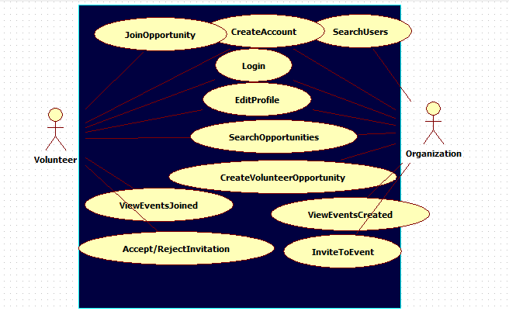

Use Case Descriptions:

* CreateAccount will allow a user to create a profile by entering the type(volunteer/organization), name, interests, location and password. if the username is already in use, it will prompt the user to select another one.
* Login will allow the user to enter a username and password to access the program’s main functions through the account associated with that username and password. If the username or password is incorrect, it will inform the user, and ask to enter a username and password again.
* EditProfile will allow a user to change data in their profile’s location and interests. as well as allow the user to view other aspects of their profile: username, previous volunteering data, events they’re currently signed up for.
* SearchOpportunities will allow a user to search for a VOL by Zipcode or interest, if no VOLs exist given a search criteria, the program will display a message informing the user as such.
* CreateVolunteerOpportunity allows an organization to create a VOL by asking for all the relevant data, then placing all the information into the list of other current VOLs. The program will reject all bad data inputs, requesting that the user re-enter the data.
* SearchUsers allows organizations to search through a list of all concurrent volunteer type users, and view their profiles. If somehow no volunteers exist given a search criteria, the program will display a message informing the user as such.
* ViewEventsCreated will show the user a list of the VOLs they have currently pending as well as those that have passed, and allow the user to see how many users have signed up for each one and check the accounts of those people. If no VOLs exist, the program will display a message informing the user as such.
* InviteToEvent allows organizations to send an invitation to a user, giving them the ability to see the VOL without searching for it. If the user who the invite is being sent to is non-existant, it will not send, and inform the organization that no such user exists.
* JoinOpportunity will allow a volunteer to “join” a selected VOL, which will add their username to the list of volunteers who will be going to the event, which can be viewed by the creator of the VOL.
* ViewEventsJoined will show the user a list of the VOLs they have currently joined and see the number of people going to each event as well as when it starts. If no VOLs exist, the program will display a message informing the user as such.
* AcceptRejectInvitation will allow a volunteer to view all invitations they currently have, and accept or reject each one in order of arrival.

**SECTION 3: Specific Requirements**

|  |
| --- |
| **No:** 1 |
| **Statement:** Users shall be able to create accounts including a username, password, interests, location and organizations worked for/with previously. |

|  |
| --- |
| **No:** 1.1 |
| **Statement:** Users shall be able to log into their previously created accounts, using their username and password. |

|  |
| --- |
| **No:** 1.2 |
| **Statement:** Users shall be able to edit the profile of their account, including interests, location, and organizations worked for/with previously. |

|  |
| --- |
| **No:** 1.3 |
| **Statement:**  Users shall be able to choose upon login whether they wish to act as an individual or an organization. |

|  |
| --- |
| **No:** 2 |
| **Statement:** Organizations shall be able to create joinable VOLs. |

|  |
| --- |
| **No:** 2.1 |
| **Statement:** VOLs shall include time, date, address or addresses, instructions on getting involved, important contact information under discretion of the organization. |

|  |
| --- |
| **No:** 3 |
| **Statement:** Users shall be able to search through a list of VOLs in their zip code based on interests as listed in the user profile. |

|  |
| --- |
| **No:** 3.1 |
| **Statement:**  Volunteers shall be able to quit an event they’ve signed up for. |

|  |
| --- |
| **No:** 4 |
| **Statement:**  Organizations and individuals shall be able to communicate and coordinate between each other. |

|  |
| --- |
| **No:** 4.1 |
| **Statement:**  users shall be able to compose and send messages to each other using their usernames. |

|  |
| --- |
| **No:** 5 |
| **Statement:**  Organizations shall be able to send VOL invitations to potential volunteers. |

|  |
| --- |
| **No:** 5.1 |
| **Statement:**  Users shall be able to view all pending invitations, and be able to accept or reject them. |

|  |
| --- |
| **No:** 6 |
| **Statement:**  Users shall be able to opt in/out on email notifications about invitations/upcoming events they’re signed up for. |

|  |
| --- |
| **No:** 7 |
| **Statement:** Organizations shall be able to view all VOLs they’ve created and how many people are currently signed up for each one, as well as who those people are. |

|  |
| --- |
| **No:** 8 |
| **Statement:**  Organizations shall be able to search through volunteers by zip codes/interests. |

Template created by G. Walton ([GWalton@mail.ucf.edu](mailto:GWalton@mail.ucf.edu)) on Aug 30, 1999 and last updated Aug 15, 2000; updated by A. Koufakou, Aug 2014

This page last modified by Daniel Scamardella ([dcscamardella6157@eagle.fgcu.edu](mailto:dcscamardella6157@eagle.fgcu.edu)) and Christopher Dreiser (cjdreiser1110@eagle.fgcu.edu) on 10/8/17.