HUBPAY Digital wallet sample project walkthrough:
This application simulates the digital wallet where user can add funds, view funds, withdrawal funds and view transaction statements.
- This application is being developed using Java 17 and spring boot with h2 database.
- To make the application up and running, your local system should get installed with JDK 17 and maven build tool.
- After downloading the project either as zip/clone, go to root of the project in intellij or cmd prompt, run the maven command “mvn clean install” to compile and build.
- After successful clean installation run the below command to make the application up and running
java -jar target/Hubpay-Wallet-Example-0.0.1-SNAPSHOT.jar src\main\java\com\hubpay\HubpayWalletExampleApplication.java
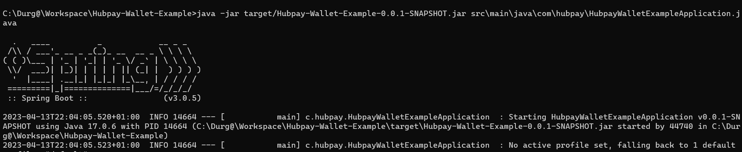
- As Customer wallet creation/signup is out of scope User and wallet creation have been pre-configured respectively during the application startup.
User Ids: [‘HP1234’,’ HP4567,’ HP7890’]
- To satisfy the business requirement 3 tables have been created to handle wallet funds, user details and transaction details. I.e., HUBPAY_WALLET, HUBPAY_USER, TRANSACTION. These table can be accessed by http://localhost:8080/h2-console/ with below credentials:
User Name : sa & Password : password

In order to perform actions on the wallet the below rest end points can be used.
- To add funds to wallet (POST request): http://localhost:8080/addFunds
Ex:
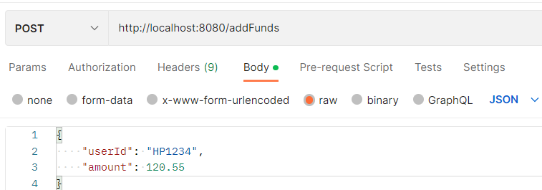

- In order to add funds to the user wallet, userId and amount have to passed as part of the POST request. Fail to pass any required param, results error message.
Ex2: Missing required params
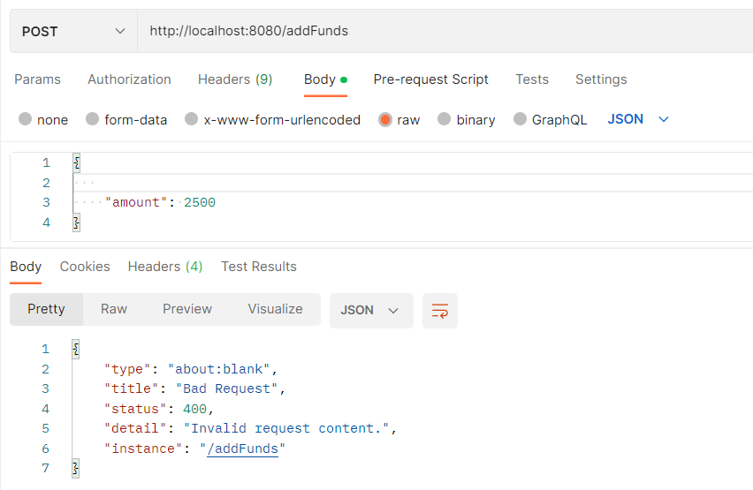

- To view funds from wallet (GET request) : http://localhost:8080/getBal/{userId}
Ex: http://localhost:8080/getBal/HP1234
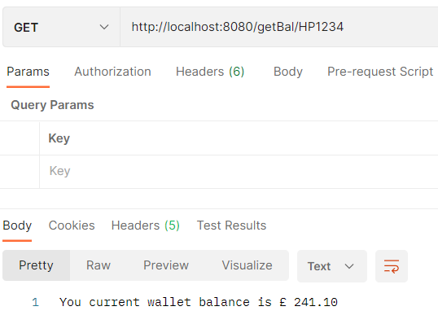
Ex2: trying to get wallet info for unregistered user, it will throws an error message.
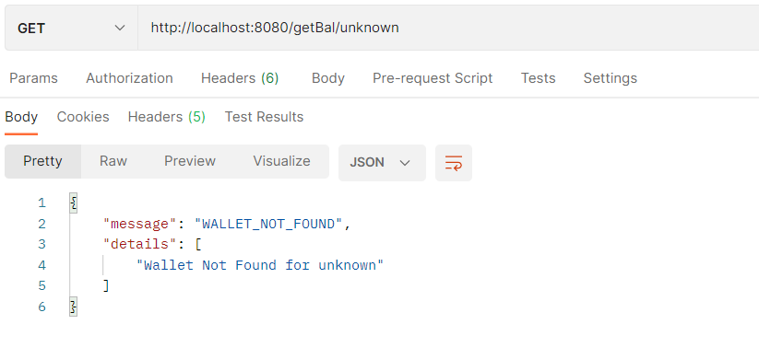

- To withdrawal money (PUT request) : http://localhost:8080/withdrawMoney
Ex:
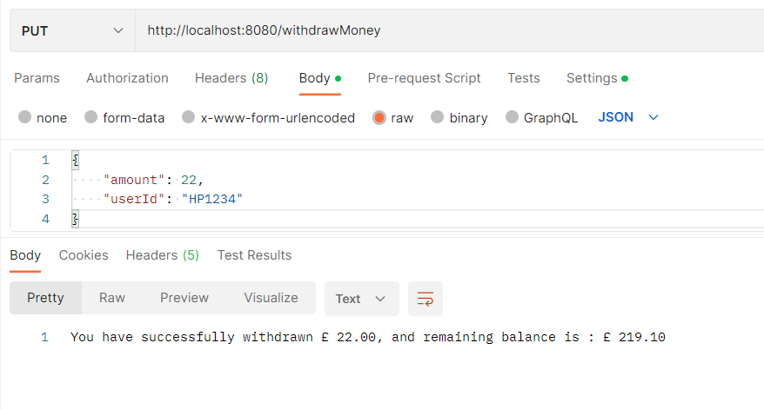
Ex2: failed to pass amount/userId params in the request, you will see an error message
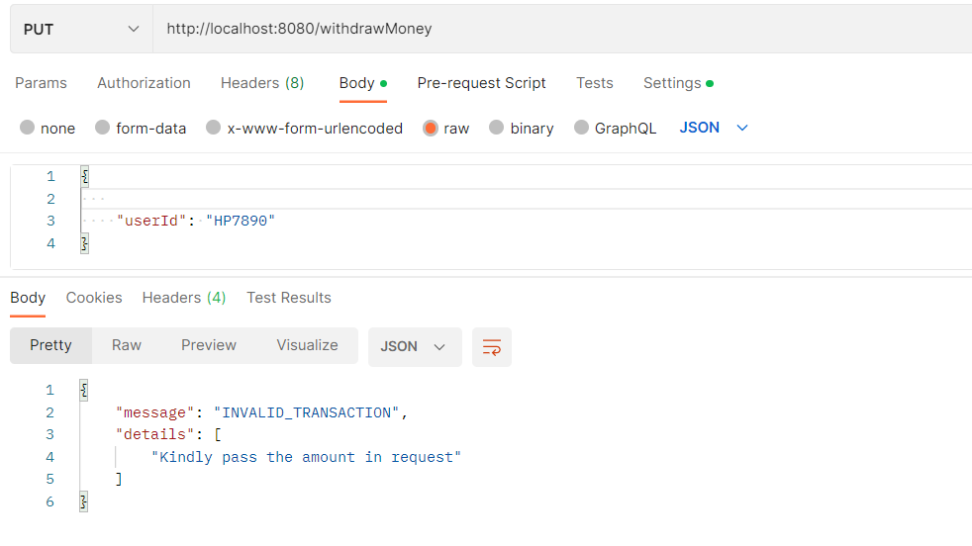

- To view transaction history for each user (GET request) : http://localhost:8080/txnHistory{userId}
Note: since the user transactions can be viewed by pagination, offset and page size parameters have to be passed in the request.
Ex 1: http://localhost:8080/txnHistory/HP1234
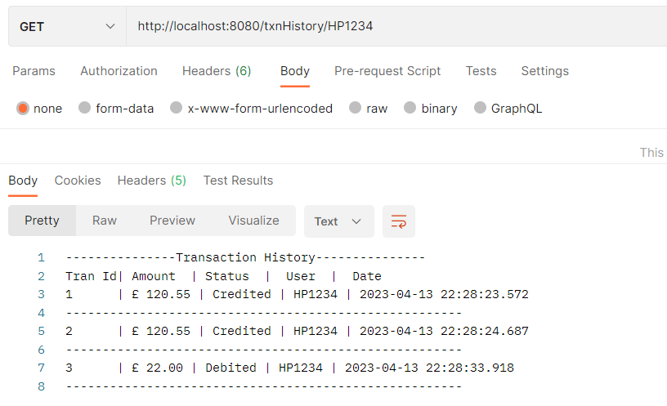
Ex2: with offset and pageSize query params, failed to pass values or miss any one of the params will results all the transactions.
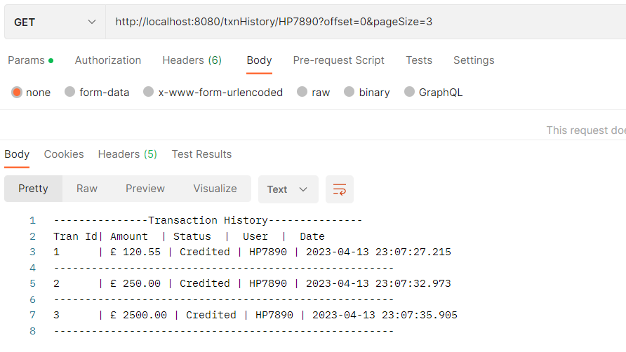
Ex3: trying to get transactions for unregistered user, you will see an error message
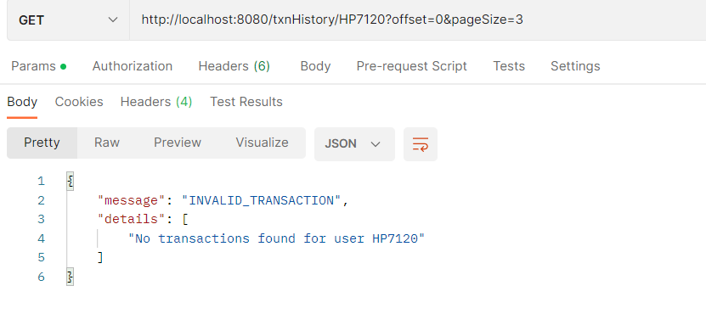

** In order to prevent dual submissions during the withdrawals a redirection technique has been used where we redirect the page to new page after successful withdrawals.

** In order to handle concurrent withdrawals and prevent the wallet to go into negative amount synchronization has been implemented. I have tested the concurrency using Apache Jmeter tool.
Test results:
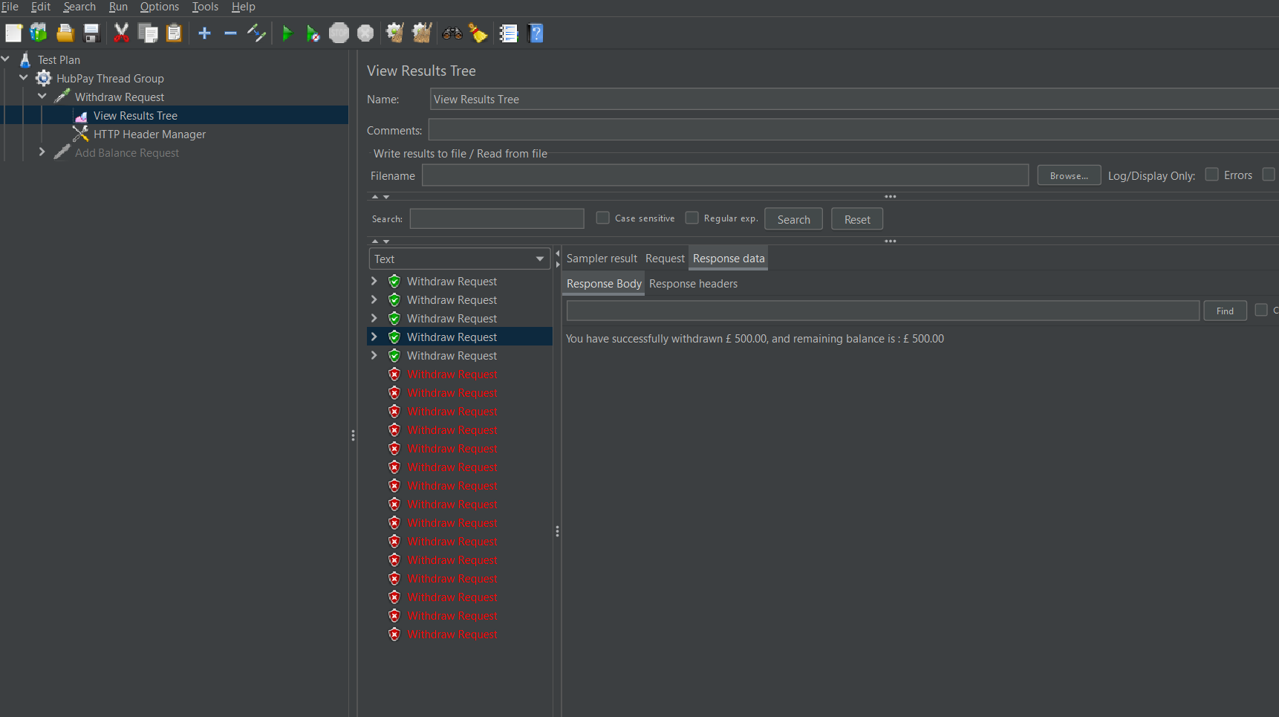

I have also attached the Jmeter test file in the Github to quickly open and test the withdrawal scenraio.
** As of now no security has been provided to application.

