Protocol for PCR Band Quantification
Edited by Emeline Manganela and Rannyele P. Ribeiro
ÖZPOALT LAB

Outline: This protocol can be used to estimate gene expression via intensity quantification of agarose gel bands. We modified and improved this protocol with guidance from Lauren Kunselman (Elaine Seaver’s Lab).

Use this protocol with FIJI to quantify differences in PCR bands on a gel without performing qPCR

- Take a picture of gel and save a copy that is inverted but unmanipulated (no adjustment of contrast, brightness, etc.).
- Open gel image in FIJI. If the image isn’t inverted, it can be inverted in FIJI: Edit > Invert. Select Rectangle tool and draw a box around first desired lane so the band of interest is inside the box. Other bands that you are not interested in can be included within the box as well.
- Select Analyze > Gels > Select First Lane
- Move mouse to middle of selected box (should not be labeled with a “1”) so cursor becomes an arrow and click and drag box to next lane of interest.
- Select Analyze > Gels > Select Next Lane. Repeat steps 4 and 5 for remaining lanes of interest.
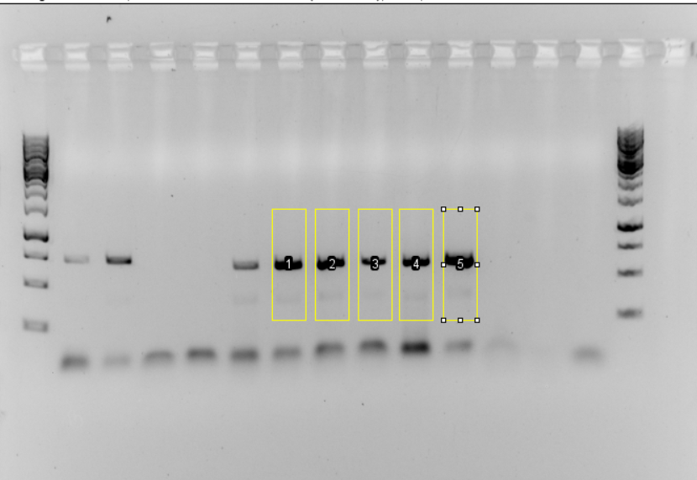
- Select Analyze > Gels > Plot Lanes
- Use Hand Grab tool to move plots in and out of view or can zoom out to see all plots at once. Use Line Selection tool to draw vertical lines on either side of the peaks (one line down from top of all plots to bottom, on either side of peaks of interest) so each peak of interest defines a closed area. Hold down spacebar to temporarily switch to hand tool if needed.
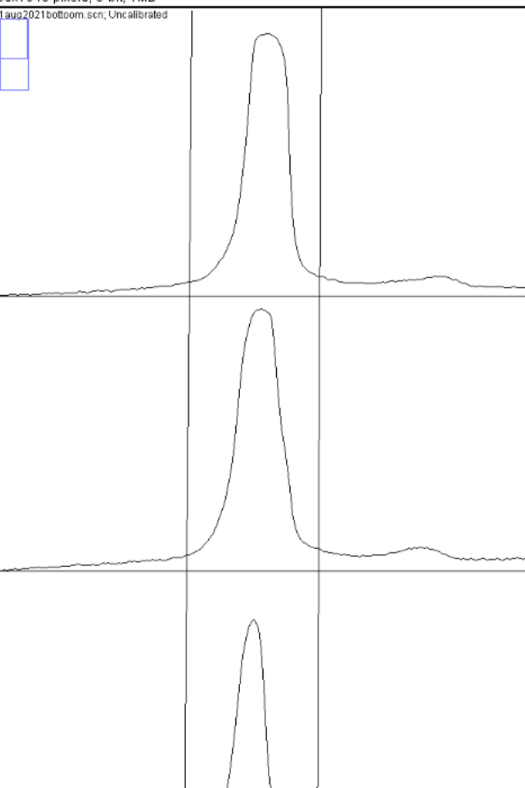
- For each peak, measure area under peak and between boundary lines by clicking inside area with the Wand tool.
- A bar graph can be made from the areas and it can also be helpful to normalize using the information given from housekeeping gene lanes.
  - Normalizing a la Lauren Kunselman: If you have two bands to compare (for example, treatment compared to control), take the area under the control band and divide it by the area under the experimental band to make a ratio. Once you have that ratio number, multiply it by the areas of the bands for the treatment on the denominator. The areas for the treatment on the numerator, leave as is. It doesn’t matter which treatment you put on the numerator or denominator. A bit confusing but email Lauren Kunselman in Elaine Seaver’s lab for clarification.

Extra Useful Features:
- Select Analyze > Gels > Label Peaks to label each measured peak with it’s size as a percentage of the total size of the measured peaks
- If the boundary lines need to be redrawn on the peak plots, exe out of the plot and select Analyze > Gels > Re-Plot Lanes to plot lanes again. Plot Lanes will not work if it has already been used.

Alternative Quantification Method
Alternatively, instead of measuring the area with vertical lines, you can proceed as in this tutorial Quantification or densitometric analysis of agarose gel electrophoresis bands using ImageJ .

This tutorial used vertical lines for measurements. Measuring the area with vertical lines (like explained in the protocol above) can create additional areas even in negative controls. This can result in having values of expression of negative controls comparable with the ones from positive controls after normalization. Be careful!! The method linked above from Youtube uses horizontal lines at the base of the peak to measure the area, which is more accurate.

