qRT-PCR with BioRad SsoAdvanced Universal SYBR Green Supermix

Özpolat Lab
Edited by Rannyele P. Ribeiro, 22 July 2024

Materials
- BioRad CFX96 qPCR instrument
- cDNA samples
- Ice
- SsoAdvanced™ Universal SYBR® Green Supermix
- Hard-Shell 96-Well PCR Plates, low profile, thin wall, skirted, white/clear
- Pipettes (10ul, 100ul, 1000ul)
- Optical clear seal membrane for 96-well plates: Microseal 'B' PCR Plate Sealing Film, adhesive, optical #MSB1001 | Bio-Rad

Primer design
For your experiment, you need to use primers following the sequences of the mRNA of your target gene (i.e. its transcript). Design all primers to have more or less the same annealing (Ta) and melting (Tm) temperature. Use this tool: https://www.ncbi.nlm.nih.gov/tools/primer-blast/

Procedures
- Extract RNA following specific protocols adapted to the tissue of interest.
- Make cDNA from your RNA sample. We have different kits, follow the protocols for your specific kit User Guide: SuperScript IV Reverse Transcriptase.
- Prepare 20uL qRT-PCR reactions in 8-tube-strips following manufacturer instructions. Remember to keep all reagents in ice or cold rack.
  - The reaction has 20uL of Mix, 1.25uL of each R and F primers, 2uL of cDNA template. Make at least 2 replicates of your samples (= samples x2).
  - Load reactions to a Hard-Shell 96-Well PCR Plate. Make notes of your sample IDs.
- Seal your plate with 96-well plastic sealing membrane. Spin it down - we have a centrifuge for 96-well plates in the shared equipment room McD 134.
- Bring your plate to the BioRad CFX Opus 96 qPCR machine (Mallot Lab, McD 353).
- Initialize computer.
- Open BioRad CFX Manager
  - > Startup Wizard > Create a new experiment
  - Protocol > Express load
  - SYBR Green recommendations: 2StepAmp+Melt protocol
  - Plate > Express load (SYBR Green recommendation: Quick plate 96 wells SYBR only)
  - Edit Selected > Select fluorophores > SYBR
  - Mark sample types: Sample type > standard /positive
  - > Target name: gene name
  - > Sample name: sample condition, e.g. control, treated,
  - > Load > cDNA concentration
  - > Replicate series: 1 and 2
  - Alternatively, there is no need to label the samples in the software, you can do it after. Make sure to select at least the fluorophores (SYBR for this protocol) and cDNA concentration (minimal).
- Run. Make sure the Machine is detected by the software. If there is already a user on the controller (e.g. Guest), log out and hit the option Detect machine. After detection, you will see MallotLab_qPCR. Then, you can run.
- Analysis: watch the videos in APPENDIX II to understand how to interpret and analyze the data. The data you will analyze is the column Cq in the results of the qPCR. analysis, check the melt graphs to assess the quality of your PCR products and whether you should discard the results of a given sample. Consider:
  - Negative templates will result in NaN or Cq < 35-39.
  - If the melting plot of your results have more than one peak, you are amplifying unspecific regions of your target gene. You should optimize parameters and primers for this kind of result.
  - You need at least two technical replicates to perform the analysis.
  - Cq of positive samples and reference (housekeeping) genes should be around 15±10.
- Optionally: run a gel electrophoresis to check amplification of your PCR products.

Step | 1 | 2 | 3 | 4 | 5 | 6
Name | Denaturation | Denaturation | Annealing/ Extension | End
Temp | 95C | 95C | 60C | 95C | 65C | 95
Time | 2:00 | 00:10 | 00:30 | 00:10 | 00:05 | pause
Cycles | 1X | 39X |  | 1X
**Check the table of Ta (annealing temperature) for each primer pair.
SsoAdvanced SYBR Green polymerase is a fusion polymerase and works well at the extension temperature of 60C

APPENDIX I: list of primers
Name | Sequence | Ta
Pdu-psmt-Q1-F | CCAGGGCTGTGCCAACATCT | 60C
Pdu-psmt-Q1-R | CGGGATGTGTTCCGCCACTT | 60C
Pdu-psmt-Q4-F | GGATGCTTGCCATGGTTGCC | 60C
Pdu-psmt-Q4-F | CACTCGGCCGTTGCTAACCT | 60C
Pdu-lrcct-Q1-F | ACGGTCTCTCCAACCGACCA | 64-65C
Pdu-lrcct-Q1-R | TCCCGGAAGTCGGAACCAGT | 65-65C
Pdu-lrcct-Q2-F | TCCAAGCAGGAGGGGGAGAC | 64-65C
Pdu-lrcct-Q2-R | AGAAGCCCTGAAGGTCCGGT | 64-65C

APPENDIX II: Helpful links for procedures
Tutorials for setting up qPCR plates:
https://www.youtube.com/watch?v=QFQG8LYqewU&t=14s
https://www.youtube.com/watch?v=AaBXRe_JVWI

Tutorials for using BioRad CFX96 controller
https://www.youtube.com/watch?v=vD_ITe2ek90&ab_channel=TheLabWorldGroup
https://www.youtube.com/watch?v=7ru70LnDtFI&ab_channel=americanbiotech

Tutorials for understanding qPCR data analysis
https://www.youtube.com/watch?v=y8tHiH0BzGY

Calculate 2-∆∆Ct:
https://www.youtube.com/watch?v=Kkle8T7aXjk&t=119s
https://www.youtube.com/watch?v=Uj0uDpNgc7U

APPENDIX III: SsoAdvanced™ Universal SYBR® Green Supermix Brochure
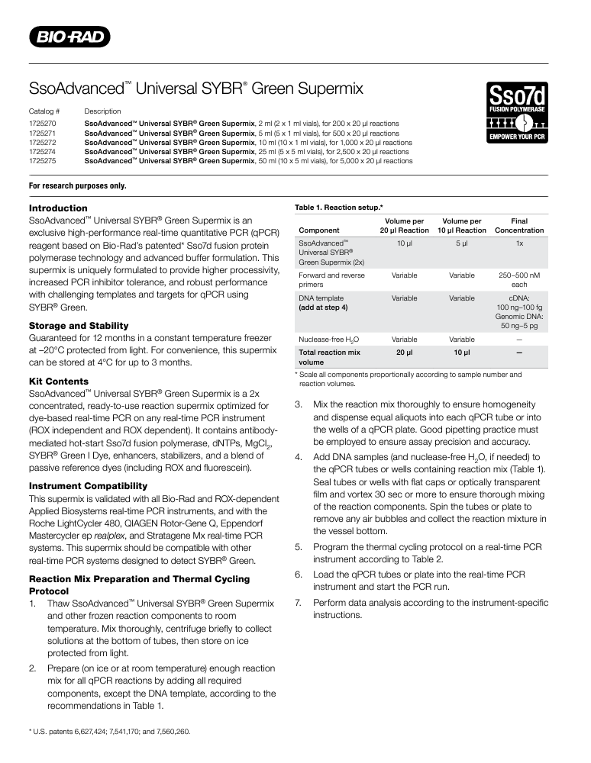

APPENDIX IV: Recommended cycles

