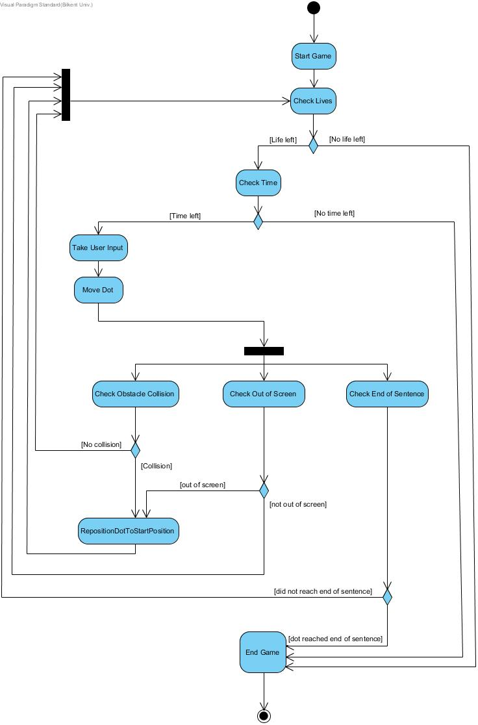

After the game starts the letters, obstacles and the Dot is placed to their initial positions. When the game starts the time starts ticking. The game ends because of 3 possible cases, which are;

1. When there is no life for dot left,
2. When there is no time left,
3. When the dot reaches the end of the sentence, which means the game is completed successfully.

Firstly, whether there is still at least one life for dot or not is checked. If the dot did not use all its lives, the remaining time is checked to continue the game. Then the input of the user is waited. According to the input that comes from the user, the dot is moved. After the dot’s position is changed, the collision it could be making with the obstacles; whether it exceeded the screen and whether it reached to the end of the sentence are checked.

When the condition that the dot goes out of screen, which means the dot has fallen to the ground, is checked, if the dot didn’t get out of screen, player can continue playing. Otherwise, program goes back to checking the lives left and continues with the loop.

If the dot has reached the end of the sentence, the game is won, thus the game ends. If it’s not the end of the sentence, then this means that the Dot has fallen to the ground, thus the position of the Dot will be set to the starting position and the game will continue on until the game is won or the time is up or no leaves left. If collision of Dot and an obstacle is made, then the Dot will be repositioned to the starting point. If a collision is not detected with the obstacle, the game will continue.