ABSTRACT
DEXTROUS represents the pinnacle of collaborative innovation in robotics, driven by a shared passion for technological advancement. Our project centers around the development of a sophisticated 6-degree-of-freedom (6-DOF) robotic arm, poised to redefine automation technology. The project team, comprising diverse experts in robotics and engineering, strategically selected the ESP32 and Raspberry Pi 3 platforms for their unparalleled versatility and adaptability to robotics applications.
At its core, DEXTROUS embodies a dual commitment to innovation and skill enhancement. Drawing upon our collective expertise in mechanical design, electronics, and programming, we navigate each challenge with unwavering determination and a spirit of resilience. Each obstacle encountered serves not as a roadblock but as a catalyst for personal and collective growth, pushing the boundaries of our technical prowess.
DEXTROUS symbolizes the fusion of passion, expertise, and ambition, creating a collaborative environment where exploration and discovery flourish. Through our combined efforts, we aim to transcend existing limitations and create a groundbreaking 6-DOF robotic arm that epitomizes the intersection of challenge and innovation.
In summary, DEXTROUS stands as a testament to our relentless pursuit of excellence in robotics. It is more than a project; it is a manifestation of our collective vision to revolutionize automation technology and shape the future of robotics through ingenuity, collaboration, and unwavering determination.

Vishal Sanjay Bhokare
Vedant Dinesh Butala
Sumedh Ravindra Kasat

List of figures:

Sr. No | Figure number and Figure caption | Page no.
1 | Fig. 2.1. Block schematic of system | 9
2 | Fig.2.2. Detailed block schematic of the system | 10
3 | Fig.4.1. CAD Diagram | 20
4 | Fig.4.2. Schematics of PCB | 21
5 | Fig.4.3. PCB Layout | 21
6 | Fig.4.4. Top View of PCB | 21
7 | Fig.4.5. Side View of PCB | 21
8 | Fig.4.6. Pairing of PS4 | 22
9 | Fig.4.7. Entire Robot in Box for Size Mapping | 22
10 | Fig.4.8. Locomotion Testing | 22
11 | Fig.4.9. Bot’s Half Arm Testing | 22
12 | Fig.4.10. Completed Robot with Arm | 22
13 | Fig.4.11. Complete Bot in Working State | 22
14 | Fig.5.1. BER Performance of Basic Linear Array | 23

List of tables:

Sr. No | Table number and Table caption | Page no.
1 | Table 2.1. : Transistor selection table | 12
2 | Table 3.1. : List of components required in the project | 16
3 | Table 4.1. : Tests and Consecutive Results Table | 18
4 Table 5.1. : Bill of Materials Table 24

CONTENTS

 | Abstract |  | i
 | List of Figures |  | ii
 | List of Tables |  | iii
 | Abbreviations |  | iv
1 | Introduction |  | 2-7
 | 1.1 | Background and Context | 2
 | 1.2 | Relevance | 2
 | 1.3 | Literature Survey | 3
 | 1.4 | Motivation | 4
 | 1.5 | Aim and Objectives | 5
 | 1.6 | Technical Approach | 6
2 | Block Diagram |  | 7-11
 | 2.1 | Theoretical background | 7
 | 2.2 | Block diagram | 7
 | 2.3 | Requirements | 9
 | 2.4 | Selection of Sensors and Major Components | 10
3 | System Design |  | 11-16
4 | Implementation, Testing and Debugging |  | 16-21
5 | Results and discussion |  | 21
 | Conclusions and Future Scope |  | 22-23
 | Bill of Material |  | 24
 | References |  | 25
 | Datasheets |  | 26-44

Feasibility report

Title : DEXTROUS - 6 DOF Robotic Arm
Group members:
- Vishal Sanjay Bhokare 2) Vedant Dinesh Butala 3)Sumedh Ravindra Kasat

Tools required | Testing possibility | Controller | Cost
Hardware/components | Hardware  Yes | ESP32  PCA9685  MG995/996  LM2596S DC-DC Buck | Rs. 1648 /-
Software | Software  Yes | - Fusion 360  - KiCAD  - Arduino IDE | Free with  Student License
Tools available within campus or outside | Sensors required | Signal conditioning if any | -
- Blue Wire Cutter  - Electric Soldering Tool  - Breadboard  - Multimeter  - Wires and Jumper Cables  - Power Tools in Workshop  - CAD Lab for 3D Printing | The robotic arm employs key sensors for accurate operation: position encoders, proximity sensors, IMUs, current sensors, temperature sensors, and optional force sensors. Additionally, voltage/current and communication interface sensors enhance power management and data exchange efficiency. | Signal conditioning components enhance sensor performance by amplifying, filtering, converting, linearizing, calibrating, shifting voltage levels, isolating, and integrating signals for improved accuracy. | -
Applications if any | PCB design and fabrication | Datasheets/ application notes available | -
The robotic arm finds applications in various fields such as manufacturing, automation, logistics, healthcare, and research.  Its versatility allows it to perform tasks like assembly, pick-and-place operations, material handling, surgical assistance, and experimentation in controlled environments. | - KiCad EDA 8.0.1  - Flux.ai | Datasheets and application notes are essential references providing detailed specifications, characteristics, and usage guidelines for project components.  - MG995/996  - ESP32  - PS4 Controller  - PCA9685 Module | -
Mechanical design | Enclosure design | Demonstration | -
The mechanical design encompasses the physical structure and components of the robotic arm, ensuring robustness, precision, and functionality. | The enclosure design involves the creation of a protective casing or housing for the robotic arm components, safeguarding them from environmental factors and ensuring safe operation. | The demonstration involves highlighting the robotic arm's functionality, including its motion capabilities, interaction with external devices, and execution of predefined tasks. | -
Title of project : DEXTROUS - 6 DOF Robotic Arm
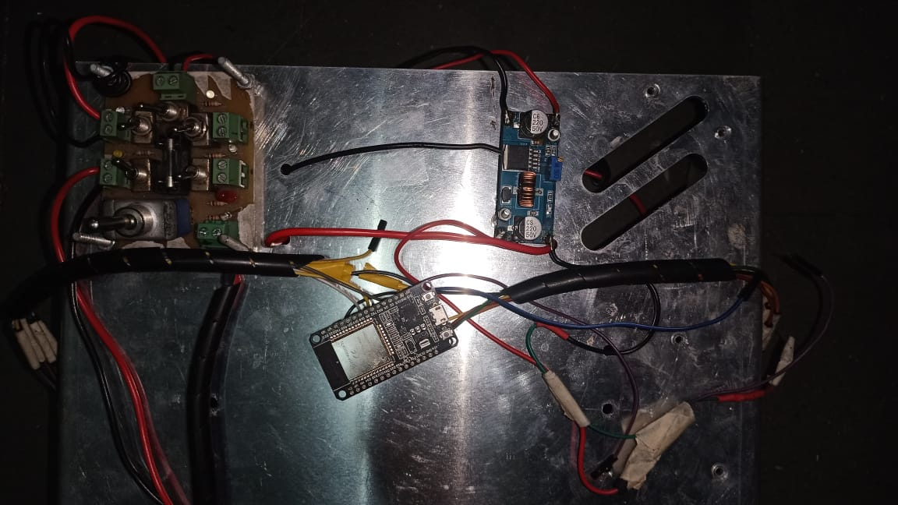

Electric specification Mechanical specification

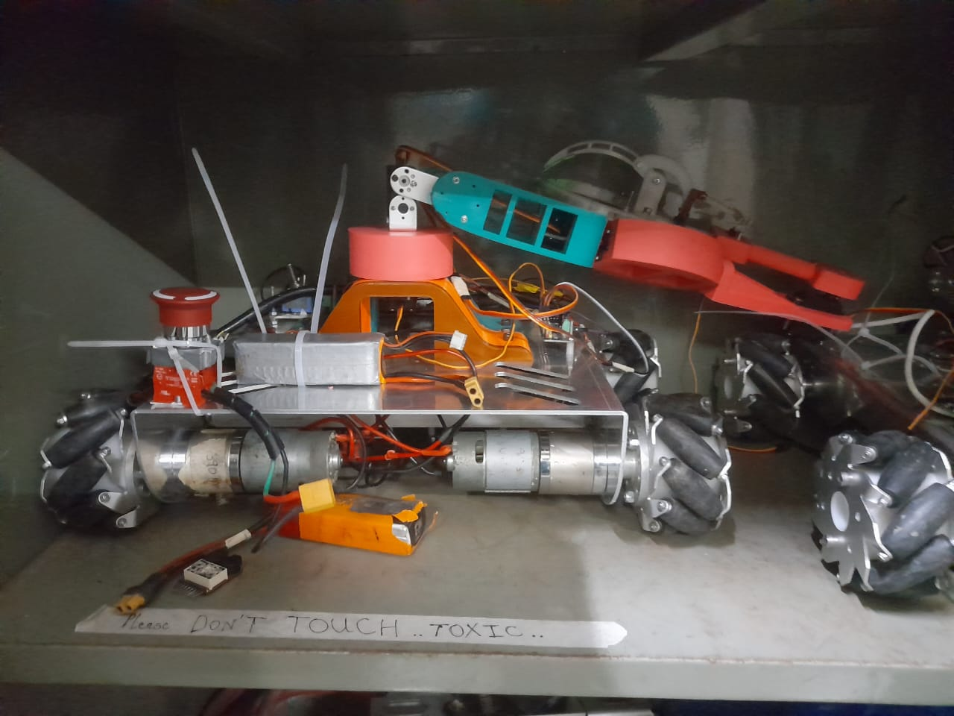
Input Specifications:
- Voltage Range: 12V DC
- Current Rating: 2A
Output Specifications:
- Voltage: 5V DC
- Current: Up to 1A
Features:
- Overcurrent & Short Circuit Protection
- Efficiency: >60%

High Efficiency, Compact Design, and Robust Protection Features.
Cost of System : Rs. 27,035
The cost of the system is competitively priced, offering exceptional value for its efficiency, reliability, and features.

Group members:
32112 | Vishal Sanjay Bhokare
32113 | Vedant Dinesh Butala
32134 | Sumedh Ravindra Kasat

