Instructions
Page setup:
Page size A4 (8.27” X 11.69”),
orientation portrait, Single column
margins: Top:1”, Bottom :1”, Left: 1”, Right :0.75”.
Line spacing: 1.5 normal text, for headings before and after paragraph keep 6pt.

Font:
The entire report shall be Times New Roman (TNR) font normal text size 12 point,
Heading 14 point bold (starting with chapter number. heading number example: for chapter2 first heading will be 2.1),

subheading 12 point (starting with chapter number. heading number. Subheading number example: for chapter 2 first heading and first subheading will be 2.1.1)

Figure (see Figure 1) and table (Table 1) caption fonts TNR font normal text size 10-point, center alignment.
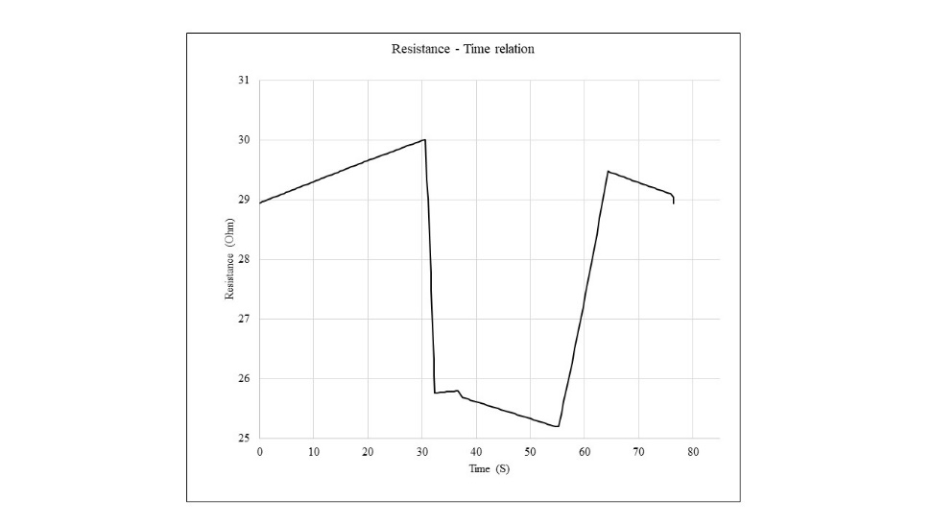
Figure 1: Relation between time and resistance
Table 1: Comparison of various parameters
Voltage | Current
1 | 5
2 | 6
3 | 7
4 | 8
5 | 9

Table data and figure data TNR normal text 10 points, center alignment.

Equations 12 points TNR. Every equation must be explained clearly. For instance, Eqn. (2.1) indicates that the equation number one in second chapter.

$$A=πr^{2} (2.1)$$

The whole project report may be divided into appropriate number of chapters. Every chapter must be introduced by linking the previous chapter, it has to be concluded and linked to the next chapter. It is mandatory that the report is divided into chapters, each of which may be structured into sections (1.1, 1.2) and sub-sections (1.2.1, 1.2.2). Do not exceed this level of sectioning. The sections and sub-sections must carry titles. If possible, try and use fonts for section titles and sub-section titles as given in this template. Every subheading, equation, table, figure must be indexed correctly and referred to in the text at appropriate part of the text. All the figures, diagrams, flow charts, graphs to be treated as figures and indexed accordingly uniformly. Mere scanned copies of equations, figures, table etc. must be strictly avoided.

Do not disturb the index, it can be automatically updated (text and page numbers) after completion of your writing, follow heading style strictly, then hover your cursor on top left corner of index, select auto update table.

Start each chapter on new page.

Refer to the same file to intact formatting for project report, remove unwanted text afterwards.

Contents
CHAPTER 1: Introduction 4
1.1 Background 4
1.2 Relevance 4
1.3 Literature Survey 4
1.4 Motivation 4
1.5 Aim and Objectives 4
1.6 Technical Approach 4
CHAPTER 2: Block Schematic and Requirements 5
2.1 Introduction 5
2.2 Block Diagram 5
2.3 Requirements 5
2.4 Selection of sensors and major components 5
CHAPTER 3: System Design 6
3.1 Calculations Block1 6
3.2 List of Components 6
CHAPTER 4: Implementation, testing and debugging 6
4.1 Implementation on bread board, observation table 6
4.2 Testing, Debugging. Observation table 6
4.3 Simulation results, observation table 6
4.4 PCB design 6
4.5 final project photograph and working 6
CHAPTER 5: Results and Discussion 7
Conclusions 7
Future Scope 8
References 8

CHAPTER 1: Introduction

1.1 Background
The genesis of our project stems from a shared passion for robotics ignited by a team member's proposal to engineer a 6-degree-of-freedom (6-DOF) robotic arm. Recognizing the potential for innovation and skill enhancement, our team, comprising individuals with diverse backgrounds in robotics and engineering, eagerly embraced the challenge. In selecting the ESP32 and Raspberry Pi 3 platforms, we prioritized their versatility and suitability for robotics applications, laying a solid foundation for our endeavor. Motivated by the dual objectives of innovation and skill development, we embarked on this journey with a collective vision for success. Anticipating inevitable hurdles, we approached each challenge with resilience and resourcefulness. These obstacles not only tested our technical prowess but also served as catalysts for personal and collective growth. At its core, our project represents the convergence of passion, expertise, and ambition. It reflects our commitment to pushing the boundaries of technological innovation in the realm of automation. This commitment is underscored by our collaborative and supportive environment, fostering exploration and discovery. Through our collective efforts, we aim to realize the vision of creating a functional, sophisticated, and groundbreaking 6-DOF robotic arm. This project epitomizes the fusion of challenge and innovation, symbolizing our dedication to advancing automation technology.

1.2 Relevance
The project of engineering a 6-degree-of-freedom (6-DOF) robotic arm holds immense relevance to the field of Electronics and Communication engineering and related subjects within the curriculum. Firstly, it aligns closely with the core principles of robotics and automation, which are integral components of these disciplines. By delving into the design, construction, and control of a robotic arm, students gain practical insights into complex electromechanical systems, enhancing their understanding of fundamental concepts such as sensors, actuators, microcontrollers, and communication protocols.
Moreover, the project offers a hands-on opportunity for students to apply theoretical knowledge gained in courses related to electronics, control systems, and signal processing. Through the integration of platforms like ESP32 and Raspberry Pi 3, students learn to leverage cutting-edge technologies to address real-world challenges in robotics. This practical experience not only reinforces theoretical concepts but also cultivates problem-solving skills essential for success in the field.
Furthermore, the project's emphasis on innovation and skill enhancement resonates with the objectives of Electronics and Communication engineering programs, which strive to produce graduates equipped with the creativity and technical expertise to drive technological advancement. By engaging in projects like the development of a 6-DOF robotic arm, students are better prepared to tackle the evolving demands of industries ranging from manufacturing and automation to healthcare and aerospace.
In summary, the project holds significant relevance to Electronics and Communication engineering and related subjects by providing a practical platform for students to apply theoretical knowledge, develop essential skills, and contribute to the advancement of robotics and automation technology.

1.3 Literature Survey
Advancements in 6-DOF Robotic Arms with Locomotion
Introduction:
The quest for versatile robotic arms capable of both agility and mobility has garnered significant attention in recent years. This literature survey delves into key studies focusing on 6-degree-of-freedom (6-DOF) robotic arms utilizing ESP32 and Raspberry Pi 3 controllers, emphasizing advancements in control capabilities, affordability, and integration with locomotion.
Study 1: "Advanced Robotic Arm Control via IoT with ESP32 and Raspberry Pi 3" (2020)
- Features: 6 DOFs, ESP32, Raspberry Pi 3, IoT connectivity.
- Insight: This study showcases the potential of ESP32 and Raspberry Pi 3 in orchestrating complex robotic arm movements through IoT connectivity, offering advanced control capabilities.
- Source: Academia.edu
Study 2: "Affordable 3D-Printed 6-DOF Robotic Arm with ESP32 and Raspberry Pi 3" (2021)
- Features: 6 DOFs, 3D-printed, Bluetooth control.
- Insight: Highlighting affordability and flexibility, this study emphasizes the role of 3D printing in creating cost-effective 6-DOF robotic arms. Integration of Bluetooth control enhances accessibility.
- Source: Hiwonder

Study 3: "Integrating Locomotion with a 6-DOF Robotic Arm using ESP32 and Raspberry Pi 3" (2019)
- Features: 6 DOFs, mounted on mobile platform, synchronized control with Raspberry Pi 3.
- Insight: Successfully integrating arm manipulation with mobile locomotion, this study demonstrates the synergy between ESP32, Raspberry Pi 3, and mobility platforms, opening new possibilities for robotic applications.
- Source: Journal of Robotics and Automation

Overall, these studies represent significant contributions to the field by showcasing advancements in control capabilities, affordability, and integration with locomotion. Each approach offers unique advantages and insights, laying the groundwork for further innovation in the development of versatile 6-DOF robotic arms.

1.4 Motivation

Our project germinated from a shared enthusiasm for robotics, catalyzed by a team member's proposal to engineer a 6-DOF robotic arm. Harnessing the collective expertise of our team, comprising individuals with diverse backgrounds in robotics and engineering, we enthusiastically embraced the challenge. Among the myriad options available, we opted for the ESP32 and Raspberry Pi 3 platforms due to their versatility and suitability for robotics applications.

Motivated by the dual objectives of innovation and skill enhancement, we recognized the project as an opportunity to contribute meaningfully to the realm of automation technology. Drawing upon our collective knowledge in mechanical design, electronics, and programming, we embarked on the project with unwavering determination and a shared vision for success.

Despite anticipating inevitable hurdles along the journey, we approach them with a spirit of resilience and resourcefulness. Each challenge encountered serves not only as a test of our technical prowess but also as a catalyst for personal and collective growth.

At its core, our project's background epitomizes a convergence of passion, expertise, and ambition. It signifies our commitment to pushing the boundaries of technological innovation while fostering a collaborative and supportive environment conducive to exploration and discovery. Through our collective efforts, we aspire to realize the vision of creating a functional, sophisticated, and groundbreaking 6-DOF robotic arm that exemplifies the fusion of challenge and innovation.

1.5 Aim and Objectives
State the problem what you are going tackle/solve in the project very clearly and precisely here.

1.6 Technical Approach
How you went about solving the problem and what is the technical approach you have adopted to solve the problem.

CHAPTER 2: Block Schematic and Requirements
2.1 Introduction
Write brief about only proposed project idea.
2.2 Block Diagram
Diagram shall include a caption below figure as shown below font 10 center aligned, it should be cited in the text before placing of figure as “” As shown in Fig.1”

Block-1
Block-2
Block-3
Block-4
Block-5

Fig.1. Block schematic of system
Block1 write description about each block without mention of any specific components/ IC numbers. It should be generalized.
Block2
Block3
2.3 Requirements
List all requirements for the projects in terms of hardware and software as separate list.
2.4 Selection of sensors and major components

Select any major part like transistor, diode, thyristor, microcontroller, etc. by comparing them either from same family, manufacturer, or sensing quantity. For example, if you are writing transistor selection refer to the following example.
Table 2: Transistor selection table
List Parameter | Design Requirement | Models |  |  | Units
 |  | Model no.1 | Model no. 2 | Model no. 3
 |  | [1] | [2] | [3]
I_{C} |  |  |  |  | A
V_{CEO} |  |  |  |  | V
h_{fe} |  |  |  |  | --
P_{D} |  |  |  |  | W
V_{BE} |  |  |  |  | V
Package |  |  |  |  | --
Type | NPN | NPN | NPN |  | --
Thermal

After the table write the selection from table that you want to continue in your circuit design. Specify why to choose that particular component/part. Mention datasheets reference number in place [1], [2] in table as shown.

CHAPTER 3: System Design

3.1 Calculations Block1
Design of each block systematically is expected here. Make subsections block wise that used in chapter 2. All detail calculations with mathematical formula or derivation must be written in this section.

3.2 List of Components
Finally list all the components selected, calculated in the table below

Table 3: List of components required in project.
Sr. No | Name and description of part | Value / model number
1
2
3
4
5

Write how to test the circuit of each block in detail.

Write how to test the circuit of each block in detail using any simulation environment. Include mechanical design if any in the same sections.

CHAPTER 4: Implementation, testing and debugging

4.1 Implementation on bread board, observation table

4.2 Testing, Debugging. Observation table

4.3 Simulation results, observation table

4.4 PCB design

4.5 final project photograph and working

CHAPTER 5: Results and Discussion

All the results and solutions obtained by carrying out project work may be discussed qualitatively and quantitatively in detail. Each block observation must be tabulated and compared. The table must include designed values, bread board testing, PCB testing, simulation. Indicate the agreements or deviation in results with proper reasoning suggest suitable solution in case.
Figure 2 :BER Performance of Basic Linear Array
N=2,φ =[15⁰ -30⁰ 60⁰ -70⁰ 80⁰],µ=0.06,N_{I}=15,M=5
(Co-ordinates in the block indicate X=SNR, Y=BER )

All the graphs should be clearly visible with title, labels of each axis, legends, and line markers as shown in Fig. 2.2 above. Graphs, results must be clearly interpreted in the text by explaining the numerical, its significance and inferences as followed. BER performance of the basic linear array of isotropic elements is carried out for various SNR and plotted in Fig. 2.2. Here, the algorithmic parameter µ is set to 0.06 and the initial weight vector to [0.1+0i 0.1+0i]. MBER solution converged to a lesser BER after 15 iterations that compared with MMSE solution. At SNR=15, the BER is found to be 10^{-7.662} and the weight vector to be [0.0228+0.0056i 0.0197+0.0127i] by MMSE approach, whereas, by MBER approach, BER is 10^{-9.907} and weight vector is [0.4800 0.7456+0.4623i].

Conclusions

This summarizes what has been done and concluded based on the experiments/simulations/ project. The conclusions can be summed up as “What have you done, achieved and learnt by the end of the project?” Add important achievements with measurable outcomes. Also explain the applications of the work/project.

Future Scope

Explain any limitations in your results and how things might be improved. Discuss how your work might be developed further. Reflect on your results in isolation and in relation to what others have achieved in the same field. This self-analysis is particularly important. You should give a critical evaluation of what went well, and what might be improved. This section should guide the future students to get motivated to take this work ahead.

References

Books:

- Constantine A. Balanis, Antenna Theory: Analysis and Design, 2nd Edition; John Wiley Sons Inc. New York, 2001,pp12-130
Transaction/Journals:
- Inder J Gupta, Aharon A Ksienski, “Effect of Mutual Coupling on the Performance of Adaptive Arrays” IEEE Trans. Antennas Propagat., vol. AP-31, no.5, pp.785-791, Sept. 1993

International/National Conference Proceedings:

- S. Chen,L. Hanzo, N.N. Ahmad, and A. Wolfgang “Adaptive minimum bit error rate beam forming assisted QPSK receiver,” Proc. IEEE International Conference on Communications, June,2004, Paris, France
- J. Lundback, S. Nordebo, “Analysis of a tripole array for polarization and direction of arrival estimation” Proc. IEEE Sensor Array and Multichannel Signal Processing Workshop Proceedings, 2004, 18-21, July 2004, pp. 284 - 288
Standards/Patents:
- G.Brandli and M. Dick, “Alternating current fed power supply,” U.S.Patent 4 084 217, Nov.4,1978
Technical Reports:

- E. E. Reber, R. L. Mitchell, and C. J. Carter, “Oxygen absorption in the Earth’s atmosphere,” Aerospace Corp., Los Angeles, CA, Tech. Rep. TR-0200 (4230-46)-3, Nov. 1968
Website:
- M. Duncan. “Engineering Concepts on Ice. Internet: www.iceengg.edu/staff.html, Oct. 25, 2000 [Nov. 29, 2003].

Note: Above Red colored titles should not be included in the report. Only references are to be included.

