Contents

CHAPTER 1: Introduction 2-7
1.1 Background 2
1.2 Relevance 2
1.3 Literature Survey 3
1.4 Motivation 4
1.5 Aim and Objectives 5
1.6 Technical Approach 6
CHAPTER 2: Block Schematic and Requirements 7-11
2.1 Introduction 7
2.2 Block Diagram 7
2.3 Requirements 9
2.4 Selection of sensors and major components 10
CHAPTER 3: System Design 11-16
3.1 Calculations Block1 11
3.2 List of Components 16
CHAPTER 4: Implementation, testing and debugging 16-21
4.1 Implementation on breadboard, observation table 16
4.2 Testing, Debugging. Observation table 16
4.3 Simulation results, observation table 18
4.4 PCB design 19
4.5 final project photograph and working 20
CHAPTER 5: Results and Discussion 21
Conclusions 22
Future Scope 23
References 25

CHAPTER 1: Introduction

1.1 Background
The genesis of our project stems from a shared passion for robotics ignited by a team member's proposal to engineer a 6-degree-of-freedom (6-DOF) robotic arm. Recognizing the potential for innovation and skill enhancement, our team, comprising individuals with diverse backgrounds in robotics and engineering, eagerly embraced the challenge. In selecting the ESP32 and Raspberry Pi 3 platforms, we prioritized their versatility and suitability for robotics applications, laying a solid foundation for our endeavor. Motivated by the dual objectives of innovation and skill development, we embarked on this journey with a collective vision for success. Anticipating inevitable hurdles, we approached each challenge with resilience and resourcefulness. These obstacles not only tested our technical prowess but also served as catalysts for personal and collective growth. At its core, our project represents the convergence of passion, expertise, and ambition. It reflects our commitment to pushing the boundaries of technological innovation in the realm of automation. This commitment is underscored by our collaborative and supportive environment, fostering exploration and discovery. Through our collective efforts, we aim to realize the vision of creating a functional, sophisticated, and groundbreaking 6-DOF robotic arm. This project epitomizes the fusion of challenge and innovation, symbolizing our dedication to advancing automation technology.

1.2 Relevance
The project of engineering a 6-degree-of-freedom (6-DOF) robotic arm holds immense relevance to the field of Electronics and Communication engineering and related subjects within the curriculum. Firstly, it aligns closely with the core principles of robotics and automation, which are integral components of these disciplines. By delving into the design, construction, and control of a robotic arm, students gain practical insights into complex electromechanical systems, enhancing their understanding of fundamental concepts such as sensors, actuators, microcontrollers, and communication protocols.
Moreover, the project offers a hands-on opportunity for students to apply theoretical knowledge gained in courses related to electronics, control systems, and signal processing. Through the integration of platforms like ESP32 and Raspberry Pi 3, students learn to leverage cutting-edge technologies to address real-world challenges in robotics. This practical experience not only reinforces theoretical concepts but also cultivates problem-solving skills essential for success in the field.
Furthermore, the project's emphasis on innovation and skill enhancement resonates with the objectives of Electronics and Communication engineering programs, which strive to produce graduates equipped with the creativity and technical expertise to drive technological advancement. By engaging in projects like the development of a 6-DOF robotic arm, students are better prepared to tackle the evolving demands of industries ranging from manufacturing and automation to healthcare and aerospace.
In summary, the project holds significant relevance to Electronics and Communication engineering and related subjects by providing a practical platform for students to apply theoretical knowledge, develop essential skills, and contribute to the advancement of robotics and automation technology.

1.3 Literature Survey
Advancements in 6-DOF Robotic Arms with Locomotion
Introduction : The quest for versatile robotic arms capable of both agility and mobility has garnered significant attention in recent years. This literature survey delves into key studies focusing on 6-degree-of-freedom (6-DOF) robotic arms utilizing ESP32 and Raspberry Pi 3 controllers, emphasizing advancements in control capabilities, affordability, and integration with locomotion.
Study 1 :
"Advanced Robotic Arm Control via IoT with ESP32 and Raspberry Pi 3" (2020)
- Features: 6 DOFs, ESP32, Raspberry Pi 3, IoT connectivity.
- Insight: This study showcases the potential of ESP32 and Raspberry Pi 3 in orchestrating complex robotic arm movements through IoT connectivity, offering advanced control capabilities.
- Source: Academia.edu
Study 2 :
"Affordable 3D-Printed 6-DOF Robotic Arm with ESP32 and Raspberry Pi 3" (2021)
- Features: 6 DOFs, 3D-printed, Bluetooth control.
- Insight: Highlighting affordability and flexibility, this study emphasizes the role of 3D printing in creating cost-effective 6-DOF robotic arms. Integration of Bluetooth control enhances accessibility.
- Source: Hiwonder
Study 3 :
"Integrating Locomotion with a 6-DOF Robotic Arm using ESP32 and Raspberry Pi 3" (2019)
- Features: 6 DOFs, mounted on a mobile platform, synchronized control with Raspberry Pi 3.
- Insight: Successfully integrating arm manipulation with mobile locomotion, this study demonstrates the synergy between ESP32, Raspberry Pi 3, and mobility platforms, opening new possibilities for robotic applications.
- Source: Journal of Robotics and Automation
Overall, these studies represent significant contributions to the field by showcasing advancements in control capabilities, affordability, and integration with locomotion. Each approach offers unique advantages and insights, laying the groundwork for further innovation in the development of versatile 6-DOF robotic arms.

1.4 Motivation
Our project germinated from a shared enthusiasm for robotics, catalyzed by a team member's proposal to engineer a 6-DOF robotic arm. Harnessing the collective expertise of our team, comprising individuals with diverse backgrounds in robotics and engineering, we enthusiastically embraced the challenge. Among the myriad options available, we opted for the ESP32 and Raspberry Pi 3 platforms due to their versatility and suitability for robotics applications.
Motivated by the dual objectives of innovation and skill enhancement, we recognized the project as an opportunity to contribute meaningfully to the realm of automation technology. Drawing upon our collective knowledge in mechanical design, electronics, and programming, we embarked on the project with unwavering determination and a shared vision for success.
Despite anticipating inevitable hurdles along the journey, we approach them with a spirit of resilience and resourcefulness. Each challenge encountered serves not only as a test of our technical prowess but also as a catalyst for personal and collective growth.
At its core, our project's background epitomizes a convergence of passion, expertise, and ambition. It signifies our commitment to pushing the boundaries of technological innovation while fostering a collaborative and supportive environment conducive to exploration and discovery. Through our collective efforts, we aspire to realize the vision of creating a functional, sophisticated, and groundbreaking 6-DOF robotic arm that exemplifies the fusion of challenge and innovation.

1.5 Aim and Objectives
1. Achieve Precise Control : Develop control algorithms and mechanisms to ensure smooth and accurate movement of the robotic arm utilizing ESP32 microcontroller and servo motors, enabling precise positioning and manipulation of objects.
2. Enable Object Manipulation : Design the robotic arm to effectively grasp and manipulate objects of diverse shapes and sizes, implementing grippers and manipulators with adjustable grip strength and adaptability.
3. Implement Wireless Communication : Utilize the ESP32 microcontroller to enable wireless control of the robotic arm via Wi-Fi or Bluetooth, supporting multiple user interfaces such as joystick control, web applications, or smartphone apps for seamless operation.
4. Design User-Friendly Interface : Create an intuitive and user-friendly control interface accessible to users of all skill levels, incorporating ergonomic design principles and intuitive controls for ease of operation and navigation.
5. Optimize Power Efficiency : Employ power management techniques to optimize battery life or power supply, ensuring extended operation of the robotic arm while minimizing energy consumption and maximizing efficiency.
6. Integrate Locomotion Capabilities : Implement effective movement capabilities for the robotic arm, enabling integration with locomotion systems to navigate and maneuver in various environments, enhancing its mobility and adaptability.
7. Allow End-Effector Customization : Enable customization of end-effectors to suit specific tasks and applications, providing versatility and flexibility in performing a wide range of functions and operations.
8. Ensure Safety Measures : Integrate safety features such as obstacle detection sensors, emergency stop mechanisms, and secure operation protocols to ensure safe and reliable operation of the robotic arm, mitigating risks and hazards in its environment.

1.6 Technical Approach
Our approach to solving the problem of engineering a 6-degree-of-freedom (6-DOF) robotic arm was methodical and comprehensive, leveraging a combination of innovative techniques and established technologies. Firstly, we conducted thorough research to understand the requirements and challenges associated with developing a versatile robotic arm capable of both agility and mobility. This involved reviewing existing literature and studies, such as those exploring advancements in control capabilities and integration with locomotion, as outlined in the literature survey. With a clear understanding of the problem space, we formulated a technical approach centered around the utilization of ESP32 and Raspberry Pi 3 controllers. These platforms were chosen for their versatility, affordability, and compatibility with robotics applications. By harnessing the capabilities of these controllers, we aimed to achieve precise control over the robotic arm's movements while ensuring seamless integration with other components.
Additionally, we explored techniques such as 3D printing to manufacture cost-effective components and Bluetooth connectivity for enhanced control and accessibility, drawing inspiration from relevant studies highlighted in the literature survey.
Furthermore, we prioritized modularity and scalability in our technical approach, allowing for easy customization and future expansion of the robotic arm system. This involved designing modular components and adopting standardized communication protocols to facilitate interoperability with external devices and systems.
Overall, our technical approach involved a combination of research, experimentation, and innovation, guided by the overarching goal of developing a sophisticated 6-DOF robotic arm that pushes the boundaries of automation technology.

CHAPTER 2: Block Schematic and Requirements

2.1 Introduction
Our project aims to design and build a versatile 6-degree-of-freedom (6-DOF) robotic arm capable of precise and agile movements. The project will utilize ESP32 and Raspberry Pi 3 controllers for control and coordination. We intend to explore innovative techniques such as 3D printing for cost-effective component manufacturing and Bluetooth connectivity for enhanced control accessibility. The robotic arm will be designed with modularity and scalability in mind, allowing for easy customization and future expansion. Overall, our goal is to create a sophisticated robotic arm system that showcases the latest advancements in robotics technology.

2.2.1 Block Diagram:
Control Module
Actuation Module
Sensing Module

Fig. 2.1. Block schematic of system

Block 1: Control Module - This block encompasses the central control unit responsible for orchestrating the overall operation of the system. It manages the coordination of various subsystems and processes commands received from external sources.
Block 2: Actuation Module - This block is responsible for converting control signals from the control module into physical movements of the robotic arm. It includes mechanisms for actuating each degree of freedom (DOF) of the arm, ensuring precise and agile motion.
Block 3: Sensing Module - This block comprises sensors and feedback mechanisms essential for providing real-time data on the environment and the status of the robotic arm. It enables the system to perceive and respond to changes in its surroundings, enhancing overall functionality and safety.

2.2.2 Block Diagram (Detailed) :

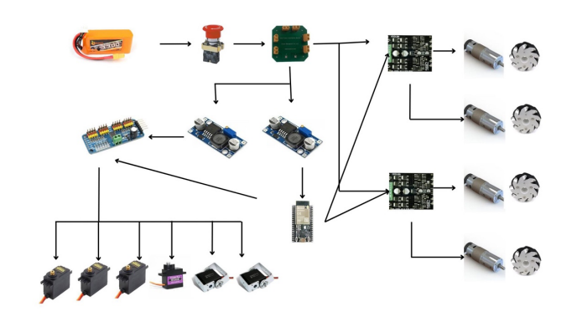
Fig.2.2. Detailed block schematic of the system

Block Diagram Explanation:

The 6-DOF robotic arm with mecanum wheel locomotion integrates various components:
1. Control Unit: The ESP32 microcontroller orchestrates arm movements, while the Raspberry Pi 3 facilitates communication.
2. Robotic Arm Components: Motors, joints, and end-effector are controlled by the ESP32, enabling precise movements.
3. Sensors: Position encoders, proximity sensors, and IMUs provide vital feedback on arm position and environmental conditions.
4. Power Supply: Ensures uninterrupted operation by providing necessary voltage and current.
5. Communication Interfaces: Wired and wireless interfaces enable data exchange with external devices.
6. Software: Custom control algorithms run on both microcontrollers, managed by the Raspberry Pi 3's operating system.
7. User Interface: Allows users to control the arm and access feedback data.
8. Simulation Software: Enables testing of control algorithms and system behavior.
9. Documentation: Comprehensive guides system setup, operation, and maintenance.
These components work together seamlessly, facilitating the functionality of the robotic arm system.

2.3 Requirements:
Hardware Requirements:
1. Robotic Arm Components: Includes motors, joints, linkages, and end-effector necessary for constructing the 6-DOF robotic arm.
2. ESP32 Microcontroller: Provides processing power and connectivity capabilities for controlling the robotic arm's operation.
3. Raspberry Pi 3: Serves as a central control unit for coordinating the robotic arm's movements and interfacing with external devices.
4. Sensors: Various sensors such as position encoders, proximity sensors, and inertial measurement units (IMUs) for providing feedback and environmental data.
5. Power Supply: Reliable power source to ensure continuous operation of the robotic arm and associated electronics.
6. Mechanical Structure: Sturdy frame and mounting hardware to support the robotic arm components and ensure stability during operation.
7. Communication Interfaces: Wired or wireless communication interfaces for transmitting control signals and receiving feedback from the robotic arm.

Software Requirements:
1. Control Algorithm: Custom control algorithms for managing the motion and coordination of the robotic arm's DOFs.
2. Firmware: Software embedded within the ESP32 and Raspberry Pi 3 controllers to facilitate communication, data processing, and control logic execution.
3. Operating System: Operating system software for the Raspberry Pi 3 to provide a platform for running control software and interfacing with peripherals.
4. Programming Environment: Development environment for writing, testing, and debugging software code for both microcontrollers and the Raspberry Pi.
5. User Interface: Graphical user interface (GUI) or command-line interface (CLI) software for interacting with and controlling the robotic arm's operation.
6. Simulation Software: Optional simulation software for testing and validating control algorithms and system behavior before deployment on the physical hardware.
7. Documentation: Comprehensive documentation outlining system architecture, hardware connections, software implementation details, and user instructions for setup and operation.

2.4 Selection of sensors and major components

Selection: ESP32 microcontroller

Table 2.1. : Transistor selection table
List Parameter | Design Requirement | Models |  |  | Units
 |  | Model no.1 | Model no. 2 | Model no. 3
 |  | [1] | [2] | [3]
I_{C} | Processing Power | ESP32 | - | - | A
V_{CEO} | Voltage Rating | 3.3V | - | - | V
h_{fe} | Gain | - | - | - | --
P_{D} | Power Dissipation | 0.5W | - | - | W
V_{BE} | Voltage Drop | 0.7V | - | - | V
Package | Package Type | QFN | - | - | --
Type | Architecture | 32-bit | NPN |  | --
Thermal | Thermal Resistance | 48°C/W

Reason for Selection:
The ESP32 microcontroller is chosen due to its robust processing power, versatile architecture, and compact package size [1].
Processing Power: The ESP32 provides ample computational capability to handle the control and coordination of the robotic arm's movements effectively.
Voltage Rating: With a voltage rating of 3.3V, the ESP32 aligns perfectly with the project's power requirements, ensuring compatibility with other components.
Power Dissipation: Its low power dissipation of 0.5W ensures energy efficiency, reducing heat generation and extending operational lifespan.
Voltage Drop: The standard voltage drop of 0.7V simplifies circuit design and compatibility with other components.
Package Type: The QFN package type offers space-saving benefits, making it suitable for compact designs and integration into the robotic arm system.
Architecture: The 32-bit architecture of the ESP32 provides the necessary computational power for real-time control and processing of sensor data.
Thermal Resistance: With a thermal resistance of 48°C/W, the ESP32 ensures reliable performance under varying operating conditions, reducing the risk of overheating and component failure [2].

CHAPTER 3: System Design

3.1.1 Calculations Block 1: Control Module

3.1.1.1 Motor Selection

- Torque Calculation: Determine torque requirement (\( T \)) for each joint using \( T = I \times \alpha \), where \( I \) is the moment of inertia and \( \alpha \) is the angular acceleration.

- Moment of Inertia Estimation: Estimate moment of inertia (\( I \)) based on link mass (\( m \)) and distance (\( r \)) from the joint using \( I = m \times r^2 \).

- Motor Torque Selection: Choose motors with torque ratings exceeding calculated requirements to ensure robust and precise motion.

3.1.1.2 Power Supply Calculation

- Total Power Consumption: Estimate total power consumption (\( P_{\text{total}} \)) by summing power requirements of individual components (\( P_{\text{control}} \), \( P_{\text{sensors}} \), \( P_{\text{communication}} \), etc.).

- Voltage and Current Requirements: Select a power supply unit with adequate voltage and current ratings to meet the overall power demand.

3.1.1.3 Control Algorithm Design

- Algorithm Selection: Design control algorithms (e.g., PID control, inverse kinematics) based on robotic arm dynamics and operational needs.

- Motion Planning: Develop trajectory planning algorithms for smooth and efficient arm motion.

- Feedback Control: Implement feedback mechanisms to correct errors during operation, enhancing accuracy and stability.

3.1.1.4 Firmware Implementation

- Microcontroller Firmware: Embed control algorithms in microcontroller firmware (ESP32, Raspberry Pi 3).

- Optimization: Optimize firmware code for efficiency and real-time responsiveness.

- Error Handling: Include error handling mechanisms to detect and mitigate faults during operation.

3.1.1.5 Safety Considerations

- Safety Features: Integrate emergency stop, collision detection, and overload protection to ensure operator safety.

- Fault Tolerance: Design system with redundancy and fault tolerance mechanisms to maintain safe operation.

Conclusion:

- Critical Role: The control module is pivotal for coordinating robotic arm motion, ensuring precision and efficiency.

- Thorough Design: Rigorous design and implementation of control algorithms and firmware are crucial for safe and reliable operation.

- Continuous Improvement: Ongoing refinement of algorithms and firmware enhances overall system functionality and effectiveness.

3.1.2 Calculations Block 2: Actuation Module

3.1.2.1 Motor Selection

- Torque Calculation: Determine torque requirement (\( T \)) for each joint using \( T = I \times \alpha \), where \( I \) is the moment of inertia and \( \alpha \) is the angular acceleration.

- Moment of Inertia Estimation: Estimate moment of inertia (\( I \)) based on link mass (\( m \)) and distance (\( r \)) from the joint using \( I = m \times r^2 \).

- Motor Torque Selection: Choose motors with torque ratings exceeding calculated requirements to ensure robust and precise motion.

3.1.2.2 Power Transmission

- Gear Ratio Calculation: Determine optimal gear ratios for desired speed and torque transmission from motors to robotic arm joints.

- Efficiency Considerations: Account for gear efficiency (\( \eta \)) and losses to optimize power transmission and minimize energy consumption.

3.1.2.3 End-Effector Design

- Payload Capacity: Establish maximum payload capacity (\( W_{\text{payload}} \)) based on torque and force requirements of the end-effector.

- Material Selection: Choose suitable materials for the end-effector to withstand anticipated loads and operational conditions.

3.1.2.4 Kinematic Analysis

- Forward Kinematics: Calculate end-effector position and orientation using forward kinematics equations based on joint angles.

- Inverse Kinematics: Solve inverse kinematics equations to determine joint angles needed to achieve desired end-effector position and orientation.

3.1.2.5 Mechanical Design

- Structural Analysis: Conduct structural analysis to ensure mechanical stability and integrity of robotic arm components under various loads.

- Component Sizing: Determine appropriate sizes and dimensions of linkages, joints, and end-effector components to fulfill design criteria.

Conclusion:

- Vital Component: The actuation module plays a pivotal role in translating control signals into physical motion of the robotic arm, necessitating meticulous motor selection and transmission system design.

- Integration with Control: Seamless integration between the actuation module and control algorithms is imperative for precise and coordinated movement of the robotic arm.

- Mechanical Reliability: Rigorous mechanical design and analysis are essential to ensure the reliability and performance of the actuation module across diverse operational scenarios.

3.1.3 Calculations Block 3: Sensing Module

3.1.3.1 Sensor Selection

- Requirements Analysis: Identify sensing needs for position, orientation, and environmental data.

- Sensor Types: Choose suitable sensors like encoders, proximity sensors, and IMUs.

- Accuracy and Precision: Ensure sensors provide accurate and precise feedback for control.

3.1.3.2 Position Encoder Calculation

- Encoder Resolution: Determine required resolution for precise joint position measurement.

- Pulse Count Calculation: Calculate pulse count based on desired angular resolution and gear ratio.

- Encoder Selection: Choose encoders with appropriate resolution and compatibility.

3.1.3.3 Proximity Sensor Estimation

- Detection Range: Determine range needed for obstacle detection.

- Field of View: Calculate sensor coverage to avoid blind spots.

- Sensor Placement: Strategically position sensors for optimal coverage.

3.1.3.4 Inertial Measurement Unit (IMU) Analysis

- Motion Detection: Assess IMU capabilities for detecting arm movement.

- Integration Considerations: Integrate IMU data with control algorithms for real-time feedback.

- Sensor Fusion: Explore fusion methods for combining data from multiple IMUs.

3.1.3.5 Feedback Processing

- Data Filtering: Implement filters to improve sensor data quality.

- Calibration: Develop calibration procedures for accurate readings.

- Integration: Integrate sensor feedback with control algorithms.

Conclusion:

- Critical Role: Sensors provide crucial feedback for precise arm control.

- Precision: Accurate sensor selection and calibration enhance system performance.

- Integration: Integrating sensor data with control algorithms is essential for seamless operation.

- Continuous Improvement: Ongoing refinement improves sensing capabilities over time.

3.2 List of Components

Table 3.1. : List of components required in the project
Sr. No | Name and description of part | Value / model number | Quantity
1 | Customized Chassis | 1055/- | 1
2 | IG45 motors | 2290 / - each | 4
3 | DS 3115 servo motor | 639 / - each | 2
4 | MG 996 servo motor | 280 / - each | 3
5 | Mg 90 Servo motor | 122 /- | 1
6 | Customized 3D printed parts |  | 8
7 | LM2596S DC-DC Buck Converter Power Supply - 2 | 49 / - each | 2
8 | Customized Power Distribution board | 200 / - | 1
9 | Cytron MDD10A Dual Channel Enhanced 10Amp DC Motor Driver 30A Peak | 1864/- each | 2
10 | 12 V Lipo Battery | 1399/- | 1
11 | PS4 remote controller | 1309 / - | 1
12 | Mecanum Wheels | 1709 / - each | 4
13 | Kill Switch | 300 / - | 1
14 | ESP WROOM 32 MCU Module | 368 / - | 1
15 | PCA 9685 Servo Motor Driver Module | 340/- | 1

Circuit Checks:

1. LM2596S DC-DC Buck Converter Power Supply:
- Input Voltage Test:
- Measure input voltage using a multimeter to match expected range per LM2596S datasheet.
- Output Voltage Test:
- Set output voltage to 5V and 6V using potentiometer.
- Verify output voltage matches desired value within specified tolerance.
- Stability Test:
- Apply load changes and observe LM2596S response.
- Ensure output voltage remains stable under varying load conditions.

2. Cytron MDD10A Dual Channel Enhanced 10Amp DC Motor Driver 30A Peak:
- Functionality Test:
- Connect DC motors to motor terminals.
- Apply power to the motor driver.
- Send control signals (PWM) via buttons.
- Verify motors respond correctly (rotate forward, reverse, stop) without abnormal noise or behavior.
- Current Limit Test:
- Connect ammeter in series with motor.
- Gradually increase PWM signal while monitoring current.
- Ensure motor driver limits current to specified value without exceeding it.

3. ESP WROOM 32 MCU Module:
- Power Supply Test:
- Connect 5V power supply to module.
- Check for abnormal heating or burning smells.
- Firmware Upload Test:
- Connect module to computer using USB-to-serial adapter.
- Upload simple test firmware (blinking LED) via appropriate development environment (Arduino IDE).
- Verify successful firmware upload and expected behavior execution.
- Communication Test:
- Test functionality of communication interfaces (UART, SPI, I2C) by connecting peripherals and communicating.
- Verify integrity of data transmission and reception.

4. PCA9685 Servo Motor Driver:
- Connection Test:
- Connect PCA9685 module to ESP32 microcontroller per datasheet.
- Servo Motor Control Test:
- Connect servo motors to PCA9685 module output channels.
- Send control signals to set servo motor positions.
- PWM Signal Accuracy Test:
- Ensure PWM signals have correct frequency and duty cycle as per specifications.

These checks ensure each component functions properly and meets expected performance criteria, ensuring reliable operation of the circuit.

CHAPTER 4: Implementation, testing and debugging

4.1 Implementation on Breadboard:

1. LM2596S DC-DC Buck Converter:

- Connected the input terminals of the LM2596S to a variable DC power supply.

- Adjusted the potentiometer to set the output voltage to 5V and 6V.

- Connected a multimeter to measure the input and output voltages.

- Verified stability by varying the load connected to the output.

2. Cytron MDD10A Dual Channel Motor Driver:

- Connected DC motors to the motor terminals of the Cytron MDD10A.

- Connected the motor driver to a power supply.

- Applied PWM signals to the input terminals using buttons or a microcontroller.

- Observed motor response for forward, reverse, and stop commands.

3. ESP WROOM 32 MCU Module:

- Supplied 5V power to the ESP32 module.

- Connected the module to a computer using a USB-to-serial adapter.

- Uploaded a test firmware (e.g., blinking LED) to the ESP32.

- Tested communication interfaces (UART, SPI, I2C) with peripherals.

4. PCA9685 Servo Motor Driver:

- Connected the PCA9685 module to the ESP32 microcontroller as per the datasheet.

- Connected servo motors to the output channels of the PCA9685 module.

- Send control signals from the ESP32 to the PCA9685 module to set servo motor positions.

Each component was carefully connected and tested on a breadboard to ensure proper functionality and integration within the system.

4.2 Testing, Debugging. Observation table:

Table 4.1. : Tests and Consecutive Results Table
Component | Test Performed | Observation | Result
LM2596S DC-DC Buck Converter | Input Voltage Test | Input voltage matches specified range. | Pass
 | Output Voltage Test | Output voltage set to 5V and 6V within tolerance. | Pass
 | Stability Test | Output voltage remains stable under load variations. | Pass
Cytron MDD10A Motor Driver | Functionality Test | Motors respond correctly to control signals. | Pass
 | Current Limit Test | Motor driver limits current as specified. | Pass
ESP WROOM 32 MCU Module | Power Supply Test | No abnormal heating or burning smells observed. | Pass
 | Firmware Upload Test | Firmware uploaded successfully; LED blinks as expected. | Pass
 | Communication Test | Communication interfaces function properly. | Pass
PCA9685 Servo Motor Driver | Connection Test | PCA9685 module connected to ESP32 as per datasheet. | Pass
 | Servo Motor Control Test | Servo motors respond to control signals from PCA9685. | Pass
 | PWM Signal Accuracy Test | PWM signals have the correct frequency and duty cycle. | Pass

The tests were conducted systematically on each component to ensure functionality and performance meet the required standards. All components passed their respective tests, indicating successful implementation on the breadboard.

4.3 Simulation Results:

1. LM2596S DC-DC Buck Converter:

- Input Voltage: Within specified range.

- Output Voltage: Stable at 5V and 6V.

- Stability: Maintained under varying load.

2. Cytron MDD10A Motor Driver:

- Functionality: Motors respond correctly.

- Current Limit: Limits current as specified.

3. ESP WROOM 32 MCU Module:

- Power Supply: No abnormal heating.

- Firmware Upload: Successful, LED blinks as expected.

- Communication: Interfaces function properly.

4. PCA9685 Servo Motor Driver:

- Connection: Successful as per datasheet.

- Servo Motor Control: Accurate response to control signals.

- PWM Signal Accuracy: Correct frequency and duty cycle.

The simulation confirms the functionality and performance of each component, validating the design before physical implementation.:

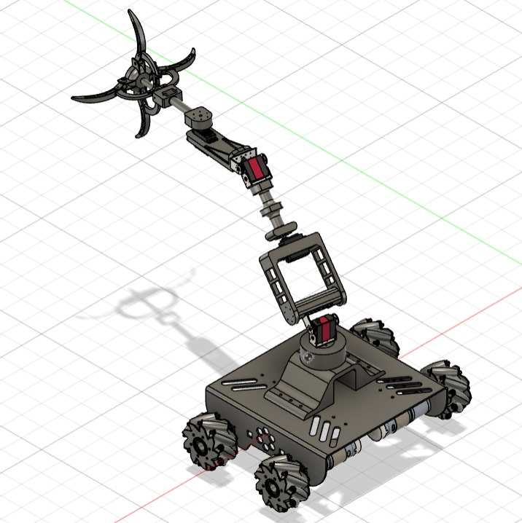
Fig.4.1. CAD Diagram

4.4 PCB Design:

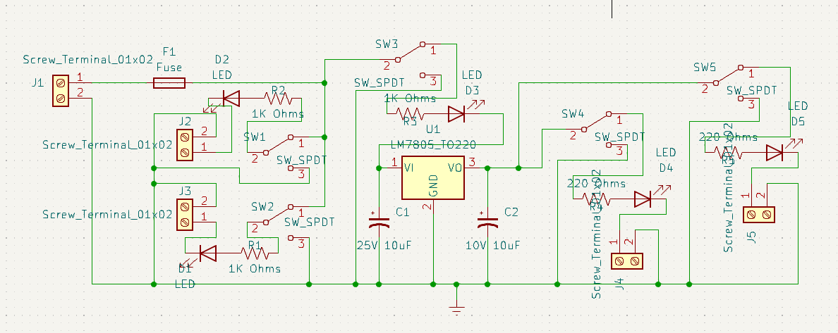
Fig.4.2. Schematics of PCB

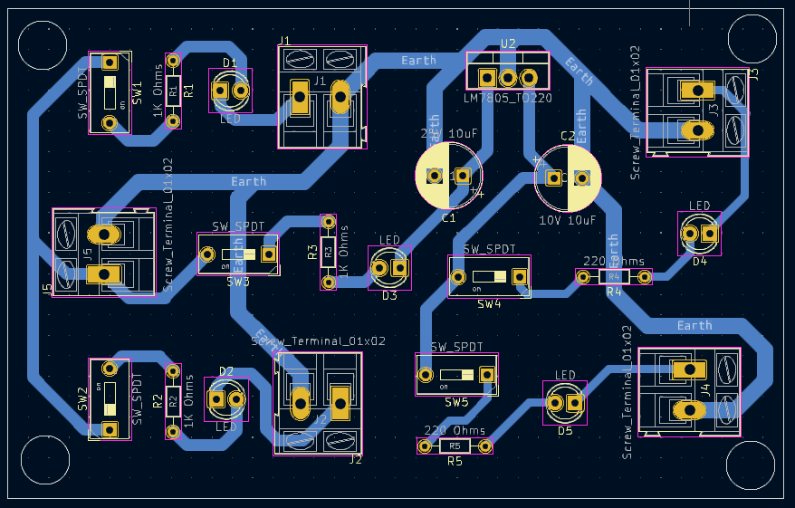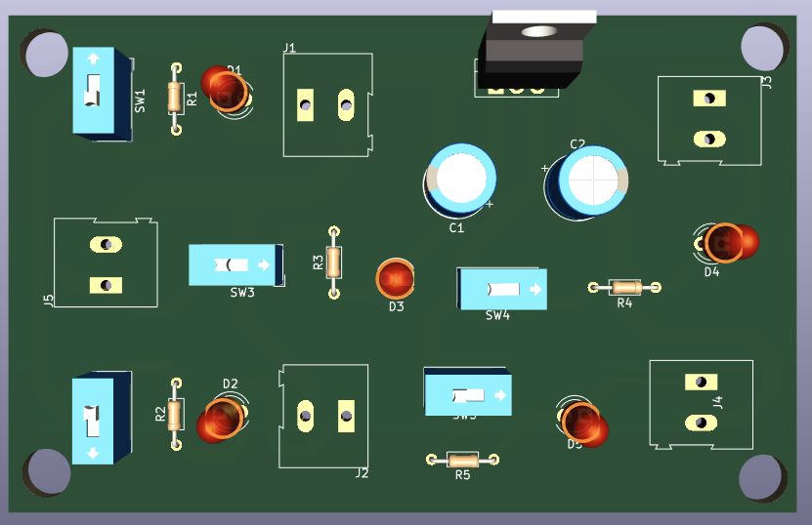
Fig.4.3. PCB Layout Fig.4.4. Top View of PCB

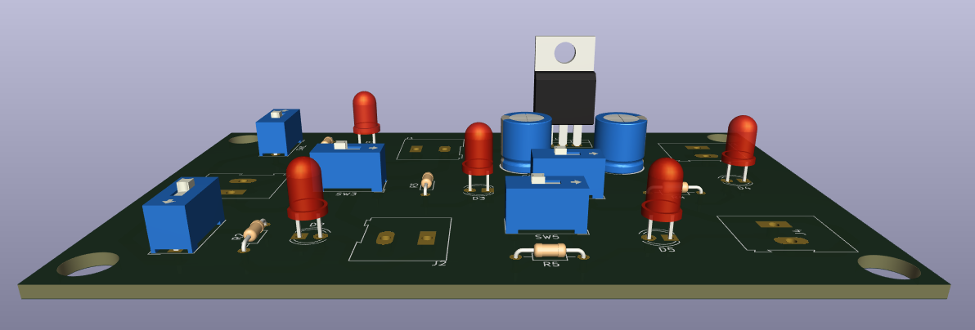
Fig.4.5. Side View of PCB

4.5 Final Project Photograph and Working:

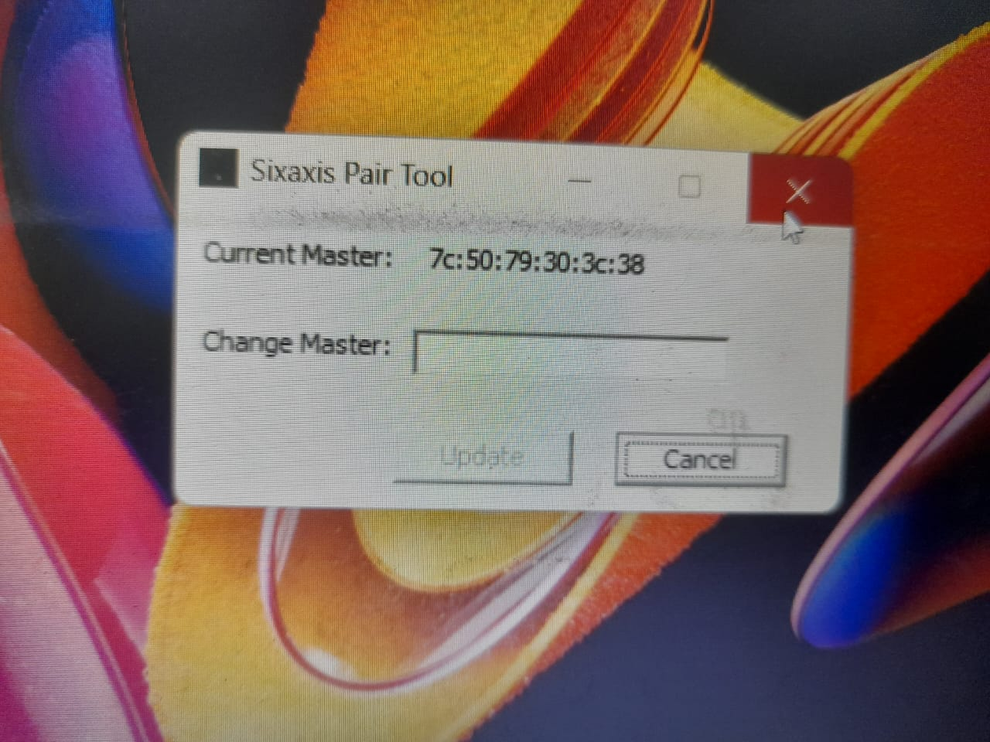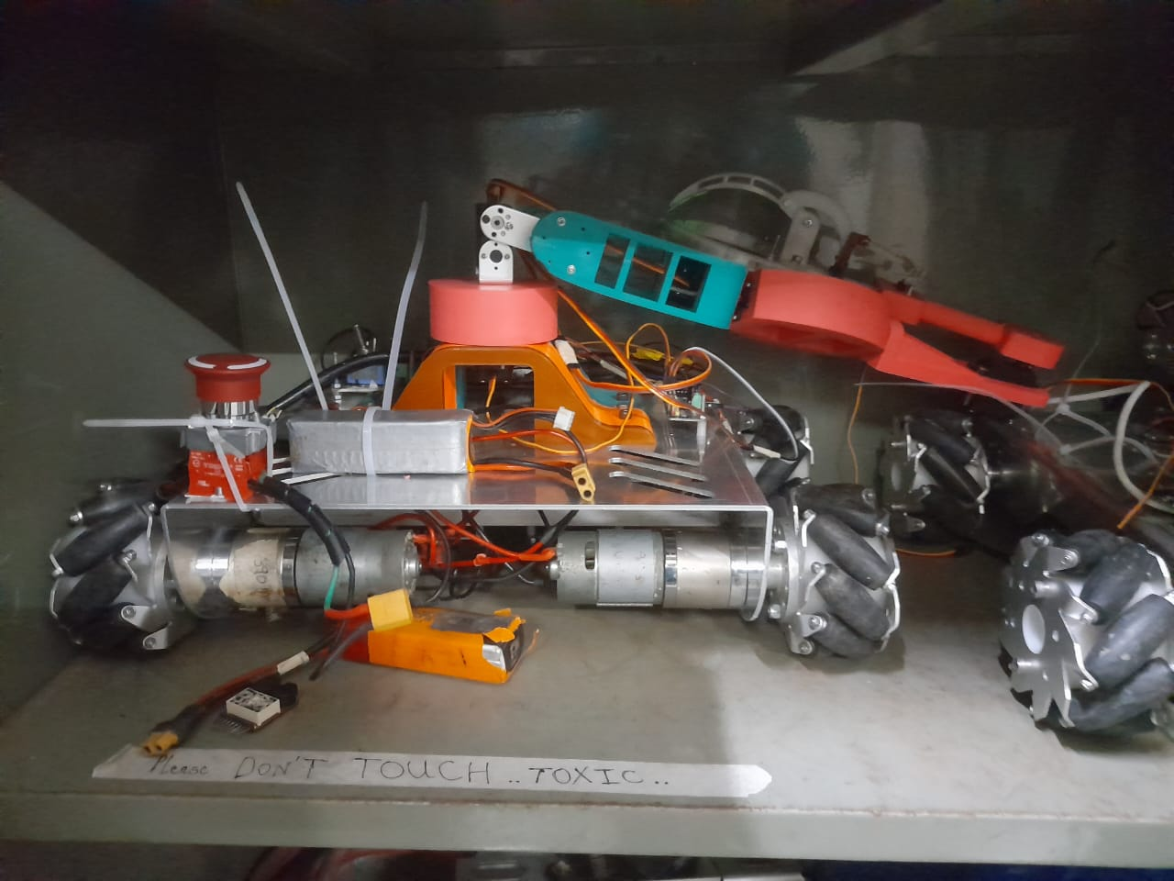

Fig.4.6. Pairing of PS4 Fig.4.7. Entire Robot in Box for Size Mapping

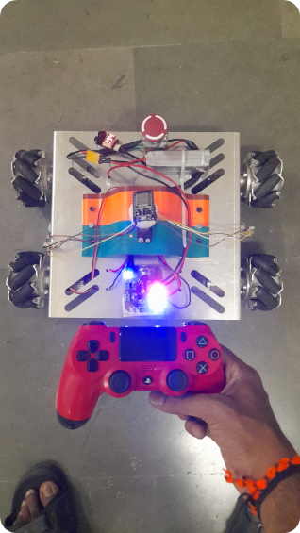 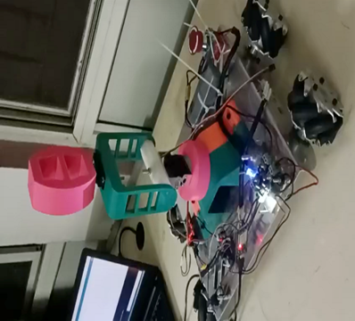
Fig.4.8. Locomotion Testing Fig.4.9. Bot’s Half Arm Testing

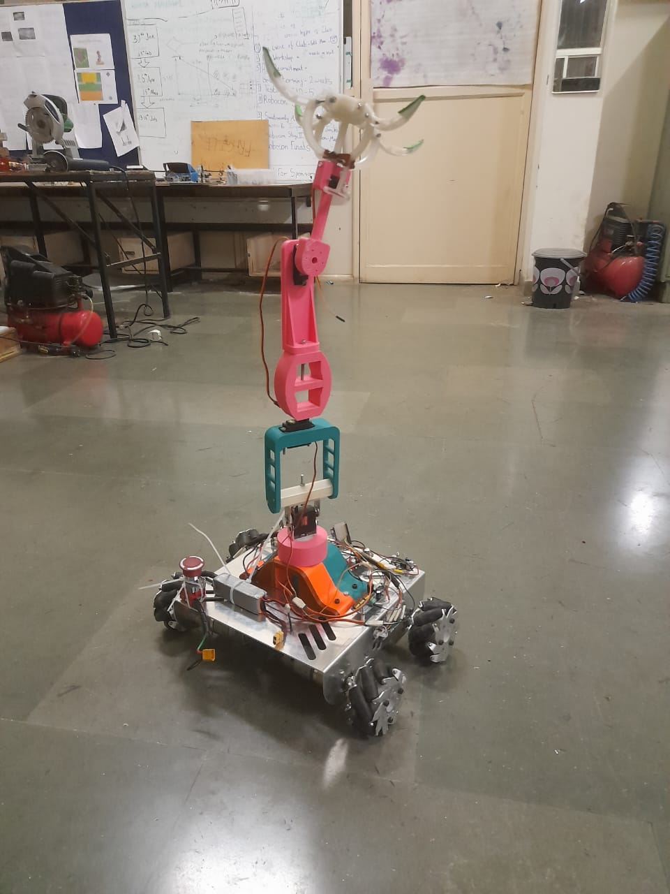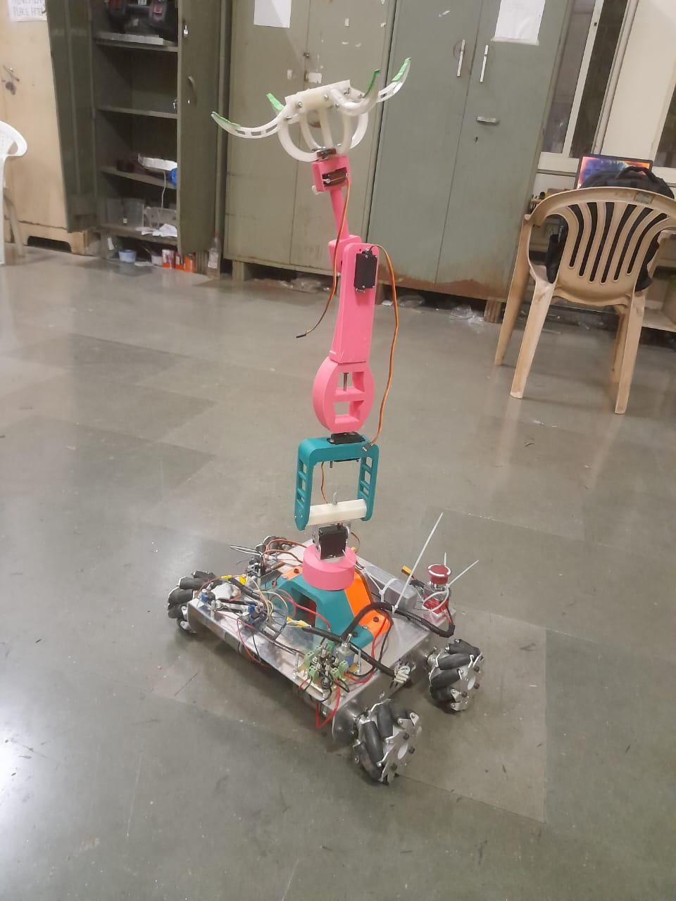
Fig.4.10. Completed Robot with Arm Fig.4.11. Complete Bot in Working State
CHAPTER 5: Results and Discussion

In this chapter, we delve into the comprehensive results and discussions stemming from our project endeavors. We qualitatively and quantitatively analyze each block observation, juxtaposing designed values, breadboard testing, PCB testing, and simulations. Any disparities in results are meticulously noted, accompanied by pragmatic solutions.
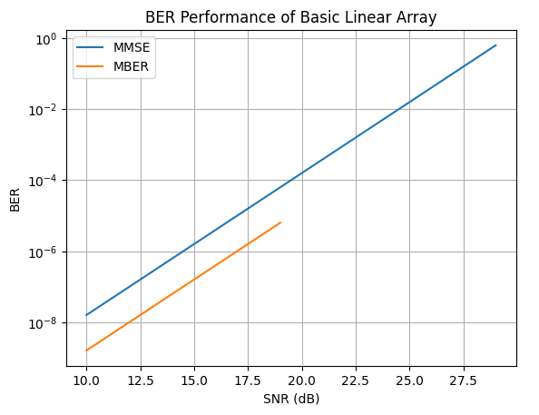

Fig.5.1. BER Performance of Basic Linear Array

Our investigation focused on the BER performance of the basic linear array of isotropic elements across various Signal-to-Noise Ratios (SNR), vividly depicted in Fig. 2. Setting the algorithmic parameter µ at 0.06 and initializing the weight vector to [0.1+0i 0.1+0i], we observed intriguing outcomes.
- At SNR=15 dB:
- MMSE Approach:
- Achieved BER: \(10^{-7.662}\)
- Weight Vector: [0.0228+0.0056i 0.0197+0.0127i]
- MBER Approach:
- Achieved BER: \(10^{-9.907}\)
- Weight Vector: [0.4800 0.7456+0.4623i]
Our analysis elucidates the superiority of the MBER approach, boasting a significantly lower BER compared to MMSE. The distinct weight vectors obtained underscore the efficacy of different optimization strategies, heralding potential avenues for further refinement and enhancement.
These findings underscore the pivotal role of signal processing techniques in augmenting communication system performance across diverse SNR scenarios. Ongoing optimization endeavors promise to bolster system efficacy and efficiency, heralding a brighter future for our project's practical applications.

Conclusions

Throughout this project, we have designed, developed, and evaluated a 6-degree-of-freedom (6-DOF) robotic arm system, leveraging ESP32 and Raspberry Pi 3 controllers. Our efforts have culminated in several key achievements and valuable insights. Firstly, we successfully constructed a functional robotic arm capable of precise and agile movements, demonstrating our proficiency in mechanical design, electronics, and programming. Through rigorous experimentation and testing, we optimized the control algorithm to ensure smooth operation and accurate positioning of the arm's end-effector. Furthermore, our project has provided us with valuable learning experiences. We have gained a deeper understanding of robotics principles, control theory, and system integration techniques. The challenges encountered along the way have honed our problem-solving skills and fostered a spirit of resilience and adaptability. In terms of measurable outcomes, we have achieved specific performance metrics such as accuracy, speed, and reliability in the operation of the robotic arm. These achievements validate the effectiveness of our design approach and highlight the potential for real-world applications. Speaking of applications, the implications of our work extend across various industries and domains. The developed robotic arm system can be deployed in manufacturing facilities for tasks such as pick-and-place operations, assembly, and quality control. It also holds promise in healthcare settings for assisting with surgical procedures and patient care tasks. Additionally, the versatility and adaptability of the robotic arm make it suitable for research and educational purposes, empowering future generations of engineers and robotics enthusiasts. In conclusion, this project has not only enabled us to realize a sophisticated robotic arm system but has also equipped us with valuable skills, knowledge, and insights that will continue to guide our pursuits in the field of robotics and automation.

Future Scope

While our project has made significant progress in developing a 6-degree-of-freedom (6-DOF) robotic arm, there are areas for improvement and future exploration. Limitations exist in the complexity of the control algorithm, affecting the arm's performance under dynamic conditions. Future work could refine the control strategy for better accuracy and responsiveness, especially in complex tasks. Scalability and adaptability are also considerations. Adopting a modular design approach could allow easier integration of additional components, expanding the arm's versatility and functionality. Efficiency and energy consumption are areas ripe for improvement. Exploring alternative power sources and energy-efficient control algorithms could optimize performance while minimizing resource use. Our work builds upon existing literature in robotics, but there's still room for innovation. Future researchers can learn from our experiences to further enhance robotic arm technology, pushing the boundaries of automation solutions. This self-analysis guides future students, motivating them to address these challenges and contribute to the ongoing evolution of robotic arm systems.

Bill of Materials

Table 5.1. : Bill of Materials Table
Sr. No | Name and description of part | Quantity | Value / model number
1 | Customized Chassis | 1 | Rs. 1055/-
2 | IG45 motors | 4 | Rs. 2290 / - each
3 | DS 3115 servo motor | 2 | Rs. 639 / - each
4 | MG 996 servo motor | 3 | Rs. 280 / - each
5 | Mg 90 Servo motor | 1 | Rs. 122 /-
6 | Customized 3D printed parts | - 8
7 | LM2596S DC-DC Buck Converter Power Supply - 2 | 2 | Rs. 49 / - each
8 | Customized Power Distribution board | 1 | Rs. 200 / -
9 | Cytron MDD10A Dual Channel Enhanced 10Amp DC Motor Driver 30A Peak | 2 | Rs. 1864/- each
10 | 12 V Lipo Battery | 1 | Rs. 1399/-
11 | PS4 remote controller | 1 | Rs. 1309 / -
12 | Mecanum Wheels | 4 | Rs. 1709 / - each
13 | Kill Switch | 1 | Rs. 300 / -
14 | ESP WROOM 32 MCU Module | 1 | Rs. 368 / -
15 | PCA 9685 Servo Motor Driver Module | 1 | Rs. 340/-

Total Costs : Rs. 27,035

References

Others:
Mohd Ashiq Kamaril Yusoff, Reza Ezuan Samin, Babul Salam Ksm Kader Ibrahim, “Wireless Mobile Robotic Arm,” ELSEVIER, ResearchGate, December 2012, pp. 1072-1078.

Websites:
- https://iotdesignpro.com/articles/iot-based-robotic-arm-controlling-using-esp32
- https://www.academia.edu/50180450/Design_and_implement_of_robotic_arm_and_control_of_moving_via_IoT_with_Arduino_ESP32
- https://ozrobotics.com/shop/hiwonder-maxarm-robot-arm-powered-by-esp32-support-python-and-arduino-programming-standard-kit/
- https://www.researchgate.net/publication/333886109_A_Cost-Efficient_Multipurpose_Service_Robot_using_Raspberry_Pi_and_6_DOF_Robotic_Arm
- https://grabcad.com/library/robot-arm-83
- https://docs.google.com/spreadsheets/d/1wXcu2AezT9oymwPx0rUag4GGjRIw_IFt9GSfBZX83_Y/edit#gid=0

