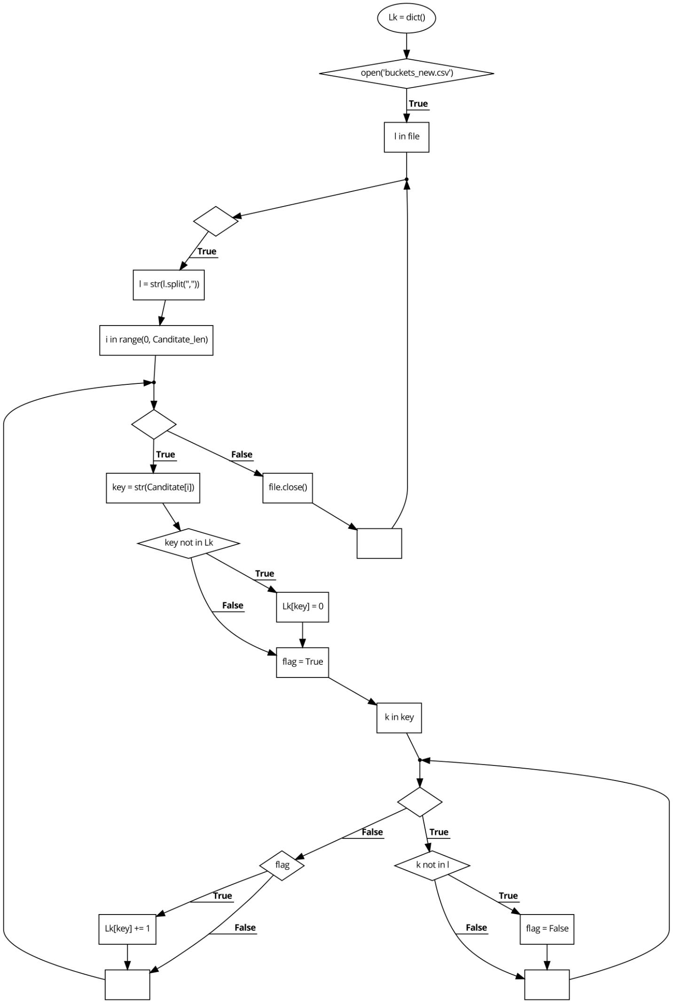

**Program to find subset in Apriori:**

Lk = dict();

if(open('buckets_new.csv')){

for (l in file){

l = str(l.split(","));

for (i in range(0, Canditate_len)){

key = str(Canditate[i]);

if (key not in Lk)

Lk[key] = 0;

flag = True;

for (k in key){

if (k not in l)

flag = False;

}

if (flag)

Lk[key] += 1

}

file.close()

**CYCLOMATIC COMPLEXITY**

1. V(G)= E- N +2 = 28- 15 +2 = **15**
2. V(G)=Nos of predicate nodes + 1 = 3 + 1 =**4**
3. V(G)=Nos of regions = **7**

**INDEPENDENT PATHS**

1-2-4

1-2-3-4-5

1-2-4-6-7-8-9-11-12-14-15-16-20-22-21

|  |  |  |
| --- | --- | --- |
| **TEST CASE ID** | **EXPECTED RESULT** | **INDEPENDENT PATH** |
| 1 | File not found | 1-2-4 |
| 2 | Entry not found in file | 1-2-3-4-5 |
| 3 | Frequent subsets found | 1-2-4-6-7-8-9-11-12-14-15-16-20-22-21 |