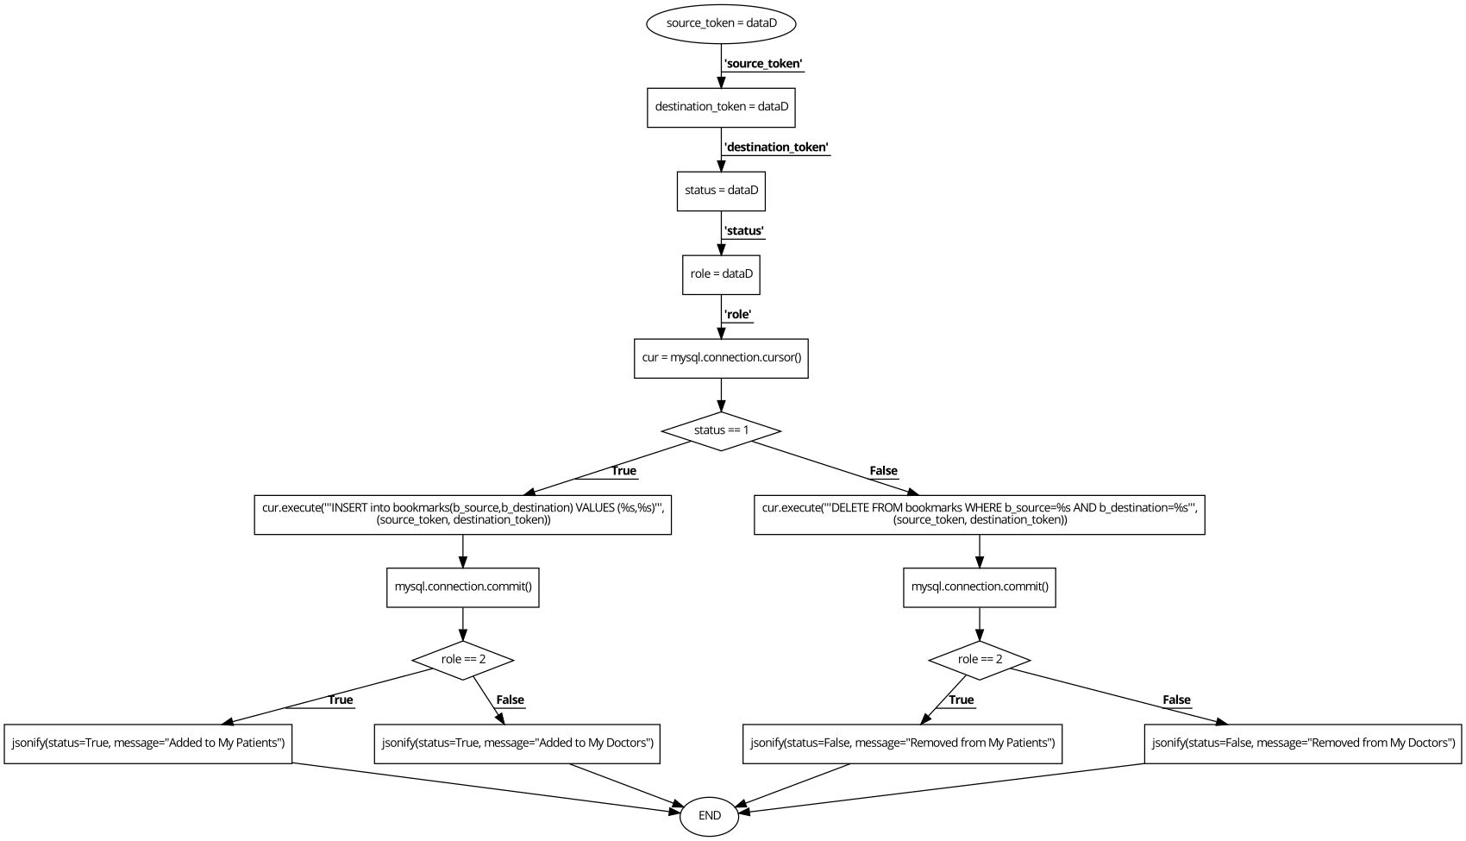

**Program to bookmark doctor or patient:**

source_token = dataD['source_token'];

destination_token = dataD['destination_token'];

status = dataD['status'];

role = dataD['role'];

cur = mysql.connection.cursor();

if (status == 1){

cur.execute('''INSERT into bookmarks(b_source,b_destination) VALUES (%s,%s)''',

(source_token, destination_token));

mysql.connection.commit();

if role == 2 {

jsonify(status=True, message="Added to My Patients");

}

else{

jsonify(status=True, message="Added to My Doctors");

}

END;

}

else{

cur.execute('''DELETE FROM bookmarks WHERE b_source=%s AND b_destination=%s''',

(source_token, destination_token));

mysql.connection.commit();

if role == 2{

jsonify(status=False, message="Removed from My Patients");

}

else{

jsonify(status=False, message="Removed from My Doctors");

}

END;

**CYCLOMATIC COMPLEXITY**

1. V(G)= E- N +2 = 19- 16 +2 = **5**
2. V(G)=Nos of predicate nodes + 1 = 0 + 1 = **1**
3. V(G)=Nos of regions = **4**

**INDEPENDENT PATHS**

1-2-3-4-5-6-7-9-11-12-16

1-2-3-4-5-6-7-9-11-13-16

1-2-3-4-5-6-8-10-12-14-16

1-2-3-4-5-6-8-10-12-15-16

|  |  |  |
| --- | --- | --- |
| **TEST CASE ID** | **EXPECTED RESULT** | **INDEPENDENT PATH** |
| 1 | Add doctor to bookmarks | 1-2-3-4-5-6-7-9-11-12-16 |
| 2 | Remove doctor from bookmarks | 1-2-3-4-5-6-7-9-11-13-16 |
| 3 | Add patient to bookmarks | 1-2-3-4-5-6-8-10-12-14-16 |
| 4 | Remove patient from bookmarks | 1-2-3-4-5-6-8-10-12-15-16 |