Software Requirements Specification

for

Questions for college :Anytime ,Anywhere

Prepared by

Jagdale Shital M(421048)

Sejkar Divyani A(422043)

Ghadage Pushpanjali B(421043)

Punamiya Ritu R(422029)

Vishwakarma Institute Of Information Technology

22-09-2018

**Requirement Analysis:**

* Before admission, student don’t have any clear idea about the college and college facility like hostel, transport etc so student have to personally go to the college for enquiry.
* New student also don’t have any information about department, classrooms, timetable, teacher staff, library, canteen etc.
* This system helps the student to be updated about the college activities.
* The system analyzes the question and then answers to the user.

**Functional specification:**

* Chat bots typically provide a text-based user interface, allowing the user to type commands (questions) and receive text (response).
* This project is built using artificial algorithms that analyzes user’s queries and understand user’s message.
* This System is a web application which provides answer to the query of the student very effectively.

**Scenario:**

If a new student doesn’t know some activities that is held in our college then he/she just go through the web application and questions the system example like which is the most popular event held in viit? Then system response will be ‘Gandharva’.

**Roles:**

1. Admin:

Admin is able to handle the system and provide the answer to the questions whose answer is not provided in database.

1. Student:

Enter the query to system. If the answer found to be invalid, user just need to select the invalid answer button which will notify the admin about the incorrect answer.

1. System:

System is a web application which provides answer to the query of the student.

**Working:**

Then system receives the questions as a text string and identifies important words of the sentence to fetch the answers and provide it to the user, When the user asks the questions which is in the form of string the system performs the classification and processing of text and queries the database and provides the result to the user.

**System architecture:**

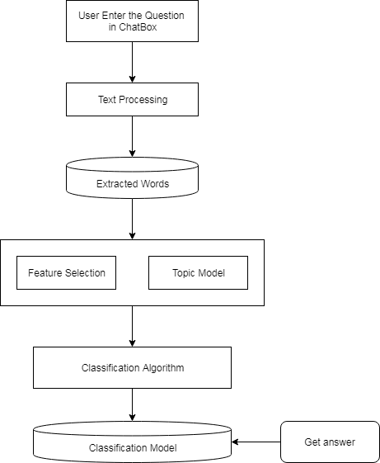

**External Interface Specification:**

* User Interface-This application consist of an user friendly GUI with a dialog box where the users enter their queries and the system provides the responses.
* Communication Protocol-This web application uses HTTP as a communication protocol.
* Hardware Interface-i3 processor.
* Database backend-MYSQL

**Technical Specification:**

* Hardware :

PC with i3 or higher processor

RAM

* Operating system : Windows 7.
* Programming Language and Technologies :

Java(J2EE)

Apache Server

* IDE : Eclipse