Health Care Satellite Account (HCSA), Employer-Sponsored Population
Table of Contents
Objective 2
Program 2
Data Sources 2
1. Current Population Survey (CPS) 2
Instructions to Obtain CPS Data 2
2. Medical Expenditure Panel Survey (MEPS) 3
Instructions to Obtain MEPS Data 3
3. MarketScan Commercial Claims and Encounters Database 4
Instructions to Obtain MarketScan Data 5
4. SSR Health 5
Instructions to Obtain SSR Data 5
5. CCSR 7
Instructions to Obtain CCSR Data 7
6. HCPCS 7
Instructions to Obtain HCPCS Data 8
7. National Health Expenditures Account (NHEA) 9
Instructions to Obtain NHEA Data 9
Methods 10
Sample Restrictions 10
Weights 10
MarketScan Inpatient & Outpatient Expenditures 12
MarketScan Prescription Drug Expenditures 12
Benchmarking 13
Output 14
Notes 15

Objective
The objective of the Health Care Satellite Account (HCSA) is to redefine healthcare expenditure by disease (e.g., cost of heart conditions) rather than by service location (e.g., cost of a hospital visit). The following documentation details the construction of the HCSA with respect to the employer-sponsored insurance population.

Program
Employer_Sponsored.sas – is the master script used to create the 2000-2023 HCSA, specific to the employer-sponsored population.

Data Sources

Current Population Survey (CPS)
- HCSA Purpose: Used to create weights and calculate per capita estimates.
- Source: The U.S. Census Bureau
- Data Type: Observational
- Generalizability: Convenience sample
- Data Availability: June (see release schedule). NOTE: the data have a 1-year lag.

Instructions to Obtain CPS Data
- Visit https://www.census.gov/programs-surveys/popest/data/tables.html
- Select the latest year where there’s a table called “State Population by Characteristics: YEARX-YEARY” Select that link.
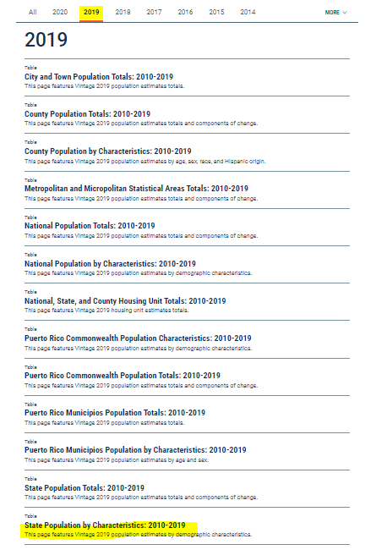

- Search for a table with a fileID similar to: “SC-ESTYEAR-AGESEX-CIV”). For example, in our previous release, we used (fileID= “SC-EST2022-AGESEX-CIV”).
- Save the file (e.g., ““sc-estYEAR-agesex-civ.csv””) to desired input folder.

Medical Expenditure Panel Survey (MEPS)
- HCSA purpose: Used to create weights and to create NDC-CCSR crosswalk.
- Source: the U.S. Agency for Healthcare Research and Quality (AHRQ)
- Data Type: self-report survey
- Generalizability: nationally-representative
- Data Availability: August (see release schedule). NOTE: the data have a 2.5-year lag (i.e., MEPS data files released by AHRQ in 2016 contain 2014 values).
- Files used:
  - Full year consolidated data – survey administration, demographics, income, person-level conditions, health status, disability days, quality of care, employment, health insurance, and person-level medical care use and expenditures.
  - Medical Conditions – medical conditions reported for a survey member. Needed to merge CCS categories to Home Health.
  - Prescribed Medicines – contains NDCs mapped to CCS/R diagnoses.
  - Appendix – links MEPS datafiles to ICD-CCS/R crosswalk.

Instructions to Obtain MEPS Data
- Visit https://meps.ahrq.gov/mepsweb/data_stats/download_data_files.jsp
- Select the appropriate year(s) from the drop-down menu under “Year”.
- Check mark the following 4 files & click “Search”:
“Full Year Consolidated Data File” | 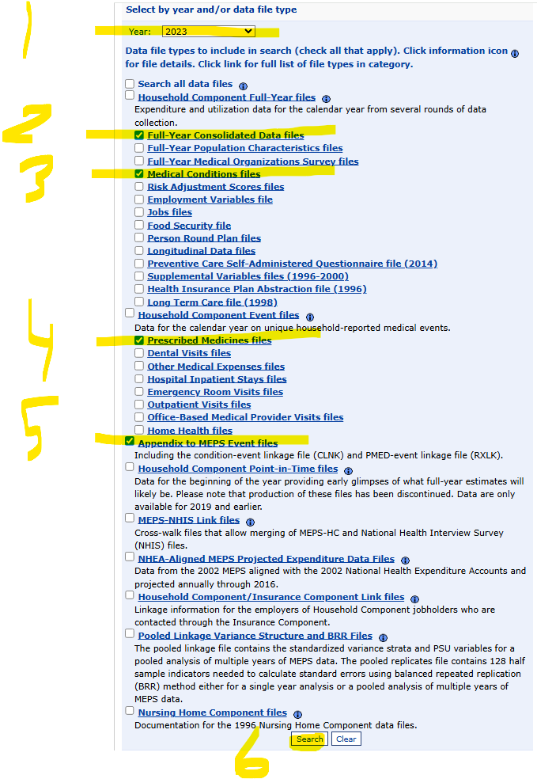
“Medical Conditions File”
“Prescribed Medicines Files”
“Appendix to MEPS Event Files”

- For each of the 4 files:
  - Click the PUF no.
  - Right-click the “Data File, SAS transport format” ZIP & select “Save target as”
  - Save to the desired input folder
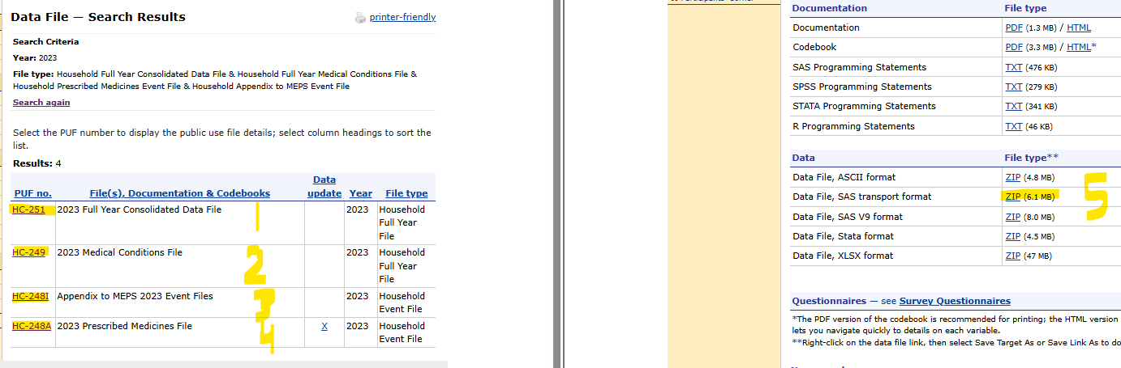
- Go to the input folder where all new data was just downloaded to and unzip all 4 files.

MarketScan Commercial Claims and Encounters Database
- HCSA Purpose: used to estimate disease-based expenditures for the employer-sponsored insurance population.
- Source: Merative
- Data Type: Commercial claims
- Generalizability: Convenience sample
- Observations: 400+ million claims annually
- Data Availability: January. NOTE: the data have a 2-year lag (i.e., MarketScan data files received in 2026 contain 2024 values).
- Files used:
  - CCAES – Commercial Claims & Encounters Inpatient Services
  - CCAEO – Commercial Claims & Encounters Outpatient Claims
  - CCAED – Commercial Claims & Encounters Prescription Drug Claims
  - Tagging file – we want to be able to follow patients (constant contributors). MarketScan provides the BEA a file with patients that contribute to multiple years.

Instructions to Obtain MarketScan Data
- Purchase a contract with Merative.

SSR Health
- HCSA Purpose: used to remove manufacturer rebates from prescriptions.
- Source: SSR Health
- Data Type: SEC Revenue and Sales filings, & Symphony Health’s drug list prices
- Generalizability: all branded drugs sold in the U.S. by a publicly traded company.
- Data Availability: Quarterly updates. NOTE: the data have a 2-quarter lag (i.e., SSR data received in 2026Q1 contain 2025Q3).
- Files used:
  - Prod.NDCLookup – a crosswalk between NDC codes and SSR drug names.
  - Prod.GTN – discount values for each drug

Instructions to Obtain SSR Data
- Visit https://sso.online.tableau.com/public/idp/SSO
- Login with Username & Password
- Select the “Appendix” page
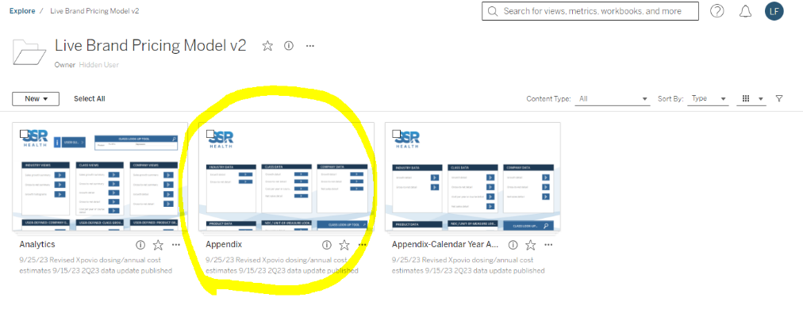

- Select the NDC crosswalk (“Prod.NDCLookup”, may also be called “Data: Product-NDC-Unit of Measure crosswalk”)
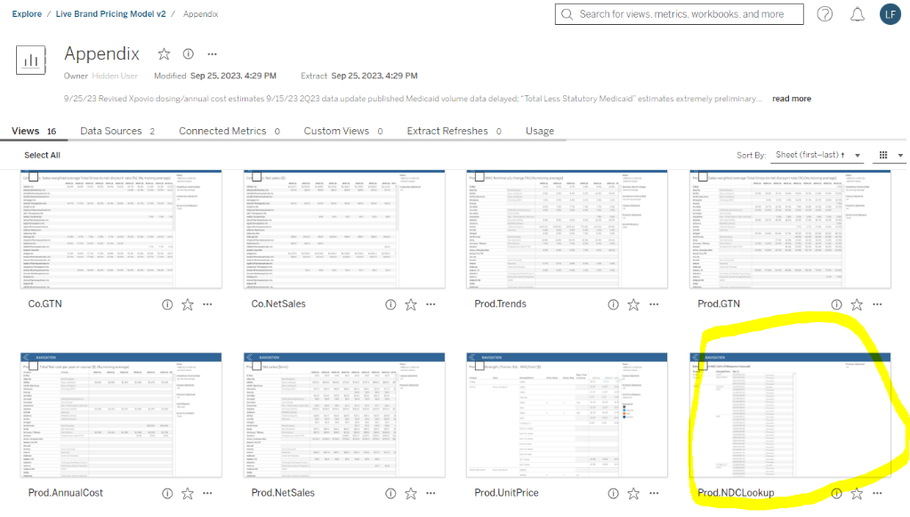

- Ensure that “All” products are selected, and then select to download the data
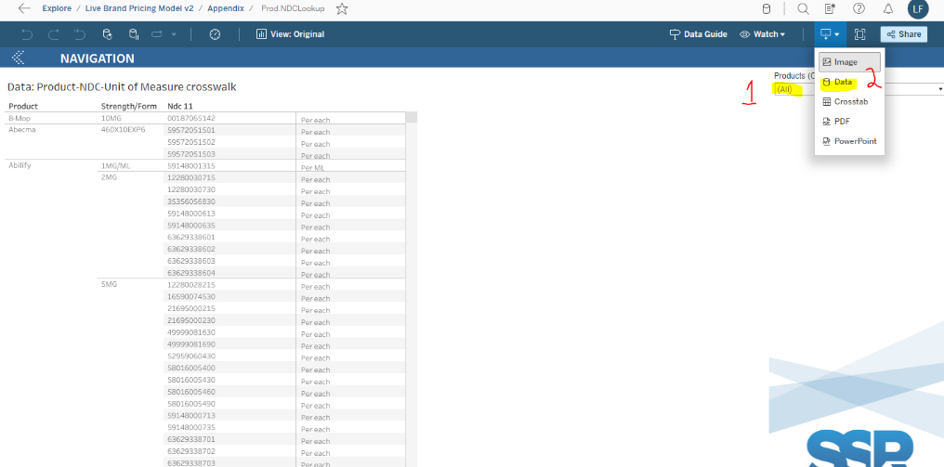

- Download the data to the desired input folder.
- Return to the “Appendix” page, and select the Discount data (“Prod.GTN”)

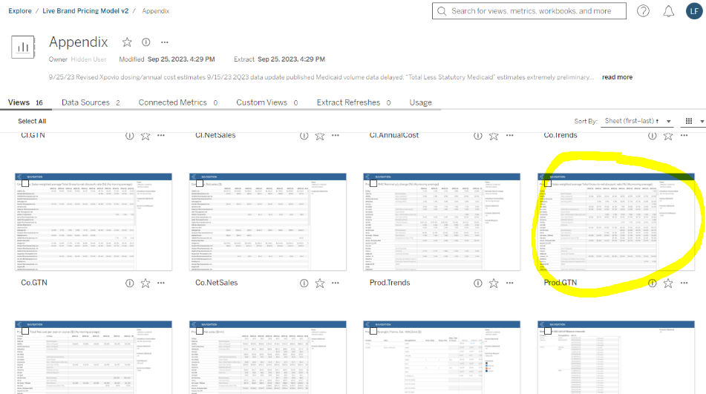

- Ensure the data go back to 2007Q1, ensure the data goes forward to the most recent year, ensure 4q moving avg is selected, ensure all classes are selected, ensure all products are selected, ensure the gross-to-net measure is “Total”.

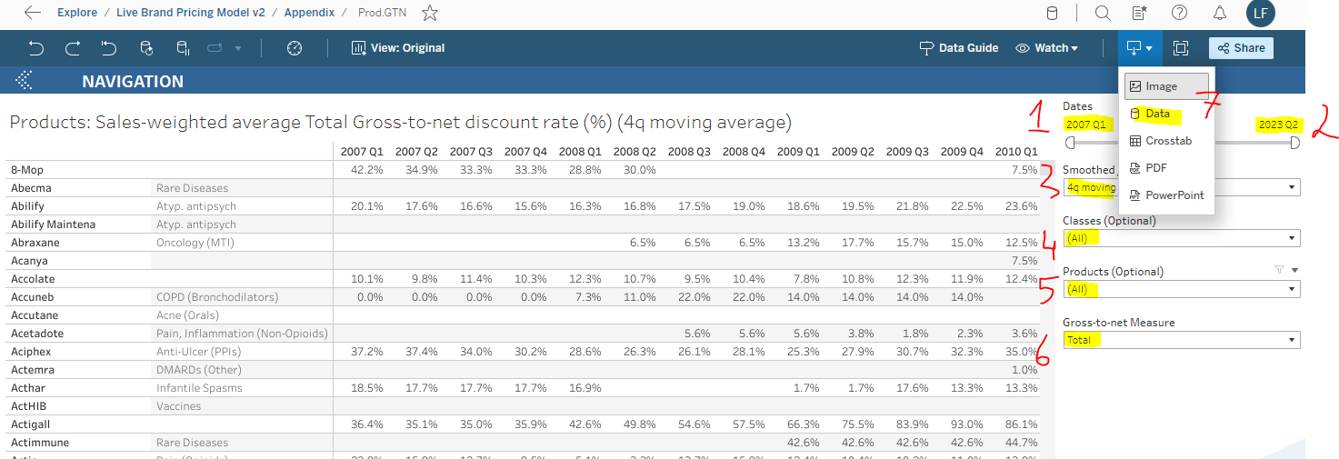

- Download the data to the desired folder, and append the file name with “_total” (e.g., “GTN.Pr.DATA_data_total.csv”).

CCSR
- HCSA Purpose: used to link ICD9/10 diagnoses from MarketScan claims to aggregate CCS/R categories.
- Source: The U.S. Agency for Healthcare Research and Quality (AHRQ)
- Data Type: crosswalk
- Data Availability: September (ICD10).
- Files used:
  - ICD10-CCSR crosswalk: https://hcup-us.ahrq.gov/toolssoftware/ccsr/dxccsr.jsp
  - ICD9-CCSR crosswalk: https://www.cms.gov/Medicare/Coding/ICD10/Downloads/2018-ICD-10-CM-General-Equivalence-Mappings.zip
    - Wayback machine: https://web.archive.org/web/20231126003646/https://www.cms.gov/Medicare/Coding/ICD10/Downloads/2018-ICD-10-CM-General-Equivalence-Mappings.zip
  - CCS-CCSR crosswalk: https://hcup-us.ahrq.gov/toolssoftware/ccsr/DXCCSR-vs-Beta-CCS-Comparison.xlsx
  - Labels: ccsr_label_v20231.sas7bdat

Instructions to Obtain CCSR Data
NOTE: the 6 SAS files above were created outside of the Employer_Sponsored.sas program. For reference, they were created here:
  - CCSR_map_v2031.sas
  - Gem18_ccsr.sas
  - CCS_CCSR_xwalk2.sas

HCPCS
- HCSA Purpose: To adjust our drug estimates for rebates, we need to differentiate retail-pharmacy drugs from hospital/office drugs (such as chemotherapies).
- Source: CMS & Palmetto
- Data Type: crosswalks
- Data Availability:
- CMS: codes available in late-December of each year, 1 year lag
- Palmetto: codes available in late-December of each year.

Instructions to Obtain HCPCS Data
- Visit https://www.cms.gov/medicare/coding-billing/healthcare-common-procedure-system/quarterly-update
- Download the latest “Alpha Numeric HCPCS File” to the desired input folder. Then unzip the item with the largest file size.

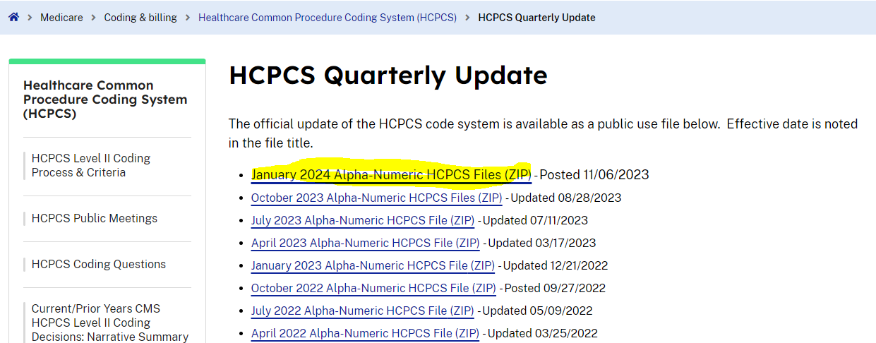

- Visit https://dmepdac.com/palmetto/PDACv2.nsf/T/NDC-+-HCPCS%20Crosswalk
- Click on the latest year of “YEAR NDC/HCPCS Crosswalk” and download the latest December NDC to HCPCS Crosswalk (Excel) to the desired input folder
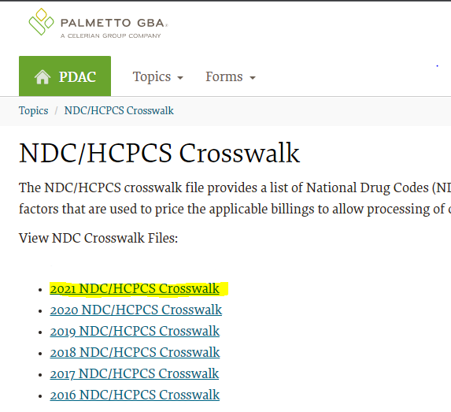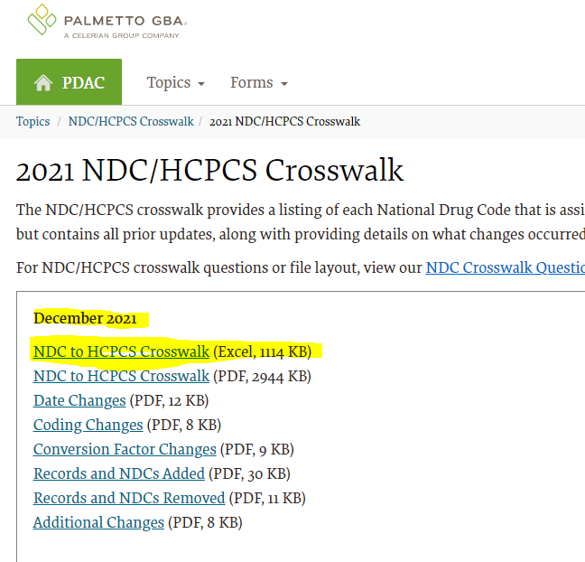

National Health Expenditures Account (NHEA)
- HCSA Purpose: To benchmark MarketScan estimates to official government statistics
- Source: CMS
- Data Type: national health care estimates
- Data Availability: December/January. NOTE: 1 year lag.
- Files used:
  - Table 07 Hospital Care Expenditures
  - Table 08 Physician and Clinical Services Expenditures
  - Table 11 Other Professional Services Expenditures
  - Table 14 Home Health Care Expenditures
  - Table 16 Retail Prescription Drugs Expenditures
  - Table 21 Expenditures, Enrollment and Per Enrollee Estimates of Health Insurance

Instructions to Obtain NHEA Data
- Visit https://www.cms.gov/data-research/statistics-trends-and-reports/national-health-expenditure-data/historical
- Download “NHE Tables (ZIP)”
- Save to desired input folder
- Unzip tables 7, 8, 11, 14, 16, and 21 to the desired input folder

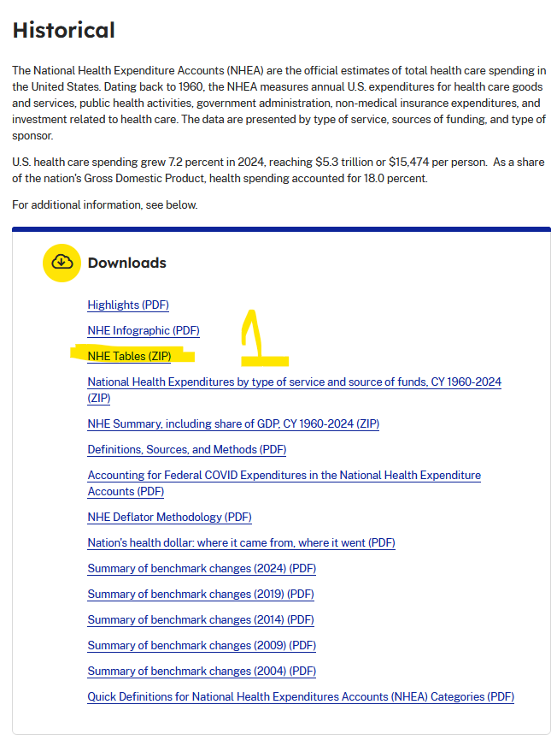

Methods

Sample Restrictions
MarketScan enrollees are only included in the estimates if they meet all of the following:
- Enrolled in at least 360 days of the year
- Has an RX plan
- Is not in a capitated plan – BEA’s research suggest cost estimates are not accurate for capitated people
- Are constant contributor (i.e., in the tagging file)

Weights
We do not use MEPS population weights because of its inconsistencies and large growth rates during 2000 and 2010 which coincided with a new Census population survey year. Consequently, we create our own person weights using MEPS and CPS. To do this, we first stratify the MEPS and CPS data into age buckets.

Ages | Bucket
0 | 1
1-17 | 2
18-24 | 3
25-34 | 4
35-44 | 5
45-54 | 6
55-64 | 7
65-69 | 8
70-74 | 9
75-79 | 10
80-84 | 11
85+ | 12

From the MEPS, we assign insurance enrollment accordingly:
- If (mcrev=1), then that enrollee is assigned to Medicare
- If (prvev=1 & mcrev=2), then that enrollee is assigned to Private

From the MEPS, we sum enrollees by age-sex-region. For example:
YEAR | REGION | SEX | AGE_BUCK | POP_MEPS | POP_PRIV | POP_MDCR
2021 | 1 | 1 | 6 | 3,286,217 | 2,523,543 | 77,725
2021 | 2 | 1 | 6 | 3,918,120 | 2,981,153 | 98,659
2021 | 3 | 1 | 6 | 7,680,360 | 5,425,623 | 402,116
2021 | 4 | 1 | 6 | 4,948,464 | 3,629,473 | 86,457
2021 | 1 | 2 | 6 | 3,805,111 | 2,961,979 | 123,071
2021 | 2 | 2 | 6 | 3,951,591 | 2,959,125 | 188,058
2021 | 3 | 2 | 6 | 7,699,971 | 5,638,477 | 247,524
2021 | 4 | 2 | 6 | 4,810,344 | 3,461,173 | 125,895

From the CPS, we sum respondents by age-sex-region. For example:
YEAR | REGION | SEX | AGE_BUCK | POP_CPS
2021 | 1 | 1 | 6 | 3,528,366
2021 | 2 | 1 | 6 | 4,135,072
2021 | 3 | 1 | 6 | 7,774,024
2021 | 4 | 1 | 6 | 4,845,053
2021 | 1 | 2 | 6 | 3,615,229
2021 | 2 | 2 | 6 | 4,083,626
2021 | 3 | 2 | 6 | 7,942,994
2021 | 4 | 2 | 6 | 4,734,812

The population private weight is calculated as
$$Private Weight=\left(\frac{POP CPS}{POP MEPS}\right)*POP PRIV$$

For example:
YEAR | REGION | SEX | AGE_BUCK | ADJ_CPS_PRIV
2021 | 1 | 1 | 6 | 2,709,493
2021 | 2 | 1 | 6 | 3,146,224
2021 | 3 | 1 | 6 | 5,491,790
2021 | 4 | 1 | 6 | 3,553,626
2021 | 1 | 2 | 6 | 2,814,171
2021 | 2 | 2 | 6 | 3,057,999
2021 | 3 | 2 | 6 | 5,816,436
2021 | 4 | 2 | 6 | 3,406,826

From MarketScan, after the aforementioned restrictions are applied, we sum enrollees by age-sex-region, for example:

YEAR | REGION | SEX | AGE_BUCK | ENROLLEES
2021 | 1 | 1 | 6 | 97,750
2021 | 2 | 1 | 6 | 132,368
2021 | 3 | 1 | 6 | 337,320
2021 | 4 | 1 | 6 | 99,719
2021 | 1 | 2 | 6 | 103,428
2021 | 2 | 2 | 6 | 138,159
2021 | 3 | 2 | 6 | 395,225
2021 | 4 | 2 | 6 | 102,935

Ultimately, MarketScan’s person weight is calculated as

$$Person Weight=\frac{ADJ CPS PRIV}{ENROLLEES}$$

For example:

ENROLID | YEAR | AGE | AGE_BUCK | SEX | REGION | WEIGHT
Sally | 2021 | 49 | 6 | 1 | 1 | 27.7186
John | 2021 | 49 | 6 | 1 | 2 | 23.76876
Mary | 2021 | 54 | 6 | 1 | 3 | 16.28065
Alice | 2021 | 54 | 6 | 1 | 4 | 35.6364
Becky | 2021 | 46 | 6 | 2 | 1 | 27.20899
Sam | 2021 | 52 | 6 | 2 | 2 | 22.13391
Leo | 2021 | 53 | 6 | 2 | 3 | 14.71677
Jake | 2021 | 46 | 6 | 2 | 4 | 33.09687

MarketScan Inpatient & Outpatient Expenditures
During a visit, the doctor may treat multiple diseases within a visit (e.g. diabetes and hypertension). For the HCSA, we only use the disease on the event listed as primary. Other methodologies were tested based off a distribution of expenditures for the residual fifteen percent of the data with more than one diagnosis and it made little difference in the aggregate results.

After applying CCSR codes & person weights to each claim, we simply aggregate patients counts & payments by CCSR code for every year. For example:

FILE | YEAR | CCSR | WEIGHTED_IPOP_PAY | WEIGHTED_PATIENT_COUNT
ipop | 2021 | CIR007 - Essential hypertension | 40,294,014 | 84,290
ipop | 2021 | MUS013 - Osteoporosis | 850,294 | 5,810
ipop | 2021 | RSP009 - Asthma | 9,194,014 | 14,521

MarketScan Prescription Drug Expenditures
The MarketScan prescription file does not have diagnoses attached to the claims. In order to assign prescription expenditures to diagnoses, we create an NDC-to-CCSR crosswalk. From the MEPS prescription file, we obtain NDCs and their respective CCSR codes, for example:

RXNDC | CCSR
55111023105 | CIR007 - Essential hypertension
55111023105 | CIR011 - Coronary atherosclerosis and other heart disease
55111023105 | END010 - Disorders of lipid metabolism
55111023105 | SYM017 - Abnormal findings without diagnosis

From the MarketScan inpatient and outpatient files, we identify a list of CCSR codes a patient has been diagnosed with in the year, for example:

ENROLID | YEAR | CCSR1 | CCSR2 | CCSR3
Sally | 2021 | CIR007 | RSP009 | SYM002

Drugs administered at a clinic/hospital, and drugs picked up by patients at a retail pharmacy both receive some sort of manufacturer rebates. For clinics and hospitals though, the rebate is already deducted from the payment in the claim, therefore, it is unnecessary to remove rebates again from the inpatient or outpatient claims. The prescription claims do need to remove rebates. To ensure that we’re only removing rebates from retail pharmacy prescriptions, it’s necessary for us to identify which drugs from the SSR are typically administered in a clinic/hospital, and thus do not need a rebate adjustment.

To do this, we sum (the number of claims) and (pay) by drugs separately between the ipop file and the prescription file. When merged, we’re able to determine whether a drug shows up more often in the prescription file or the ipop file. For the drugs that appear more often in the prescription file, we apply the respective drug-specific SSR rebates to each claim in the MarketScan prescription file.

$$Pay Net ofRebate=\left(1-gross margin\right)*pay*\left(1-average total discount rate\right)+gross margin*pay$$

Where gross margin is set at 0.035. Previous research: 3.5% markup by pharmacies. After rebates are deducted, we sum each patient’s annual prescription expenditure, for example:

ENROLID | YEAR | RX_WEIGHTED_PAY
Sally | 2021 | 3,958

Also from the MarketScan prescription file, we identify unique NDCs that each patient observes in a year, for example:

ENROLID | YEAR | NDC
Sally | 2021 | 55111023105
Sally | 2021 | 00002880559

We combine each MarketScan patient’s NDCs with the MEPS’ NDC-CCSR crosswalk, keeping only observations where there’s an intersect, for example:

ENROLID | YEAR | NDC | CCSR
Sally | 2021 | 55111023105 | CIR007

Prescription spending in the MarketScan Claims data is allocated using the regression-based method (a.k.a. Trogdon Regressions). This method regresses total prescription expenditures from an individual on indicator variables for whether the person has a given diseases in a given period. The indicator on each disease captures the marginal effect of each disease on expenditures. The regression coefficients can then be used to allocate prescription expenditures across diseases. The person-based approach can allocate expenditures for services that do not have a listed diagnosis as seen for prescription drug claims and laboratory tests. In our methodology for the HCSA, we force the intercept to diseases. Ultimately, we have an estimate of prescription payments for specific CCSRs, for example:

FILE | YEAR | CCSR | WEIGHTED_RX_PAY
rx | 2021 | CIR007 - Essential hypertension | 10,592,952
rx | 2021 | RSP009 - Asthma | 5,829,049

Benchmarking
From the NHEA tables, we obtain the private expenditures for Hospitals, Physicians and clinical services, Other professional services, home health care services, and Retail prescription drugs. To each of the private expenditures, we add the out-of-pocket (OOP) expenditures for Hospitals, Physicians and clinical services, Other professional services, home health care services, and Retail prescription drugs. We decided to add the entire out-of-pocket to private expenditure for simplicity and because Medicare and Medicaid often have smaller out-of-pocket obligations.

$$NHEA Total Health Private=\left(NHEA private hospital+NHEA OOP hospital \right)+\left(NHEA private physclin+NHEA OOP physclin\right)+\left(NHEA private othprof+NHEA OOP othprof\right)+\left(NHEA private homehealth+NHEA OOP homehealth\right)+\left(NHEA private rx+NHEA OOP rx\right)$$

“NHEA Total Health Private” contains both employer-sponsored insured individuals, and other types of private insurance such as direct-purchase. To capture just the employer-sponsored portion, we obtain the share of private expenditure attributable to (employer-sponsored) versus (direct purchase). We then apply the employer-sponsor share to “NHEA Total Health Private” to obtain “NHEA Health Employer Sponsored”.

From the MarketScan aggregation, calculate shares for each CCSR category. Apply the CCSR shares to “NHEA Health Employer Sponsored”.

Output

employer_sponsored_ccsr_output00_23_20MAR2026

SSR Health data only go back to 2007. To calculate rebate adjustments to years 2000 through 2006, we backcast rebate dollars from 2007, and set rebates to $0 in 2000.

