BCO Notification Bounce Back Handling

Key findings
BCO normally uses SMS when a user’s email fails, and email when a user’s SMS fails, with a login reminder. These messages ask the customer to update contact details. They do not resend the original transaction notice, password or Code.
When both the user’s email and mobile channels fail, notify the company’s officeEmail if eligible. If the company email fails, email is sent to APs in the same company, while system administrators receive webmail and login reminders.

Notification outcomes by failure scenario
Scenario | Email or SMS | Webmail and login reminder
A User email fails | SMS to the user’s registered mobile | Login reminder; no webmail
B User SMS fails | Email to the user’s registered address | Login reminder; no webmail
C SMS fails after email failure was handled | Company officeEmail if eligible; no further user email | User webmail and login reminder
D Email fails after SMS failure was handled | Company officeEmail if eligible; no further user email | No new webmail or login reminder
E Current company officeEmail fails | Email to company APs; no SMS | System-administrator webmail and login reminder

How recipients are selected
Recipient | Address or number source
Target user | User and company from the original sending record; current registered email/mobile.
Company | The company’s registered officeEmail.
AP | Users in the same company with IS_AP = 1, at their registered email addresses. Selection is not based on final approval.
System administrator | Same-company users with the SYSADM role, for webmail and login reminders; selected separately from APs.

From a failure record to a reminder
Control-M starts import and classification. Quartz, inside the BCO application, sends pending email/SMS. Webmail and login reminders are handled during classification.
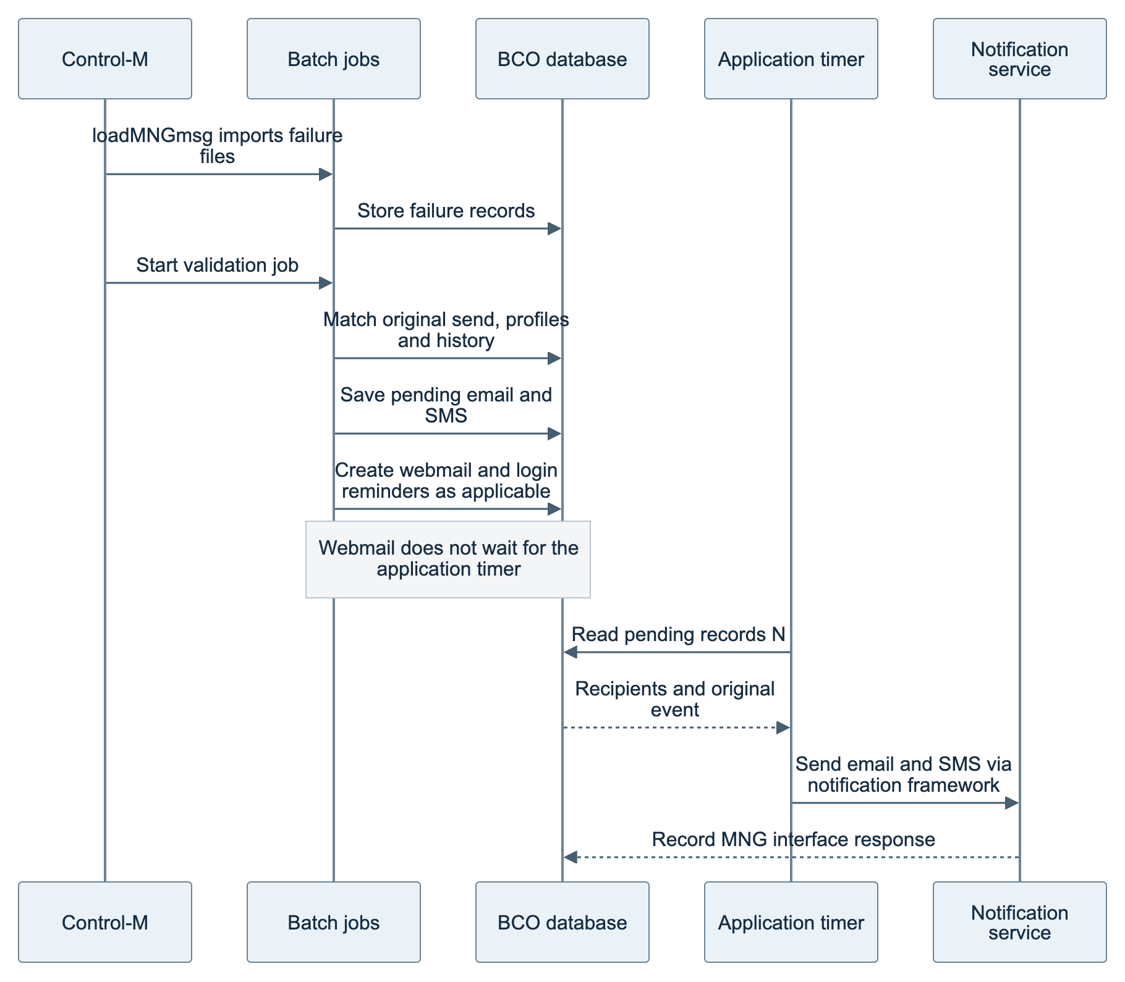
Figure 1 Import and validation are separate jobs. Validation uses ValidateAndSendBounceNotify; loadMNGmsg does not call it directly.
The configured application job runs at :00 and :40 each hour, not at fixed 40-minute intervals. The application JVM determines the time zone.

What the record statuses mean
Record | Meaning
Imported failure marked Y | That processing pass ended. Some ineligible records are also marked Y; it does not prove a reminder was generated.
Reminder arrangement marked Y | The application registered a notification, not confirmed delivery. N can also mean no recipient or no AP.
Sending history shows Success | The MNG interface returned success, not proof of customer receipt. RECIPIENTID shows the sending address/number.

loadMNGmsg imports CCB, EPH and ITP/ETS failure files. The checked validation entry handles CCB and ETS; importing EPH does not establish that the same entry sends its reminders.

How the notification channel is selected
These diagrams cover ordinary CCB personal and current company-email cases. History means relevant handling arrangements within 30 days, not successful delivery. A–E refer to page 1.

User email failure
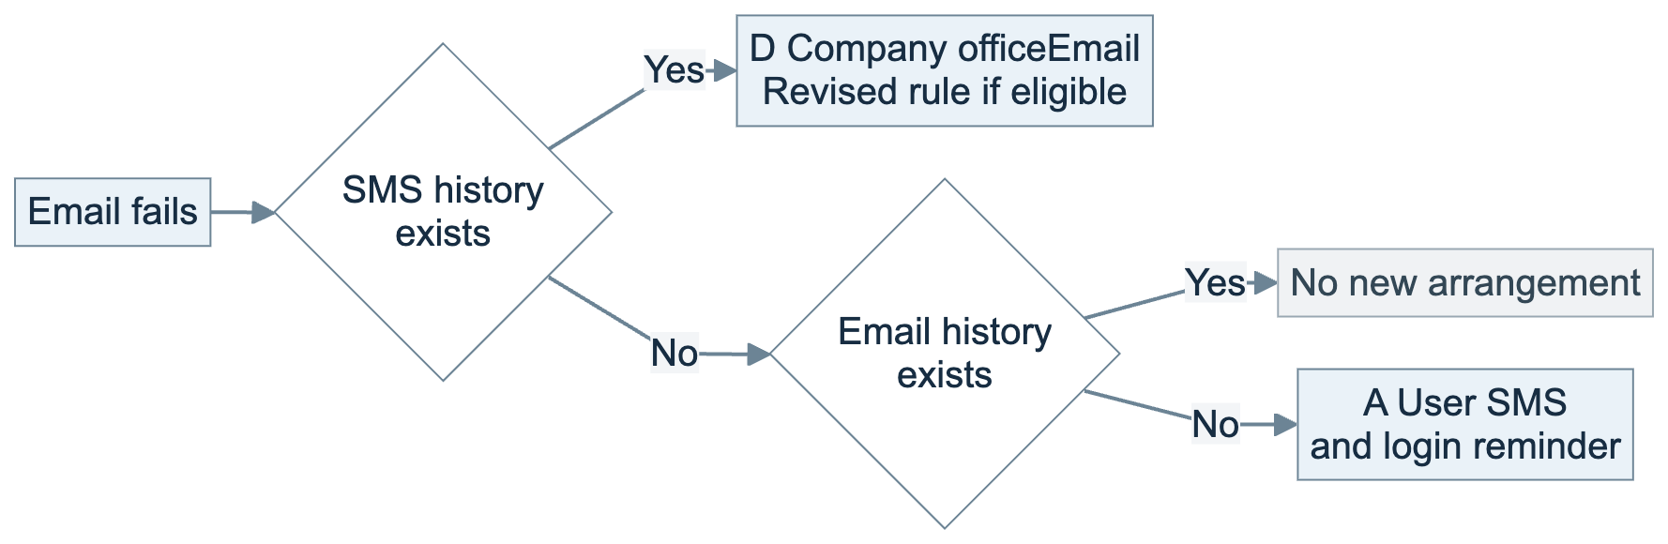

User SMS failure
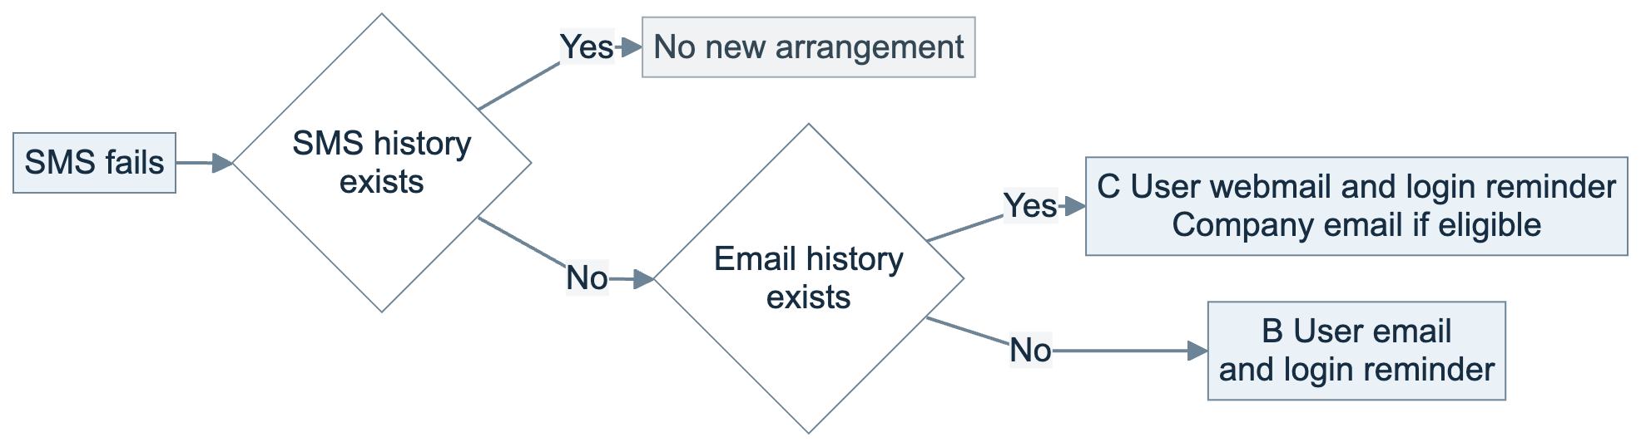

Current company email failure
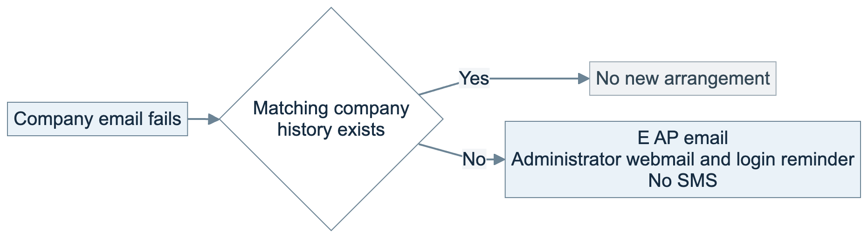
Company email in C and D requires a populated officeEmail different from the user’s current email, with no company fallback arrangement for that user within 30 days. If ineligible, C retains only user webmail and login reminders; D adds no reminder.
If user and company email addresses match, personal handling takes precedence. D is the revised rule, not confirmed by code or sending records. Empty or changed contacts fall outside these assumptions.

Repeat reminders and known limitations
Rule | Implemented behaviour
30-day history | Suppresses some repeat arrangements without confirming delivery. It is neither continuous retry nor an automatic resend on day 31.
Duplicates in one batch | Controlled by user/company combination, with email and SMS handled separately.
AP email deduplication | Identical AP email addresses are merged within one company failure record. No global deduplication across records, users, companies or events.
Event and user matching | Ordinary failures must match an original sending record and an eligible event. Sharing a contact does not mean all users sharing it receive reminders.

Old or empty contacts. Some null/empty checks are incomplete. An old personal address may enter company handling; company address-change handling also differs across local versions.
Secondary bounces. Chinese ordinary fallback SMS events are not fully covered by the event list. Sample fallback emails lack usable user/company linkage, and fallback sends lack original-reference linkage. Automatic retry is disabled; further handling is not guaranteed.

Message content and template mapping
Emails contain English and Traditional Chinese. Ordinary SMS follows the user’s English, Traditional Chinese or Simplified Chinese locale. The special login/merchant SMS is English only. Webmail text is generated in code. All request updated contact details.
Use and recipient | Event suffix | Template ID
E AP  Email | COMPANY_ALT_SYSADMIN | Bounce Back Company Email_EXTERNAL_USER_EMAIL_en
C Company  Email | EMAIL_ADDRESS_  UPDATE_SMS | Bounce Back SMS Handling_EXTERNAL_USER_EMAIL_en
A User  EN SMS | EMAIL_ADDRESS_  UPDATE_SMS | Bounce Back SMS Handling_EXTERNAL_USER_SMS_en
A User  SC SMS | EMAIL_ADDRESS_  UPDATE_SMS_SC | Bounce Back SMS SC Handling_EXTERNAL_USER_SMS_en
A User  TC SMS | EMAIL_ADDRESS_  UPDATE_SMS_TC | Bounce Back SMS TC Handling_EXTERNAL_USER_SMS_en
Login / merchant  EN SMS | ESTMT_MERCHANT_SMS | BOUNCE_BACK_ESTMT_MERCHANT_SMS
Statement / advice  EN SMS | ESTMT_SMS | Bounce Back SMS Handling_ESTMT_EXTERNAL_USER_SMS_en
Statement / advice  SC SMS | ESTMT_SMS_SC | Bounce Back SMS SC Handling_ESTMT_EXTERNAL_USER_SMS_en
Statement / advice  TC SMS | ESTMT_SMS_TC | Bounce Back SMS TC Handling_ESTMT_EXTERNAL_USER_SMS_en
B User  Email | MOBILE_NUMBER_  UPDATE_EMAIL | Bounce Back Email Handling_EXTERNAL_USER_EMAIL_en

COMPANY_ALT_SYSADMIN sends to AP email addresses; its name does not mean all administrators receive the email.
EMAIL_ADDRESS_UPDATE_SMS has Email and SMS routes: SMS goes to the user; Email is the company reminder in C. Revised branch D is intended to reuse that Email template; no sending record confirms it.
All listed routes are EXTERNAL/USER with LOCALE = en. Code determines the actual recipient. TC/SC Events carry Chinese SMS, so route locale en does not imply English content.
User contacts: DIGX_UM_USERPROFILE. Dialling code and locale: DIGX_CZ_UM_EXTENSIONDATA. Company email: DIGX_PI_PARTY_PREFERENCES.OFFICE_EMAIL. Some SMS paths reread the current mobile number at sending time.

