BCO CMS IMK MCDP Operations Guide
For CMS content editors, IMK operators and reviewers, MCDP operators, and UAT business testers
This guide describes the business workflow from published CMS content to a browser display. It does not cover server deployment or database administration.
Important dependency: MCDP zones and the MCDP activity unit are two different one-time prerequisites. IMK does not create or synchronise either one. IMK selects existing zones; after reviewer approval, IMK creates activities inside the activity unit.
Order | Owner | Required output
0a one time | MCDP operator | Four MCDP zones exist.
0b one time | MCDP operator and integration admin | An online activity unit is bound to IMK.
1 every campaign | CMS editor | English, Simplified Chinese and Traditional Chinese content is published.
2 every campaign | IMK operator | Four pending Banner tasks exist.
3 every campaign | IMK reviewer | All four tasks are approved and sent.
4 every campaign | MCDP operator | Four generated activities are online.
5 acceptance | Business tester | The browser displays the expected four placements.

1 One-time MCDP setup
1.1 Go to Intelligent Delivery > Resource Management > Zone Management. Create the four zones below before creating IMK tasks. The zone codes must match exactly.
Zone code | IMK selection | Purpose
home_rotation | BCO Web Demo - Homepage rotation | Three homepage creatives.
home_notice | BCO Web Demo - Homepage notice | Text notice.
popup_banner | BCO Web Demo - Popup banner | Security Alert popup.
floating_buoy | BCO Web Demo - Floating buoy | Digital Assistant icon.
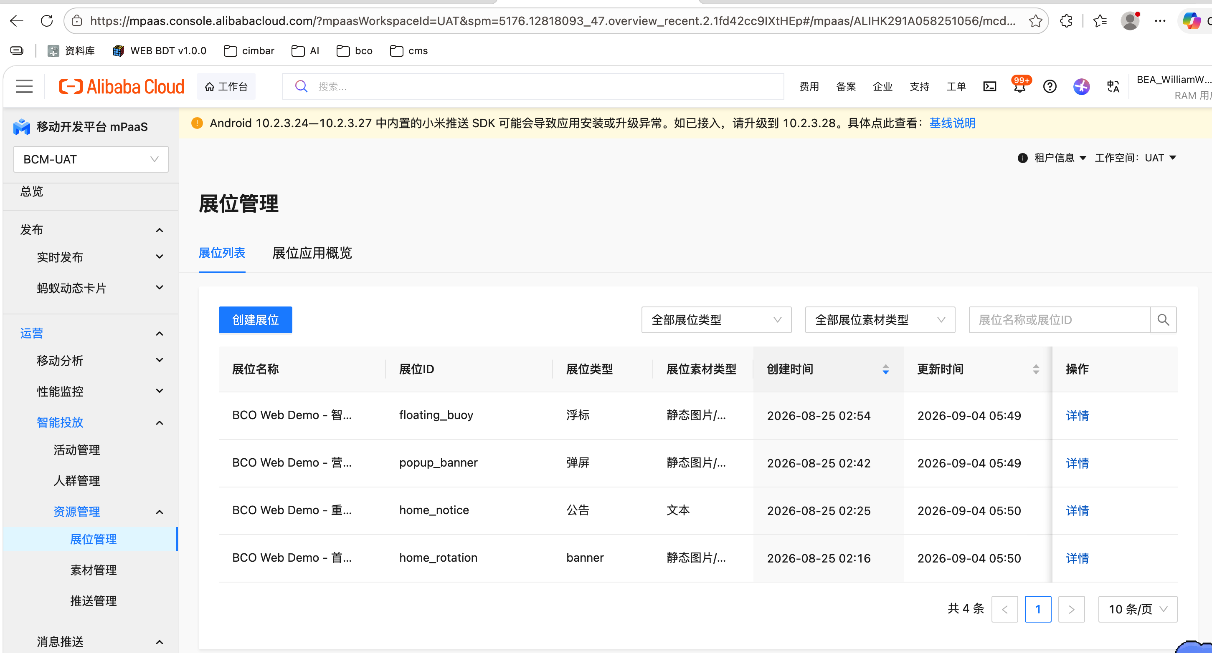
Figure 1. MCDP Zone Management: the four BCO Web Demo zones must already exist.
1.2 In Intelligent Delivery > Activity Management, select Create Activity Unit. Enter a business name, an effective period that covers UAT, and the appropriate marketing type. Save and bring the activity unit online. Record the ID and have the integration administrator bind IMK BCO publishing to that ID. In the current UAT example, the activity unit ID is 177.
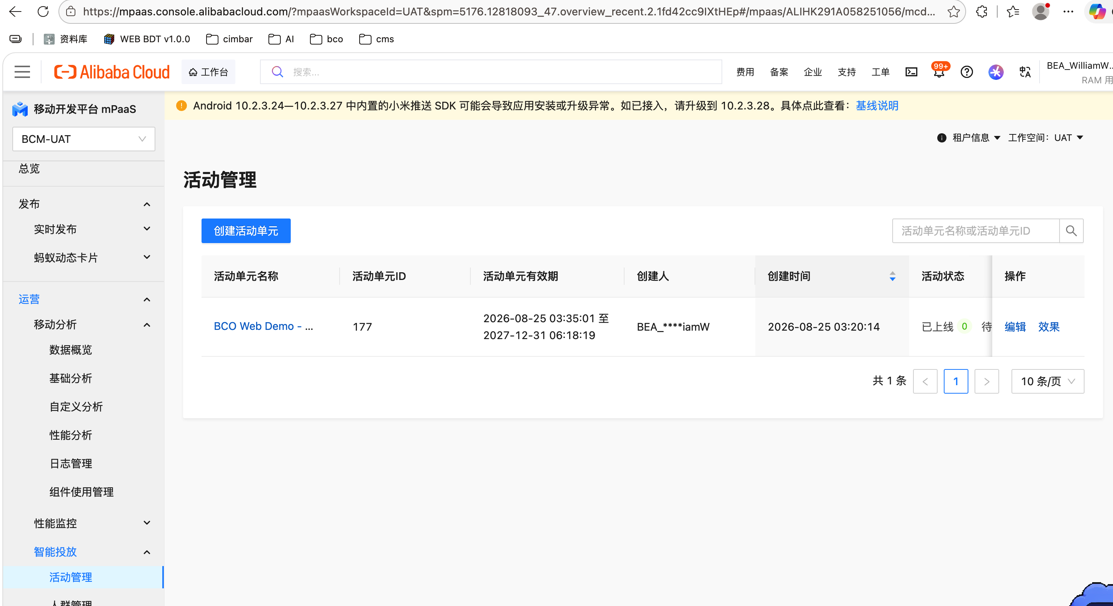
Figure 2. MCDP Activity Management: an online activity unit is a separate prerequisite from zones.

2 CMS content preparation for every campaign
2.1 Sign in as a CMS content editor and open Data Content Maintenance. Search for an existing asset or click New. Choose the correct content type and enter an unambiguous asset name.
2.2 Complete the English, Simplified Chinese, and Traditional Chinese tabs. For every language, fill the title, body, image or H5 URL, and destination URL. Save each language version before switching tabs.
2.3 Create three separate homepage-rotation assets and one asset for each of the notice, popup, and floating-buoy placements. Preview every asset, open the image/H5 URL, verify the destination URL, then publish. Only published content should be selected in IMK.
Note: no CMS editor or CMS publication-success screenshot was included in the supplied UAT evidence. This guide deliberately does not label an IMK or MCDP page as a CMS screenshot.

3 IMK task creation and review
3.1 Open Delivery Management > Banner Delivery and click New. Create one task per zone. Select BCO as the publishing channel, select All as the audience, select the corresponding existing MCDP zone, enter the activity period, and choose the correct published CMS asset.
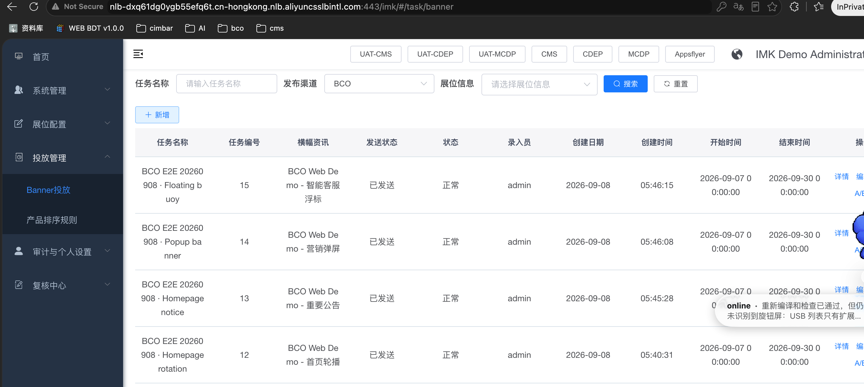
Figure 3. IMK Banner Delivery: four BCO tasks after creation.
3.2 Check the mapping before saving: rotation uses three rotation assets; notice uses only the notice asset; popup uses only the popup asset; buoy uses only the Digital Assistant asset. Do not select “All Retail Customers” for this Demo; select the first All option.
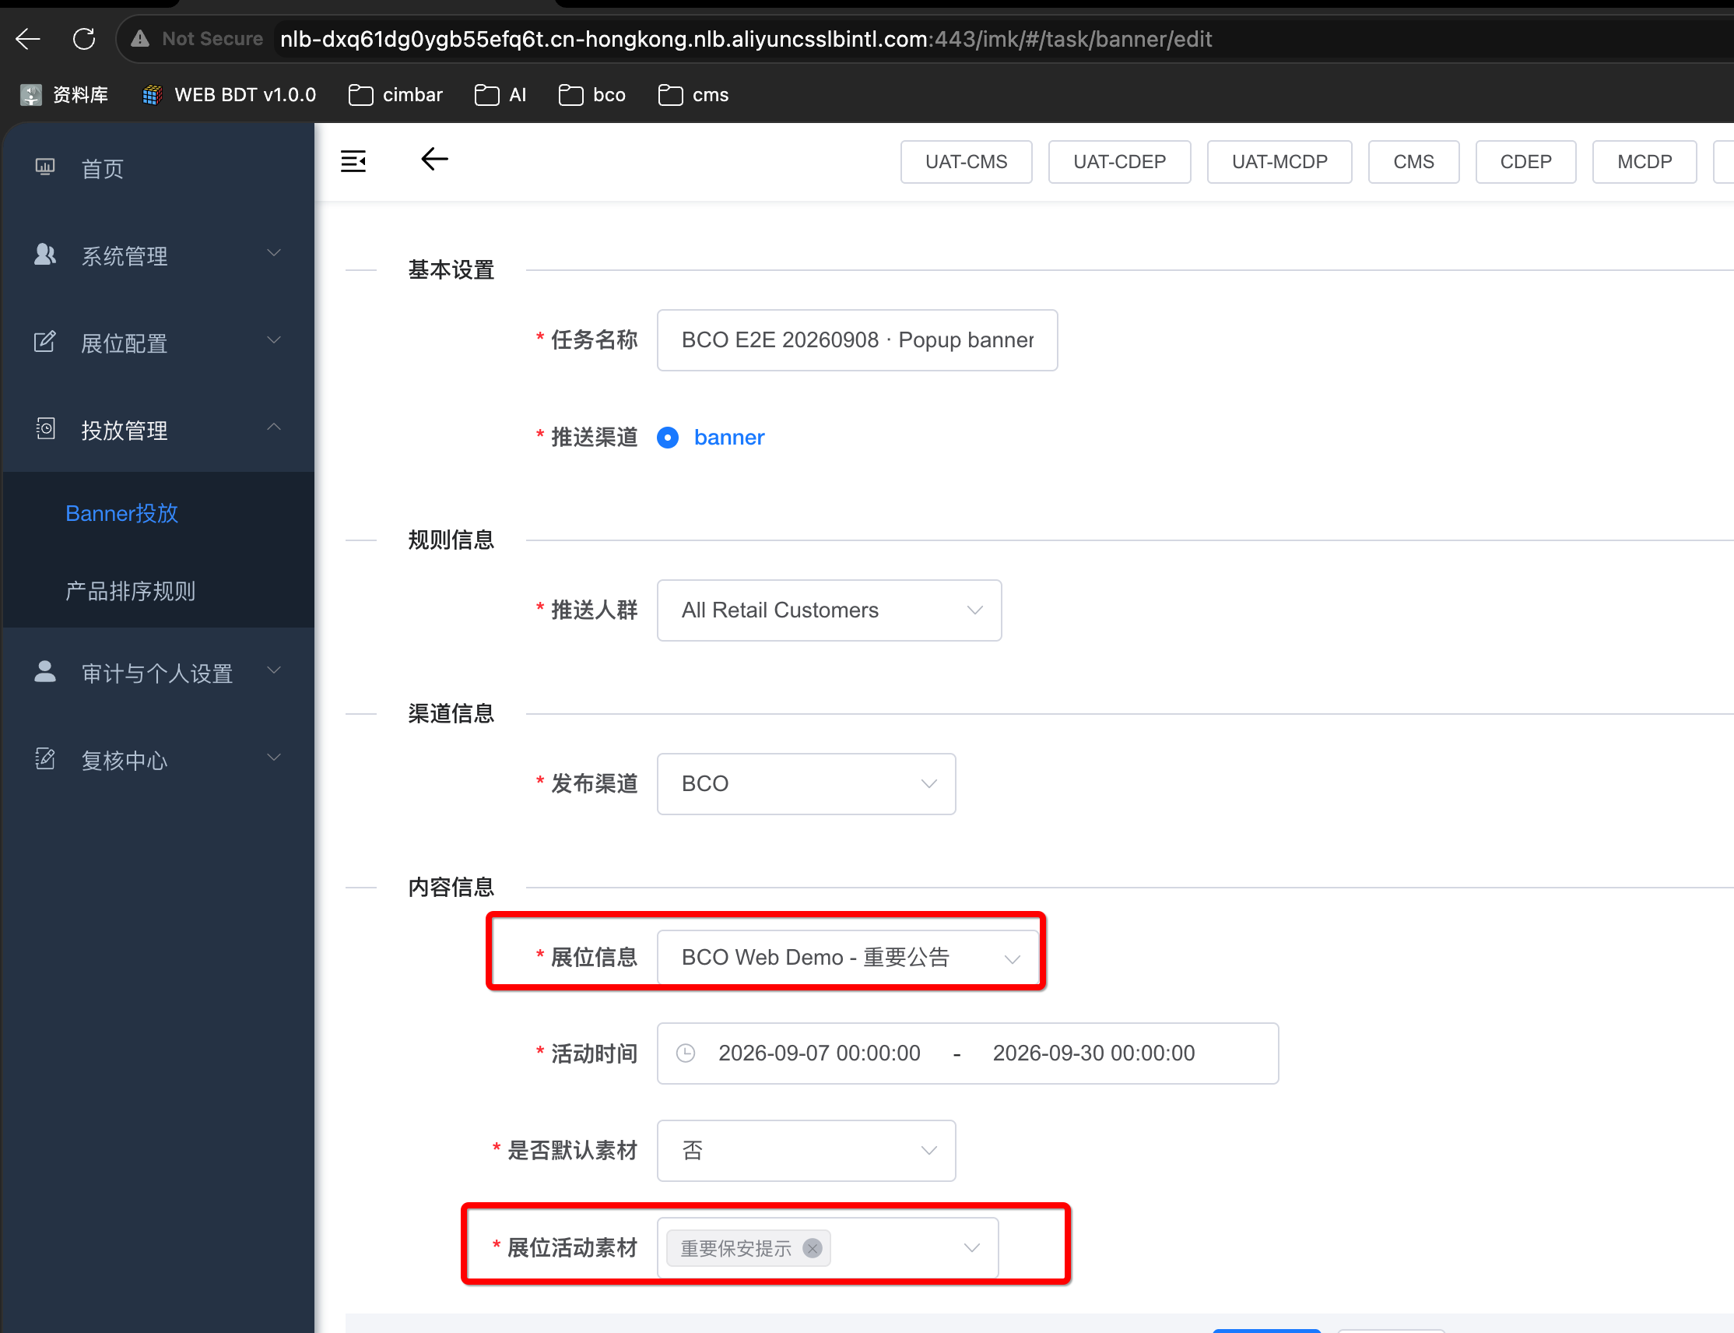
Figure 4. IMK task form: the selected zone and selected zone asset must match.
3.3 Sign in as Reviewer, open Review Center > Pending Review, open each task, check the zone, asset, audience, and effective period, select Approve, and confirm.
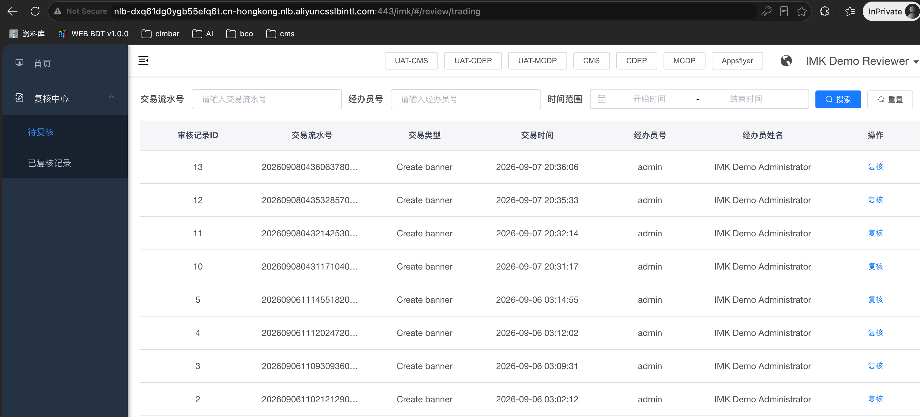
Figure 5. Reviewer pending list: each Create banner record can be reviewed.

4 MCDP activity check and browser acceptance
4.1 After approval, search MCDP Activity Management for the four generated BCO activities. Check the zone, period, and material, then bring each activity online. This creates or updates activities, not zones.
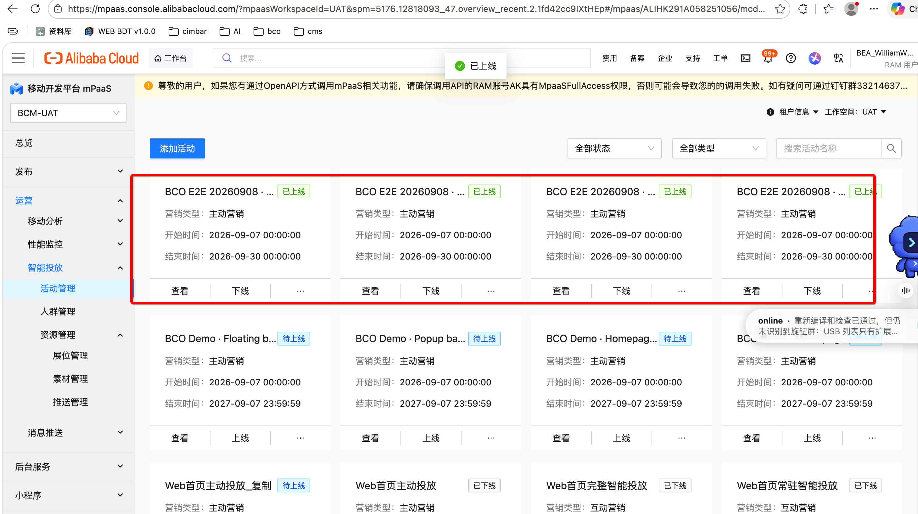
Figure 6. MCDP Activity Management: the four generated campaign cards should be online.
4.2 Open the approved UAT browser demo, choose the language, retain test user web-demo-user, and select Apply / reload. Confirm the page reports four returned zones and that the rotation, notice, popup, and floating-buoy content are correct. The floating buoy has a default position in MCDP; its browser position is controlled by the web client.

