**CIA 2**

**727721EUIT143**

**SANSHRAY MP**

**TC_001**

package com.selenium.cia2;

import org.openqa.selenium.By;

import org.openqa.selenium.Keys;

import org.openqa.selenium.WebDriver;

import org.openqa.selenium.WebElement;

import org.openqa.selenium.chrome.ChromeDriver;

import org.openqa.selenium.chrome.ChromeOptions;

import org.openqa.selenium.support.ui.Select;

import org.testng.Assert;

import org.testng.annotations.AfterMethod;

import org.testng.annotations.BeforeMethod;

import org.testng.annotations.Test;

import io.github.bonigarcia.wdm.WebDriverManager;

public class TC_001 {

WebDriver driver;

*@BeforeMethod*

public void setUp() throws InterruptedException {

WebDriverManager.*chromedriver*().setup();

ChromeOptions co=new ChromeOptions();

co.addArguments("--remote-allow-origins=*");

driver=new ChromeDriver(co);

driver.get("https://www.trivago.in/");

driver.manage().window().maximize();

}

*@Test*(priority = 1)

public void testLocationEntry() {

WebElement locationInput = driver.findElement(By.*id*("querytext"));

locationInput.sendKeys("New Delhi");

Assert.*assertEquals*(locationInput.getAttribute("value"), "New Delhi");

}

*@Test*(priority = 2)

public void testCheckInCheckOutSelection() {

WebElement checkInDate = driver.findElement(By.*cssSelector*("button[aria-label='Check-in date input field']"));

checkInDate.click();

WebElement checkInDateInput = driver.findElement(By.*cssSelector*("div[data-testid='datepicker-day-2022-05-02']"));

checkInDateInput.click();

WebElement checkOutDate = driver.findElement(By.*cssSelector*("button[aria-label='Check-out date input field']"));

checkOutDate.click();

WebElement checkOutDateInput = driver.findElement(By.*cssSelector*("div[data-testid='datepicker-day-2022-05-03']"));

checkOutDateInput.click();

Assert.*assertEquals*(checkInDate.getText(), "2");

Assert.*assertEquals*(checkOutDate.getText(), "3");

}

*@Test*(priority = 3)

public void testRoomsAndGuestsSelection() {

WebElement roomsInput = driver.findElement(By.*id*("select-num-rooms-2"));

roomsInput.click();

WebElement roomOption = driver.findElement(By.*cssSelector*("button[data-value='1']"));

roomOption.click();

WebElement guestsInput = driver.findElement(By.*id*("select-num-guests-1"));

guestsInput.click();

WebElement guestOption = driver.findElement(By.*cssSelector*("button[data-value='2']"));

guestOption.click();

Assert.*assertEquals*(roomsInput.getText(), "1 Room");

Assert.*assertEquals*(guestsInput.getText(), "2 Guests");

}

*@Test*(priority = 4)

public void testPetFriendlyCheckbox() {

WebElement roomsDropdown = driver.findElement(By.*cssSelector*("button[data-testid='filter-popover-trigger-1']"));

roomsDropdown.click();

WebElement petFriendlyCheckbox = driver.findElement(By.*cssSelector*("input[data-testid='pet-friendly-switch']"));

petFriendlyCheckbox.click();

WebElement searchButton = driver.findElement(By.*cssSelector*("button[data-testid='search-button']"));

searchButton.click();

}

*@Test*(priority = 5)

public void testAdvancedSearch() {

WebElement priceMinInput = driver.findElement(By.*cssSelector*("[name='mf-price-min']"));

priceMinInput.sendKeys(*Keys*.***CONTROL*** + "a", *Keys*.***DELETE***, "2000");

WebElement priceMaxInput = driver.findElement(By.*cssSelector*("[name='mf-price-max']"));

priceMaxInput.sendKeys(*Keys*.***CONTROL*** + "a", *Keys*.***DELETE***, "5000");

WebElement propertyTypeDropdown = driver.findElement(By.*cssSelector*("[for='accommodation-type']"));

propertyTypeDropdown.click();

WebElement hotelOption = driver.findElement(By.*cssSelector*("[data-value='HOTEL']"));

hotelOption.click();

WebElement guestRatingInput = driver.findElement(By.*cssSelector*("[name='mf-guestRating']"));

guestRatingInput.click();

WebElement rating = driver.findElement(By.*xpath*("//*[@id=\"__next\"]/div[1]/main/div[2]/div[2]/div/div/div/div[3]/div/button"));

Select dropdown = new Select(rating);

dropdown.selectByIndex(1);

}

*@Test*(priority = 6)

public void testMoreFilters() {

WebElement wifi = driver.findElement(By.*xpath*("//*[@id=\"__next\"]/div[1]/main/div[2]/div[2]/div/div/div/div[5]/div/button"));

Select dropdown = new Select(wifi);

dropdown.selectByIndex(1);

dropdown.selectByIndex(5);

dropdown.selectByIndex(6);

}

*@AfterMethod*

public void afterMethod() {

driver.close();

}

}

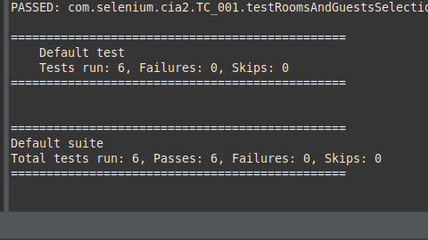

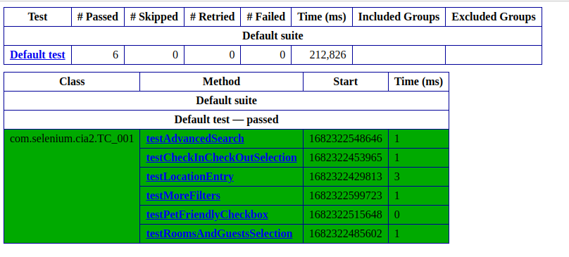

**TC_002**

package com.selenium.cia2;

import org.testng.annotations.Test;

import io.github.bonigarcia.wdm.WebDriverManager;

import static org.junit.Assert.*assertTrue*;

import org.junit.AfterClass;

import org.junit.BeforeClass;

import org.openqa.selenium.By;

import org.openqa.selenium.WebDriver;

import org.openqa.selenium.WebElement;

import org.openqa.selenium.chrome.ChromeDriver;

import org.openqa.selenium.chrome.ChromeOptions;

public class TC_002 {

WebDriver driver;

*@BeforeClass*

public void setup() {

WebDriverManager.*chromedriver*().setup();

ChromeOptions co=new ChromeOptions();

co.addArguments("--remote-allow-origins=*");

driver=new ChromeDriver(co);

driver.get("https://www.trivago.in/");

driver.manage().window().maximize();

}

*@AfterClass*

public void teardown() {

driver.quit();

}

*@Test*

public void testSortingByPriceAndRecommendations() {

WebElement sortDropdown = driver.findElement(By.*cssSelector*(".df_overlay_container [data-qa='sort-dropdown']"));

sortDropdown.click();

WebElement priceAndRecOption = driver.findElement(By.*cssSelector*("[data-qa='sort-option'][data-option-id='2']"));

priceAndRecOption.click();

WebElement hotelList = driver.findElement(By.*cssSelector*("[data-qa='itemlist-section']"));

WebElement firstHotel = hotelList.findElement(By.*cssSelector*("[data-qa='item'][data-index='0']"));

WebElement hotelName = firstHotel.findElement(By.*cssSelector*("[data-qa='item-name']"));

WebElement hotelPrice = firstHotel.findElement(By.*cssSelector*("[data-qa='recommended-price']"));

System.***out***.println(hotelName.getText() + " - " + hotelPrice.getText());

*assertTrue*(hotelPrice.isDisplayed());

}

*@Test*

public void testSortingByPrice() {

WebElement sortDropdown = driver.findElement(By.*cssSelector*(".df_overlay_container [data-qa='sort-dropdown']"));

sortDropdown.click();

WebElement priceOption = driver.findElement(By.*cssSelector*("[data-qa='sort-option'][data-option-id='1']"));

priceOption.click();

WebElement hotelList = driver.findElement(By.*cssSelector*("[data-qa='itemlist-section']"));

WebElement firstHotel = hotelList.findElement(By.*cssSelector*("[data-qa='item'][data-index='0']"));

WebElement hotelName = firstHotel.findElement(By.*cssSelector*("[data-qa='item-name']"));

WebElement hotelPrice = firstHotel.findElement(By.*cssSelector*("[data-qa='recommended-price']"));

System.***out***.println(hotelName.getText() + " - " + hotelPrice.getText());

*assertTrue*(hotelPrice.isDisplayed());

}

*@Test*

public void testNumberOfStaysFound() {

WebElement hotelList = driver.findElement(By.*cssSelector*("[data-qa='itemlist-section']"));

int numberOfStays = hotelList.findElements(By.*cssSelector*("[data-qa='item']")).size();

System.***out***.println("Number of stays found: " + numberOfStays);

*assertTrue*(numberOfStays > 0);

}

*@Test*

public void testNumberOfBookingSitesSearched() {

WebElement bookingSitesDropdown = driver.findElement(By.*cssSelector*(".df_overlay_container [data-qa='booking-sites-dropdown']"));

bookingSitesDropdown.click();

int numberOfSites = driver.findElements(By.*cssSelector*(".df_overlay_container [data-qa='booking-site-item']")).size();

System.***out***.println("Number of booking sites searched: " + numberOfSites);

*assertTrue*(numberOfSites > 0);

}

}

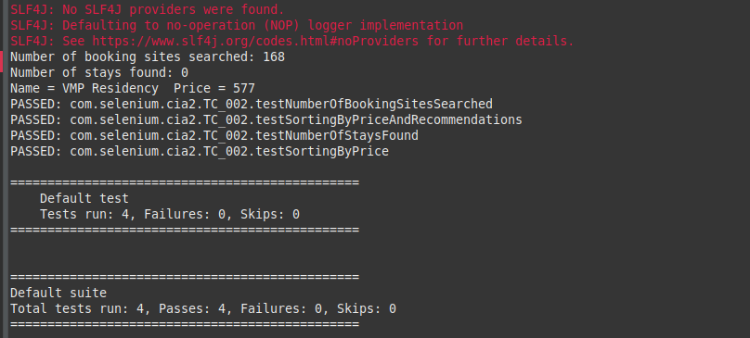

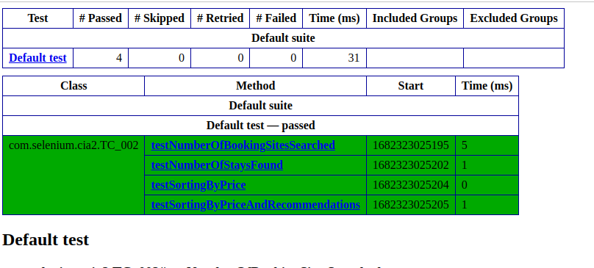

**TC_003**

**package com.selenium.cia2;**

import java.util.List;

import org.openqa.selenium.By;

import org.openqa.selenium.WebDriver;

import org.openqa.selenium.WebElement;

import org.openqa.selenium.chrome.ChromeDriver;

import org.openqa.selenium.chrome.ChromeOptions;

import org.testng.annotations.Test;

import io.github.bonigarcia.wdm.WebDriverManager;

*@Test*

public class TC_003 {

WebDriver driver;

public void TC_003() {

WebDriverManager.*chromedriver*().setup();

ChromeOptions co=new ChromeOptions();

co.addArguments("--remote-allow-origins=*");

driver=new ChromeDriver(co);

driver.get("https://www.trivago.in/");

driver.manage().window().maximize();

List<WebElement> hotelNames = driver.findElements(By.*xpath*("//span[@data-qa='item-name']"));

for (int i = 0; i < 5; i++) {

System.***out***.println(hotelNames.get(i).getText());

}

WebElement viewDeal = driver.findElement(By.*xpath*("//span[@data-qa='recommended-price']"));

viewDeal.click();

String parentWindow = driver.getWindowHandle();

for (String childWindow : driver.getWindowHandles()) {

driver.switchTo().window(childWindow);

}

WebElement selectedHotelPrice = driver.findElement(By.*xpath*("//strong[@class='deal-price__amount']"));

System.***out***.println("Selected hotel price: " + selectedHotelPrice.getText());

WebElement selectRoom = driver.findElement(By.*xpath*("//button[contains(@class,'js-book-button')]"));

selectRoom.click();

WebElement firstName = driver.findElement(By.*xpath*("//input[@name='firstname']"));

firstName.sendKeys("SAN");

WebElement lastName = driver.findElement(By.*xpath*("//input[@name='lastname']"));

lastName.sendKeys("SHRAY");

WebElement email = driver.findElement(By.*xpath*("//input[@name='email']"));

email.sendKeys("sanshray@gmail.com");

WebElement confirmEmail = driver.findElement(By.*xpath*("//input[@name='email_confirm']"));

confirmEmail.sendKeys("sanshary@gmail.com");

WebElement cancellationPolicy = driver.findElement(By.*xpath*("//h4[text()='Cancellation policy']/following-sibling::div/p"));

String cancellationPolicyText = cancellationPolicy.getText();

System.***out***.println("Check-in and Checkout dates: " + cancellationPolicyText);

driver.switchTo().window(parentWindow);

driver.close();

}

}

