PATANJALI RISHIKUL

Teliarganj, Prayagraj

A Project Report

on

Students Information Management System

For

AISSCE 2021-22 Examination

[As a part of the Computer Science (083)]

SUBMITTED BY

Devam Pandey XII-A

Roll no.:23710175

Under the Guidance of:

Mr. Hari Krishna Lal

PGT (Computer Science)

**CERTIFICATE**

This is to certify that the Project entitled **Student Information Management System**  is a bonafide work done by DEVAM PANDEY of class XII Session 2021-22 in partial fulfillment of CBSE’s AISSCE Examination 2022 and has been carried out under my direct supervision and guidance. This report or a similar report on the topic has not been submitted for any other examination and does not form a part of any other course undergone by the candidate.

## ………………………… ……………………………..

## Signature of Student Signature of Teacher/Guide

**Name: Hari Krishna Lal**

**Designation: PGT (CS) …….…………………**

### Signature of Examiner

**ACKNOWLEDGEMENT**

I

undertook this Project work, as the part of my XII-Computer Science course. I had tried to apply my best of knowledge and experience, gained during the study and class work experience. However, developing software system is generally a quite complex and time-consuming process. It requires a systematic study, insight vision and professional approach during the design and development. Moreover, the developer always feels the need, the help and good wishes of the people near you, who have considerable experience and idea.

I would like to extend my sincere thanks and gratitude to my teacher Mr. Hari Krishna Lal sir

We would like to take the opportunity to extend my sincere thanks and gratitude to our parentsfor being a source of inspiration and providing time and freedom to develop this software project.

-x-x-x-x-x-x-x-x-x-x-x-x-x-x-x-x-x-x-x-x-x-x-x-x-x-x-x-x-x-x-x-

**1. Introduction**

This project on “Students Information Management System” is very useful for easy user interface.The system utilizes the powerful database management, data retrieval and data manipulation. This project provides more ease for managing the data than manually maintaining in the documents. The project is useful for saving valuable time and reduces the huge paper work.

It will help educational institutions like schools and colleges will keep track of their student records like personal details, contact details, etc. The internet is rapidly becoming a part of the everyday lives of a majority of people in the world. People perform various activities on the internet and one of them is storing their data in database where they are interested in. Obviously, there is a need of Students Information Management System to manage student’s data.

-x-x-x-x-x-x-x-x-x-x-x-x-x-x-x-x-x-x-x-x-x-x-x-x-x-x-x-x-x-x-x-

**2. Objective & Scope of the Project**

The objective of this system is to develop a computerized Students Information Management System to decrease the burden of data entry of students information and to make it easier. This system also makes the data retrieval and manipulation like modification and deletion, etc easier to perform.

This system is expected to perform the following functionalities :-

* To provide a user friendly interface to perform all the tasks.
* The proposed system should maintain all the records and transactions, and should generate the required reports and information when required.
* To identify the critical operation procedure and possibilities of simplification using modern IT tools and practices.
* Take the feedback and ratings by the user for further updates in the system.

In its current scope, the system enables user to retrieve and update the information very easily . This software does not require much training time of the users due to easy to understand interface and simplicity.

Despite of the best effort of the developer, the following limitations and functional boundaries are visible, which limits the scope of this system.

1. This system can store records and produce reports in pre-designed format in soft copy. There is no facility yet to produce customized reports. Only specified reports are covered.
2. The data in this system is not stored in database format (rows and columns).

However all these limitations can be resolved in further updates of the system.

So far as future scope of the project is concerned, firstly it is open to any modular expansion i.e. other modules or functions can be designed and embedded to handle the user need in future. Any part of the system and reports can be modified independently without much effort.

-x-x-x-x-x-x-x-x-x-x-x-x-x-x-x-x-x-x-x-x-x-x-x-x-x-x-x-x-x-x-x-

**3. System Implementation**

## 

## 5.1 The Hardware used:

While developing the system, the used hardware are:

PC with Intel Core i3 processor and other required devices.

## 5.2 The Softwares used:

* Microsoft Windows® 10 as Operating System.
* Python 3.9
* MS-Word 2007 for documentation.

-x-x-x-x-x-x-x-x-x-x-x-x-x-x-x-x-x-x-x-x-x-x-x-x-x-x-x-x-x-x-x-

**4. System Design and Development**

HYPOTHALAMUS(MAIN)

This is the main commanding part of the system. It consists of a loop which runs the system until the user successfully exits it.

1. New Registrations
2. Search
3. Update
4. Display
5. Exit

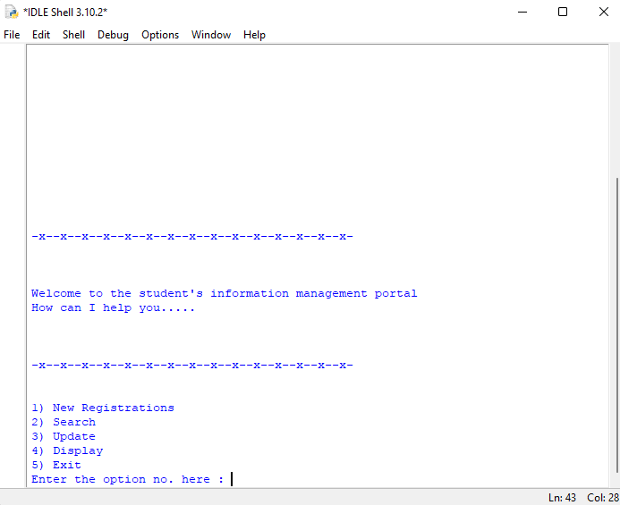

-x-x-x-x-x-x-x-x-x-x-x-x-x-x-x-x-x-x-x-x-x-x-x-x-x-x-x-x-x-x-x-

"""

This is the Hypothalamus of the system

It Commands the system

The Main Commanding Officer

"""

from Hindbrain import *

from Hippocampus import *

from Motor_Cortex import *

clean()

h_line()

space_2()

print(

"Welcome to the student's information management portal \nHow can I help you....."

)

space_2()

while True:

h_line()

print("\n\n1) New Registrations \n2) Search \n3) Update \n4) Display \n5) Exit")

option = int(input("Enter the option no. here : "))

if option == 1:

new_registration()

space_2()

response = input(

"Press Enter to get back to the main menu and any other key to go to the Exit screen"

)

h_line()

if response == "":

continue

else:

result = exit()

if result == 1:

break

else:

continue

elif option == 2:

search()

space_2()

response = input(

"Press Enter to get back to the main menu and any other key to go to the Exit screen"

)

h_line()

if response == "":

continue

else:

result = exit()

if result == 1:

break

else:

continue

elif option == 3:

update()

space_2()

response = input(

"Press Enter to get back to the main menu and any other key to go to the Exit screen"

)

h_line()

if response == "":

continue

else:

result = exit()

if result == 1:

break

else:

continue

elif option == 4:

display()

space_2()

response = input(

"Press Enter to get back to the main menu and any other key to go to the Exit screen"

)

h_line()

if response == "":

continue

else:

result = exit()

if result == 1:

break

else:

continue

elif option == 5:

result = exit()

if result == 1:

break

else:

continue

else:

space_2()

print("Wrong option Selected... \nPlease try again...\n")

continue

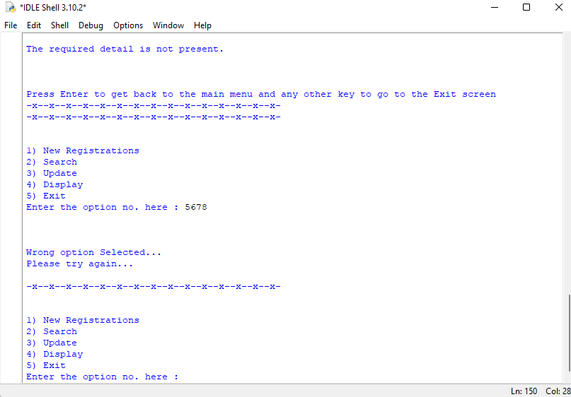

-x-x-x-x-x-x-x-x-x-x-x-x-x-x-x-x-x-x-x-x-x-x-x-x-x-x-x-x-x-x-x-

HINDBRAIN

This is the part of the system which consists of the main functions (containing the other functions of the system ) of the system which is responsible for cleanliness and smooth functioning of the system.

1. new_registration() : handles the entering of data by the user
2. search() : searches and displays the data on the users command
3. update() : modifies or deletes the data on the user command
4. display() : displays the desired data on the user command
5. exits() : takes the user out of the system and also takes feedback and ratings

-x-x-x-x-x-x-x-x-x-x-x-x-x-x-x-x-x-x-x-x-x-x-x-x-x-x-x-x-x-x-x-

"""

This is the Hindbrain of the system

It tells the system how to execute the functions

"""

from Motor_Cortex import *

from Hippocampus import *

def new_registration():

clean()

h_line()

space_3()

"""

To check for the no.of entries to be made

"""

loop = int(input("How many entries are to be made : "))

x = 1

while x < loop or x == loop:

details()

if x == 1:

space_3()

print(" One entry successfully made !!!!!")

elif x == 0:

space_3()

print("\n \n \n One more entry successfully made !!!!!")

x = x + 1

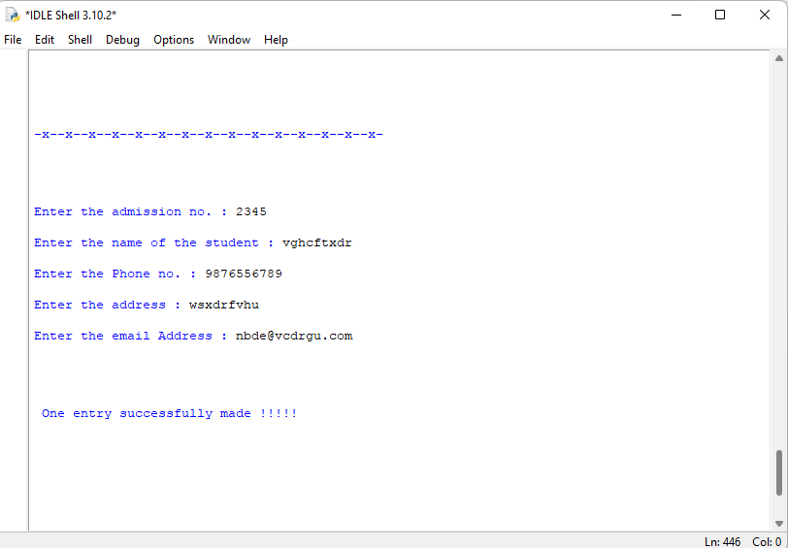

def search():

clean()

h_line()

space_3()

"""

This function is used to search for a required data asked by the user

"""

adm_no = int(

input("Enter the admission no. of the student whose info is to be searched : ")

)

if inlist(adm_no):

space_3()

print("The required data is present.\n Do you want to display it ?")

space_2()

display_confirmation = int(input("Press 1 for yes and 0 for no : "))

if display_confirmation == 1:

result = display_data(adm_no)

space_2()

print("The search result : \n", result)

elif display_confirmation == 0:

space_2()

print("Ok")

return

else:

space_2()

print("Invalid Input !!!")

else:

space_3()

print("The required detail is not present.")

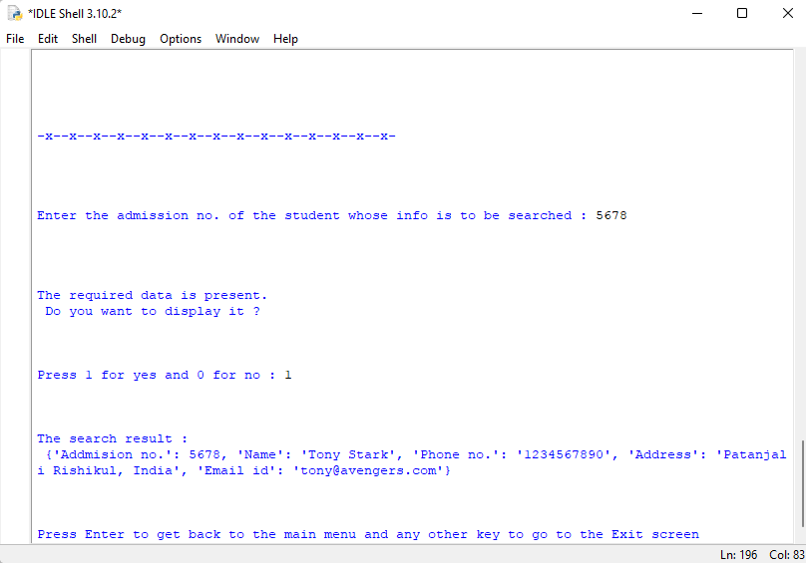

def update():

"""

This function is used the update the database

It can delete the data from the database

it can modify the existing details of the students

"""

adm_no = int(

input(

"Enter the admission number of the student whose data is to be modified : "

)

)

if inlist(adm_no):

print(

"1) Delete the existing data from the database \n2) Modify the existing data of the student "

)

answer = int(input("Enter your option number here : "))

if answer == 1:

delete(adm_no)

print("\nSUCCESS ...... \nThe data is deleted from the database")

elif answer == 2:

modify(adm_no)

print("\nSUCCESS ....... \nThe details are modified ")

else:

print("Invalid Input!!!")

else:

print("The admission no. does not exists in the database\nPlease try again")

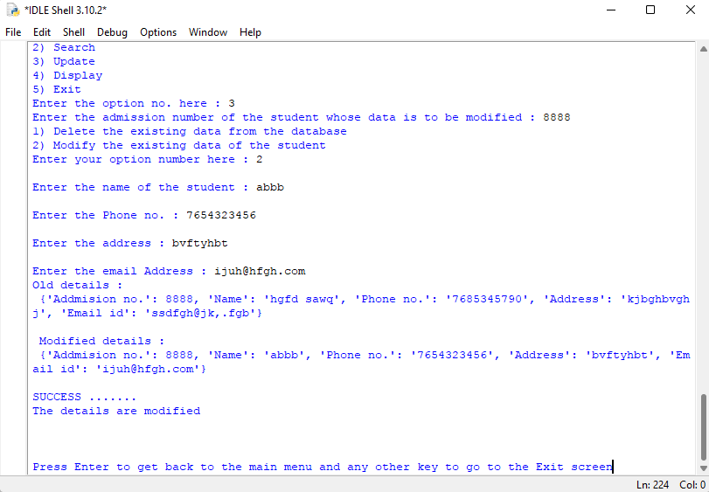

def display():

clean()

h_line()

space_3()

"""

This function is used to display data

"""

print(

"Do you want to display the whole database or the data of some specific student ?"

)

space_2()

answer = int(input("Press 1 for whole database and 0 for specific student : "))

if answer == 1:

space_2()

print("The database: \n")

with open("Data.txt", "r") as d:

print(d.read())

elif answer == 0:

space_3()

adm_no = int(input("Enter the admission no. to display data : "))

result = display_data(adm_no)

space_2()

print(result)

space_3()

else:

space_3()

print("Invalid Input !!!")

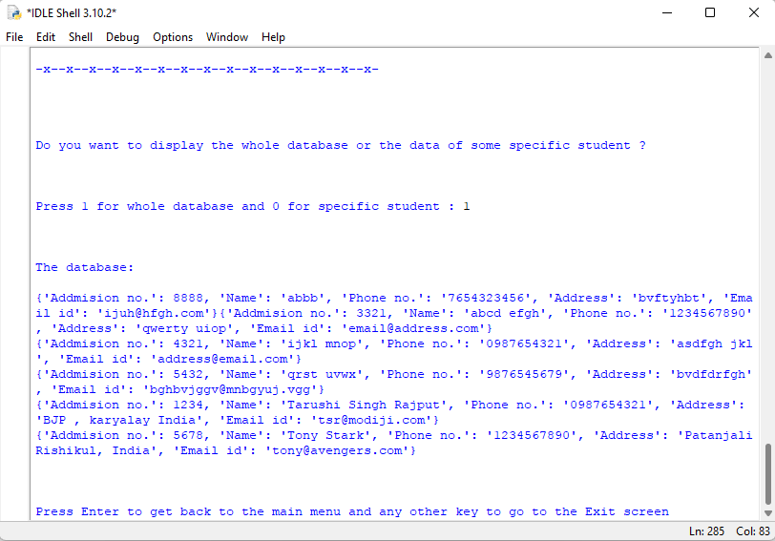

def exit():

clean()

h_line()

space_3()

"""

It controls the exit part of the system

It also manages the feedback function presentation

"""

while True:

print(" Are you sure you want to exit ?")

space_2()

exit_confirmation = int(input("Press 1 for yes and 0 for no : "))

if exit_confirmation == 1:

space_2

randf_name = input("Enter your name : ")

while True:

space_3()

print("Would you like to mention some feedback ? ")

space_2()

feedback_confirmation = int(input("Press 1 for yes and 0 for no : "))

if feedback_confirmation == 1:

f_d = feedback()

while True:

print("would you like to give ratings ?")

ratings_confirmation = int(

input("Press 1 for yes and 0 for no : ")

)

if ratings_confirmation == 1:

r_d = ratings()

randf_data = {

"Name": randf_name,

"Ratings": r_d,

"Feedback": f_d,

}

randf_storage(randf_data)

break

elif ratings_confirmation == 0:

space_2()

print("Ok no problem...")

randf_data = {

"Name": randf_name,

"Ratings": "Not given",

"Feedback": f_d,

}

randf_storage(randf_data)

break

else:

space_2()

print("Invalid Input!!")

continue

break

elif feedback_confirmation == 0:

while True:

print("would you like to give ratings ?")

print("would you like to give ratings ?")

ratings_confirmation = int(

input("Press 1 for yes and 0 for no : ")

)

if ratings_confirmation == 1:

r_d = ratings()

randf_data = {

"Name": randf_name,

"Ratings": r_d,

"Feedback": "No feedback given",

}

randf_storage(randf_data)

break

elif ratings_confirmation == 0:

space_2()

print("Ok no problem...")

break

else:

space_2()

print("Invalid Input!!")

continue

break

else:

space_3()

print("\n Invalid Input !!!")

space_2()

print("\n Try Again....")

continue

return 1

elif exit_confirmation == 0:

space_3()

print("\n \n Let's get back to the system then...")

return 0

else:

space_3()

print("\n \n Invalid Input !!!")

space_2()

print("\n \n Please try Again.....")

continue

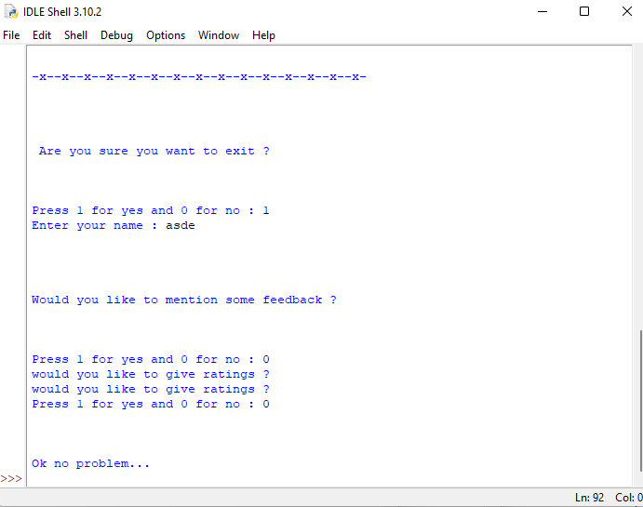

-x-x-x-x-x-x-x-x-x-x-x-x-x-x-x-x-x-x-x-x-x-x-x-x-x-x-x-x-x-x-x-

MOTOR_CORTEX

This part of the system consists of the several functions which are responsible for the functioning of the system. It has all the basic functions which are the building blocks of the system.

1. clean() : It cleans the terminal
2. h_line() : it creates a line
3. space_2() : creates a space of 2 lines
4. space_3() : creates a space of 3 lines
5. sub_details() : asks for the user to enter the basic data about the student
6. details() : takes the complete data of the student and stores in a file
7. display_data() : it displays the required data according to the user
8. modify() : it modifies the data according to the user
9. feedback() : it takes feedback from the user and saves it
10. ratings() : it takes ratings from the user and replies them according to their rating

-x-x-x-x-x-x-x-x-x-x-x-x-x-x-x-x-x-x-x-x-x-x-x-x-x-x-x-x-x-x-x-

"""

This is the Motor Cortex Of the System

It executes the functions of the system

"""

from Hippocampus import *

def clean():

"""

cleans the terminal for a clear running of the system

"""

print("\n" * 20)

def h_line():

"""

It makes a line

"""

print("-x-" * 15)

def space_2():

"""

It gives a space of 2 lines

"""

print("\n\n")

def space_3():

"""

It gives a space of 3 lines

"""

print("\n\n\n")

Fields = ["Addmision no.", "Name", "Phone no.", "Address", "Email id"]

def sub_details(adm_no):

name = input("\nEnter the name of the student : ")

phone_no = input("\nEnter the Phone no. : ")

address = input("\nEnter the address : ")

email_id = input("\nEnter the email Address : ")

student_details = {

"Addmision no.": adm_no,

"Name": name,

"Phone no.": phone_no,

"Address": address,

"Email id": email_id,

}

return student_details

def details():

clean()

h_line()

space_3()

"""

Entering the data of the students

"""

adm_no = int(input("Enter the admission no. : "))

try:

uniqueness = inlist(adm_no)

except FileNotFoundError:

uniqueness = 0

if uniqueness == 1:

space_2

print("This data is already present in the list !!!!")

space_2

print("Try again...")

return

else:

name = input("\nEnter the name of the student : ")

phone_no = input("\nEnter the Phone no. : ")

address = input("\nEnter the address : ")

email_id = input("\nEnter the email Address : ")

"""

Storing the data of the students

"""

student_details = {

"Addmision no.": adm_no,

"Name": name,

"Phone no.": phone_no,

"Address": address,

"Email id": email_id,

}

storage(student_details)

def display_data(adm_no):

"""

This gives the data of user if present in database.

:param int adm_no : Admission no of the student

:return dict: dictionary containing the user data (if present)

:return bool: 0: Not present

1: Present

"""

if inlist(adm_no):

with open("Data.txt", "r") as d:

text = d.read()

start_index = text.find("{'Addmision no.': " + str(adm_no))

end_index = text.find("}", start_index)

student = eval(text[start_index : end_index + 1])

return student

else:

message = " The data you are asking for is not present...."

return message

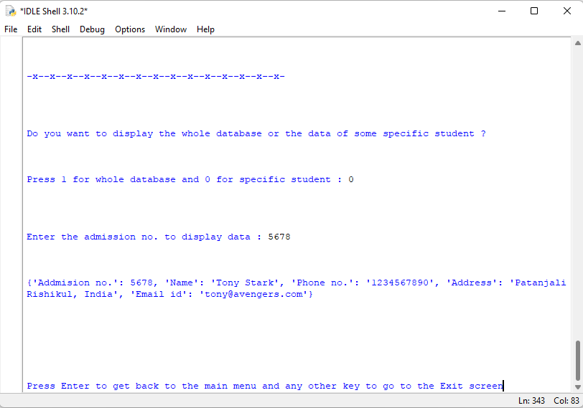

def modify(adm_no):

new_data = sub_details(adm_no)

with open("Data.txt", "r") as d:

data = d.read()

start_index = data.find("{'Addmision no.': " + str(adm_no))

end_index = data.find("}", start_index)

old_data = eval(data[start_index : end_index + 1])

print("Old details : \n", old_data)

print("\n Modified details : \n", new_data)

with open("Data.txt", "r") as d:

all_data = d.readlines()

with open("Data.txt", "w") as d:

for line in all_data:

start_i = line.find(":") + 1

end_i = line.find(",", start_i)

if int(line[start_i:end_i]) == adm_no:

d.write(str(new_data))

continue

else:

d.write(line)

def feedback():

"""

Takes feedback from user

It saves the feedback in a new file

"""

feed_back = input("Write your feed back here : ")

print(

"\n \n Thank you for your feedback.... \n We will surely work upon it ( If required ....). \n \n"

)

return feed_back

def ratings():

space_2()

while True:

print("You can rate this system on the scale of 1 to 5")

rate = int(input("Rate this system Here : "))

space_2()

if rate > 5:

print(

" We are very happy to see you this much Happy.... \nBut remember we should never forget our limits however happy we are ;) ..... \n so please rate us from 1 to 5 :)"

)

continue

elif rate == 5:

print(

" OMG this is great that you loved this system so much...... \n This makes the hardwork done by the systemmer/coder successfull..... \n After seeing this rating the systemmer/coder will cry out of happiness"

)

break

elif rate == 4:

print(

" Thanks for your rating...... \n We know there might be some problem which is stopping you from giving full ratings...... \n The systemmer/coder will surely try to solve the problem so that next time you dont have any excuse for not giving full ratings.... \n Do give your feedback when asked to do so.... "

)

break

elif rate == 3:

print(

" Ohhhh!! There might be some serious issue which kept you 2 points away from full rating........ \n Please dont forget to mention that serious issue when the feedback is asked..... \n the systemmer/coder of this system/code is very hard working and passionate and will surely try to solve the problem......"

)

break

elif rate == 2:

print(

" We respect your thoughts about this system...... But dont you think its too less for this wonderfull system and the precious efforts and hard work put together to make this system..... \n this will surely hurt the systemmer/coder :( ......"

)

break

elif rate == 1:

print(

" Ohh God!!!!! ...... \n Now this is too much.... \n Haven't you seen the system before rating? ...... \n you surely dont have a taste for good things .... \n this is a wonderfull system..... \n The systemmer get into a severe drepression state after seeing this :.(.. ..."

)

break

else:

print(

" Was it a mistake or are you mad..... \n It is clearly mentioned that you have to rate from 1 to 5......"

)

continue

print("\n")

return rate

-x-x-x-x-x-x-x-x-x-x-x-x-x-x-x-x-x-x-x-x-x-x-x-x-x-x-x-x-x-x-x-

HIPPOCAMPUS

This part of the system contains functions which are responsible for the interactions between the system and storage files.

1. Storage(user) : it stores the data of the students in the file Data.txt
2. Inlist(adm_no) : it checks if the admission no. entered by the user is present in the file Data.txt or not
3. randf_storage(fb_data) : it stores the data of the feedback and ratings given by the user in the file Ratings_and_feedbacks.txt
4. deletion_storage(d_data) : it stores the deleted details of the students in the file Deleted_files.txt
5. delete(adm_no) : it deletes the details of the students according to the admission no. given by the user

-x-x-x-x-x-x-x-x-x-x-x-x-x-x-x-x-x-x-x-x-x-x-x-x-x-x-x-x-x-x-x-

"""

It is the Hippocampus of the system

It stores and manages the storage system of the system

"""

def storage(user):

"""

This stores the user's data in database

:param dict user: dictionary containing user data

"""

with open("Data.txt", "a") as d:

d.write(str(user) + "\n")

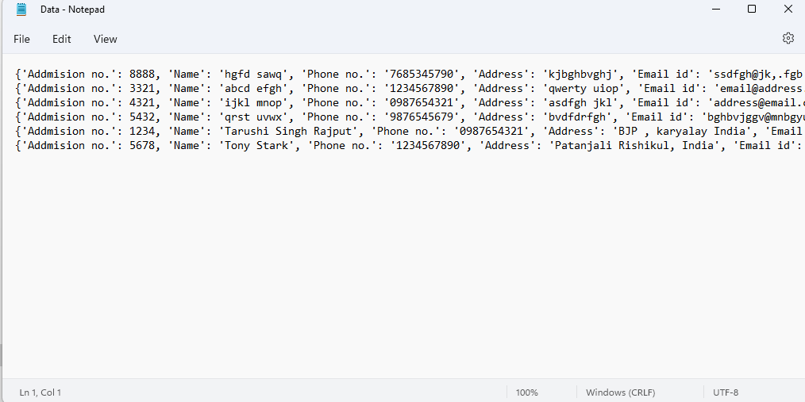

def inlist(adm_no):

"""

This checks the presence of user data in database.

:param int adm_no. : admission no. of the student

:return bool: 0: Not present

1: Present

"""

with open("Data.txt", "r") as d:

detail = d.read()

start_index = detail.find("{'Addmision no.': " + str(adm_no))

if start_index == -1:

return 0

else:

return 1

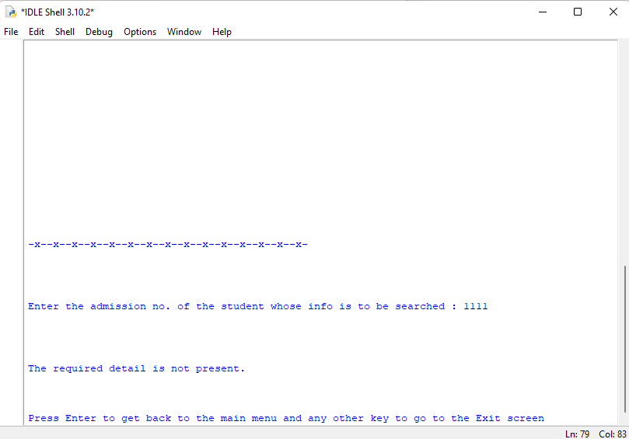

def randf_storage(fb_data):

"""

It stores and manages the feedback data

:param dict fb_data : dictionary containing feedback and ratings

"""

with open("Ratings_and_feedback.txt", "a") as fd:

fd.write(str(fb_data) + "\n")

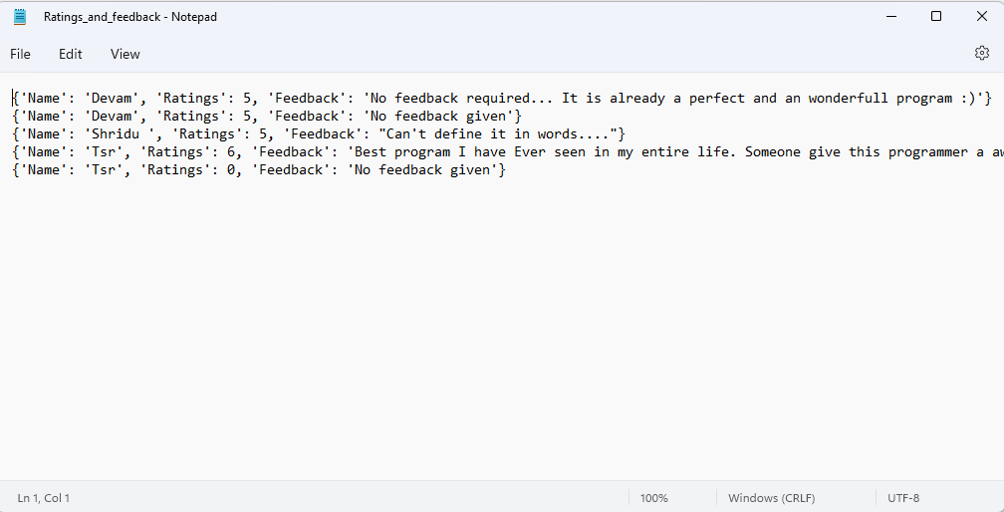

def deletion_storage(d_data):

"""

It stores and manages the deleted data

:param dict d_data : dictionary containing deleted data

"""

with open("Deleted_files.txt", "a") as df:

df.write(str(d_data) + "\n")

def delete(adm_no):

"""

This deletes the student's data from database.

:param int adm_no: admission no. of student

"""

with open("Data.txt", "r") as d:

data = d.read()

start_index = data.find("{'Addmision no.': " + str(adm_no))

end_index = data.find("}", start_index)

delete_data = eval(data[start_index : end_index + 1])

deletion_storage(delete_data)

with open("Data.txt", "r") as d:

all_data = d.readlines()

with open("Data.txt", "w") as d:

for line in all_data:

start_i = line.find(":") + 1

end_i = line.find(",", start_i)

if int(line[start_i:end_i]) == adm_no:

continue

else:

d.write(line)

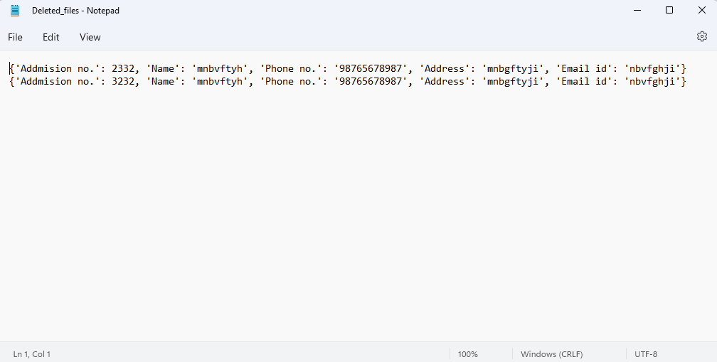

-x-x-x-x-x-x-x-x-x-x-x-x-x-x-x-x-x-x-x-x-x-x-x-x-x-x-x-x-x-x-x-

**5. User Manual**

SOFTWARE REQUIREMENTS:-

Python IDLE or Code editor like (VS Code)

HOW TO USE :-

1. Install the program Folder to your computer.
2. Run HYPOTHALAMUS and done.

-x-x-x-x-x-x-x-x-x-x-x-x-x-x-x-x-x-x-x-x-x-x-x-x-x-x-x-x-x-x-x-