  - ADVANCED PYTHON

FTCC Military Credit and
Program Recommender

Project Overview
Develop a command-line Python application that helps veterans and advisors identify FTCC programs that may align with a veteran’s Military Occupational Specialty (MOS), skill level, and documented military training. Unlike a project that begins with prepared CSV files, this application must begin with the reduced versions of the actual institutional source files and convert them into normalized application data when the program is first run.
Core design goal
The application should be resilient to future versions of the same source documents. Do not write a one-time conversion script that works only because particular data appears in a fixed cell or row. Build reusable importers that recognize structure, validate assumptions, report exceptions, and produce standardized output.

Source Files Supplied
Source | Format | Purpose
Reduced Army MOS Maps | XLSX with multiple MOS worksheets | MOS- and skill-level-based FTCC equivalencies
Military Service School Equivalencies | DOCX | Separately completed training-to-course equivalencies
Reduced 2026 FTCC Programs of Study | XLSX report with selected programs | Program requirements and choice structures

You must not manually retype the source information into Python, CSV, or JSON. The application must read the supplied source files and create normalized output files.

Required Processing Pipeline
Source XLSX / DOCX files
|
v
Source-specific importers(Functions)
|
v
Validation + normalization + issue reporting
|
v
Normalized CSV(s)
|
v
MOS/training selection(user input) + course deduplication
|
v
Program matching + explainable ranking
|
v
Console and exported reports

The above is explain in detail below

Phase 1: Detect First Run and Build Normalized Data
At startup, the program must determine whether valid normalized application files already exist.
- If normalized files are missing, create them from the three source documents.
- If the source files have changed since the previous conversion, rebuild the normalized files or offer a documented refresh command.
- If normalized files are current, load them without repeating unnecessary conversion.
- If conversion fails, display a useful error and create a conversion-issues report.,

Phase 2: Parse the Reduced Army MOS Workbook
The workbook contains one worksheet per MOS. Your importer must discover worksheets rather than rely on a hard-coded list. For every applicable worksheet, extract the MOS code and title, identify the header row, read course equivalencies, map skill-level columns, and capture the course level and notes.
- Ignore non-data rows such as accessibility instructions, footer statements, and End of Worksheet markers.
- Do not assume the table begins on the same row in every worksheet.
- Recognize skill-level headings even when line breaks or spacing differ.
- Treat zero or blank skill-level cells as no credit for that level.
- Normalize course IDs such as CIS110, CIS 110, and COM-231.
- Log and report worksheets that cannot be interpreted safely.
Required normalized output fields may include:
mos_code, mos_title, branch, skill_level, course_id,
course_title, credits, course_level, source_file, sourse_sheet,
status, notes

See example below
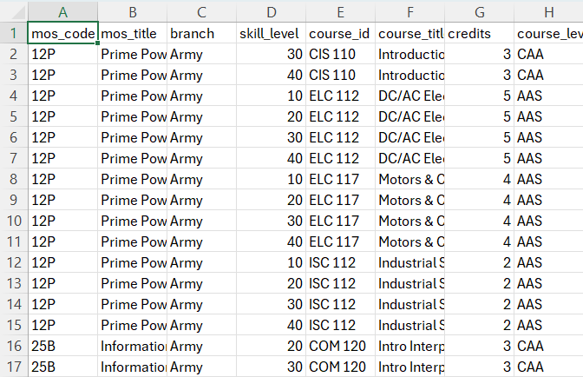

Phase 3: Parse the Training Word Document
Use python-docx to locate tables in the supplied Word document. Detect branch headings, table headers, training names, FTCC equivalencies, and total hours. A single source row may contain several FTCC course IDs and therefore must expand into several normalized records.
- Do not infer that an MOS holder completed a training course.
- Accept separators such as commas, ampersands, and line breaks in equivalency cells.
- Normalize every extracted course ID.
- Preserve branch, training name, source table, and original source text.
- Compare parsed course-credit totals with the stated Hours value when possible.
- Flag ambiguous rows rather than silently guessing.
- Ignore narrative memorandum content that is not part of an equivalency table.
Because the source table may list only a combined total for several courses, your conversion design must not invent per-course credit values. Use a course catalog lookup , for instance courses are listed in the “2026_POS_Reduced” file , preserve the combined total separately, or mark per-course credits as unresolved. Explain the selected approach.
Required normalized output fields may include:
training_id, branch, training_name, training_alias, course_id,
course_credits, source_total_hours, verification_required,
condition, source_file, source_table, status, notes

See example below

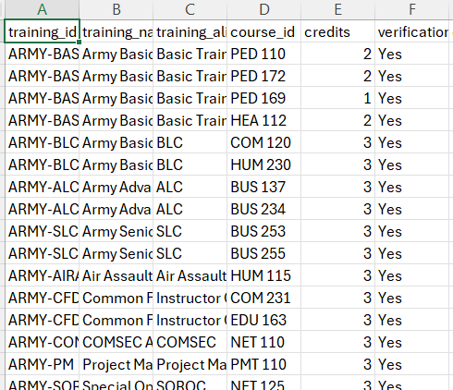

Phase 4: Parse the Reduced FTCC Program Workbook
The FTCC workbook is a report-oriented spreadsheet, not a clean database table. Your importer must locate Program of Study headings and associate subsequent rows with the correct program until the next program begins. It must identify program codes, titles, credential information, total credits, courses, and requirement structures.
- Do not assume programs begin at fixed row numbers.
- Handle repeated page headers for one program.
- Recognize normalized course IDs wherever they appear.
- Preserve requirement text and group information.
- Distinguish direct requirements from choices or elective pools when the source provides enough information.
- Do not count every course in a choice pool as simultaneously required.
- Flag unsupported or ambiguous nested rules for review.
Required normalized output fields may include:
program_code, program_title, credential_type, catalog_year,
program_total_credits, requirement_group, requirement_type,
course_id, course_credits, source_file, source_row, raw_rule_text,
status, notes

See example below
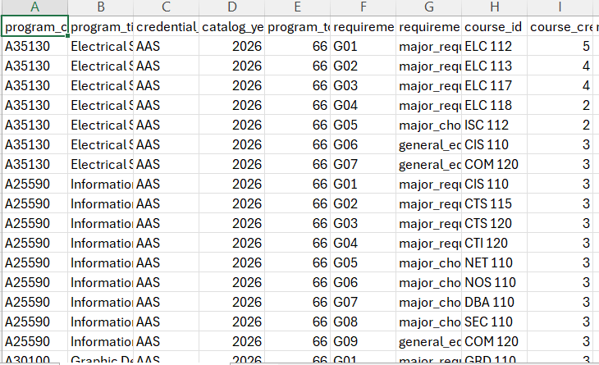

Phase 5: Validate the Conversion
After conversion, validate the normalized data before using it for recommendations.
- Required fields are present.
- Course IDs match the normalized format.
- Credits are numeric, zero, blank, or explicitly unresolved according to your schema.
- MOS code, skill level, and course combinations are not accidentally duplicated.
- Every program requirement belongs to a known program.
- Parsing issues are written to a human-readable CSV report.
Display a conversion summary similar to:
SOURCE CONVERSION SUMMARY
MOS worksheets discovered: 8
MOS worksheets converted: 7
MOS worksheets requiring review: 1
Training rows converted: 24
Program records converted: 6
Warnings: 3
Errors: 0

Phase 6: User Input and Credit Profile
- Ask for an MOS code or partial title.
- Display and validate the available skill levels found in the normalized data.
- Ask for skill level.
- Display “numbered” list of trainings. Ask user to enter the “number(s)” of completed trainings separated by a comma.
- Retrieve corresponding MOS and training equivalencies.
- Combine results, normalize course IDs, and remove duplicates.
- Preserve every source that contributed to a duplicated course.
- Calculate a potential-credit summary without claiming that credit is guaranteed.

Phase 7: Program Matching and Ranking
Use the normalized data to find which FTCC programs make the best use of the veteran’s potential course equivalencies. The program ranking must be based mainly on exact FTCC course-code matches.

Step 1: Compare Exact Course Codes
For each FTCC program, compare the veteran’s unique course IDs with the course IDs listed for that program. A direct match occurs only when the normalized course codes are the same.
Direct match: NET 110 = NET 110
Not a direct match: NET 110 != NET 125
Courses in the same subject area may help explain why a program is related, but they must not be counted as direct matches unless the course codes are identical.

Step 2: Identify How Each Matched Course Applies (Program RANKING)
For each exact match, use the normalized program data to determine how the course applies.
Requirement type | Meaning | Suggested weight
major_required | A specific course required in the program major | 3
major_choice | One course option within a major requirement group | 2
general_education_choice | A course option within a general education group | 1
If the source rule cannot be classified safely, mark it as unresolved or manual_review. Do not guess its requirement type or include it in the weighted score.

Step 3: Calculate Matched Credits and Ranking Points
Keep academic credits and ranking points separate.
Matched credits estimate how many potential credits may apply to the program. Ranking points help order the program recommendations.
ranking_points_for_match = matched_course_credits * requirement_weight
program_score = total ranking points for all valid matches
Example:
ELC 112: 5 credits x weight 3 = 15 points
ISC 112: 2 credits x weight 2 = 4 points
COM 120: 3 credits x weight 1 = 3 points

Applicable matched credits = 10
Program recommendation score = 22
In this example, the student has 10 potentially applicable credits, not 22 credits. The value 22 is used only to rank programs.

Step 4: Store Weights Separately from FTCC Data
The suggested weights are project settings, not official FTCC values. Store them in a configuration file or in the recommendation strategy. Do not add them to the converted FTCC data as though they came from the source workbook.
RECOMMENDATION_WEIGHTS = {
"major_required": 3,
"major_choice": 2,
"general_education_choice": 1
}

Step 5: Rank the Programs
Calculate a score for every program, sort the programs from highest to lowest score, and return the top three. Programs with no exact course matches should not rank above programs with valid direct matches.
When two programs have the same score, apply these rules in order:
- The program with more major-required credits matched ranks first.
- If still tied, the program with more total applicable matched credits ranks first.
- If still tied, the program with more matched courses ranks first.
- If still tied, the program with the higher match percentage ranks first.
- If still tied, sort by program title alphabetically.

Step 6: Display the Recommendation
For each of the top three programs, display:
- Program code and title
- Credential type
- Matched course IDs and credits
- How each matched course applies
- Total potentially applicable matched credits
- Recommendation score
- Estimated match percentage
- Estimated curriculum credits remaining
- A short explanation based on the actual matches
Use these estimates:
match_percentage = applicable_matched_credits / program_total_credits * 100
estimated_credits_remaining = program_total_credits - applicable_matched_credits
These values are estimates only. They do not replace an official transcript evaluation or degree audit.

Use of Course Categories
Course-prefix categories, such as ELC for Electrical Systems or NET for Networking, may be used to summarize the veteran’s strongest subject areas, explain a recommendation, or serve as a final optional tie-breaker. Category similarity must not be counted as an exact course match.

Required Architecture
Separate source conversion from recommendation logic so future file updates do not require rewriting the application.
Component | Responsibility
MOSWorkbookImporter | Discover and parse MOS worksheets
TrainingDocxImporter | Parse training equivalency tables
ProgramWorkbookImporter | Parse report-oriented program blocks and rules
Normalizer | Normalize IDs, text, credits, and source metadata
ConversionValidator | Validate schema and create issue reports
NormalizedDataRepository | Read/write normalized CSV or JSON files
CreditEvaluator | Combine MOS and training equivalencies; deduplicate
RecommendationEngine | Match, score, rank, tie-break, and explain
ReportGenerator | Console and export reports with notices

Type hints on functions and exceptions.

Suggested Project Structure
ftcc_military_recommender/
|-- main.py
|-- config.py
|-- models.py
|-- exceptions.py
|-- importers/
| |-- mos_workbook_importer.py
| |-- training_docx_importer.py
| `-- program_workbook_importer.py
|-- services/
| |-- normalizer.py
| |-- conversion_validator.py
| |-- credit_evaluator.py
| `-- recommendation_engine.py
|-- repositories/
| `-- normalized_data_repository.py
|-- reports/
| `-- report_generator.py
|-- source_data/
|-- normalized_data/
|-- conversion_issues/
|-- tests/
|-- logs/
`-- README.md

Error Handling and Logging
Create meaningful custom exceptions for missing source files, unsupported workbook structure, invalid worksheet data, DOCX parsing failures, invalid course IDs, missing program totals, invalid user selections, and export failures. Recover when safe; otherwise stop with clear next steps. Log conversion decisions, warnings, errors, record counts, selections, deduplication, ranking, and exports. Do not log sensitive personal information.

Testing Requirements
Write at least 20 meaningful tests. Use small test fixtures created for testing rather than depending only on the full supplied files.
Area | Minimum coverage
MOS importer | Sheet discovery; title/header detection; skill columns; blanks/zeros; malformed sheet
Training importer | Branch detection; multiple courses in one cell; separators; narrative exclusion; ambiguous hours
Program importer | Program boundaries; repeated headers; course extraction; choice groups; unsupported rule
Normalization | MOS and course IDs; whitespace; punctuation; numeric conversion
Validation | Missing fields; duplicate keys; unresolved credits; issue report
Refresh logic | First run; unchanged sources; changed source; missing normalized output
Evaluation | Training remains separate; source preservation; duplicate removal; correct totals
Ranking | Weights; applicable credits; sorting; ties; top-three limit

Required Demonstration
- Delete or move the normalized output and run the application to demonstrate first-run conversion.
- Show the conversion summary and at least one issue or warning handled safely.
- Run an MOS-only recommendation.
- Compare two skill levels for the same MOS.
- Add at least two documented training selections and show duplicate handling.
- Show the top-three program explanations.
- Modify a copy of a source fixture or replace it with an updated version and demonstrate refresh detection.
- Export and open a recommendation report.

Restrictions
- Do not manually prepare the normalized production data before running the application.
- Do not hard-code worksheet names, row numbers, program results, or MOS-to-training assumptions.
- Do not silently discard unrecognized rows or rules.
- Do not invent missing course credits.
- Do not build a GUI or database for the individual phase.
- Do not scrape external websites.
- Do not modify the supplied source documents during processing.
- Do not claim that results are an official evaluation or degree audit.

Deliverables
- Complete modular Python application
- Unmodified reduced source files supplied with the assignment
- Normalized files produced by the application
- README with schema, conversion rules, ranking formula, assumptions, and limitations
- flowchart
- Sample exported recommendation report
- Short reflection document

Reflection Questions
- How does your importer discover structure without depending on fixed row numbers?
- Which source variations did you normalize, and which did you flag?
- How did you avoid inventing per-course credit in ambiguous training rows?
- How does refresh detection identify an updated source file?
- How did you preserve source lineage through conversion and matching?
- Why must training remain separate from MOS-based equivalencies?
- How did you represent program choice groups?

Grading Rubric
Category | Points | Focus
Source ingestion and conversion | 25 | Three importers, dynamic discovery, normalized output, lineage
Validation and refresh logic | 15 | First-run behavior, update detection, issue reporting
Recommendation functionality | 20 | Selection, deduplication, matching, scores, explanations, export
Software design | 15 | Functions, Modularity and separation of concerns
Validating | 15 | Validating normalized results
Error handling and logging | 5 | Custom exceptions, useful recovery, appropriate logs
Documentation and usability | 5 | README, flowchart, clear prompts, notices

Total: 100 points

Required Notice
IMPORTANT
This application provides an unofficial estimate using instructional source files and student-developed conversion logic. A listed equivalency does not guarantee that credit will be awarded or apply to a specific FTCC program. Official decisions require institutional review of military documentation, current program requirements, admissions rules, credentials, substitutions, and residency requirements.

Final Reminder
The principal challenge is no longer only the recommendation algorithm. A strong project must reliably transform semi-structured institutional source documents into normalized, traceable data and then use that data to produce explainable recommendations. The conversion layer should be reusable when updated versions of similarly structured source files are provided.

