AI ASSISTED CODING
LAB-04
Prompt Engineering – Improving Prompts and Context Management.

NAME : K.BEEBI FATHIMA
ROLL NO: 2503A52371
BATCH NO: 13

Question 1: Zero-Shot Prompting – Palindrome Number Program

Write a Python function that checks whether a given number is a palindrome.
The function should take a number as input and determine whether the number is a palindrome or not.
Also provide a complete Python program that allows the user to enter a number and displays the result.

AI-Generated Code:

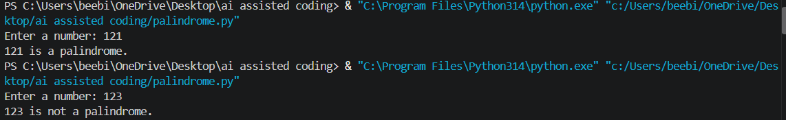
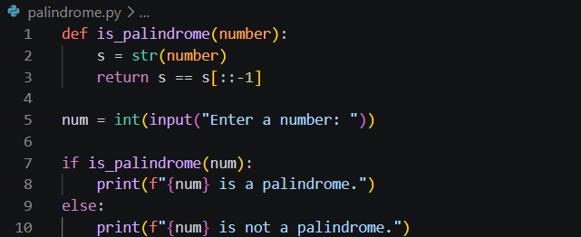
OUTPUT:

Question 2: ONE-Shot Prompting –Factorial Calculation

Write a Python function to calculate the factorial of a given number.
Use this example to understand the expected input and output:
Input: 5
Output: 120
Now generate a complete Python program that asks the user to enter a number and displays its factorial.
AI-Generated Code:
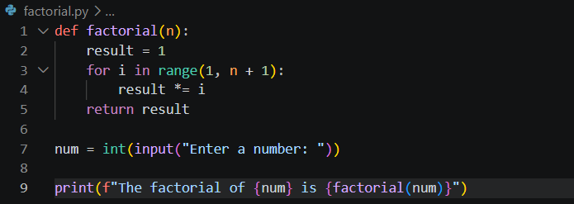

OUTPUT:

Question 3: FEW-Shot Prompting Armstrong Number

Write a Python function to check whether a given number is an Armstrong number.
Use the following examples to understand the expected input and output:
Input: 153
Output: Armstrong Number
Input: 370
Output: Armstrong Number
Input: 123
Output: Not an Armstrong Number
Now generate a complete Python program that asks the user to enter a number and displays whether it is an Armstrong Number or Not an Armstrong Number.

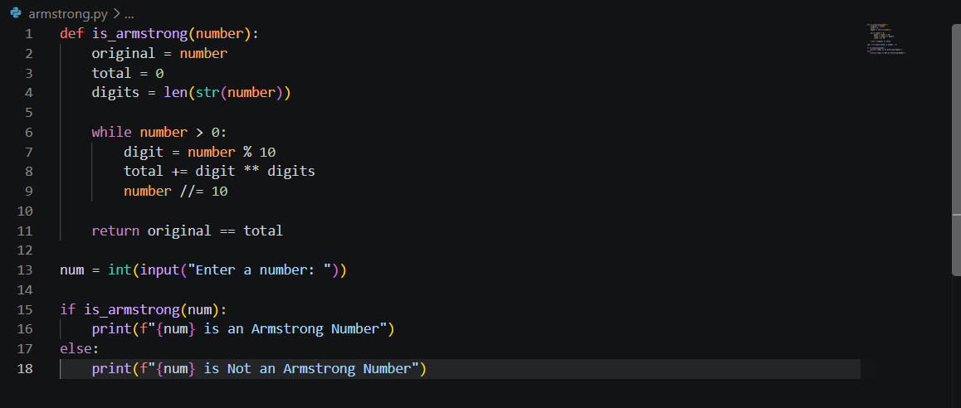
AI-Generated Code:

OUTPUT:
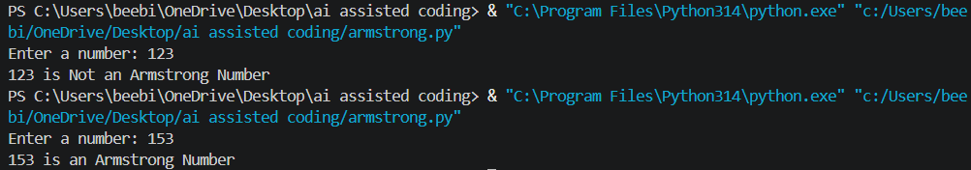

Question 4: ZERO-Shot Prompting Perfect Number

Write a Python function that checks whether a given number is a perfect number.
The function should take a number as input and determine whether it is a perfect number or not.
Also provide a complete Python program that asks the user to enter a number and displays the result.

AI-Generated Code:
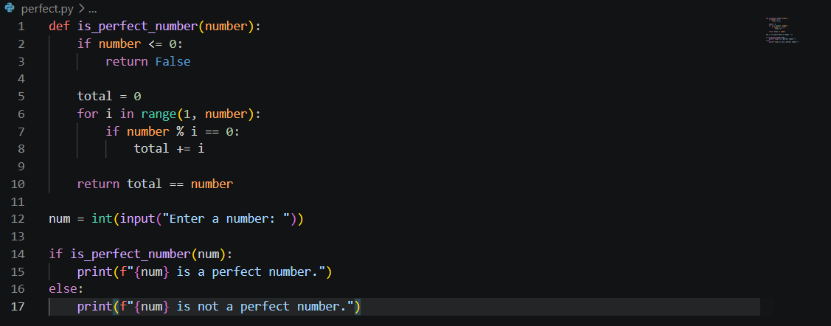

OUTPUT :
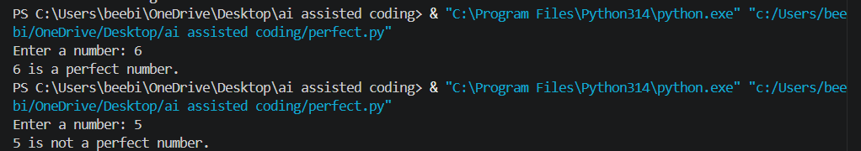
Question 4: FEW-Shot Prompting Even or Odd Calculation with Validation

You are an AI assistant that determines whether a given number is even or odd.

Rules:
1. Accept only valid integers.
2. If the input is not an integer, return "Invalid input".
3. An integer is EVEN if it is divisible by 2.
4. Otherwise, it is ODD.

Examples:

Input: 8
Output: 8 is Even

Input: 15
Output: 15 is Odd

Input: -4
Output: -4 is Even

Input: 7.5
Output: Invalid input

Input: abc
Output: Invalid input

Now process this input:
Input: 24

AI-Generated Code:
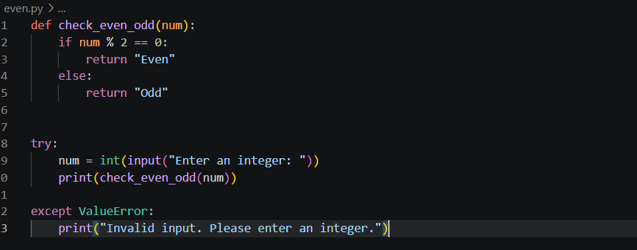

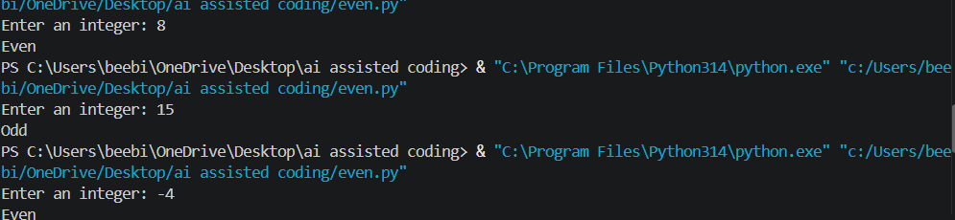
OUTPUT:

