AI ASSISTED CODING
NAME: K.BEEBI FATHIMA
ROLL.NO:2503A52371

Task 1 – Classes: Data Validation
Prompt:
Create a Python Student class with attributes name, roll_no, and marks. Add an is_pass() method that returns True if marks are ≥ 40, otherwise False. Include a constructor, sample input, and output.
CODE:
class Student:
def __init__(self, name, roll_no, marks):
self.name = name
self.roll_no = roll_no
self.marks = marks

def is_pass(self):
return self.marks >= 40

# Creating student objects
student1 = Student("Ali", 101, 75)
student2 = Student("Sara", 102, 35)

print(student1.name, student1.is_pass())
print(student2.name, student2.is_pass())

OUTPUT:

Task 2 – Loops: Pattern Generation

Prompt:
Write Python functions to print a right-angled triangle star pattern using both a for loop and a while loop. Use 5 rows and show the output.

CODE:
#for loop version of the triangle pattern
def triangle_for(n):
for i in range(1, n + 1):
print("*" * i)
triangle_for(5)

#while loop version of the triangle pattern
def triangle_while(n):
i = 1
while i <= n:
print("*" * i)
i += 1

triangle_while(4)
OUTPUT:
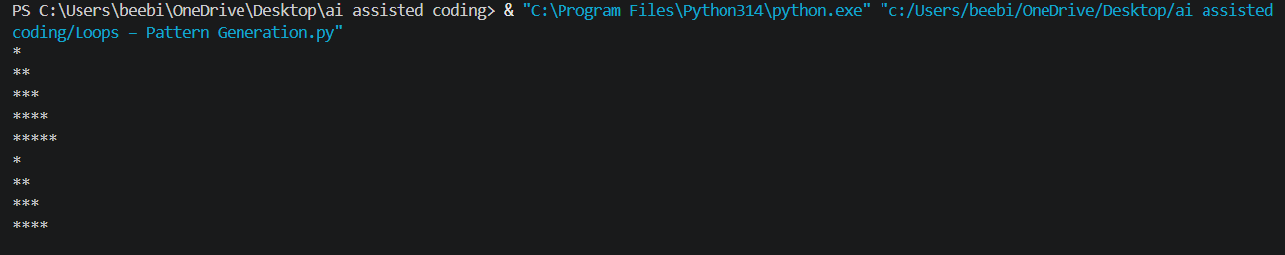

Task 3 – Conditional Statements: Number Analysis
Prompt:
Write a Python function using if-elif-else to check whether a given number is positive, negative, or zero. Test it with multiple numbers and show the output.
CODE:
def check_number(number):
if number > 0:
return "Positive"
elif number < 0:
return "Negative"
else:
return "Zero"

# Testing with multiple inputs
print("10:", check_number(10))
print("-5:", check_number(-5))
print("0:", check_number(0))
print("25:", check_number(25))
print("-12:", check_number(-12))
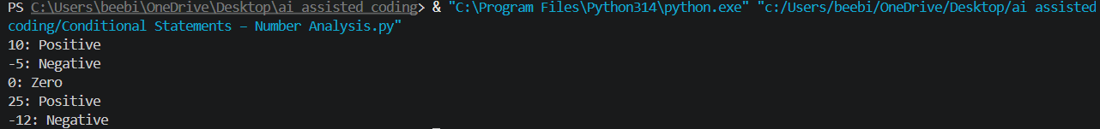
OUTPUT:

Task 4 – Nested Conditionals
Prompt:
Write a Python function check_discount(age, is_member) using nested if statements. Give a senior discount for age ≥ 60 and an additional discount for members. Explain the decision flow and show sample outputs.
CODE:
def check_discount(age, is_member):
if age >= 60:
if is_member:
return "Senior discount + Additional member discount"
else:
return "Senior discount"
else:
if is_member:
return "Additional member discount"
else:
return "No discount"

# Testing with multiple inputs
print("Age: 65, Member: True ->", check_discount(65, True))
print("Age: 65, Member: False ->", check_discount(65, False))
print("Age: 30, Member: True ->", check_discount(30, True))
print("Age: 30, Member: False ->", check_discount(30, False))

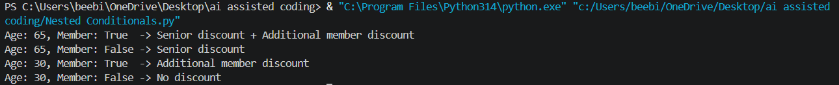
OUTPUT:

Task 5 – Classes: Mathematical Operation
Prompt:
Create a Python Circle class with a radius attribute and methods area() and circumference(). Use π = 3.14, include sample input/output, and briefly explain the code.
CODE:
import math

class Circle:
def __init__(self, radius):
self.radius = radius

def area(self):
return math.pi * self.radius ** 2

def circumference(self):
return 2 * math.pi * self.radius

# Creating Circle objects
circle1 = Circle(5)
circle2 = Circle(10)

# Displaying results
print("Circle 1")
print("Radius:", circle1.radius)
print("Area:", round(circle1.area(), 2))
print("Circumference:", round(circle1.circumference(), 2))

print("\nCircle 2")
print("Radius:", circle2.radius)
print("Area:", round(circle2.area(), 2))
print("Circumference:", round(circle2.circumference(), 2))

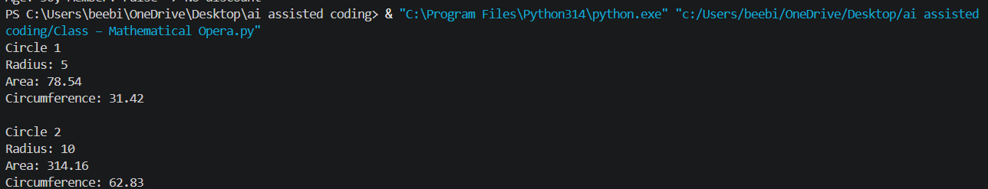
OUTPUT:

