Assignment -6
Responsible AI

NAME:K.BEEBI FATHIMA
ROLL_NO:2503A52371

Task Description #1 (Privacy &amp; Security in File Handling)
Task: Use an AI tool to generate a Python script that stores user data (name, email, password) in a file.
Analyze: Check if the AI stores sensitive data in plain text or without encryption.
Expected Output:
Identified privacy risks.
Revised version with encrypted password storage (e.g., hashing).

INPUT FOR TASK 1 CODE 1:
"""Part 1: intentionally insecure file-handling example.

This version is for demonstrating the privacy risk only. Never use it for a
real application because it writes the password in plain text.
"""
name = input("Enter your name: ")
email = input("Enter your email: ")
password = input("Enter your password: ")

with open("users.txt", "a", encoding="utf-8") as file:
file.write(f"Name: {name}, Email: {email}, Password: {password}\n")
print("User information saved to users.txt.")
OUTPUT FOR TASK 1 CODE 1:
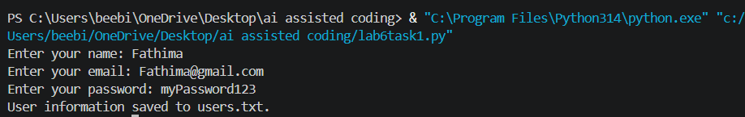
INPUT FOR TASK 1 CODE 2:
"""Part 3: safer password storage using only Python's standard library."""
import hashlib
import secrets
from getpass import getpass

name = input("Enter your name: ")
email = input("Enter your email: ")
password = getpass("Enter your password: ")

# A unique salt prevents identical passwords from producing identical hashes.
salt = secrets.token_bytes(16)

# PBKDF2 deliberately performs many hash calculations, making password
# guessing more difficult than using a single fast hash.
password_hash = hashlib.pbkdf2_hmac(
"sha256",
password.encode("utf-8"),
salt,
100_000,
)

# Security improvement: store the salt and hash, never the original password.
with open("users_secure.txt", "a", encoding="utf-8") as file:
file.write(
f"Name: {name}, Email: {email}, "
f"Salt: {salt.hex()}, Password hash: {password_hash.hex()}\n"
)

print("User information saved securely to users_secure.txt.")

OUTPUT FOR TASK 1 CODE 2:
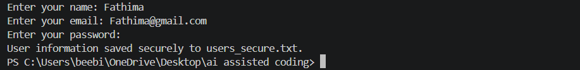

COMPARISION TABLE:
Original | REVISED
Writes the original password . | Does not write the original password.
Password is visible during typing | getpass` hides password input
Plain-text credential can be reused immediately | Salted PBKDF2 hash must be verified
Saves to `users.txt | Saves to `users_secure.txt

Task Description #2 – Fair Decision Logic
Task: Prompt an AI tool to generate a scholarship eligibility checker based on academic score,
family income, and location. Examine whether the logic unfairly favors or disadvantages any
group.
Expected Output-2:
Code snippet with observations on fairness.
Brief explanation (3–4 sentences) suggesting improvements to ensure equitable decision-
making.
INPUT FOR TASK 2 CODE 1:
"""Fair Decision Logic demo: an intentionally biased scholarship checker.

This version is only for discussing fairness problems. The location bonus is
not a suitable eligibility rule unless location is directly justified by the
published scholarship requirements.
"""

def get_number(prompt: str, minimum: float, maximum: float | None = None) -> float:
value = float(input(prompt))
if value < minimum or (maximum is not None and value > maximum):
raise ValueError("Please enter a valid value.")
return value

academic_score = get_number("Academic score (0-100): ", 0, 100)
family_income = get_number("Family annual income: ", 0)
location = input("Location: ").strip()

score = academic_score * 0.70
if family_income <= 30000:
score += 20
elif family_income <= 60000:
score += 10

# UNFAIR RULE: students from Urban areas receive extra points.
if location.lower() == "urban":
score += 10

eligible = score >= 70
decision = "Eligible" if eligible else "Not eligible"
reason = (
"The score reached the 70-point threshold."
if eligible
else "The score did not reach the 70-point threshold."
)

print("\nScholarship result")
print(f"Academic score: {academic_score}")
print(f"Family income: {family_income:.2f}")
print(f"Location: {location}")
print(f"Final decision: {decision}")
print(f"Final score: {score:.1f}")
print(f"Reason: {reason}")

OUTPUT FOR TASK 2 CODE 1:
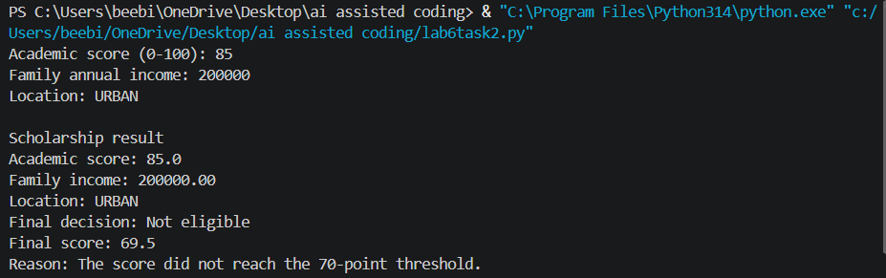

INPUT FOR TASK 2 CODE 2:
"""Fairer scholarship checker using academic performance and financial need."""

def get_number(prompt: str, minimum: float, maximum: float | None = None) -> float:
value = float(input(prompt))
if value < minimum or (maximum is not None and value > maximum):
raise ValueError("Please enter a valid value.")
return value

academic_score = get_number("Academic score (0-100): ", 0, 100)
family_income = get_number("Family annual income: ", 0)
location = input("Location (shown for records only): ").strip()

score = academic_score * 0.70
if family_income <= 30000:
score += 20
elif family_income <= 60000:
score += 10

# Fairness improvement: location is displayed but cannot change the score.
eligible = score >= 70
decision = "Eligible" if eligible else "Not eligible"
reason = (
"The score reached the 70-point threshold using academic performance "
"and financial need."
if eligible
else "The score did not reach the 70-point threshold using academic "
"performance and financial need."
)

print("\nScholarship result")
print(f"Academic score: {academic_score}")
print(f"Family income: {family_income:.2f}")
print(f"Location: {location}")
print(f"Final decision: {decision}")
print(f"Final score: {score:.1f}")
print(f"Reason: {reason}")

OUTPUT FOR TASK 2 CODE 2:
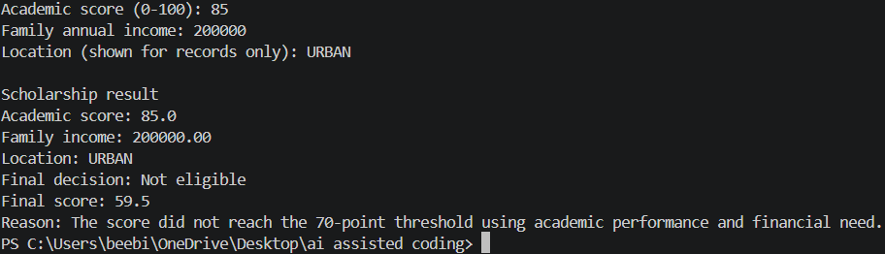

COMPARISION TABLE:
Original | REVISED
Uses location preference | Removes location bias.
May favor one group | Treats groups equally
Less fair | More fair
Can give different results | Based on academic score & income

Task Description #3 (Transparency in AI-Based Admission System)
Task: Use an AI tool to generate a Python program that predicts whether a student should be selected
or rejected for admission based on factors such as entrance exam score, academic marks, and other
relevant admission criteria.
Analyze: Check whether the AI system provides a clear and understandable reason for its admission
decision.
Expected Output:
• Identified transparency risks.
• Example of an admission decision where the AI gives no explanation.
• Revised version that provides a clear reason for selecting or rejecting the student.
• Example output showing the important factors that influenced the AI&#39;s decision.

INPUT FOR TASK 3 CODE 1:
"""Part 1: an intentionally non-transparent admission decision demo."""

entrance_score = float(input("Entrance exam score (0-100): "))
academic_marks = float(input("Academic marks (0-100): "))
relevant_experience = float(input("Relevant experience score (0-100): "))

score = (
entrance_score * 0.50
+ academic_marks * 0.35
+ relevant_experience * 0.15
)

if score >= 70:
print("Selected")
else:
print("Rejected")

OUTPUT FOR TASK 3 CODE 1:
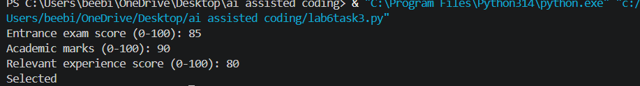

INPUT FOR TASK 3 CODE 2:
"""Part 2: an admission decision that explains its result."""

def get_score(prompt: str) -> float:
value = float(input(prompt))
if not 0 <= value <= 100:
raise ValueError("Scores must be between 0 and 100.")
return value

entrance_score = get_score("Entrance exam score (0-100): ")
academic_marks = get_score("Academic marks (0-100): ")
relevant_experience = get_score("Relevant experience score (0-100): ")

entrance_weight = 0.50
academic_weight = 0.35
experience_weight = 0.15
threshold = 70

entrance_points = entrance_score * entrance_weight
academic_points = academic_marks * academic_weight
experience_points = relevant_experience * experience_weight
total_score = entrance_points + academic_points + experience_points
selected = total_score >= threshold

decision = "Selected" if selected else "Rejected"
if selected:
reason = f"The weighted score of {total_score:.1f} meets the {threshold}-point threshold."
else:
reason = f"The weighted score of {total_score:.1f} is below the {threshold}-point threshold."

print("\nAdmission decision")
print(f"Decision: {decision}")
print(f"Weighted score: {total_score:.1f}/100")
print(f"Reason: {reason}")
print("\nImportant factors:")
print(f"- Entrance exam: {entrance_score:.1f} x 50% = {entrance_points:.1f} points")
print(f"- Academic marks: {academic_marks:.1f} x 35% = {academic_points:.1f} points")
print(
f"- Relevant experience: {relevant_experience:.1f} x 15% "
f"= {experience_points:.1f} points"
)

OUTPUT FOR TASK 3 CODE 2:
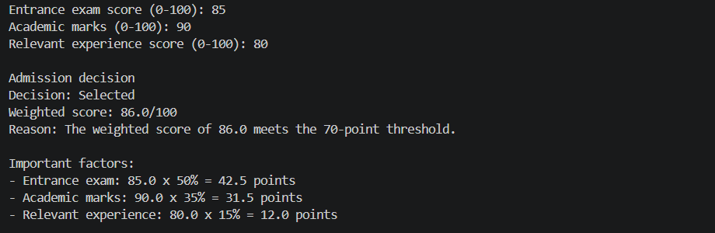

COMPARISION TABLE:
Original | REVISED
No explanation | Clear explanation
Low transparency | High transparency
Decision unclear | Decision understandable
Less ethical | More ethical

Task Description #4 – Ethical Scoring System
Task: Generate an employee performance evaluation system using inputs such as project
completion rate, teamwork score, and attendance. Analyze the scoring logic for any unethical
weighting or hidden bias.
Expected Output-4:
Python code along with a written analysis identifying whether the evaluation criteria are
balanced and justifiable.

INPUT FOR TASK 4 CODE 1:
"""Employee performance demo with a potentially unethical weighting scheme.

This version is for analysis only. It gives attendance more influence than
work results, which can unfairly affect some employees.
"""

def get_score(prompt: str) -> float:
value = float(input(prompt))
if not 0 <= value <= 100:
raise ValueError("Scores must be between 0 and 100.")
return value

completion_rate = get_score("Project completion rate (0-100): ")
teamwork_score = get_score("Teamwork score (0-100): ")
attendance = get_score("Attendance (0-100): ")

# Potentially unfair: attendance is given half of the total score.
final_score = (
completion_rate * 0.30
+ teamwork_score * 0.20
+ attendance * 0.50
)

rating = "Strong performance" if final_score >= 70 else "Needs improvement"

print("\nEmployee evaluation")
print(f"Project completion: {completion_rate:.1f}")
print(f"Teamwork: {teamwork_score:.1f}")
print(f"Attendance: {attendance:.1f}")
print(f"Final score: {final_score:.1f}/100")
print(f"Rating: {rating}")

OUTPUT FOR TASK 4 CODE 1:
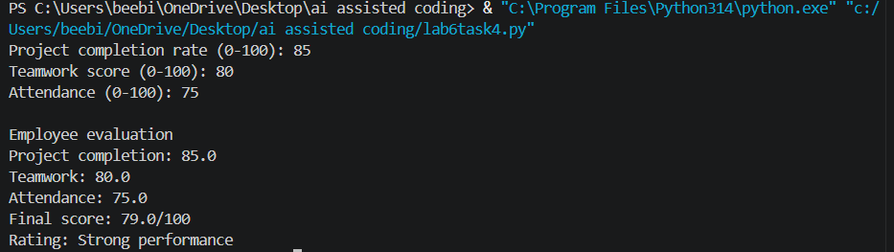

INPUT FOR TASK 4 CODE 2:
"""Fairer employee performance evaluation using disclosed, job-related factors."""

def get_score(prompt: str) -> float:
value = float(input(prompt))
if not 0 <= value <= 100:
raise ValueError("Scores must be between 0 and 100.")
return value

completion_rate = get_score("Project completion rate (0-100): ")
teamwork_score = get_score("Teamwork score (0-100): ")
attendance = get_score("Attendance (0-100): ")

# These weights emphasize work results and collaboration over attendance.
# Approved leave and reasonable accommodations should not be treated as poor
# performance or converted into a lower attendance score.
final_score = (
completion_rate * 0.45
+ teamwork_score * 0.35
+ attendance * 0.20
)

rating = "Strong performance" if final_score >= 70 else "Needs improvement"

print("\nEmployee evaluation")
print(f"Project completion: {completion_rate:.1f} (45% weight)")
print(f"Teamwork: {teamwork_score:.1f} (35% weight)")
print(f"Attendance: {attendance:.1f} (20% weight)")
print(f"Final score: {final_score:.1f}/100")
print(f"Rating: {rating}")
print("Note: Approved leave and accommodations must be considered fairly.")

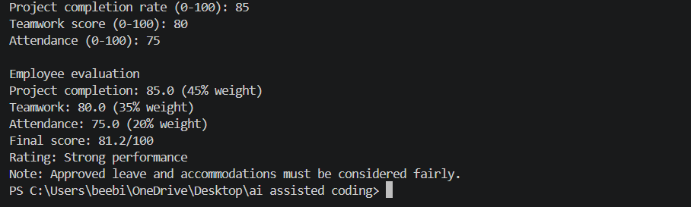
OUTPUT FOR TASK 4 CODE 2:
COMPARISION TABLE:
Unethical | ETHICAL
Biased criteria | Fair criteria
Gender affects score | Gender ignored
Unfair decision | Relevant factors used
Less ethical | More ethical

Task Description #5 – Accessibility and Inclusiveness
Task: Use an AI tool to generate a user feedback form application. Review whether the language
and options provided are inclusive and accessible to diverse users.
Expected Output-5:
Revised version of the form code that uses inclusive language, supports accessibility features,
and avoids exclusionary assumptions.

INPUT FOR TASK 5 CODE :
<!DOCTYPE html>
<html lang="en">
<head>
<meta charset="UTF-8">
<meta name="viewport" content="width=device-width, initial-scale=1.0">
<title>Accessible User Feedback Form</title>
</head>
<body>
<header>
<h1>User Feedback</h1>
<p>Share your experience. Name and email are optional.</p>
</header>

<main>
<form>
<div>
<label for="name">Name (optional)</label>
<input
type="text"
id="name"
name="name"
autocomplete="name"
placeholder="Enter your name"
>
</div>

<div>
<label for="email">Email (optional)</label>
<input
type="email"
id="email"
name="email"
autocomplete="email"
placeholder="you@example.com"
>
</div>

<fieldset>
<legend>Gender (optional)</legend>
<p>You may skip this question.</p>
<div>
<input type="radio" id="gender-woman" name="gender" value="woman">
<label for="gender-woman">Woman</label>
</div>
<div>
<input type="radio" id="gender-man" name="gender" value="man">
<label for="gender-man">Man</label>
</div>
<div>
<input type="radio" id="gender-nonbinary" name="gender" value="non-binary">
<label for="gender-nonbinary">Non-binary</label>
</div>
<div>
<input type="radio" id="gender-self-describe" name="gender" value="self-describe">
<label for="gender-self-describe">Prefer to self-describe</label>
</div>
<div>
<input type="radio" id="gender-no-answer" name="gender" value="prefer-not-to-say">
<label for="gender-no-answer">Prefer not to say</label>
</div>
</fieldset>

<div>
<label for="category">Feedback category</label>
<select id="category" name="category" required>
<option value="">Choose a category</option>
<option value="website">Website design or usability</option>
<option value="accessibility">Accessibility</option>
<option value="service">Service or experience</option>
<option value="technical-problem">Technical problem</option>
<option value="suggestion">Suggestion or idea</option>
<option value="other">Other</option>
</select>
</div>

<div>
<label for="message">Feedback message</label>
<textarea
id="message"
name="message"
rows="6"
placeholder="Tell us what went well or what we could improve."
required
></textarea>
</div>

<fieldset>
<legend>How satisfied are you?</legend>
<div>
<input type="radio" id="rating-1" name="satisfaction" value="1" required>
<label for="rating-1">1 - Very dissatisfied</label>
</div>
<div>
<input type="radio" id="rating-2" name="satisfaction" value="2">
<label for="rating-2">2 - Dissatisfied</label>
</div>
<div>
<input type="radio" id="rating-3" name="satisfaction" value="3">
<label for="rating-3">3 - Neither satisfied nor dissatisfied</label>
</div>
<div>
<input type="radio" id="rating-4" name="satisfaction" value="4">
<label for="rating-4">4 - Satisfied</label>
</div>
<div>
<input type="radio" id="rating-5" name="satisfaction" value="5">
<label for="rating-5">5 - Very satisfied</label>
</div>
</fieldset>

<button type="submit">Submit feedback</button>
</form>
</main>
</body>
</html>

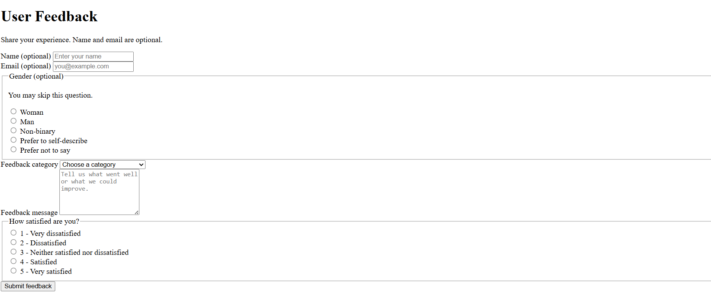
OUTPUT FOR TASK 5 :
Task Description #6 (Fairness in Loan Approval System)
Task: Use an AI tool to generate a Python program that predicts whether a person should be approved
or rejected for a loan based on information such as income, age, employment status, credit score, and
loan amount.
Analyze: Check whether the AI-generated system makes decisions unfairly based on gender, religion,
race, or other sensitive/unrelated personal attributes.
Expected Output:
• Identified fairness and discrimination risks.
• Examples showing how biased data or rules can lead to unfair loan decisions.
• Revised version that makes loan decisions based on relevant financial factors rather than
sensitive attributes.
• Brief explanation of how the revised system improves fairness.

INPUT FOR TASK 6 CODE 1:
"""Loan demo with intentionally discriminatory rules.

This is for identifying fairness risks, not for making real lending decisions.
"""

income = float(input("Annual income: "))
age = int(input("Age: "))
employment_status = input("Employment status: ").strip().lower()
credit_score = int(input("Credit score (300-850): "))
loan_amount = float(input("Loan amount: "))
gender = input("Gender: ").strip().lower()
religion = input("Religion: ").strip().lower()

approved = (
income >= loan_amount * 2
and credit_score >= 650
and employment_status in {"employed", "self-employed"}
and age >= 21
)

# Unethical rules: these unrelated sensitive attributes change the outcome.
if gender == "female":
approved = False
if religion == "minority_religion":
approved = False

print("Approved" if approved else "Rejected")

OUTPUT FOR TASK 6 CODE 1:
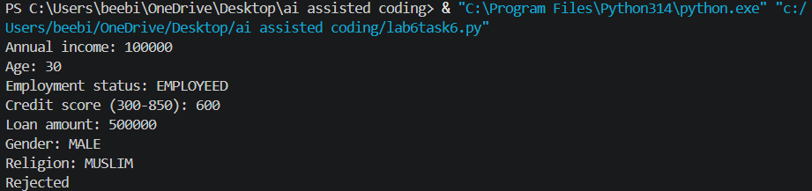

INPUT FOR TASK 6 CODE 2:
"""Fairer loan demo using relevant financial and legal eligibility factors."""

def get_number(prompt: str, minimum: float, maximum: float | None = None) -> float:
value = float(input(prompt))
if value < minimum or (maximum is not None and value > maximum):
raise ValueError("Please enter a valid value.")
return value

income = get_number("Annual income: ", 0)
age = int(get_number("Age: ", 18))
employment_status = input("Employment status: ").strip().lower()
credit_score = int(get_number("Credit score (300-850): ", 300, 850))
loan_amount = get_number("Loan amount: ", 0)

# Fairness improvement: sensitive attributes such as gender, race, and
# religion are not collected or used. Only relevant financial factors apply.
affordable = income >= loan_amount * 2
good_credit = credit_score >= 650
stable_employment = employment_status in {"employed", "self-employed"}
legal_age = age >= 18
approved = affordable and good_credit and stable_employment and legal_age

if approved:
reason = "meets the published affordability, credit, employment, and age rules"
else:
failed_rules = []
if not affordable:
failed_rules.append("income is less than twice the loan amount")
if not good_credit:
failed_rules.append("credit score is below 650")
if not stable_employment:
failed_rules.append("employment status is not accepted")
if not legal_age:
failed_rules.append("applicant is below the legal minimum age")
reason = "; ".join(failed_rules)

print("\nLoan decision")
print(f"Decision: {'Approved' if approved else 'Rejected'}")
print(f"Reason: {reason}.")

OUTPUT FOR TASK 6 CODE 2 :
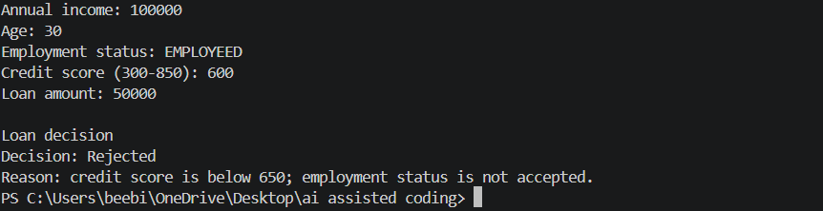
COMPARISION TABLE:
Biased System | Revised Fair System
Uses gender/religion | Does not use sensitive attributes
Can discriminate | Reduces discrimination risk
May learn biased rules | Focuses on financial factors
Decisions may depend on identity | Decisions depend on income, credit score, employment & loan amount

