Documentation Generation – Automatic Documentation and Code Comments

NAME:K.BEEBI FATHIMA
ENROLL_NO:2503A52371

Aim / Objective
To understand automatic documentation generation and learn how to create documentation for Python programs using Docstrings, Inline Comments, and Google-Style Documentation. To compare the three approaches and identify the most effective documentation style for a mathematical utilities library.

1](a) Docstring
A docstring is a documentation string written immediately after the function definition. It describes the purpose and functionality of the function.

CODE:
def find_max(numbers):
"""
Finds the maximum value from a list of numbers.
Parameters:
numbers: A list of numerical values.
Returns:
The maximum value present in the list.
"""
return max(numbers)
numbers = [10, 25, 5, 40, 15]
print("Maximum value:", find_max(numbers))
OUTPUT:

(b) Inline Comments
Inline comments are written inside the program using the # symbol. They explain specific statements and operations performed by the program.
CODE:
def find_max(numbers):
# Find the largest number in the given list
result = max(numbers)
# Return the maximum value
return result
numbers = [10, 25, 5, 40, 15]
print("Maximum value:", find_max(numbers))
OUTPUT:
(c) Google-Style Documentation
Google-style documentation follows a structured format. It describes the function, arguments, return values, and possible exceptions.

CODE:
def find_max(numbers):
"""Finds the maximum value from a list of numbers.

Args:
numbers (list): A list of numerical values.

Returns:
int or float: The maximum value in the list.

Raises:
ValueError: If the input list is empty.
"""
return max(numbers)

numbers = [10, 25, 5, 40, 15]
print("Maximum value:", find_max(numbers))
OUTPUT:
2] (a) Docstring
A docstring is a documentation string written immediately after the function definition. It explains the purpose of the function, its parameters, and its return value.
CODE:
def login(user, password, credentials):
"""
Verifies the login details of a user.

Parameters:
user: The username entered by the user.
password: The password entered by the user.
credentials: A dictionary containing usernames and passwords.
Returns:
True if the username and password match.
False otherwise.
"""
return credentials.get(user) == password
credentials = {
"admin": "admin123",
"student": "student123"
}
print(login("admin", "admin123", credentials))
OUTPUT:
(b) Inline Comments
Inline comments are written inside the program using the # symbol. They explain individual statements and operations.
CODE:
def login(user, password, credentials):
# Get the stored password for the given username
stored_password = credentials.get(user)
# Compare the stored password with the entered password
result = stored_password == password
# Return True if credentials match, otherwise False
return result
credentials = {
"admin": "admin123",
"student": "student123"
}
print(login("admin", "admin123", credentials))
OUTPUT:
(c) Google-Style Documentation
Google-style documentation follows a structured format. It describes the function, its arguments, return values, and possible exceptions.
CODE:
def login(user, password, credentials):
"""Verifies the login credentials of a user.

Args:
user (str): The username entered by the user.
password (str): The password entered by the user.
credentials (dict): A dictionary containing
usernames and their corresponding passwords.

Returns:
bool: True if the credentials match,
otherwise False.
"""
return credentials.get(user) == password
credentials = {
"admin": "admin123",
"student": "student123"
}
print(login("admin", "admin123", credentials))
OUTPUT:
3]CODE:
Step 1: Create the Python Module
Create a Python file named calculator.py and write the following code.
"""
Calculator Module
This module provides basic arithmetic operations
such as addition, subtraction, multiplication,
and division.
"""
def add(a, b):
"""Add two numbers.
Args:
a (int or float): First number.
b (int or float): Second number.
Returns:
int or float: Sum of the two numbers.
"""
return a + b
def subtract(a, b):
"""Subtract the second number from the first.
Args:
a (int or float): First number.
b (int or float): Second number.
Returns:
int or float: Difference between the two numbers.
"""
return a - b
def multiply(a, b):
"""Multiply two numbers.
Args:
a (int or float): First number.
b (int or float): Second number.
Returns:
int or float: Product of the two numbers.
"""
return a * b
def divide(a, b):
"""Divide the first number by the second.
Args:
a (int or float): First number.
b (int or float): Second number.
Returns:
float: Quotient of the two numbers.
Raises:
ZeroDivisionError: If the second number is zero.

"""
return a / b
OUTPUT: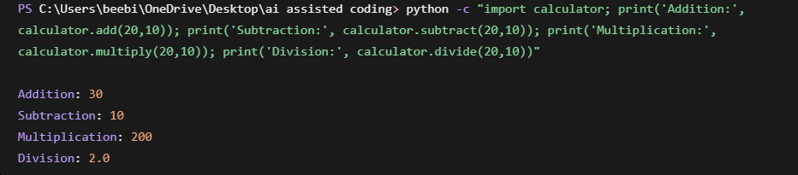
Step 2: Execute the Python Module
Create another Python file or use the Python terminal to execute the calculator functions.
import calculator

print("Addition:", calculator.add(20, 10))
print("Subtraction:", calculator.subtract(20, 10))
print("Multiplication:", calculator.multiply(20, 10))
print("Division:", calculator.divide(20, 10))

Step 3: Display Documentation in the Terminal
Use Python's built-in help() function to display the documentation of the calculator module.
Command:
python -c "import calculator; help(calculator)"
To display documentation for individual functions, use:
python -c "import calculator; help(calculator.add)"
python -c "import calculator; help(calculator.subtract)"
python -c "import calculator; help(calculator.multiply)"
python -c "import calculator; help(calculator.divide)"

OUTPUT:
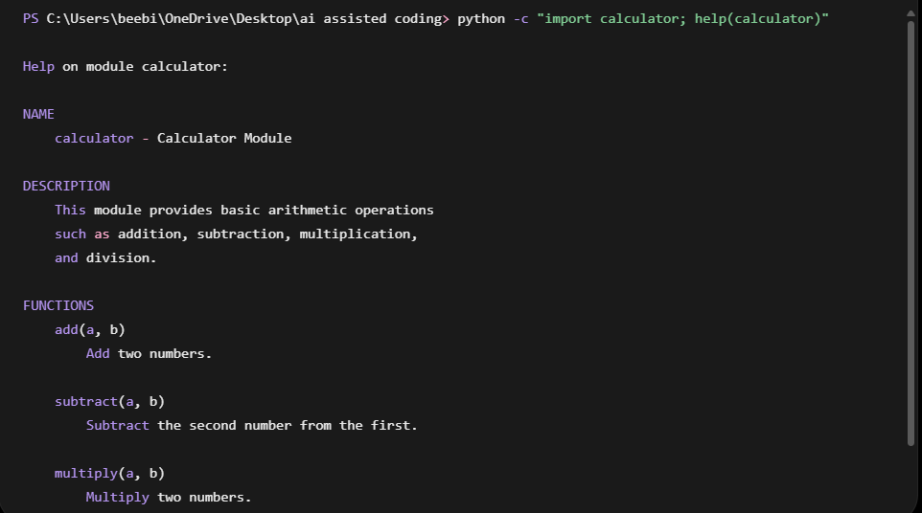
Step 4: Generate HTML Documentation Using pydoc
Open the terminal in the folder containing calculator.py and execute the following command:
python -m pydoc -w calculator
OUTPUT:
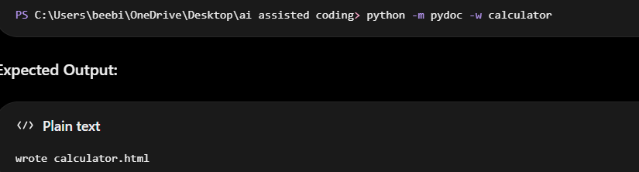
Step 5: Open the Generated HTML File
Use the following command to open the generated documentation in the default web browser:
start calculator.html
OUTPUT:


