Code Review and Quality: Using AI to Improve Code Quality and Readability

NAME:S.MANIDEEPTHI
ROLL.NO:2503A52388
Task Description #1 – Syntax and Logic Errors
Task: Use AI to identify and fix syntax and logic errors in a faulty
Python script.
Sample Input Code:
# Calculate average score of a student
def calc_average(marks):

Week5 -
Monday

total = 0
for m in marks:
total += m
average = total / len(marks)
return avrage # Typo here
marks = [85, 90, 78, 92]
print(&quot;Average Score is &quot;, calc_average(marks)
Expected Output:
Corrected and runnable Python code with explanations of the
fixes.
PROMPT:
Review this Python code, find syntax and logic errors, fix them, and give the corrected code with a short explanation.
INPUT CODE:
# Calculate average score of a student
def calc_average(marks):
total = 0
for m in marks:
total += m

average = total / len(marks)
return average

marks = [85, 90, 78, 92]
print("Average Score is", calc_average(marks))
OUTPUT:
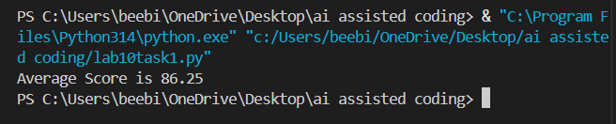
Task Description #2 – PEP 8 Compliance
Task: Use AI to refactor Python code to follow PEP 8 style
guidelines.
Sample Input Code:
def area_of_rect(L,B) : return L*B
print(area_of_rect(10,20))
Expected Output:
Well-formatted PEP 8-compliant Python code.
PROMPT:
Refactor this Python code according to PEP 8 guidelines. Improve spacing, formatting, and readability without changing the logic.
INPUT CODE:
def area_of_rect(length, breadth):
return length * breadth

print(area_of_rect(10, 20))
OUTPUT:
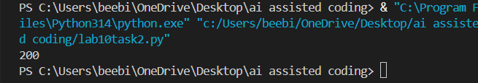
Task Description #3 – Readability Enhancement
Task: Use AI to make code more readable without changing its
logic.
Sample Input Code:
def c(x,y):
return x*y/100
a=200
b=15
print(c(a,b))
Expected Output:
Python code with descriptive variable names, inline

comments, and clear formatting.
PROMPT:
Make this Python code more readable without changing its logic. Use descriptive variable names, clear formatting, and comments.
INPUT CODE:
def calculate_percentage(value, percentage):
# Calculate the given percentage of a value
return value * percentage / 100

amount = 200
percentage = 15

print(calculate_percentage(amount, percentage))
OUTPUT:
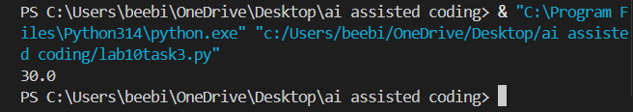
Task Description #4 – Refactoring for Maintainability
Task: Use AI to break repetitive or long code into reusable
functions.
Sample Input Code:
students = [&quot;Alice&quot;, &quot;Bob&quot;, &quot;Charlie&quot;]
print(&quot;Welcome&quot;, students[0])
print(&quot;Welcome&quot;, students[1])
print(&quot;Welcome&quot;, students[2])
Expected Output:
Modular code with reusable functions.
PROMPT:
Refactor this Python code by removing repetition and creating a reusable function. Keep the same output.
INPUT CODE:
students = ["Alice", "Bob", "Charlie"]

def welcome_student(name):
print("Welcome", name)

for student in students:
welcome_student(student)
OUTPUT:
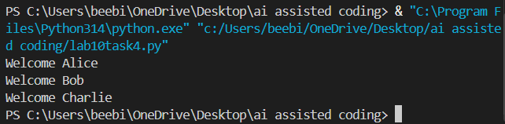
Task Description #5 – Performance Optimization
Task: Use AI to make the code run faster.
Sample Input Code:
# Find squares of numbers
nums = [i for i in range(1,1000000)]
squares = []

for n in nums:
squares.append(n**2)
print(len(squares))
Expected Output:
Optimized code using list comprehensions or vectorized
operations.
PROMPT:
Optimize this Python code for better performance and readability. Use an efficient list comprehension while keeping the same result.
INPUT CODE:
# Find squares of numbers
nums = range(1, 1000000)

squares = [n ** 2 for n in nums]

print(len(squares))
OUTPUT:
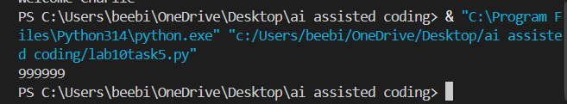
Task Description #6 – Complexity Reduction
Task: Use AI to simplify overly complex logic.
Sample Input Code:
def grade(score):
if score &gt;= 90:
return &quot;A&quot;
else:
if score &gt;= 80:
return &quot;B&quot;
else:
if score &gt;= 70:
return &quot;C&quot;
else:
if score &gt;= 60:
return &quot;D&quot;
else:
return &quot;F&quot;
Expected Output:
Cleaner logic using elif or dictionary mapping.
PROMPT:
Simplify this complex nested Python logic using elif statements. Keep the same grading logic and output.
INPUT CODE:
def grade(score):
if score >= 90:
return "A"
elif score >= 80:
return "B"
elif score >= 70:
return "C"
elif score >= 60:
return "D"
else:
return "F"
print(grade(85))
OUTPUT:
