**LONELINESS STUDY**

**Effect of gender and social media usage on loneliness in college students.**

[NAME]

[DEPARTMET, UNIVERSITY]

[COURSE CODE: COURSE NAME]

[PROFESSOR NAME]

[ASSIGNMENT DUE DATE]

**LONELINESS STUDY**

**Effect of gender and social media usage on loneliness in college students.**

1. **Before opening the data, what would you hypothesize about this research study?**

***H1: Students with high social media usage will report higher loneliness scores compared to those with moderate or low usage.***

***H2: There may be gender differences in reported loneliness, with females potentially scoring higher.***

***H3: The impact of social media usage on loneliness may differ by gender.***

1. **Conduct descriptive analyses (mean, Standard deviation) and report them here. What would you interpret based on the Mean values?**

|  |  |  |
| --- | --- | --- |
| Social Media Use | Gender | M (SD) |
| Low | Male | 26.0 (5.27) |
| Low | Female | 34.5 (5.56) |
| Moderate | Male | 42.1 (7.20) |
| Moderate | Female | 49.9 (7.36) |
| High | Male | 63.2 (4.16) |
| High | Female | 69.9 (5.38) |

Table 1. Descriptive statistics

***Trend Across Social Media Use: As social media use increases (from low to high), so does loneliness — for both males and females.***

***Comparison on Gender: At each level of social media use, males tend to report slightly higher loneliness than females.***

1. **Conduct a Two-Way ANOVA. Report your statistical findings (including any applicable tables or figures in APA format).**

|  |  |  |  |  |  |
| --- | --- | --- | --- | --- | --- |
| **Two-Way ANOVA** | | | | | |
| Dependent Variable: lonliness | | | | | |
| Source | Type III Sum of Squares | df | Mean Square | F | Sig. |
| Corrected Model | 14143.600a | 5 | 2828.720 | 80.446 | <.001 |
| Intercept | 135945.600 | 1 | 135945.600 | 3866.159 | <.001 |
| SocialmediaUse | 13253.700 | 2 | 6626.850 | 188.461 | <.001 |
| Gender | 881.667 | 1 | 881.667 | 25.074 | <.001 |
| SocialmediaUse * Gender | 8.233 | 2 | 4.117 | .117 | .890 |
| Error | 1898.800 | 54 | 35.163 |  |  |
| Total | 151988.000 | 60 |  |  |  |
| Corrected Total | 16042.400 | 59 |  |  |  |
| a. R Squared = .882 (Adjusted R Squared = .871) | | | | | |

1. **Are there any significant main effects?**

* ***Gender: Significant main effect (p < .001) Women report significantly higher loneliness.***
* ***Main effect of Social Media Usage: Highly significant — social media use level has a strong effect on loneliness.***

1. **Is the interaction effect significant?**

***Interaction effect (Gender × Social Media Use): Not significant (p > .001) The effect of social media usage on loneliness does not differ significantly by gender.***

1. **What would you conclude from this analysis? Is your hypothesis supported?**

***Conclusion:***

***Our hypothesis that both gender and social media use influence loneliness is supported.***

***The interaction effect is not supported, suggesting that while both gender and social media use affect loneliness independently, their effects do not increase or decrease each other in combination.***

1. **What would be your next steps, if this were your research project? What follow up tests will you conduct? What would the follow up tests indicate?**

**Next step:**

***Regression modeling to examine the predictive strength and effect sizes.***

**Follow up test:  
*Conduct post-hoc tests (Tukey HSD).***

***Since social media usage has three levels, I would conduct post-hoc tests to determine which specific pairs of social media usage groups differ significantly in loneliness scores.***

1. **Create a boxplot to show the interaction effect between gender and social media usage on loneliness.**

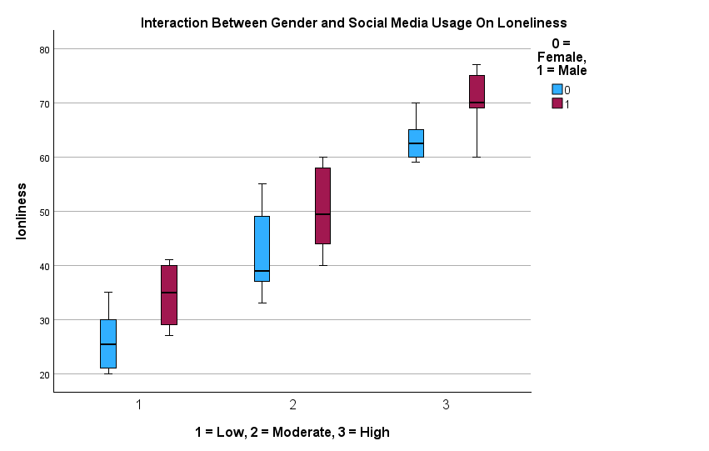

Figure 1. Boxplot showing the interaction between gender and social media usage on loneliness.

***The boxplot illustrates:***

***A clear increase in loneliness scores from low → moderate → high social media usage.***

***Male students show slightly higher loneliness scores at each level compared to females.***

***The spread (variation) of loneliness is higher in the moderate use group.***

***Again, this aligns with the ANOVA results — strong main effects for both gender and usage, but no major interaction pattern.***

**RESULT OF THE ANALYSIS**

A two-way analysis of variance (ANOVA) was conducted to examine the effects of gender and social media usage on loneliness among college students. The independent variables were gender (male, female) and social media usage (low, moderate, high). The dependent variable was the loneliness score, measured using the Revised UCLA Loneliness Scale.

Descriptive statistics was also conducted and from (Table 1) the output indicated that women reported significantly higher loneliness than men across all levels of social media use.

|  |  |  |  |  |  |
| --- | --- | --- | --- | --- | --- |
| **Source** | **SS** | **df** | **MS** | **F** | **p** |
| Social Media Use | 13,253.70 | 2 | 6,626.85 | 188.46 | <.001 |
| Gender | 881.67 | 1 | 881.67 | 25.07 | <.001 |
| Social Media Use × Gender | 8.23 | 2 | 4.12 | 0.12 | .890 |
| Error | 1,898.80 | 54 | 35.16 |  |  |

R² = .882, Adjusted R² = .871  
Table 2. Two Way ANOVA Summary

The ANOVA also revealed a significant main effect of gender, F(1, 54) = 25.07, p < .001, η² = .045, Indicating Gender significantly influenced loneliness levels (Table 2). There was also a significant main effect of social media usage for it had a statistically significant effect on loneliness, F(2, 54) = 188.46, p < .001, η² = .875, Indicating that different levels of social media use significantly affected loneliness (Table 2).

However, the interaction between gender and social media usage was not statistically significant, F(2, 54) = 0.12, p = .89, η² = .002, suggesting that the effect of social media use on loneliness did not differ by gender (Table 2).

A boxplot (Figure 1) also suggests that loneliness increases with social media usage, and women consistently report higher loneliness scores than men across all levels. The roughly parallel lines in the visualization confirm the non-significant interaction effect.

**References**

Huang, C. (2022).  
Associations between social media use and loneliness in a cross-national sample of young adults. Journal of Social and Personal Relationships, 39(12), 3504–3520.  
<https://doi.org/10.1177/02654075221103530>

Yıldırım, M., & Solmaz, F. (2024).  
 A cross-sectional survey of college student loneliness: The role of social media usage and gender. Journal of American College Health, 72(1), 123–131.  
https://doi.org/10.1080/19325037.2024.2396586

**spssanalysis.com.** (n.d.). Two-way ANOVA in SPSS. Retrieved from <https://spssanalysis.com/two-way-anova-in-spss/>