State model

1 Subsystem description
Linear model of the car. Only the bloc which concerns the clutch's command and only for the restart of the ICE.

2 System organization
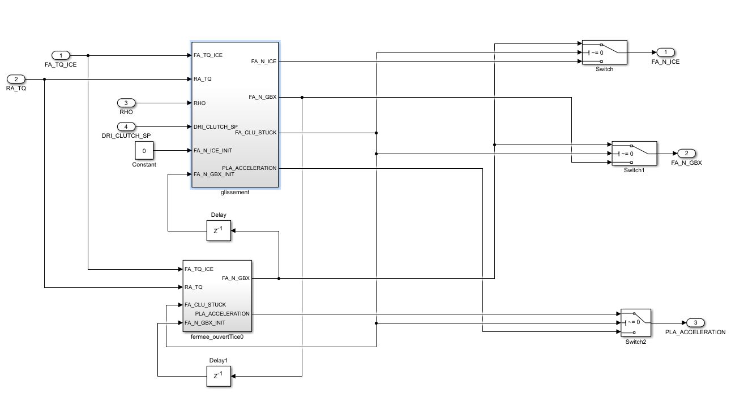
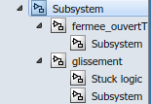

3 Signals and parameters

Inputs

Name | Description | Note
FA_TQ_ICE | Torque to wheel from the front axle
RA_TQ | Torque to wheel from the real axle
RHO | Sensibility
DRI_CLUTCH_SP | Clutch pedal value | Range [0,1]

Outputs
Name | Description | Note
FA_N_ICE | Rotation speed of the ICE | rpm
FA_N_GBX | Rotation speed fo the GBX | rpm
PLA_ACCELERATION | Acceleration of the car

Parameters
Native

Name | Type | Unit | Description | Source | Linked to
B1 | Matrix [2x3] |  | Command  matrix (clutch slipping)
B2 | Matrix [2x3] |  | Command  matrix (clutch slipping)
A | matrix |  | State matrix (clutch slipping)
Bferme1 | Matrix [2x3] |  | Command  matrix (clutch close)
Bferme2 | Matrix [2x3] |  | Command  matrix (clutch close)
Aferme | matrix |  | State matrix (clutch close)

4 Subsystems description

Slipping state:
Calculate the speed of the ICE and the GBX in slipping mode.
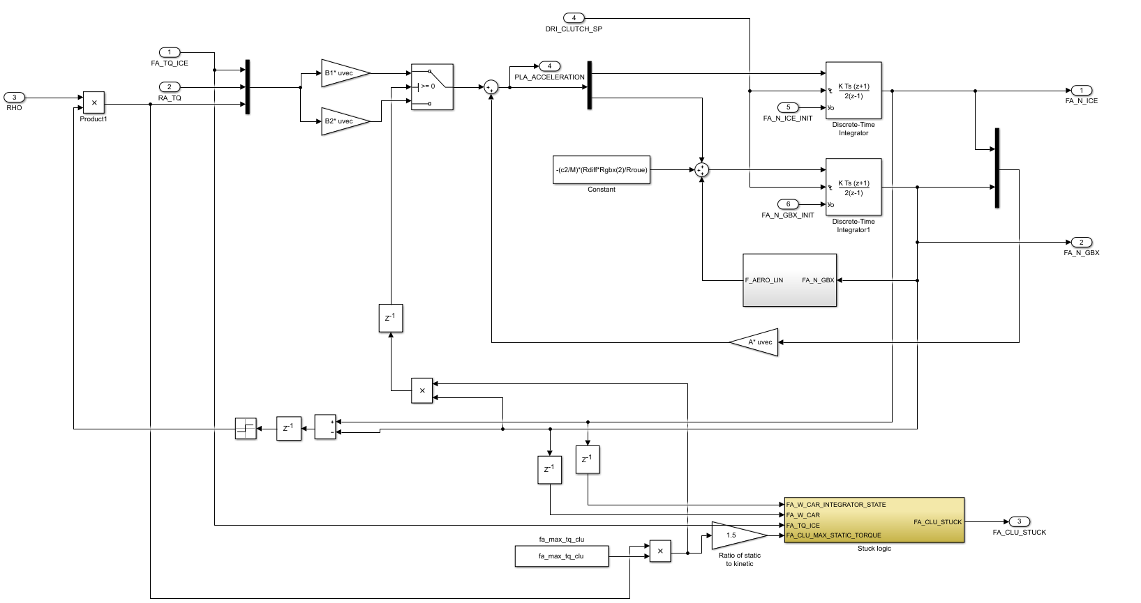

Open state:
Calculate the speed of the ICE and the GBX in close or open state.
