CKAD

EQUIPE :BEJGANA ABDERAZZAK

REMERCIEMENTS

....

SOMMAIRE

REMERCIEMENTS 2
I. Introduction 4
I. Objectif 4
I. Objectif 4

- Introduction
L’objectif de ce document est de préparer le certificat CKAD
Certified Kubernetes Application Developer

- Objectif
Deux mois pour préparer ce certificat :
Date de passage : 5 janvier 2026

- CKAD Curriculum
Application Design and Build20%:
Define, build and modify container images
Choose and use the right workload resource (Deployment, DaemonSet, CronJob, etc.)
Understand multi-container Pod design patterns (e.g. sidecar, init and others)
Utilize persistent and ephemeral volumes
Application Deployment20%
Use Kubernetes primitives to implement common deployment strategies (e.g. blue/green or canary)
Understand Deployments and how to perform rolling updates
Use the Helm package manager to deploy existing packages
Kustomize
Application Observability and Maintenance15%
Understand API deprecations
Implement probes and health checks
Use built-in CLI tools to monitor Kubernetes applications
Utilize container logs
Debugging in Kubernetes

Application Environment, Configuration and Security25%
Discover and use resources that extend Kubernetes (CRD, Operators)
Understand authentication, authorization and admission control
Understand requests, limits, quotas
Understand ConfigMaps
Define resource requirements
Create & consume Secrets
Understand ServiceAccounts
Understand Application Security (SecurityContexts, Capabilities, etc.)

Services and Networking20%
Demonstrate basic understanding of NetworkPolicies
Provide and troubleshoot access to applications via services
Use Ingress rules to expose applications

Date de passage : 15 December 2025
- Application Design and Build

- Docker
- containerD

ctr : command plus bas pour manipuler sur containerD.
nerdctl provide a command like docker
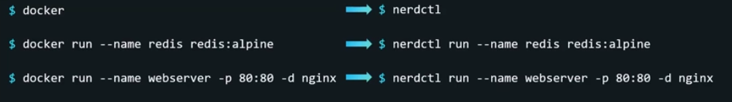

Pod

4 éléments sont nécessaires pour crée un Pod.
apiVersion: v1
kind: Pod
metadata:
name: myapp-pod

spec:

piVersion: v1
kind: Pod
metadata:
name: mypod
labels:
env: prod
spec:
containers:
- name: nginx
image: nginx

ReplicationController

apiVersion : v1
kind: ReplicationController
metadata:
name: myapp-rc
labels:
app: myapp
type: front-end

spec:
template:
metadata:
name: myapp-pod
labels:
app: myapp
type: front-end
spec:
containers:
- name: nginx-container
image: nginx
replicas: 3

Replicat set
Les paramètres qui sont changés par rapport au ReplicationControl sont en rouge :

apiVersion : apps/v1
kind: ReplicaSet
metadata:
name: replicat
labels:
app: myapp
type: front-end

spec:
template:
metadata:
name: myapp-pod
labels:
app: myapp
type: front-end
spec:
containers:
- name: nginx-container
image: nginx
replicas: 3
selector:
matchLabels:
type: front-end

DEPLOYEMENT

apiVersion : apps/v1
kind: Deployement
metadata:
name: deployement
labels:
app: myapp
type: front-end

spec:
template:
metadata:
name: myapp-pod
labels:
app: myapp
type: front-end
spec:
containers:
- name: nginx-container
image: nginx
replicas: 3
selector:
matchLabels:
type: front-end

Namespace
Il existe 4 namespace par défaut sur Kubernetes
- default
- kube-system
- kube-public

Pour ajouter un Namespace:
namespace.yaml
apiVersion: v1
kind: Namespace
metadata:
name: dev

kubectl apply -f namespace.yaml

Ou
kubectl create namespace prod

Ajouter le pod sur un namespace :
apiVersion : v1
kind: Pod
metadata:
name: mypod
namespace: prod
labels:
env: prod

spec:
containers:
- name: nginx
image: nginx

Ou
kubectl apply -f nginx.yaml --namespace=dev

Pour changer le namespace par defaut à un autre :
kubectl config set-context $(kubectl config current-context) --namespace=prod

Services

