

Work done by: Bekuzak Darkhan, Yermekbayev Bekslan, Tairzhan Kassenov

Work for: Shynggys Alshynov

AITU FORUM

PROJECT RELEVANCE:

In the present time, a plethora of students are being closed and introvert from the real world, and spent their time in the Internet. Furthermore, weak development of the forum industry in Kazakhstan. Our team supposed that is one of the problems of teenager students in the era of globalization and technologies. With this problem, we wanted to create type of web application, in which the students of different views and hobbies discuss a topic, share their ideas and experience, hold discussions, express opinions. The main purpose of the project is creating the web application, namely AIFORUM, in which students feel comfort and taking the forums. In fact, AIFORUM can be used for various purposes, not only as a means of communicating people, but also getting answers or help.

COMPETITORS OR SIMILAR PROJECTS:

As we know, there are a plethora of forum-based similar websites in the Kazakhstan, however, some of the are world-known websites, such as:

<https://tengrinews.kz/> : A popular news website in Kazakhstan that also has a forum section for discussing current events, politics, and other topics.

<http://astanaforum.kz/> : A general discussion forum for residents of Astana and other parts of Kazakhstan.

Of course, the mentioned websites one of the best forum websites in Kazakhstan. However, our application has more features and plans, which we can be competitive with others. Let’s start with:

1. **Unique features**: One of the best unique features of our forum application is a user-friendly interface, with specialized functionalities. If we go to other forum websites, there has only small section and not correctly interface for forums.

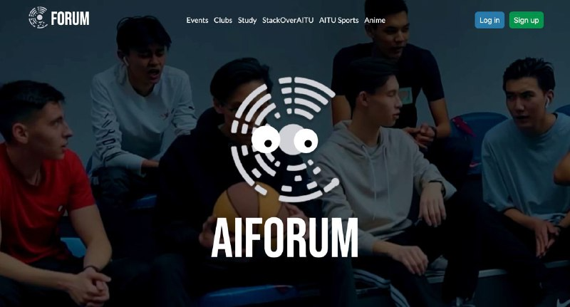

1. **Market positioning**: If we talk about positioning in the market relative, it will success without any doubt. As it targets for youngers, it can offer a broader appeal in the future. In the current time, there has no forum websites for students, and we think our application can reach market positioning in the world of news forums.

1. **User feedback**: After deploying all the functions of application for the public, we start look for feedbacks from users of website that could indicate its competitive potential. Of course, the positive feedback could suggest that our app is meeting a demand that other apps are not.
2. **Marketing strategy**: Definitely, one of features of extent the application is plan to market the app and built its user base. There has some ways for enhancing, as social media promotion, targeted advertising, or partnerships with other relevant organizations. The marketing strategy has more influences for upholding the application for world-class.

With this planning, the application can be one of the best forum student website in Kazakhstan.

PROJECT AUDITORY:

Without any doubt, when writing the audience of the project, it is pivotal to provide a clear understanding of who the project is intended for and why. Firstly:

**Demographics**:

1. Age : The probably users of the application will be in age from 18 to 25.
2. Gender : The application is equally for men and for women.
3. Location : The first use and location will be in walls of AITU. But if it will be succeed the all Kazakhstan can use.
4. Education level : As the project for students and teenagers, we prefer that it will be bachelor degree.

This information can help to paint a picture of who the project is designed for.

**Needs and interests**:

If we want to enhance the level of project, we need to discuss the needs and interests of target audience, and how the project addresses these.

PROJECT FEATURES:

**Eye-Catching Functionalities: for Front Pages**

1. **Interactive user interface (UI**):

In this step, we add hover effects, custom icons and nav bar for more visually appealing the users.

1. **Personalization features:**

In this step, we add color schemes like rgb for other pages, and font sizes with 19px for titles of pages. It is for increase the user engagement.

**Eye-Catching Functionalities: for Back-end (Go)**

1. **Real-time data processing**:

The clean code includes visual tools for analyzing and visualizing data in real-time.

1. **Modular architecture**:

This include tools for generating and managing modules, as well as visual tools for navigating module dependencies.

1. **API development**:

The eye-catching functionality include visual tools for designing and documenting API’s, and tools for testing and monitoring API performance.

As for unique features, there will be most important and unique aspects of our project that set it apart from others. Key points:

1. **User-friendly design**:

The project is done with the Html/CSS for the front pages, and Golang for the back-end pages. Additionally, we added JavaScript, as it has more impacts in designing the website, and it can illustrate a plethora of possibilities in levelling the project.

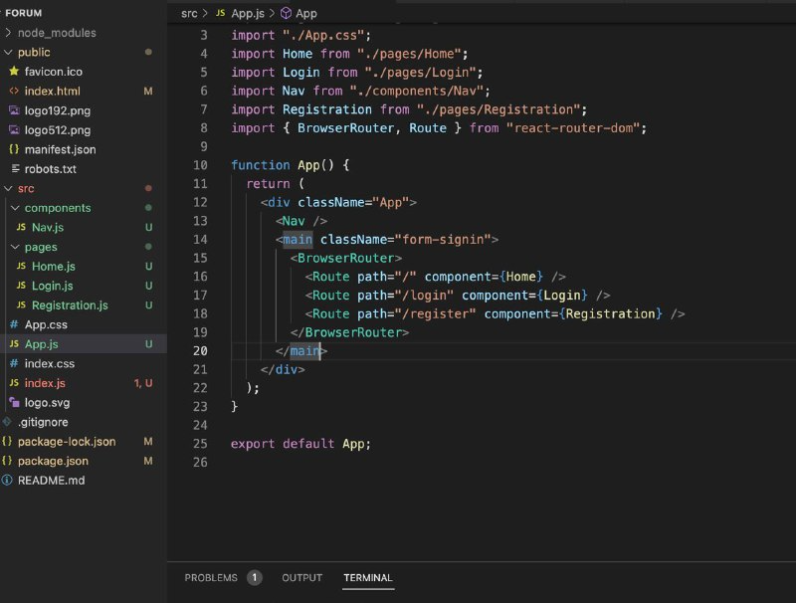

PROJECT DESCRIPTION:

**Use-case**:

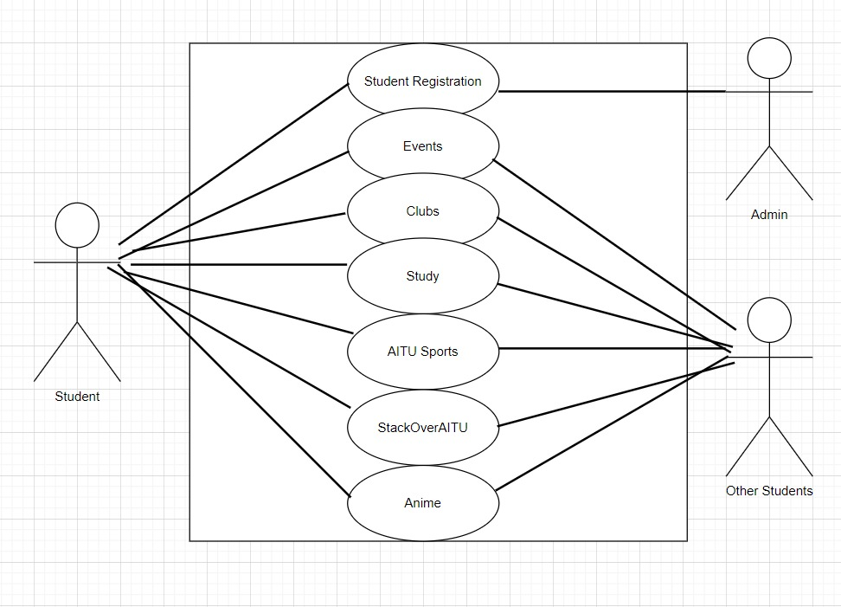

**ERD**:

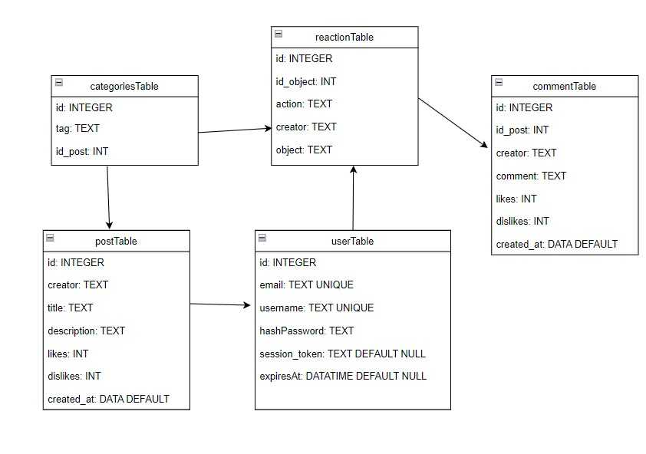

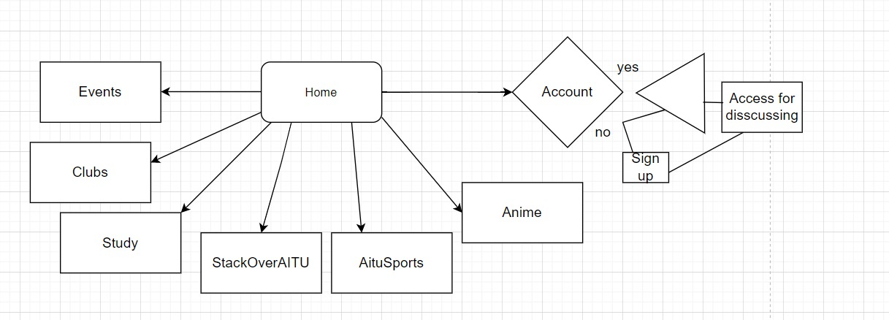

**UML**:

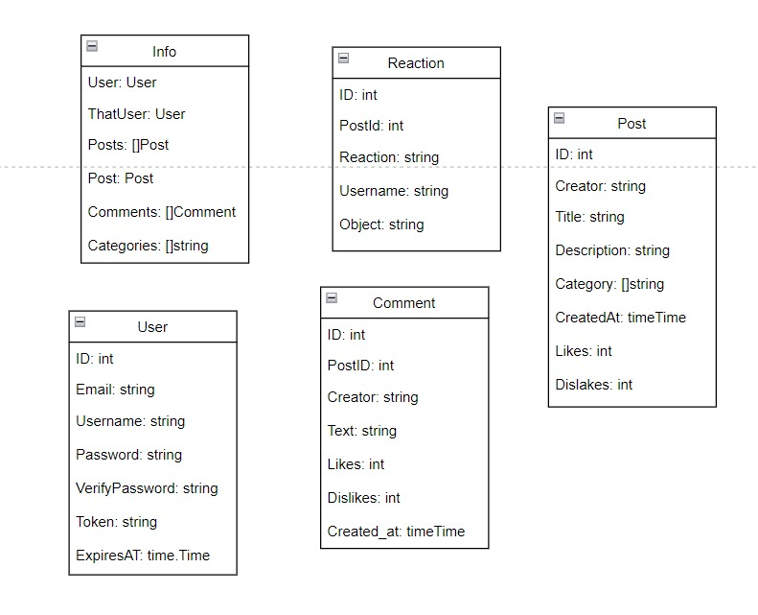

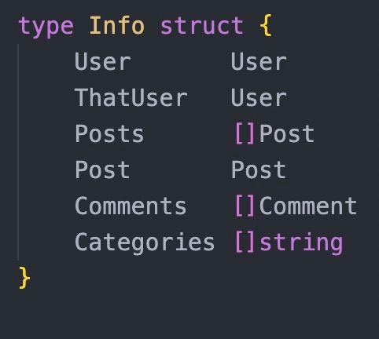

CONCLUSION:

In conclude, we can say without any doubt through the project work we gained a plethora of experience in web development with Golang. And we hope that, our application can reach the high levels in the Kazakhstan.