**INSTALLATION OF CENTOS[using LVM]**

**STEP1:** Open the URL <https://www.centos.org/download/>in the browser.

Now select the type of system architecture based on the processor x86_64 and click on any of the mirror links to download the iso image.

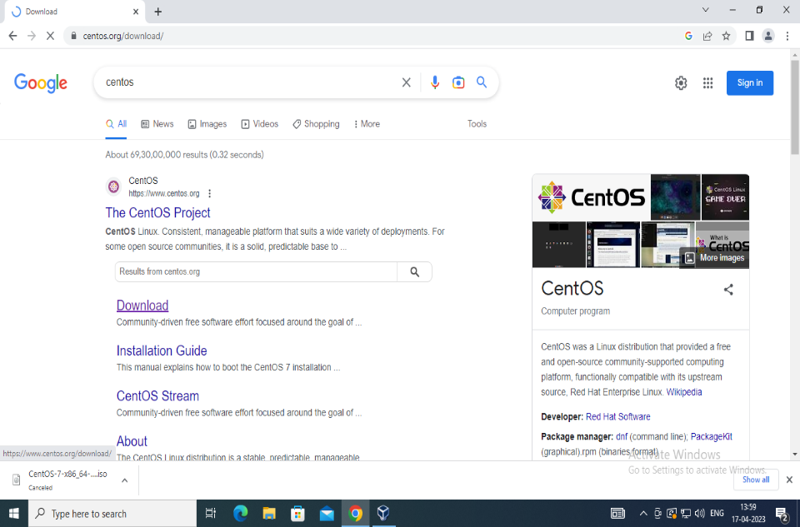

**Fig1: Screenshot of Centos**

**STEP2:** Download the minimal version of the ISO image and locate it in the downloads folder of the system.

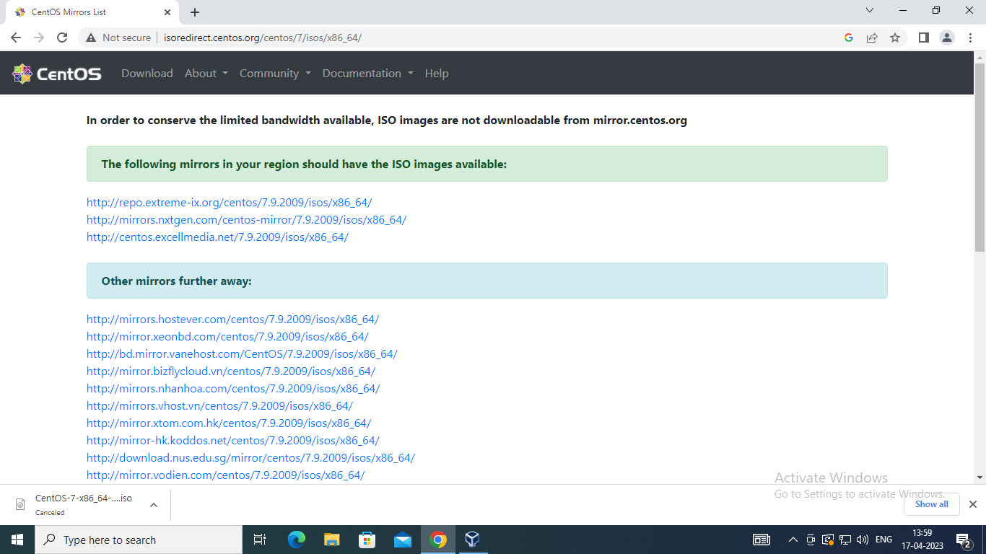

**Fig2: Screenshot of CentOS mirror List**

**STEP3**: Once the CentOS is downloaded, it is ready to be installed on VirtualBox. Open VirtualBox, click the “New” button to create a new virtual machine. 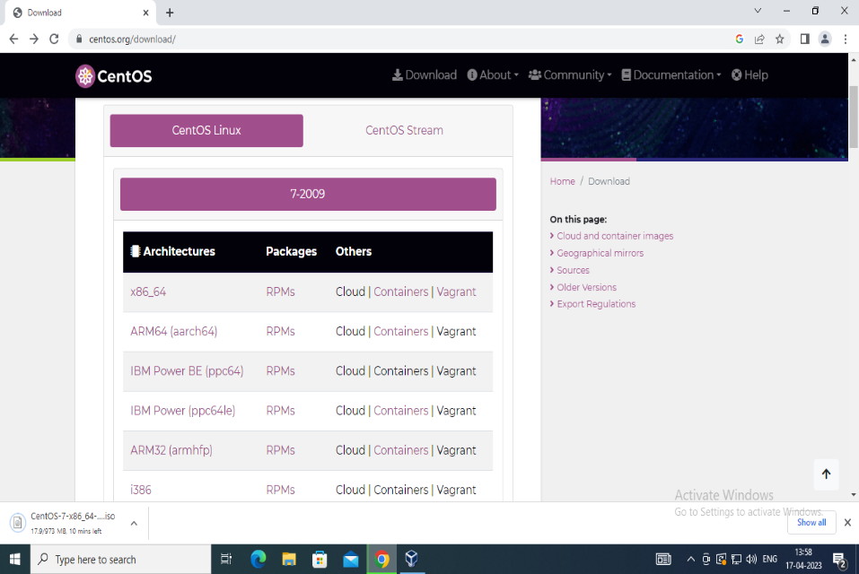

**Fig3: Screenshot of Centos Linux**

**STEP4:**  click the “New” button to create a new virtual machine. Hold on till the installation process completes

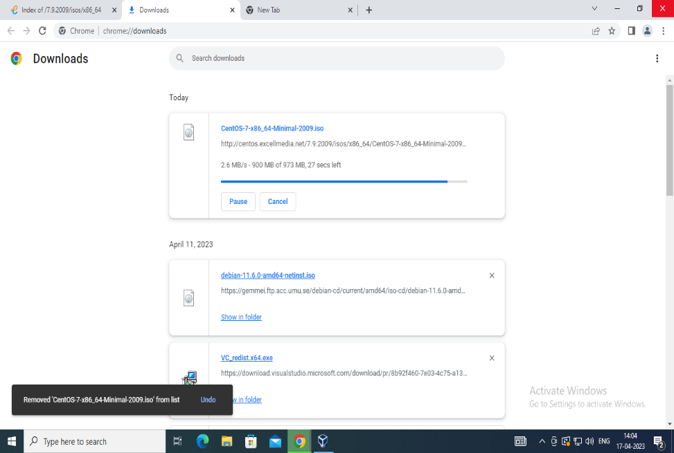

**Fig4: Screenshot of downloading CentOS**

**STEP5:** Set the hardware memory and process length

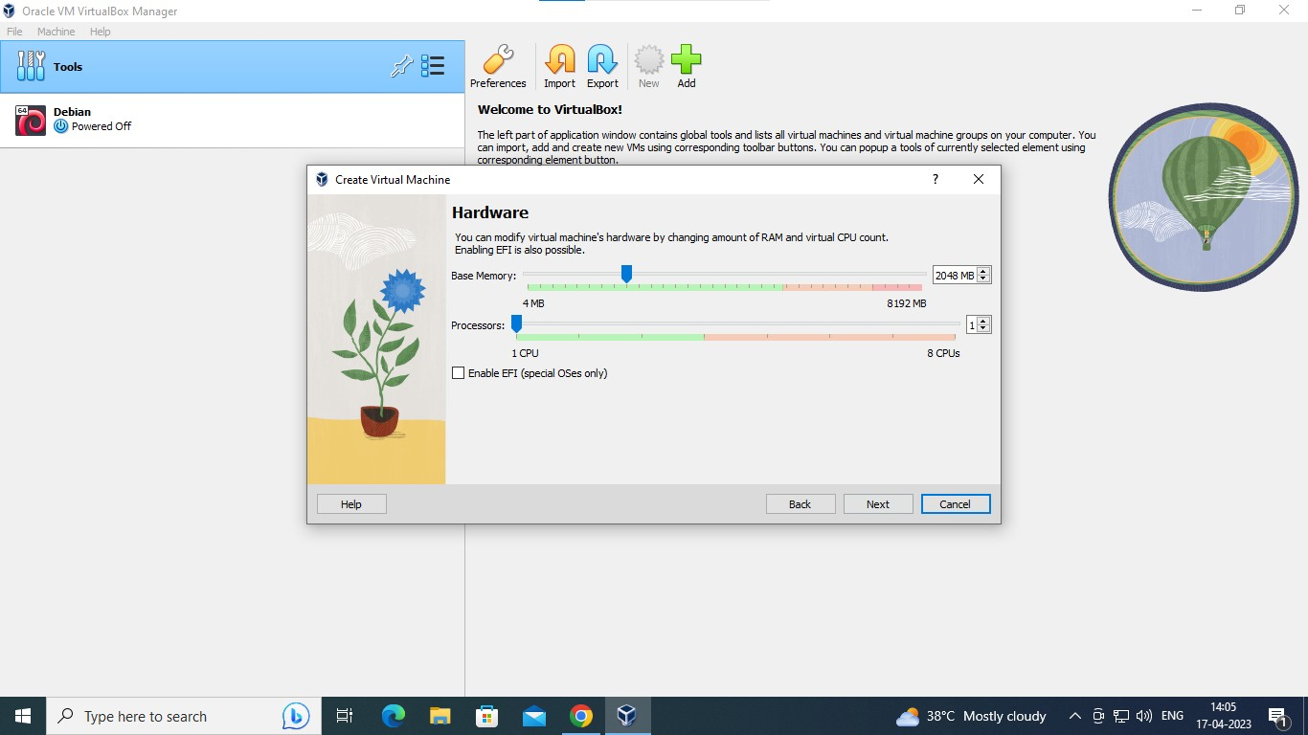

**Fig5: Screenshot to set the hardware length**

**STEP6:** Click on the CentOS virtual machine and then click on the “Start” button present on the top. Click “Create” to continue and now the summary will be displayed showing the details of the os.

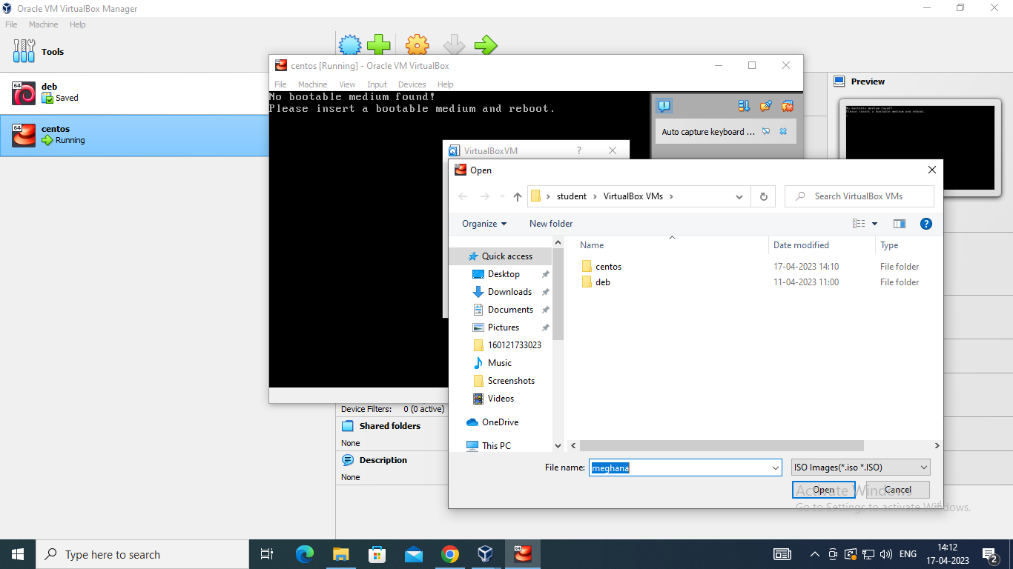

**Fig6: Screenshot of Loading CentOS**

**STEP7:** Let it load on to the Virtual machine it may take few seconds

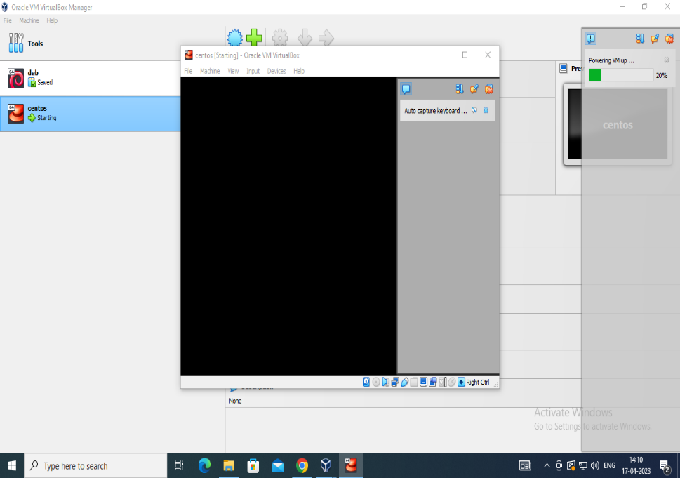

**Fig7: Screenshot of loading of CentOS**

**STEP8:** Open the CentOS Home page to view the contents and proceed .

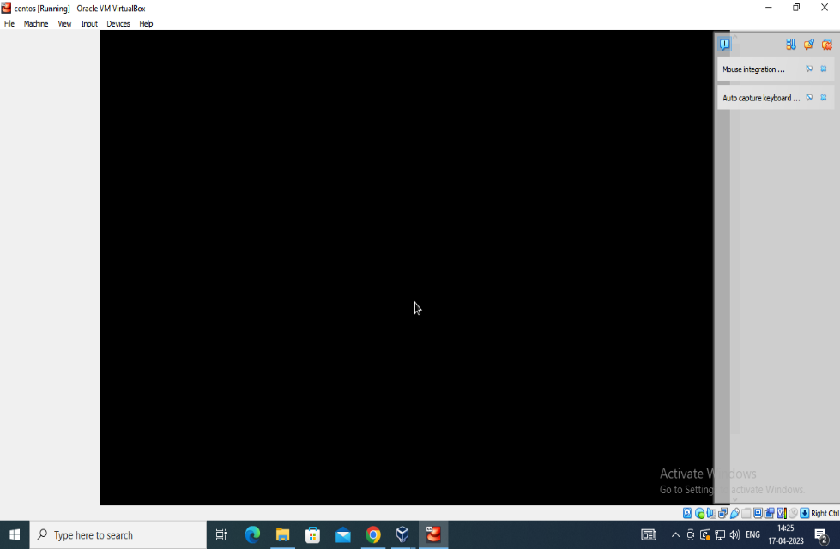

**Fig8: Screenshot of CentOS**

**STPE9:** Once all the above settings are saved, you will notice that the “Begin Installation” button is enabled. Click it to start the installation.

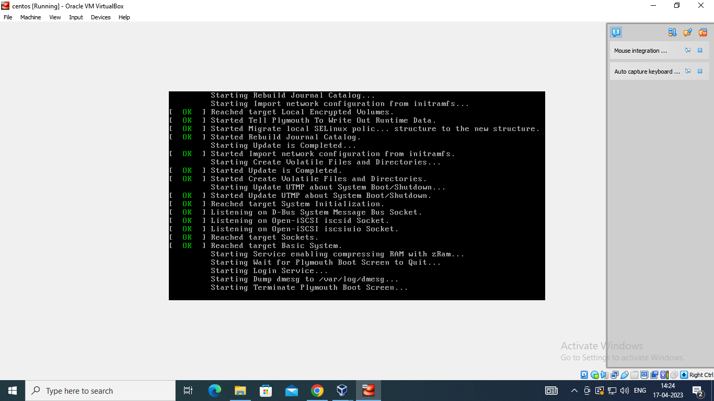

**Fig9: Screenshot of Oracle VM VirtualBox**

**STEP10:** After finishing providing the root password. You can go ahead creating a user. Click a “User creation” icon present on the window.

When you have provided the above details, click “Done” to continue

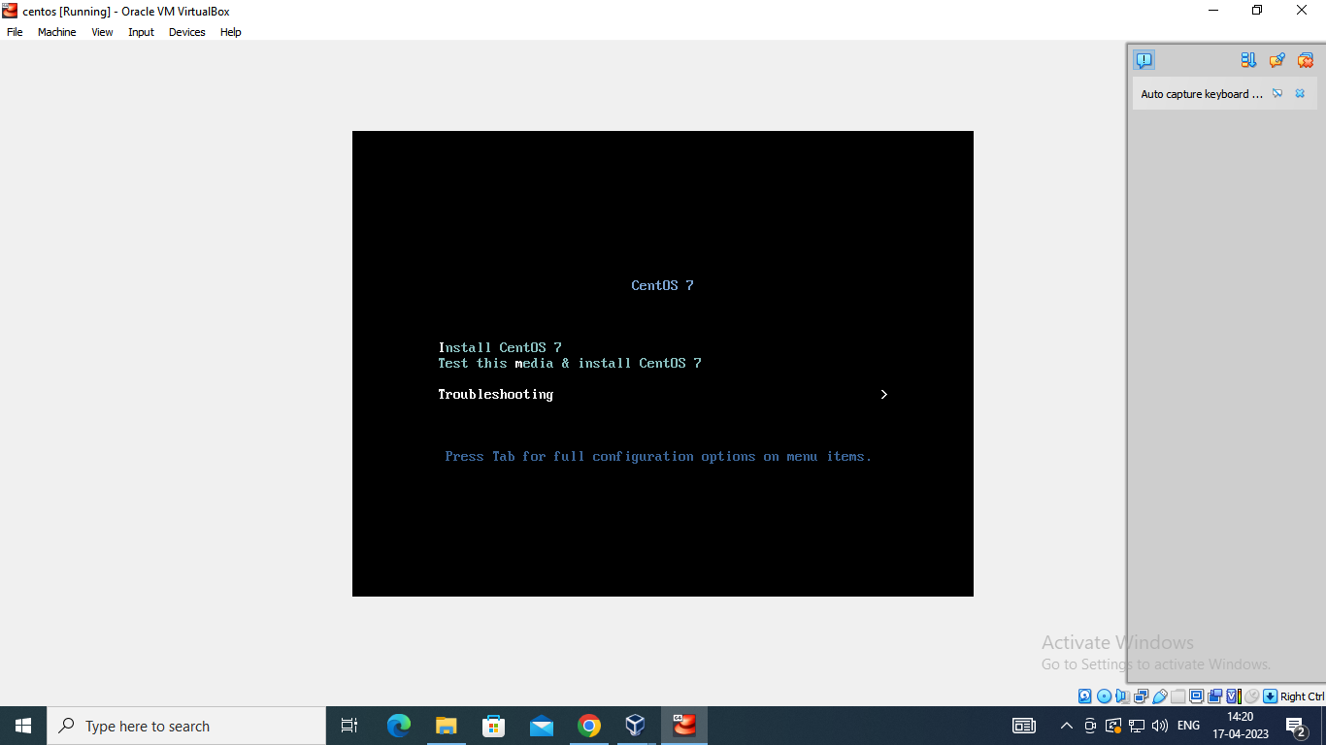

**Fig10: Screenshot of installing of CentOS**

**STEP11:** “Create a virtual hard disk now” option is checked by default. Click “Create” to proceed.

The next interface is about the hard disk file type. By default, it is VDI (VirtualBox Disk Image) and it is a standard. Click “Next” to proceed.

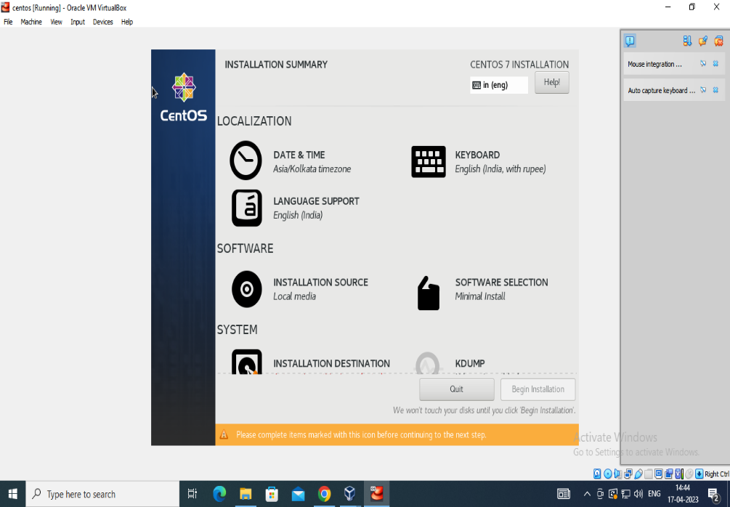

**Fig11: Screenshot of installation summary**

**STEP12:** In the next step, we need storage on a physical hard drive. By default, it is “Dynamically allocated.” Click “Next” when done.

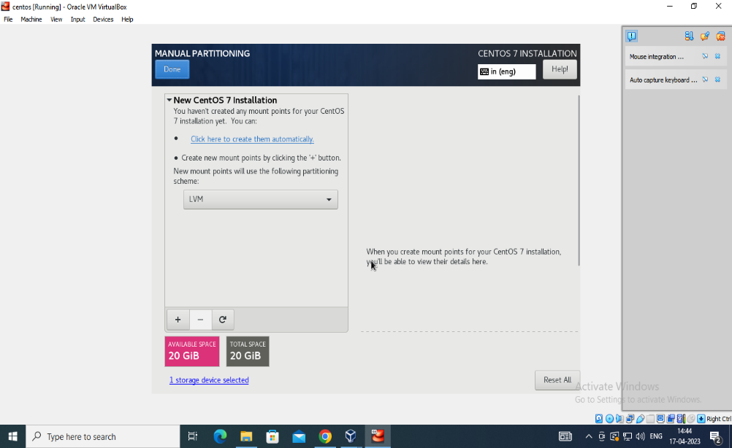

**Fig12: Screenshot of Manual Partitioning**

**STEP13:** In the next step, we need storage on a physical hard drive. By default, it is “Dynamically allocated.” Click “Next” when done. And enter the mount point.

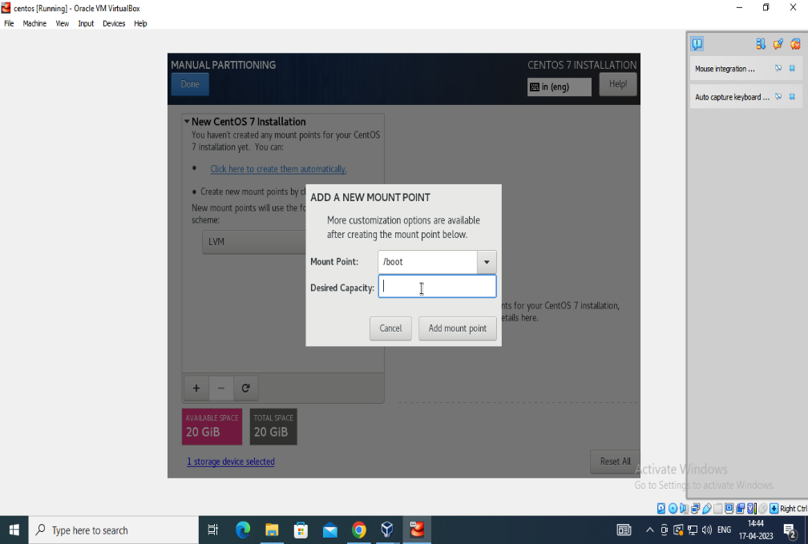

**Fig13: Screenshot of manual partitioning and popup menu of mount paint**

**STEP14:** The minimum virtual hard disk which CentOS needs is 8GB but again it depends on the computer. You can adjust it according to the hard disk size of system. Provide the path of virtual hard disk

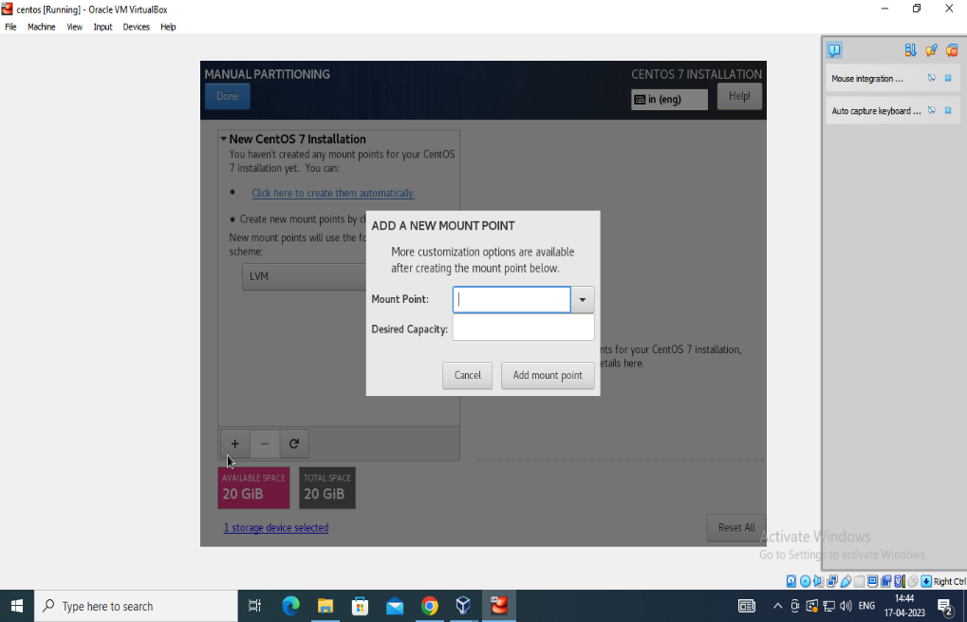

**Fig14: Screenshot of Mount Paint dialogue box**

**STEP15:** We have three major setting categories and those are Localization, Software, and System and choose desired capacity.

Let us start with the localization category, click the “Keyboard” option.

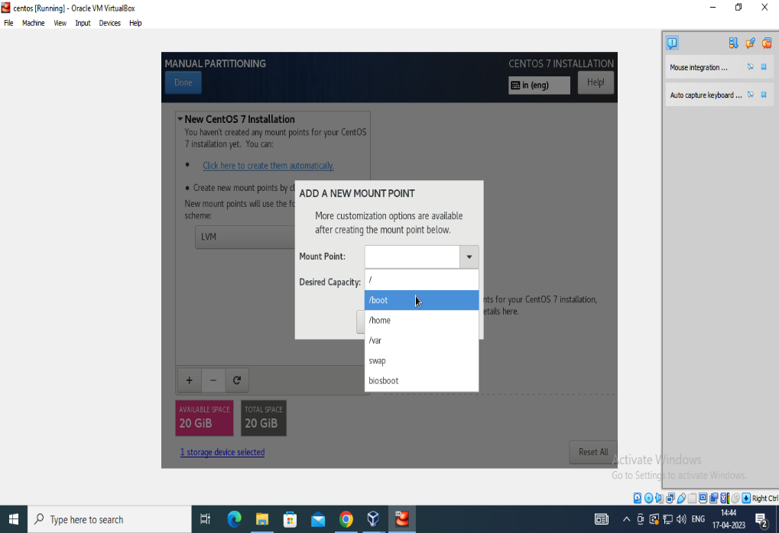

**Fig15: Screenshot of manual partitioning to choose desired Capacity**

**STEP16**: By default, it has chosen “English” You can adjust it accordingly by clicking on the”+” icon. Click “Done” to continue.

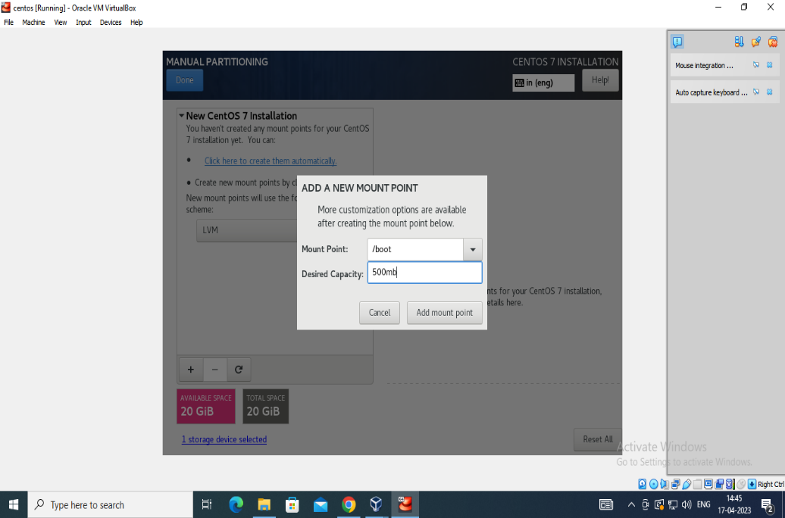

**Fig16: Screenshot to choose Desired Capacity**

**STEP17:** Set the Mount Point and Set the desired capcity in Manual Partitioning

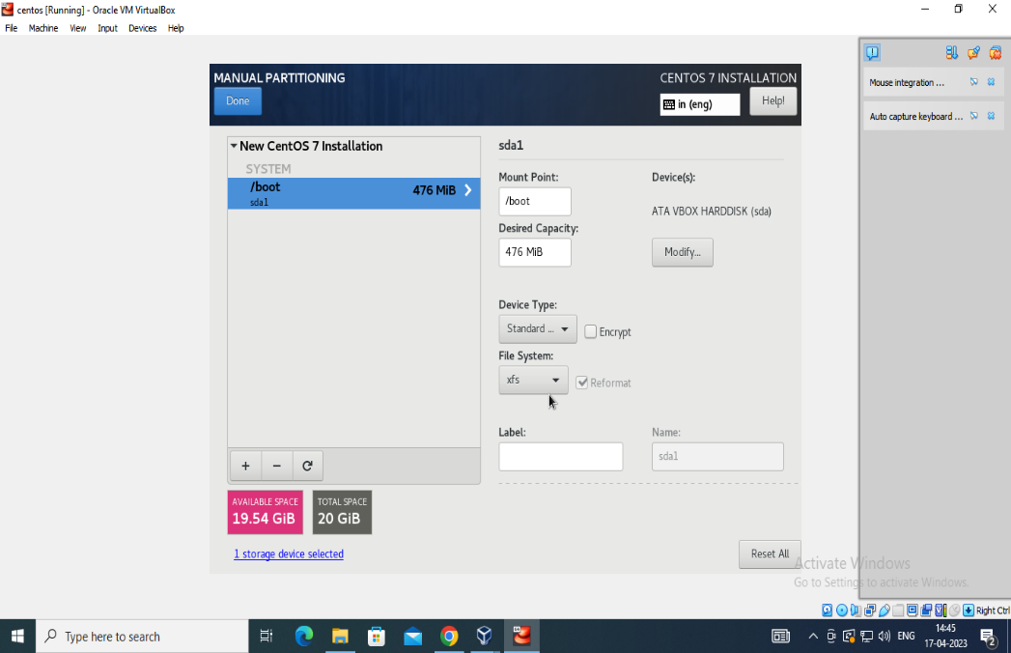

**Fig17: Screenshot of configuration of Mutual Partitioning**

**STEP18:**  Select the installation destination and Double click on it to proceed next .

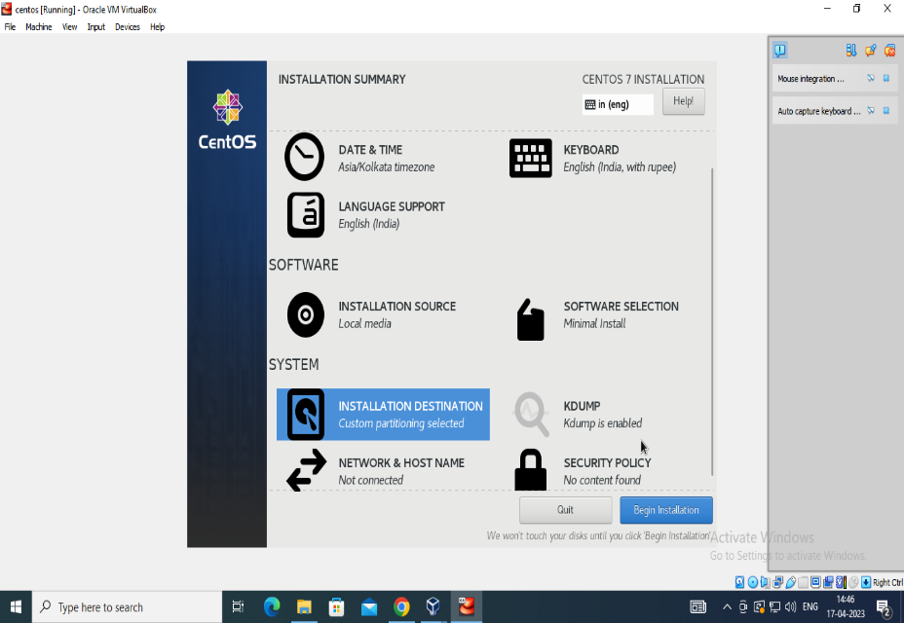

**Fig20: Screenshot of installation Destination**

**STEP19:**  Select the summary of changes to proceed to further modifications.The below are the 12 summary of changes with which we can proceed further.

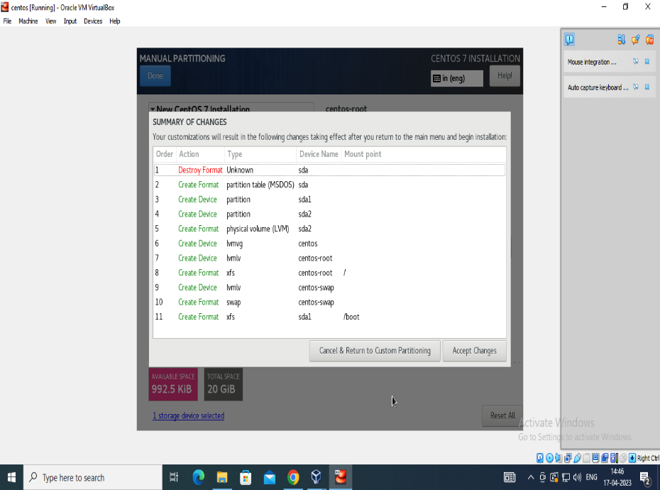

**Fig21: Screenshot of summary of changes**

**STEP20:**  Select the root password and User creation to Rectify the error

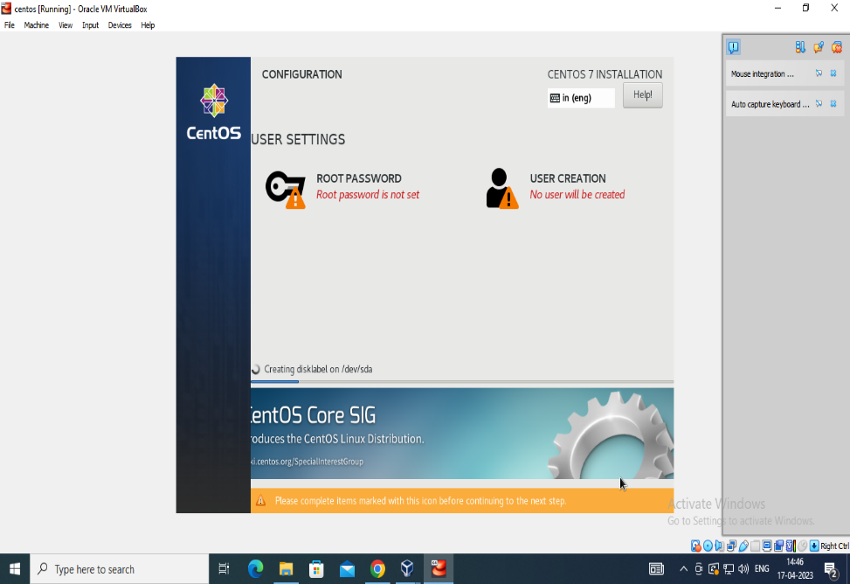

**Fig22: Screenshot of Configuration of User settings**

**STEP21:** Enter the Root password and confirm the root .

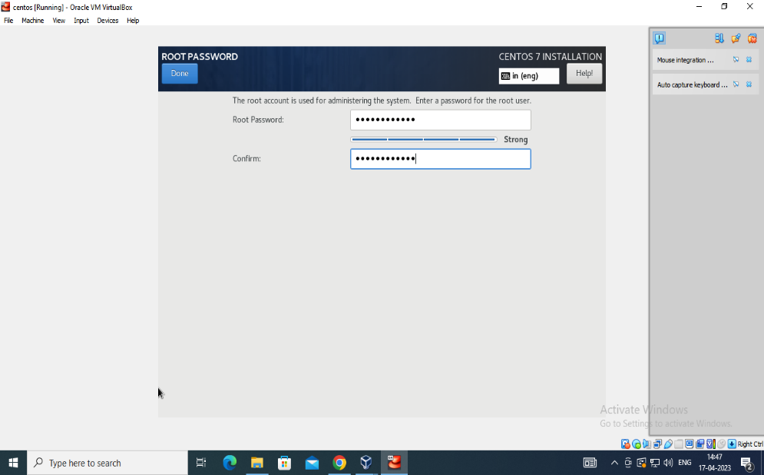

**Fig23: Screenshot of root password display box**

**STEP22**: Enter the details like Fullname , Username , Password and reenter the password to confirm it.

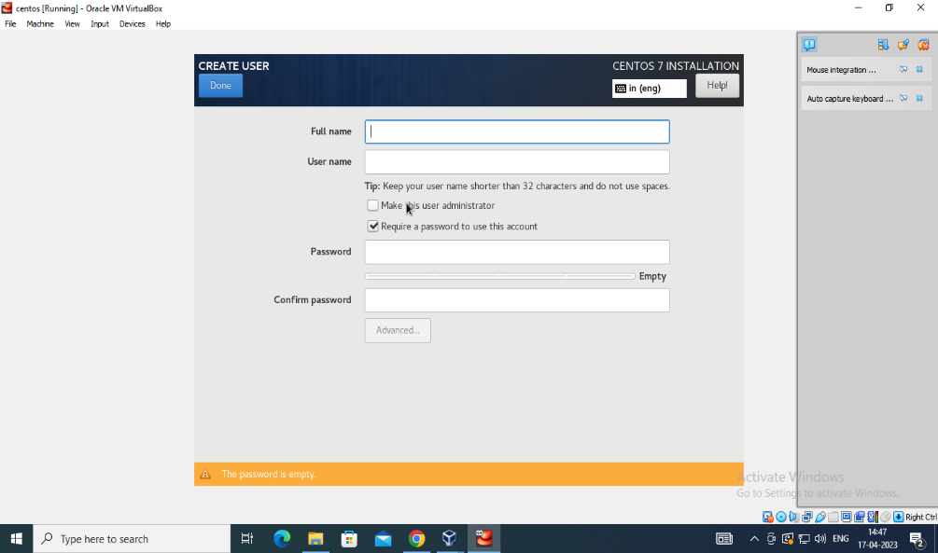

**Fig24: Screenshot of display box to write full name**

**STEP22:** The Below are the details that are to be entered to proceed with centOS.

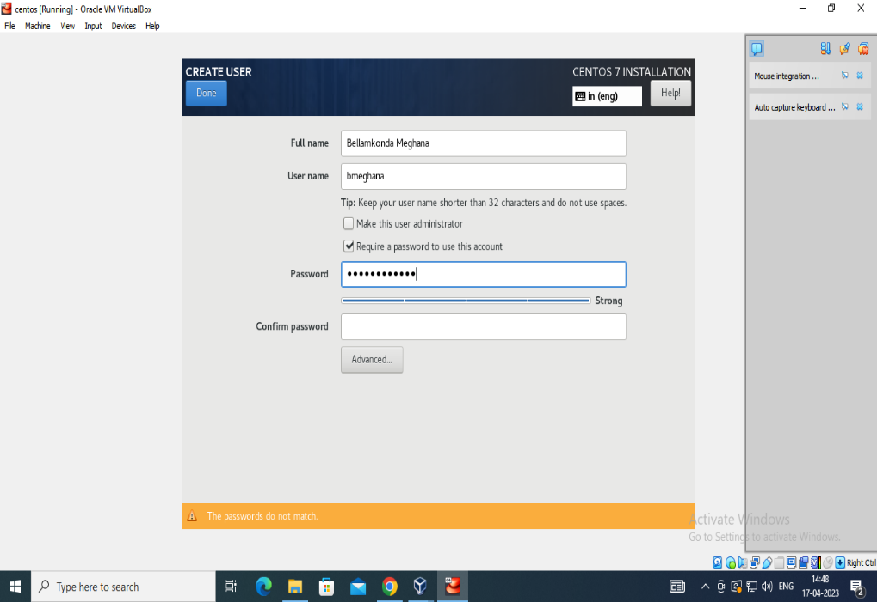

**Fig25: Screenshot of display box to write Password, full name, User name**

**STEP23:** As we have already given the ISO file path and it is auto-detected here. We do not need to do anything. Click “Done” to continue.

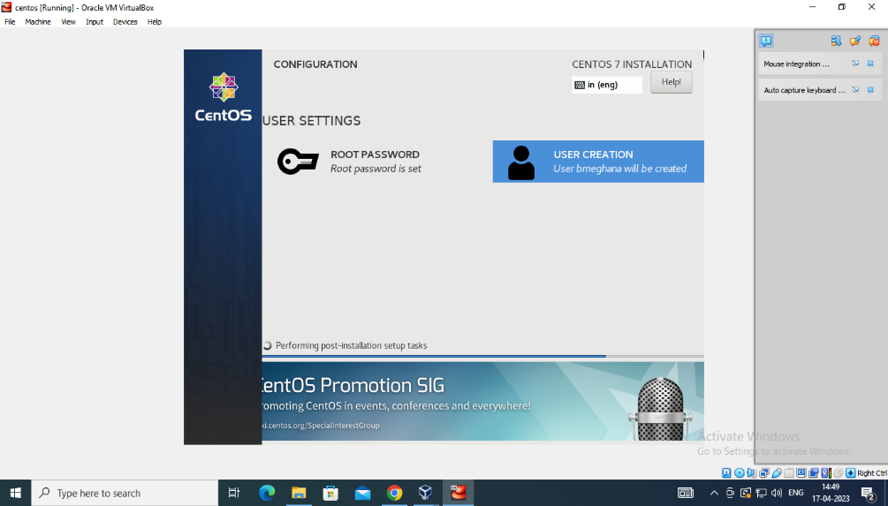

**Fig13: Screenshot of creation of CentOS completion**

**STEP24:** Login to localhost and enter password to proceed further by entering the details as shown below

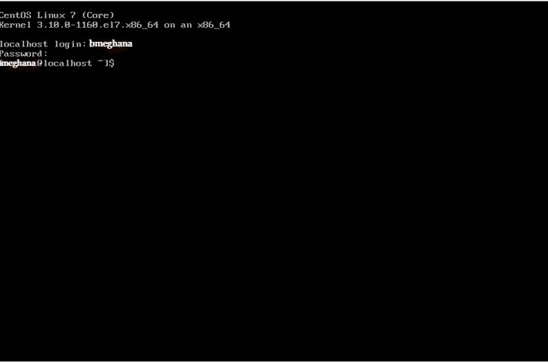

**Fig14: Screenshot of login Credentials**

**STEP25:** After restarting of system a user screen will prompt for asking password login to centos and begin using it.

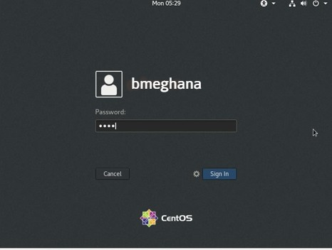

**Fig15: Screenshot of user Credentials**

**INSTALLATION OF CENTOS [ using LVM ]**

**STEP1:** Open the URL <https://www.centos.org/download/>in the browser.

Now select the type of system architecture based on the processor x86_64 and click on any of the mirror links to download the iso image.



**Fig1: Screenshot of Centos**

**STEP2:** Download the minimal version of the ISO image and locate it in the downloads folder of the system.



**Fig2: Screenshot of CentOS mirror List**

**STEP3**: Once the CentOS is downloaded, it is ready to be installed on VirtualBox. Open VirtualBox, click the “New” button to create a new virtual machine.



**Fig3: Screenshot of Centos Linux**

**STEP4:**  click the “New” button to create a new virtual machine. Hold on till the installation process completes



**Fig4: Screenshot of downloading CentOS**

**STEP5:** Set the hardware memory and process length



**Fig5: Screenshot to set the hardware length**

**STEP6:** Click on the CentOS virtual machine and then click on the “Start” button present on the top. Click “Create” to continue and now the summary will be displayed showing the details of the cent OS.



**Fig6: Screenshot of Loading CentOS**

**STEP7:** Let it load on to the Virtual machine it may take few seconds



**Fig7: Screenshot of loading of centOS**

**STEP8:** Open the CentOS Home page to view the contents and proceed .



**Fig8: Screenshot of CentOS**

**STPE9:** Once all the above settings are saved, you will notice that the “Begin Installation” button is enabled. Click it to start the installation.



**Fig9: Screenshot of Oracle VM VirtualBox**

**STEP10:** After finishing providing the root password. You can go ahead creating a user. Click a “User creation” icon present on the window.

When you have provided the above details, click “Done” to continue



**Fig10: Screenshot of installing of CentOS**

**STEP11:** “Create a virtual hard disk now” option is checked by default. Click “Create” to proceed.

The next interface is about the hard disk file type. By default, it is VDI (VirtualBox Disk Image) and it is a standard. Click “Next” to proceed.



**Fig11: Screenshot of installation summary**

**STEP12:** In the next step, we need storage on a physical hard drive. By default, it is “Dynamically allocated.” Click “Next” when done.



**Fig12: Screenshot of Manual Partitioning**

**STEP13:** In the next step, we need storage on a physical hard drive. By default, it is “Dynamically allocated.” Click “Next” when done. And enter the mount point.



**Fig13: Screenshot of manual partitioning and popup menu of mount paint**

**STEP14:** The minimum virtual hard disk which CentOS needs is 8GB but again it depends on the computer. You can adjust it according to the hard disk size of system. Provide the path of virtual hard disk



**Fig14: Screenshot of Mount Paint dialogue box**

**STEP15:** We have three major setting categories and those are Localization, Software, and System and choose desired capacity.

Let us start with the localization category, click the “Keyboard” option.



**Fig15: Screenshot of manual partitioning to choose desired Capacity**

**STEP16**: By default, it has chosen “English” You can adjust it accordingly by clicking on the”+” icon. Click “Done” to continue.



**Fig16: Screenshot to choose Desired Capacity**

**STEP17:** Set the Mount Point and Set the desired capcity in Manual Partitioning



**Fig17: Screenshot of configuration of Mutual Partitioning**

**STEP18:**  Select the installation destination and Double click on it to proceed next .



**Fig18: Screenshot of installation Destination**

**STEP19:**  Select the summary of changes to proceed to further modifications.The below are the 12 summary of changes with which we can proceed further.



**Fig19: Screenshot of summary of changes**

**STEP2O:**  Select the root password and User creation to Rectify the error



**Fig20: Screenshot of Configuration of User settings**

**STEP21:** Enter the Root password and confirm the root .



**Fig21: Screenshot of root password display box**

**STEP22**: Enter the details like Fullname , Username , Password and reenter the password to confirm it.



**Fig22: Screenshot of display box to write full name**

**STEP23:** The Below are the details that are to be entered to proceed with centOS.



**Fig23: Screenshot of display box to write Password, full name, User name**

**STEP24:** As we have already given the ISO file path and it is auto-detected here. We do not need to do anything. Click “Done” to continue.



**Fig24: Screenshot of creation of centOS completion**

**STEP25:** Login to your centos os using password which was created previously.

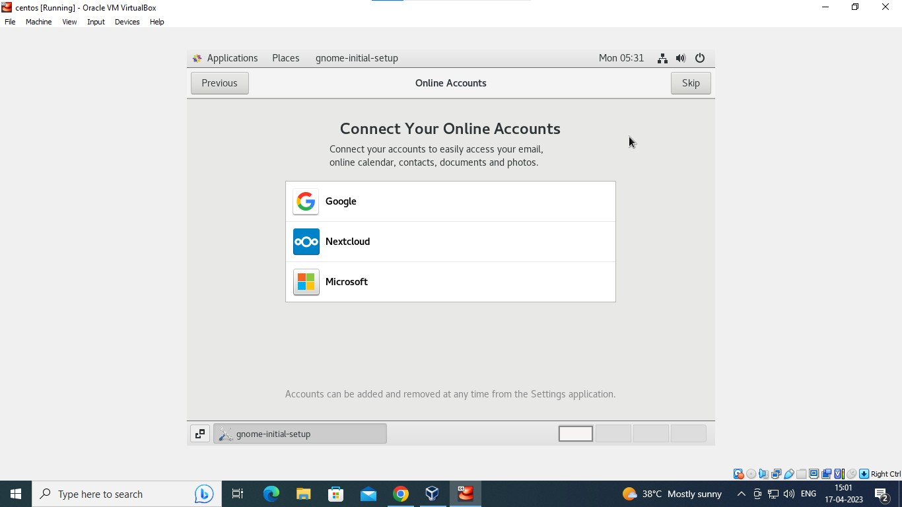

**Fig25: Screenshot of creation of connections of online accounts**

**STEP26:** Login to localhost and enter password to proceed further by entering the details as shown below



**Fig26: Screenshot of login credentials**

**STEP27:** Allow all the privacy settings and location services

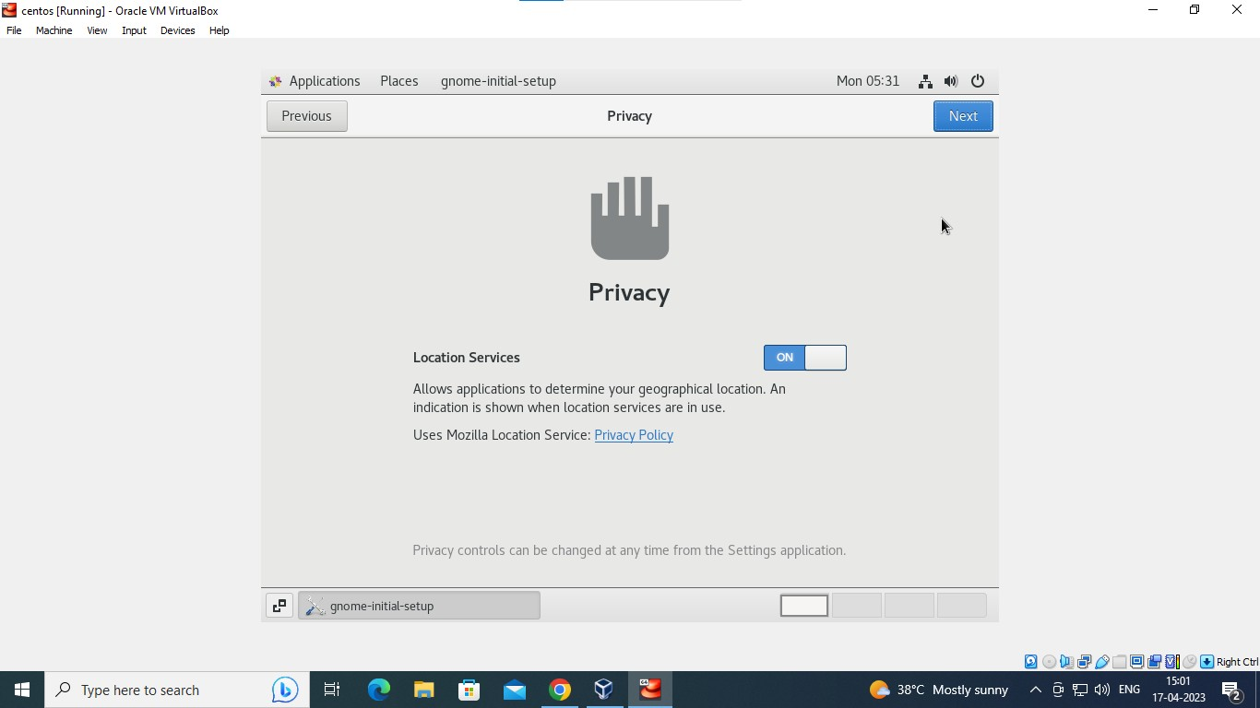

**Fig27: Screenshot of user credentials and Privacy settings**

**STEP28:** After restarting of system a user screen will prompt for asking password login to centos and begin using it.



**Fig28: Screenshot of user credentials**

**STEP29:** Login to your centos os using password which was created previously.

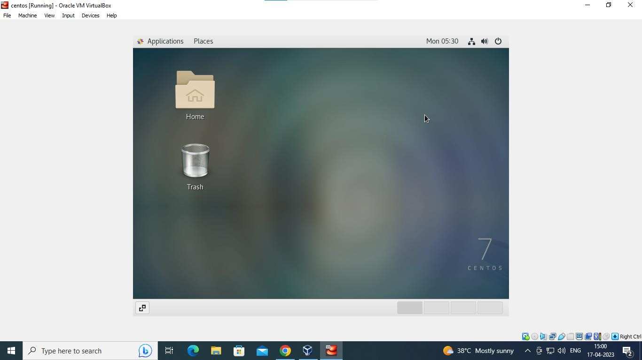

**Fig29: Screenshot of completion of centOS**

We have successfully completed the CentOS installation.

**CONCLUSION:** Hence, we successfully completed to install the centos in two different ways i.e., using the LVM and without using LVM.

Centos Linux distribution is widely used as system operating system and software development due to its secure and robust features and it is the best among various Linux flavours.