March 2022

Type BEP20

Network BSC

Address 0xf6875AD490233C0C91c4163Aca45F7636338634A

Audited by © cyberscope

## Table of Contents

**Table of Contents** **1**

**Contract Review** **2**

**Audit Updates** **2**

**Contract Analysis** **3**

**Contract Diagnostics** **4**

**L01 - Public Function could be Declared External** **5**

**Description** **5**

**Recommendation** **5**

**L02 - State Variables could be Declared Constant** **6**

**Description** **6**

**Recommendation** **6**

**L05 - Unused State Variable** **7**

**Description** **7**

**Recommendation** **7**

**L04 - Conformance to Solidity Naming Conventions** **8**

**Description** **8**

**Recommendation** **8**

**Contract Functions** **9**

**Contract Flow** **12**

**Domain** **13**

**Summary** **14**

**Disclaimer** **15**

**About Cyberscope** **16**

## Contract Review

| **Contract Name** | EasterDoge |
| --- | --- |
| **Compiler Version** | v0.8.4+commit.c7e474f2 |
| **Optimization** | 200 runs |
| **Licence** | MIT |
| **Explorer** | https://bscscan.com/token/0xf6875AD490233C0C91c4163Aca45F7636338634A |
| **Symbol** | EDoge |
| **Decimals** | 9 |
| **Total Supply** | 1,000,000,000,000,000 |
| **Source** | contract.sol |
| **Domain** | easterdoge.club |

## Audit Updates

| **Initial Audit** | 19th March 2022 |
| --- | --- |
| **Corrected** |  |

## Contract Analysis

|  | ⬤ | Critical | ⬤ | Medium | ⬤ | Minor | ⬤ | Pass |
| --- | --- | --- | --- | --- | --- | --- | --- | --- |

| **Severity** | **Code** | **Description** |
| --- | --- | --- |
| ⬤ | ST | Contract Owner is not able to stop or pause transactions |
| ⬤ | OCTD | Contract Owner is not able to transfer tokens from specific address |
| ⬤ | OTUT | Owner Transfer User's Tokens |
| ⬤ | ELFM | Contract Owner is not able to increase fees more than a reasonable percent (25%) |
| ⬤ | ULTW | Contract Owner is not able to increase the amount of liquidity taken by dev wallet more than a reasonable percent |
| ⬤ | MT | Contract Owner is not able to mint new tokens |
| ⬤ | BT | Contract Owner is not able to burn tokens from specific wallet |
| ⬤ | BC | Contract Owner is not able to blacklist wallets from selling |

## Contract Diagnostics

|  |  |  | ⬤ | Critical | ⬤ | Medium | ⬤ | Minor |
| --- | --- | --- | --- | --- | --- | --- | --- | --- |

| **Severity** | **Code** | **Description** |
| --- | --- | --- |
| ⬤ | L01 | Public Function could be Declared External |
| ⬤ | L02 | State Variables could be Declared Constant |
| ⬤ | L05 | Unused State Variable |
| ⬤ | L04 | Conformance to Solidity Naming Conventions |

### L01 - Public Function could be Declared External

| **Criticality** | minor |
| --- | --- |
| **Location** | contract.sol#L110,116,184,188,192,196,204,209,213,218 and 6 more |

#### Description

Public functions that are never called by the contract should be declared external to save gas.

| excludeMultipleAccountsFromFees  toggleSwap  setFee  setNewMarketingAddress  setNewDevAddress  rescueForeignTokens  transferFrom  approve  allowance  ... |
| --- |

#### Recommendation

Use the external attribute for functions never called from the contract.

### L02 - State Variables could be Declared Constant

| **Criticality** | minor |
| --- | --- |
| **Location** | contract.sol#L93 |

#### Description

Constant state variables should be declared constant to save gas.

| _previousOwner |
| --- |

#### Recommendation

Add the constant attribute to state variables that never change.

### L05 - Unused State Variable

| **Criticality** | minor |
| --- | --- |
| **Location** | contract.sol#L93,127 |

#### Description

There are segments that contain unused state variables.

| _tOwned  _previousOwner |
| --- |

#### Recommendation

Remove unused state variables.

### L04 - Conformance to Solidity Naming Conventions

| **Criticality** | minor |
| --- | --- |
| **Location** | contract.sol#L34,299,305,312,300,398,132,145,146,147 and 2 more |

#### Description

Solidity defines a naming convention that should be followed. Rule exceptions:

* Allow constant variable name/symbol/decimals to be lowercase.
* Allow _ at the beginning of the mixed_case match for private variables and unused parameters.

| _decimals  _symbol  _name  _tTotal  _swapEnabled  _amount  _to  _tokenAddr  marketingAddressUpdated  ... |
| --- |

#### Recommendation

Follow the Solidity naming convention. [https://docs.soliditylang.org/en/v0.4.25/style-guide.html#naming-conventions](https://docs.soliditylang.org/en/v0.4.25/style-guide.html#naming-convention)

## Contract Functions

| **Contract** | **Type** | **Bases** |  |  |
| --- | --- | --- | --- | --- |
|  | **Function Name** | **Visibility** | **Mutability** | **Modifiers** |
|  |  |  |  |  |
| **IERC20** | Interface |  |  |  |
|  | totalSupply | External️ |  | -️ |
|  | balanceOf | External️ |  | -️ |
|  | transfer | External️ | ✓ | -️ |
|  | allowance | External️ |  | -️ |
|  | approve | External️ | ✓ | -️ |
|  | transferFrom | External️ | ✓ | -️ |
|  |  |  |  |  |
| **Token** | Interface |  |  |  |
|  | transferFrom | External️ | ✓ | -️ |
|  | transfer | External️ | ✓ | -️ |
|  |  |  |  |  |
| **IUniswapV2Factory** | Interface |  |  |  |
|  | createPair | External️ | ✓ | -️ |
|  |  |  |  |  |
| **IUniswapV2Router02** | Interface |  |  |  |
|  | swapExactTokensForETHSupportingFeeOnTransferTokens | External️ | ✓ | -️ |
|  | factory | External️ |  | -️ |
|  | WETH | External️ |  | -️ |
|  | addLiquidityETH | External️ | Payable | -️ |
|  |  |  |  |  |
| **Context** | Implementation |  |  |  |
|  | _msgSender | Internal |  |  |
|  |  |  |  |  |
| **SafeMath** | Library |  |  |  |
|  | add | Internal |  |  |
|  | sub | Internal |  |  |
|  | sub | Internal |  |  |
|  | mul | Internal |  |  |
|  | div | Internal |  |  |
|  | div | Internal |  |  |
|  |  |  |  |  |
| **Ownable** | Implementation | Context |  |  |
|  | <Constructor> | Public️ | ✓ | -️ |
|  | owner | Public️ |  | -️ |
|  | renounceOwnership | Public️ | ✓ | onlyOwner |
|  | transferOwnership | Public️ | ✓ | onlyOwner |
|  |  |  |  |  |
| **EasterDoge** | Implementation | Context, IERC20, Ownable |  |  |
|  | <Constructor> | Public️ | ✓ | -️ |
|  | name | Public️ |  | -️ |
|  | symbol | Public️ |  | -️ |
|  | decimals | Public️ |  | -️ |
|  | totalSupply | Public️ |  | -️ |
|  | balanceOf | Public️ |  | -️ |
|  | transfer | Public️ | ✓ | -️ |
|  | allowance | Public️ |  | -️ |
|  | approve | Public️ | ✓ | -️ |
|  | transferFrom | Public️ | ✓ | -️ |
|  | tokenFromReflection | Private |  |  |
|  | _approve | Private | ✓ |  |
|  | _transfer | Private | ✓ |  |
|  | swapTokensForEth | Private | ✓ | lockTheSwap |
|  | sendETHToFee | Private | ✓ |  |
|  | _tokenTransfer | Private | ✓ |  |
|  | rescueForeignTokens | Public️ | ✓ | onlyDev |
|  | setNewDevAddress | Public️ | ✓ | onlyDev |
|  | setNewMarketingAddress | Public️ | ✓ | onlyDev |
|  | _transferStandard | Private | ✓ |  |
|  | _takeTeam | Private | ✓ |  |
|  | _reflectFee | Private | ✓ |  |
|  | <Receive Ether> | External️ | Payable | -️ |
|  | _getValues | Private |  |  |
|  | _getTValues | Private |  |  |
|  | _getRValues | Private |  |  |
|  | _getRate | Private |  |  |
|  | _getCurrentSupply | Private |  |  |
|  | manualswap | External️ | ✓ | -️ |
|  | manualsend | External️ | ✓ | -️ |
|  | setFee | Public️ | ✓ | onlyDev |
|  | toggleSwap | Public️ | ✓ | onlyDev |
|  | excludeMultipleAccountsFromFees | Public️ | ✓ | onlyOwner |

## Contract Flow

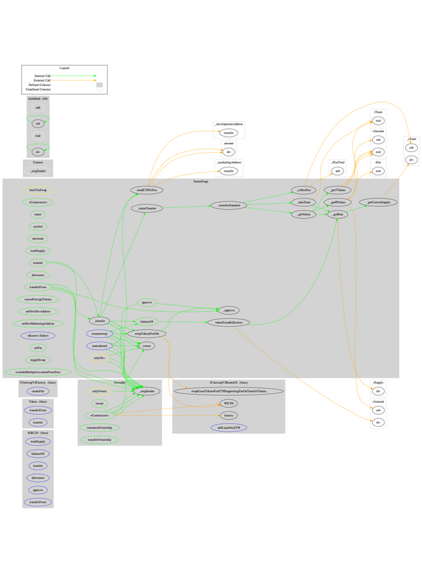

## Domain

| Domain Name | easterdoge.club‌ |
| --- | --- |
| Registry Domain ID | DB08384B8487442488756C34B2023AA76-GDREG‌ |
| Creation Date | 2022-03-19T19:26:26Z‌ |
| Updated Date | 2022-03-19T19:26:28Z‌ |
| Registry Expiry Date | 2023-03-19T19:26:26Z‌ |
| Registrar WHOIS Server | whois.godaddy.com‌ |
| Registrar URL | whois.godaddy.com‌ |
| Registrar | GoDaddy.com, LLC‌ |
| Registrar IANA ID | 146‌ |

The domain has been created about 1 hour before the creation of the audit. It will expire in 12 months.

There is no public billing information, the creator is protected by the privacy settings.

## 

## Summary

EasterDoge is an interesting project that has a friendly and growing community. The Smart Contract analysis reported no compiler errors or critical issues. The contract Owner can access some admin functions that can not be used in a malicious way to disturb the users’ transactions. There is also a limit of max 18% fees.

## Disclaimer

All the content provided in this document is for general information only and should not be used as financial advice or a reason to buy any investment.

Cyberscope team provides no guarantees against the sale of team tokens or the removal of liquidity by the project audited in this document. Always Do your own research and protect yourselves from being scammed.

The Cyberscope team has audited this project for general information and only expresses their opinion based on similar projects and checks from popular diagnostic tools. Under no circumstances did Cyberscope receive a payment to manipulate those results or change the awarding badge that we will be adding in our website.

Always Do your own research and protect yourselves from scams. This document should not be presented as a reason to buy or not buy any particular token.

The Cyberscope team disclaims any liability for the resulting losses.

## About Cyberscope

Coinscope audit and K.Y.C. service has been rebranded to Cyberscope.

Coinscope is the leading early coin listing, voting and ​​auditing authority firm. The audit process is analyzing and monitoring many aspects of the project. That way, it gives the community a good sense of security using an informative report and a generic score.

Cyberscope and Coinscope are aiming to make crypto discoverable and efficient globally. They provides all the essential tools to assist users draw their own conclusions.



The Cyberscope team

https://www.cyberscope.io