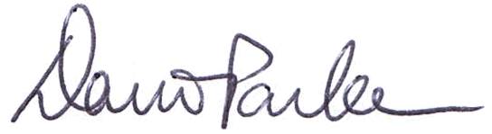

The OpenAgile Institute presents
with the
Date of Completion: February 1, 2011
Certificate#: OALevel7 100 006
http://www.openagile.com/user/42
David D. Parker
Executive Director of the
OpenAgile Institute
This certificate acknowledges:
• in-depth knowledge of helping organizations in using OpenAgile
• experience in helping an organization adopt Truthfulness, Consultative Decision-Making and Systematic Learning
Catalyst
James M. Heidema


Level 7 Certificate:

