
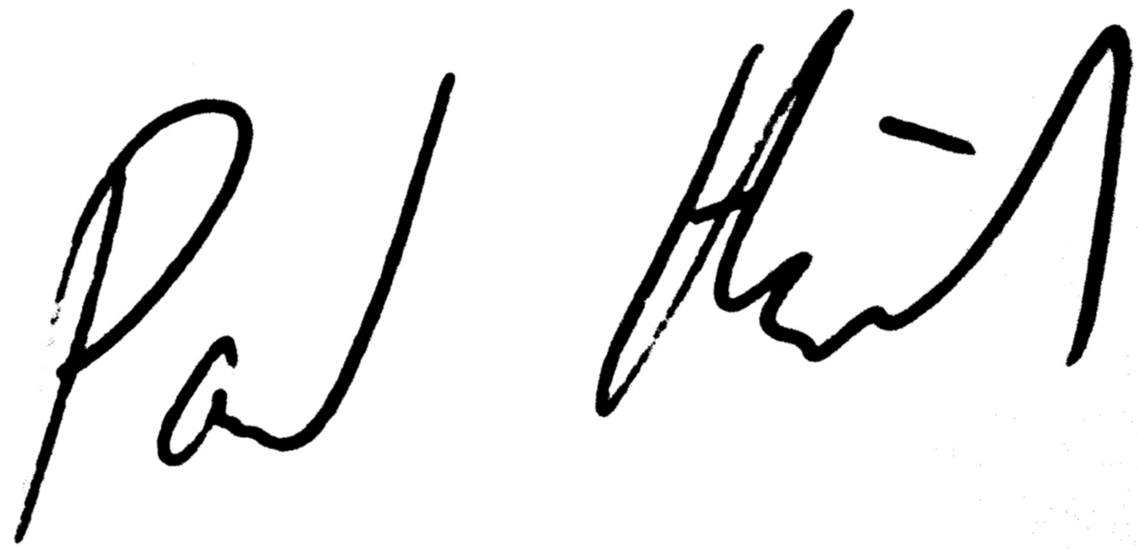
The OpenAgile Institute presents
with the
Date of Completion: January 6, 2012
Certificate#: OALevel1 100 114
http://www.openagile.com/user/1192
Paul Heidema
Secretary, OpenAgile Institute
This certificate acknowledges:
• basic knowledge of OpenAgile
Readiness
Dan Penny

Level 1 Certificate:

