
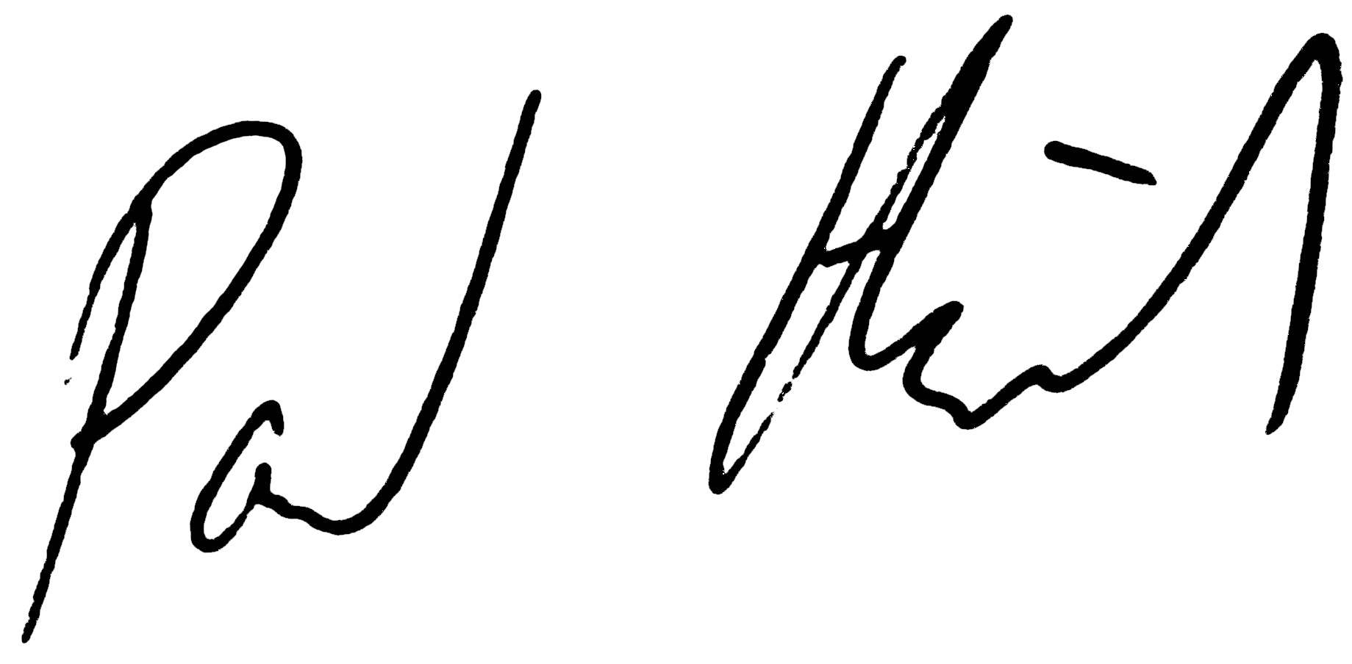

Christen
Paul Heidema
Secretary, OpenAgile Institute
Date of Completion: January 21, 2013
Certificate#: OALevel1 100 261
http://www.openagile.com/user/2330
OpenAgile Institute
presents
Level 1 Readiness Certificate
Foundational Knowledge of OpenAgile

