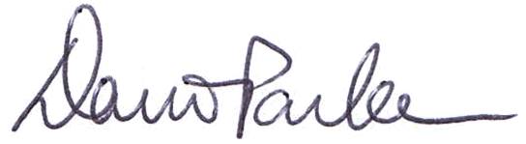

The OpenAgile Institute presents
with the
Date of Completion: October 27, 2011
Certificate#: OALevel2 100 018
http://www.openagile.com/user/773
David D. Parker
Executive Director of the
OpenAgile Institute
This certificate acknowledges:
• knowledge of the OpenAgile team member role
• putting the foundations into practice
(truthfulness, consultative decision-making, the learning circle)
• experience as a team member on an agile team
Team Member
Nudrat Usmani


Level 2 Certificate:

