Smart Face Recognition System for Secure Identification with Python and SQL Integration

AnanthLaxman S(95072412018)
Asmar U (95072412030)
Azeel U (95072412031)

INTRODUCION
Face recognition has emerged as one of the most significant applications of computer vision and artificial intelligence, enabling automated identification and verification of individuals based on their facial features. With the increasing demand for secure and contactless systems, face recognition technology is widely used in applications such as attendance systems, surveillance, authentication, and access control. Traditional identification methods like ID cards or passwords are prone to loss, theft, or misuse, whereas face recognition offers a more reliable and efficient alternative. In real-world environments, managing and verifying identity manually is time-consuming and error-prone, especially when dealing with large numbers of individuals. This creates a need for an automated system that can accurately detect and recognize faces in real time while maintaining a structured record of data. Integrating face recognition with a database system enhances its usability by enabling storage, retrieval, and management of user information efficiently. This project focuses on the design and development of a Face Recognition System using a web-based interface. The frontend is developed using HTML and CSS to provide a simple and interactive user experience, while the backend is implemented in Python to handle face detection and recognition using computer vision techniques. A SQL database is used to store user details and recognition records, ensuring data persistence and easy access. The system allows users to register their facial data, store it in the database, and later perform recognition through a live or captured image. Upon successful identification, the system retrieves and displays the corresponding user information. This project aims to bridge the gap between theoretical knowledge of computer vision and its practical implementation, providing a functional solution for real-time face recognition integrated with web technologies and database management.
.

ABSTRACT
Face recognition is a widely used computer vision technique for identifying individuals based on their facial features. This project presents the design and development of a web-based Face Recognition System that integrates a frontend built using HTML and CSS with a backend implemented in Python, along with a SQL database for data management. The system is designed to automate the process of identifying and verifying users in an efficient and reliable manner. The application allows users to register their facial data, which is processed using computer vision algorithms and stored in the database along with relevant user information. During recognition, the system captures an image, detects the face, and compares it with stored data to identify the individual. Upon successful recognition, the corresponding user details are retrieved from the database and displayed through the interface. The system focuses on providing accurate and real-time recognition while maintaining a simple and user-friendly interface. By combining web technologies with backend processing and database integration, the project demonstrates a practical implementation of face recognition for applications such as attendance management, security systems, and user authentication.
Overall, this project bridges the gap between theoretical concepts of computer vision and real-world application, offering an efficient solution for automated identity recognition.

SYSTEM ARCHITECTURE

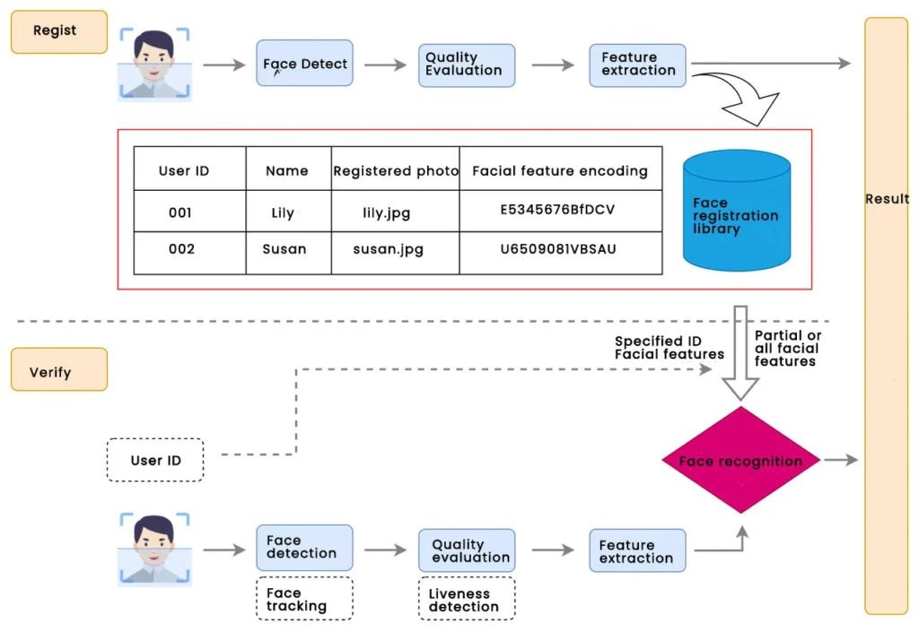

MODULES DESCRIPTION

The Face Recognition System is designed as a combination of multiple functional modules that work together to perform user identification efficiently. The process begins with the user interface module, developed using HTML and CSS, which allows users to register their details and initiate the recognition process. When a user registers, the image capture module activates the webcam to collect multiple facial samples, which are then passed to the backend for processing. The face detection module, implemented using OpenCV, identifies and extracts the facial region from the captured images, ensuring that only relevant features are processed. Once the face is detected, the face recognition module analyzes the extracted features and compares them with previously stored data to identify the user. The backend processing module, developed in Python, coordinates all these operations by handling image processing, executing recognition algorithms, and managing communication between the frontend and the database. The system uses a SQL database such as MySQL to store user information along with their facial data, enabling efficient retrieval during recognition. Additionally, frameworks like Flask can be used to establish a seamless connection between the frontend interface and backend logic. All these modules are tightly integrated to ensure smooth data flow from image capture to final recognition output. The modular design not only improves system organization but also allows easy scalability and future enhancements, such as improving recognition accuracy or integrating advanced machine learning techniques.

HARDWARE AND SOFTWARE REQUIREMENTS

Hardware Requirements
Don’t overcomplicate this—your system is not high-end AI infrastructure.
- Processor: Intel i3 or above
- RAM: Minimum 4 GB (8 GB recommended if you don’t want lag)
- Storage: 500 GB HDD / 256 GB SSD
- Webcam: Required for image capture (built-in or external)
- System Type: 64-bit machine

Software Requirements
Be precise—this is where many people lose marks.
- Operating System: Windows / Linux / macOS
- Programming Language: Python
- Frontend: HTML, CSS
- Libraries: OpenCV for face detection and recognition
- Database: MySQL
- IDE/Editor: VS Code / PyCharm
- Browser: Chrome / Edge
- Framework (optional but recommended): Flask

SAMPLE SCREENSHOT


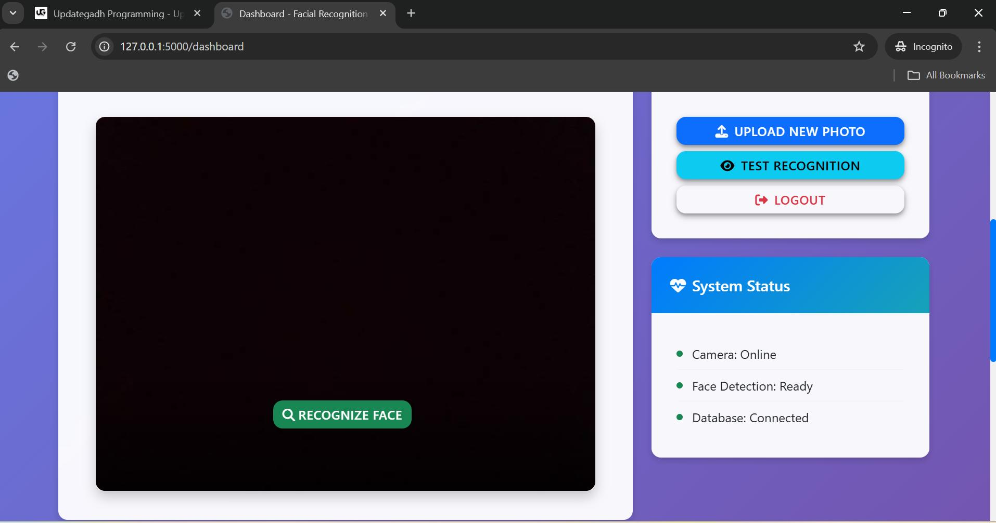

CONCLUSION

This project successfully demonstrates the development of a face recognition system by integrating frontend web technologies with backend processing and database management. The system is capable of capturing facial images, detecting and recognizing faces, and retrieving user information efficiently. Compared to traditional identification methods, the implemented system provides a faster and more reliable approach to identity verification. However, the system is not perfect. Its performance depends heavily on lighting conditions, camera quality, and dataset accuracy. Without proper training data, recognition errors can occur. Despite these limitations, the project provides a strong foundation for real-world applications such as attendance systems, security access control, and user authentication. Overall, this project bridges theoretical knowledge and practical implementation, giving a clear understanding of how computer vision, web development, and database systems can be combined to build an intelligent recognition system.

