Abstract
Introduction
- Importance of Models for predicting Performance in partial Load
- State of the Art: Principally Detailed Models/ Models obtained by regression on empirical data (STAFFEL). Lack of literature presence regarding the modelling in partial load, lack of information given by the manufacturer.
- Normative tends to oversimplify the real behaviour of the unit, especially considering the case the performance differs dramatically changing the operative points (maybe plot a graph of the fcop vs PLR?).
- Necessity of new uniformed standard to check the performance in partial load
Methodology
Preprocessing: STATUS Analysis.
Step for the identification of the functioning state of the different units. Considered DES conditions (power, HC, SET, LExT):
- If Pow <= 5% Pow_DES => Unit OFF
- If T > 50 °C => DHW production (analyse the different installations sites and check if the temperature of operation is lower than 50°C, empirically chosen).
- If LExT – LET <= 1°C and AtW => Defrost. (Can be improved considering the external temperatures/ umidity?)

For AtW:
$$status= \left\{\begin{aligned}STAT if \left|\frac{Q_{t+1}-Q_{t-1}}{2t}\right|≤5\% HC_{des} \\ ACC if \frac{Q_{t+1}-Q_{t-1}}{2t}>5\% HC_{des} \\ DECC if \frac{Q_{t+1}-Q_{t-1}}{2t}<5\% HC_{des}\end{aligned}\right.$$

For WtW:
$$status= \left\{\begin{aligned}STAT if \left|\frac{Q_{t+1}-Q_{t-1}}{2t}\right|≤1\% HC_{des} \\ ACC if \frac{Q_{t+1}-Q_{t-1}}{2t}>1\% HC_{des} \\ DECC if \frac{Q_{t+1}-Q_{t-1}}{2t}<1\% HC_{des}\end{aligned}\right.$$

The reason is because the water source heat pumps tend to be more stable compared to the air to water heat pumps. Thus, there is less fluctuations on the functioning regime and the dead band can be more precise in identifying the transitory regimes. The rule is less precise with WtW machine despite the strict functioning band. Maybe there could be a better strategy to evaluate the different status conditions ( Temporal convolution analysis)
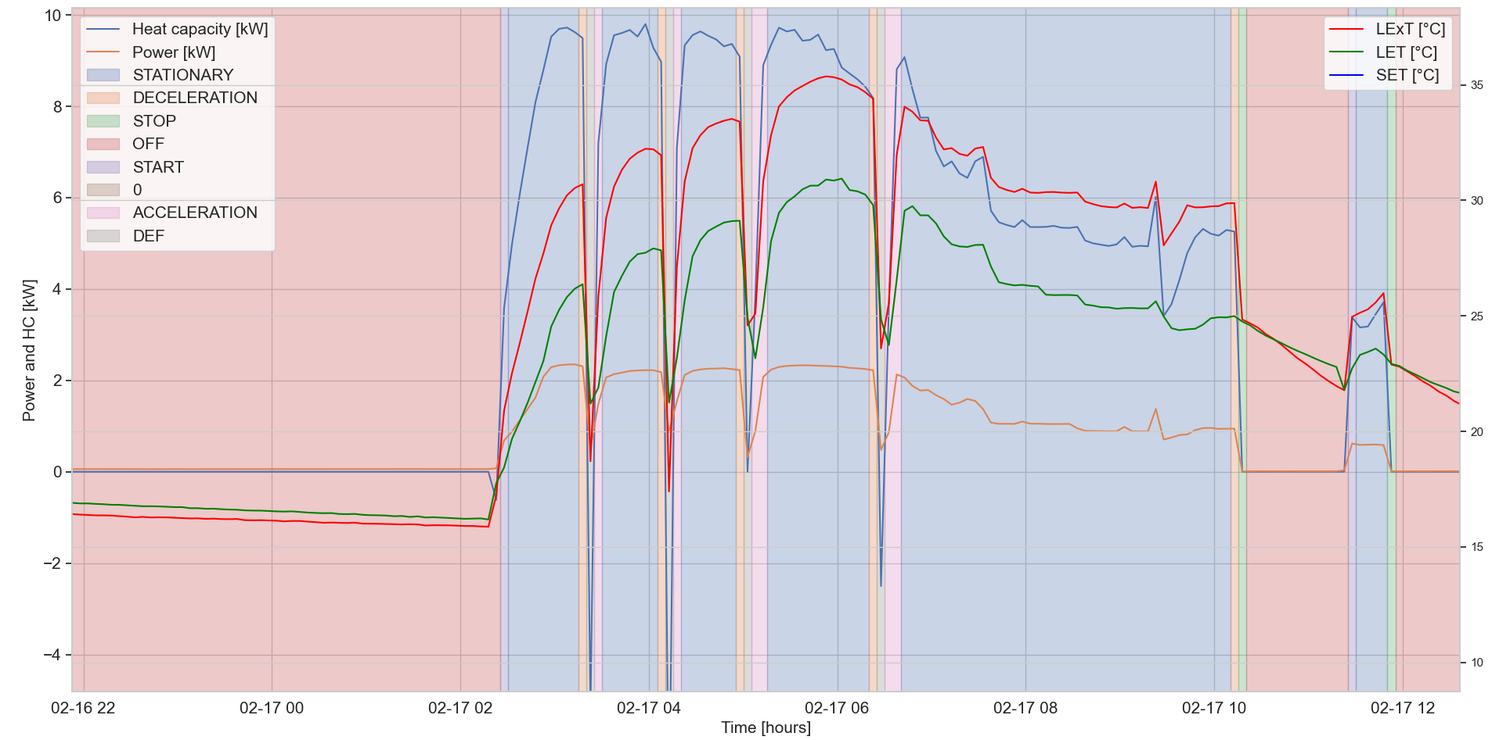
Figure 1. Time behaviour and STATUS Analysis of one AtW unit

Figure 2. Time behaviour and STATUS Analysis of one WtW unit.

Preprocessing: Regression on Full Load Data
Looking at the results obtained, a new regression methodology is required to improve the performance on the full load models. The full load calculation is a mandatory step in order to calculate the partial load ratio, expressed as:
$$PLR=\frac{Q_{pl}(SET, LExT)}{Q_{fl}(SET, LExT)}$$

Two linear regression models were developed to predict the full load heating capacity and the full load power:
$$\frac{Q_{fl}}{{Q_{fl}}_{DES}}=α_{1}\left(\frac{ΔT}{ΔT_{DES}}\right)+β_{1}$$
$$\frac{W_{fl}}{{W_{fl}}_{DES}}=α_{2}\left(\frac{ΔT}{ΔT_{DES}}\right)+β_{2}$$

After the first regression on catalogues data in full load, it is possible to calculates the residuals compared to the first regression. Residuals are calculated using statsmodel (I do not find how the library model works for the calculations) and then the values are used as weights (1/RES^2) for the second regression (weighted regression). The results on the final scores improves thanks to the weighted regression.
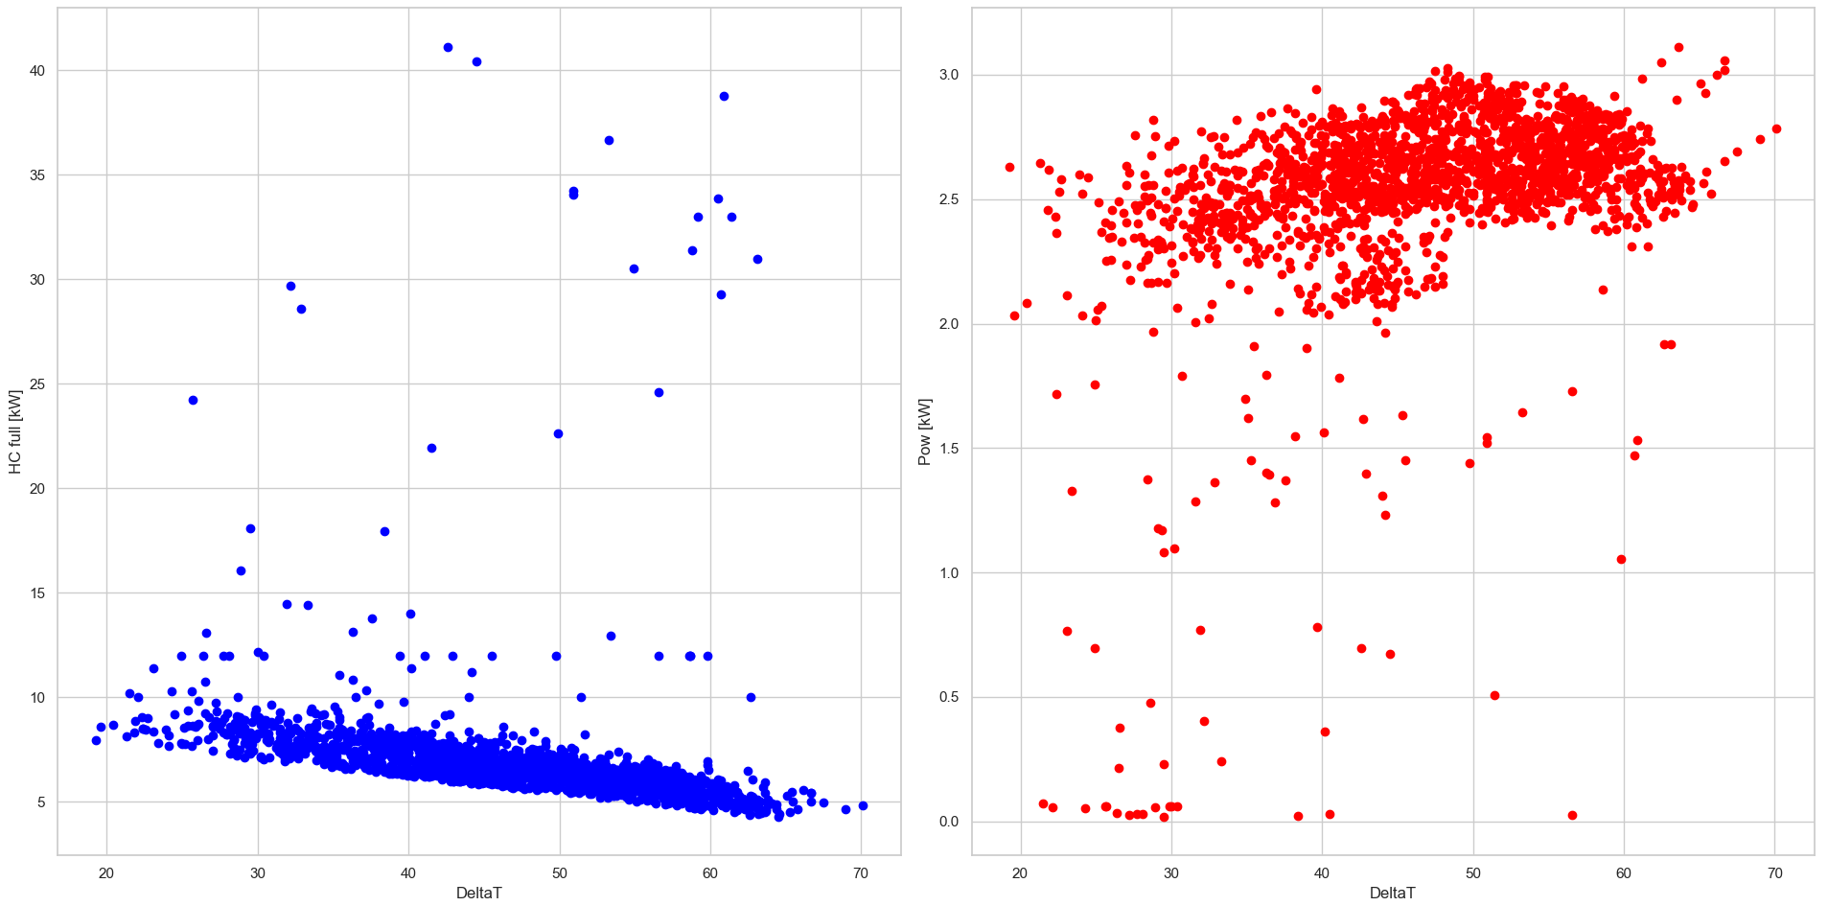
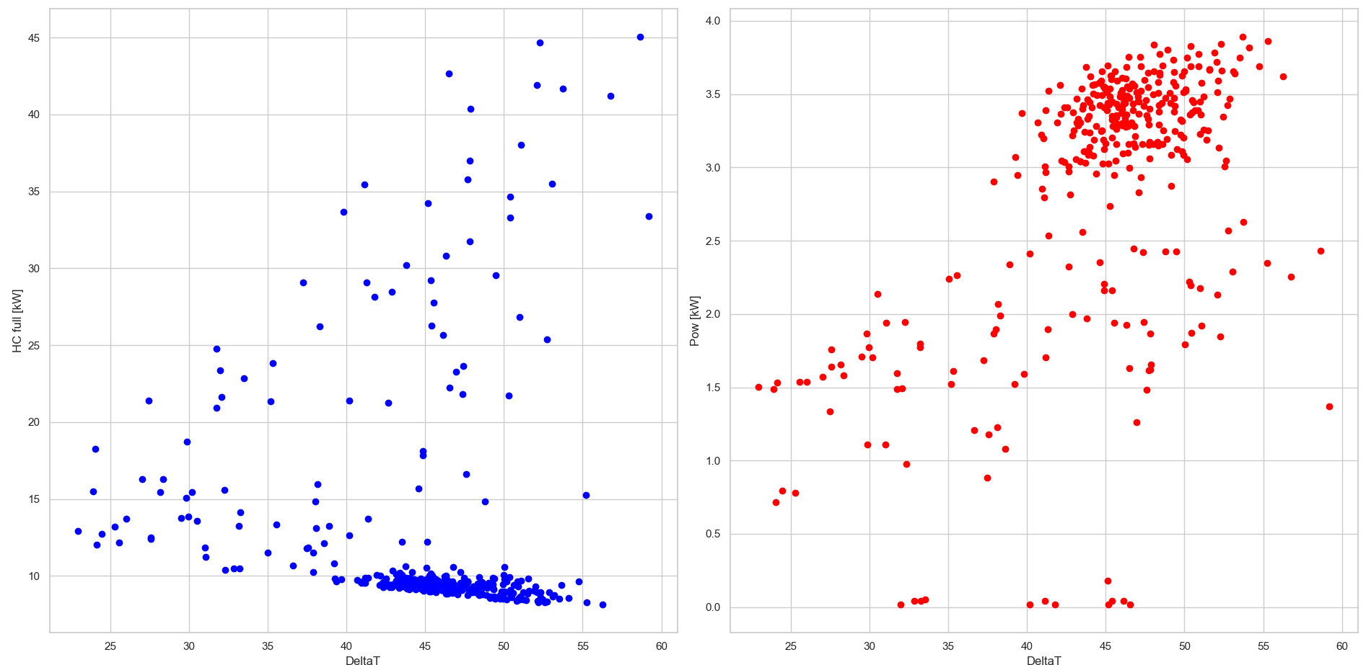

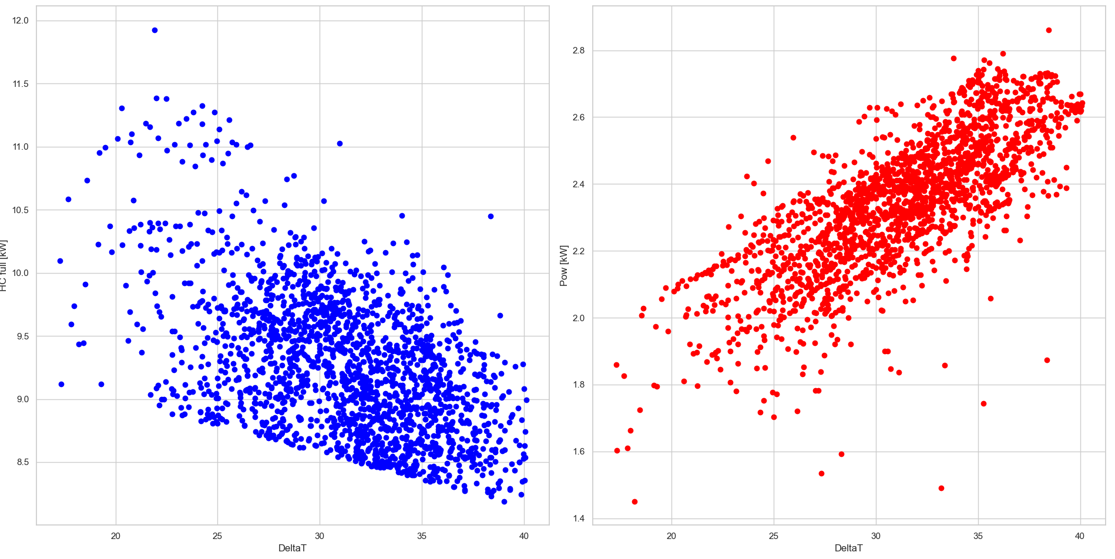
Figure 3. Pattern Behaviour with PLR filtered using the weighted linear regression for Vaillant, NIBE 2050 and RIELLO.

Model for Power in partial load
The electrical power consumed by the compressor is proportional to the temperature difference between load and source (including the temperature difference between secondary fluids and the heat exchangers) and the mass flow rate of refrigerant in the circuit.
$$W_{pl}∝(ΔT+ ΔT_{HE,PL}, m_{ref,pl})$$
$$W_{fl} ∝(ΔT+ ΔT_{HE,fl}, m_{ref,fl})$$
The models can be linearly combined one with the other obtaining the following equation (imposing PLR proportional to the mass flow rate ratio):
$$\frac{W_{pl}}{W_{fl}}= α_{3}PLR\frac{∆T+ ∆T_{HE,pl} }{∆T+ ∆T_{HE,fl}}+ε$$
$$\frac{W_{pl}}{W_{fl}}= α_{3}PLR\frac{∆T}{∆T+ ∆T_{HE,fl}}+\frac{β_{3}PLR\left(∆T_{HE,pl}\right)}{∆T+ ∆T_{HE,fl}} +ε$$

Neglecting the effect of the HE (to verify it), it is possible to write the final model:

$$\frac{W_{pl}}{W_{fl}}= α_{3}PLR+\frac{β_{3}PLR}{∆T} +ε$$

The model is tested on 10 different installations with different power/ number of points per application and type of secondary fluid (two geothermal HPs).
Results
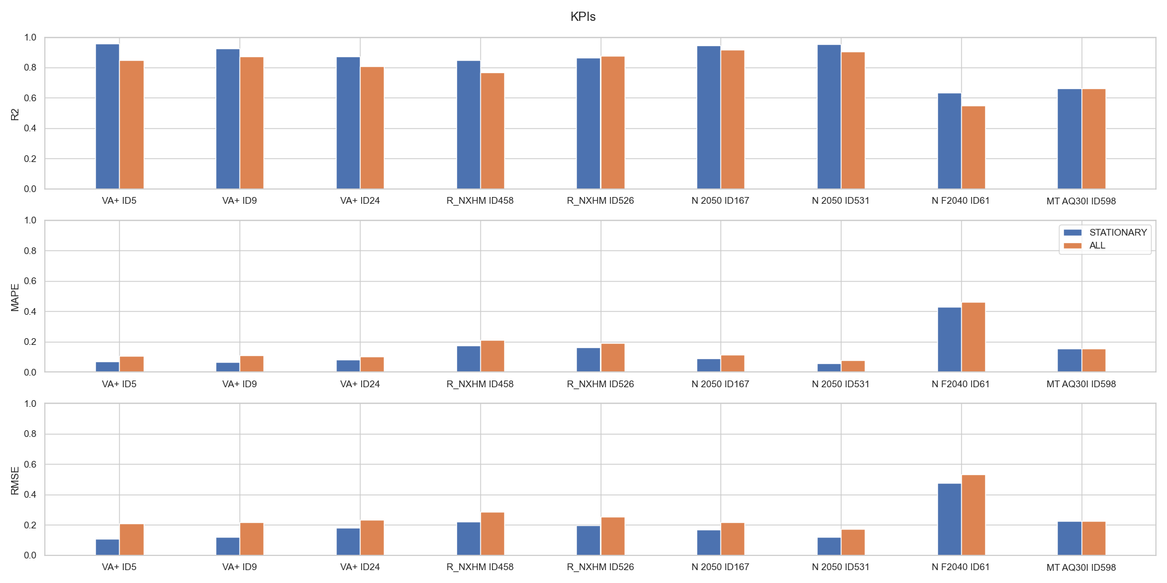
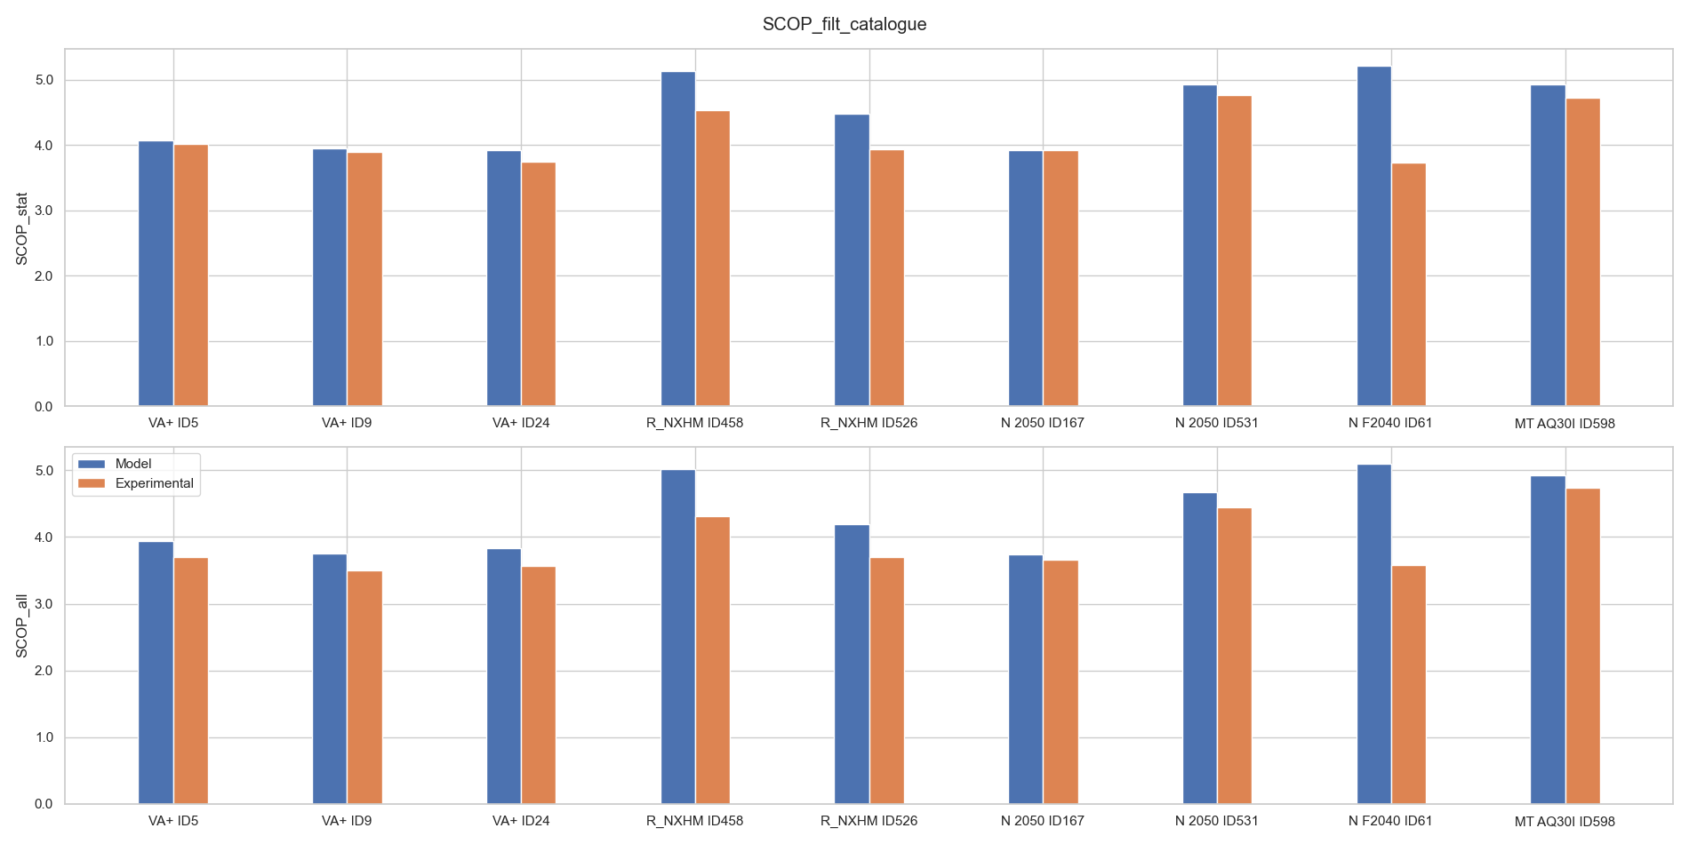
The main results are showed down here:
- R2 is generally good for all the installations/ machines with few exeptions. It is around 0.5 with the operation for the unit NF2040. The catalogue of this unit present partial load points just in the conditions with LExT = 55°c which is generally too high for a real application scenario. Thus, the model tends to fail in the predictions of the SCOP and of the power. In this case, MAPE is above 20%;
- In all almost all models, the predictions are better in the stationary regime compared to the functioning considering even defrost, DHW, acceleration and deceleration are always better. The model is more precise when predicts the stationary conditions.
- The SCOP is higher in the stationary regime compare to the other. The SCOP of the geothermal HP is the highest compare to the installation ID 2050. In case of geothermal HPs, the source temperature is not related to the outdoor temperature, but to the temperature of the water – glycol mixture flowing through the evaporator.
- The models which fails the most in the prediction of the SCOP are the ones which have a lower amount of points in partial load operation.
- In order to work, the model requires at least 4 – 5 points in partial load and the corresponding points in full load (a total amount of 8 points). The points should be taken with different combinations of SET and LExT in order to cover a good part of the envelope.
- The transitory regime have an effect on the SCOP, decreasing the performance of the unit all over the periods analysed. To predict the coefficient of performance of the unit in partial load operation during the transitory regimes, it would be necessary to analyse that specific states.

