Title
Francesco Benà¹, Mohamad Hasan Khajedehi¹, Jacopo Vivian¹, Angelo Zarrella¹
¹ Department of Industrial Engineering - Applied Physics Section, University of Padova, Via Venezia 1 – 35131, Italy

Abstract
According to… .

Keywords
Keyword1, kkkkkk, wwwwwwwww, xxxxxx, yyyyy.

List of symbols
$AAA$ | Explanation of symbol | [U.M.]

Subscripts
S | Meaning of the subscript
- Introduction
  - Background
Piccola introduzione. Contesto in cui si inserisce la ricerca.
  - Literature Review
Cosa dice la letteratura sulla tematica?
  - Aim and novelty
Perché vale la pena pubblicare questo lavoro? Novità introdotte dalla ricerca e obiettivi, viste le lacune evidenziate al paragrafo 1.2.
- Methodology
In this chapter, the methodology used for the calculation of the absorbed power by the compressor of the Heat Pump is presented. First, preprocessing of the experimental dataset is required to identify in which status the machine is operating, since there is no direct access to the controller of the heat pump. After that, to apply the final model, it is required to calculate the heat capacity and power absorbed in full load by the machine. Finally, the model for the partial load operation is obtained and applied in different case studies.
  - Status Analysis
To identify in which regime the machine is operating, an empirical law is developed. To identify the status, a rated working condition must be known (in terms of $W_{des}, HC_{des}, SET, LExT$). The different states are:
- OFF status: the power absorbed by the machine is below 5% of the $W_{des};$
- START status: if at the time instant $t_{i-1}$ , the unit is in OFF status, whereas at the time instant $t_{i}$ the absorbed is greater than $W_{des}$, the unit is turning ON;
- STOP status: if at the $t_{i-1}$ the unit is ON, whereas at instant $t_{i}$ the absorbed is lower than $W_{des}$, the unit is stopping;
- DHW status: all the analyzed units have been designed for an operative temperature lower than 50°C for space heating and all the systems are equipped with a domestic hot water tank. If the $LExT$ rises above a defined threshold of 50 °C, the machine is producing domestic hot water.
- Defrost status: since there is no direct control on the evaporator, it is assumed that Air to Water Heat pumps are defrosting if the temperature difference between $LExT$ and $LET$ drops below 1 K. The reason why this threshold is defined is because, looking at the temporal series of the temperatures, in some cases, the units exits from defrost status before the two temperatures switches (in an inverse loop defrost, the $LET$ is expected to become greater than $LExT$ because the condenser is now operating as evaporator).;
- STATIONARY, ACCELERATION and MODULATION status: the three conditions are identified by the following formula for Air to Water Heat Pumps (AtW HPs):

$$status= \left\{\begin{aligned}STAT if \left|\frac{Q_{t+1}-Q_{t-1}}{2t}\right|≤5\% HC_{des} \\ ACC if \frac{Q_{t+1}-Q_{t-1}}{2t}>5\% HC_{des} \\ DECC if \frac{Q_{t+1}-Q_{t-1}}{2t}<5\% HC_{des}\end{aligned}\right. (1)$$

Where $t$ is the time between two measurements (5 minutes). The threshold of 5% is empirically chosen, looking at the temporal behavior of the machines;
- STATIONARY, ACCELERATION and MODULATION status: the three conditions are identified by the following formula for Water to Water Heat Pumps (WtW HPs):

$$status= \left\{\begin{aligned}STAT if \left|\frac{Q_{t+1}-Q_{t-1}}{2t}\right|≤1\% HC_{des} \\ ACC if \frac{Q_{t+1}-Q_{t-1}}{2t}>1\% HC_{des} \\ DECC if \frac{Q_{t+1}-Q_{t-1}}{2t}<1\% HC_{des}\end{aligned}\right. (2)$$

Where $t$ is the time between two measurements (5 minutes). The threshold of 1% is empirically chosen, looking at the temporal behavior of the machines and it is smaller compared to the one selected for the AtW Heat Pumps since this kind of units tend to be more stable compared to the air source ones. Thus, to better identify the transitory regimes, it is required to strict the gap to identify the steady- state operation.
In Figure 1, an example of the identification of the different states is reported for an AtW unit. It is possible to notice the STATIONARY status does not correspond to a flat pattern of the different magnitudes displayed. This is because, in real installations, the machines will never have a perfect flat behavior thanks to all the noises present, which can be removed in a climatic chamber. For the type of study reported in this paper, the conditions reported in the two previous equations give enough satisfactory results.
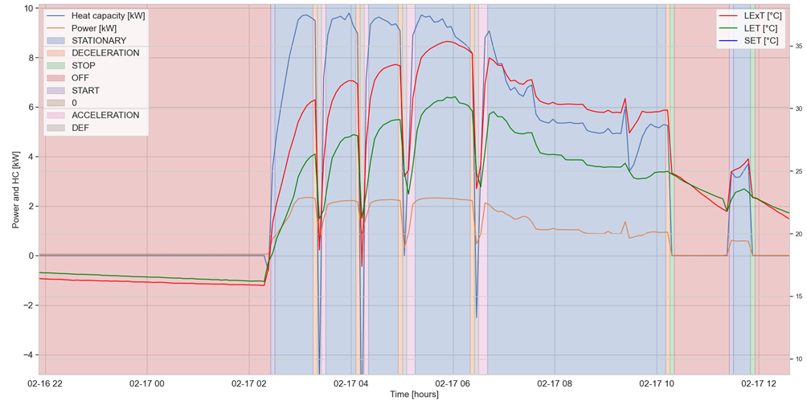
Figure 1: Status identification sown with different colours for a AtW HPs.

- Results
Text.
Figure 1: Plan view of the CORE-CARE laboratory
Tab. 1: Dimensions of the CORE-CARE laboratory
- Discussion and future works
Nella discussion (facoltativa) vanno confrontati i risultati ottenuti con la letteratura di settore.
- Conclusion

Acknowledgments

References

