AUTOMATED TECHNICAL REPORT
Italian Household Archetypes and Energy Analysis
Automated methods and results report
Household clustering, dwelling probabilities, Type-II ANOVA, and Tukey-Kramer groups
Generated from workflow outputs. Statistical interpretation is intentionally omitted.

1. Data and workflow configuration
The report is generated from the raw ISTAT household survey, the restored four-archetype assignments, the windowed dwelling probability dataset, and the GRINS annual electricity results.
Table 1. Workflow inputs, row counts, and deterministic configuration.
Item | Value
Raw ISTAT households | 20000
Archetyped households | 17855
PFE windows | 63
Energy-analysis households | 17605
Age seed | 42
Cluster seed | 1
Dwelling seed | 42
ANOVA alpha | 0.05

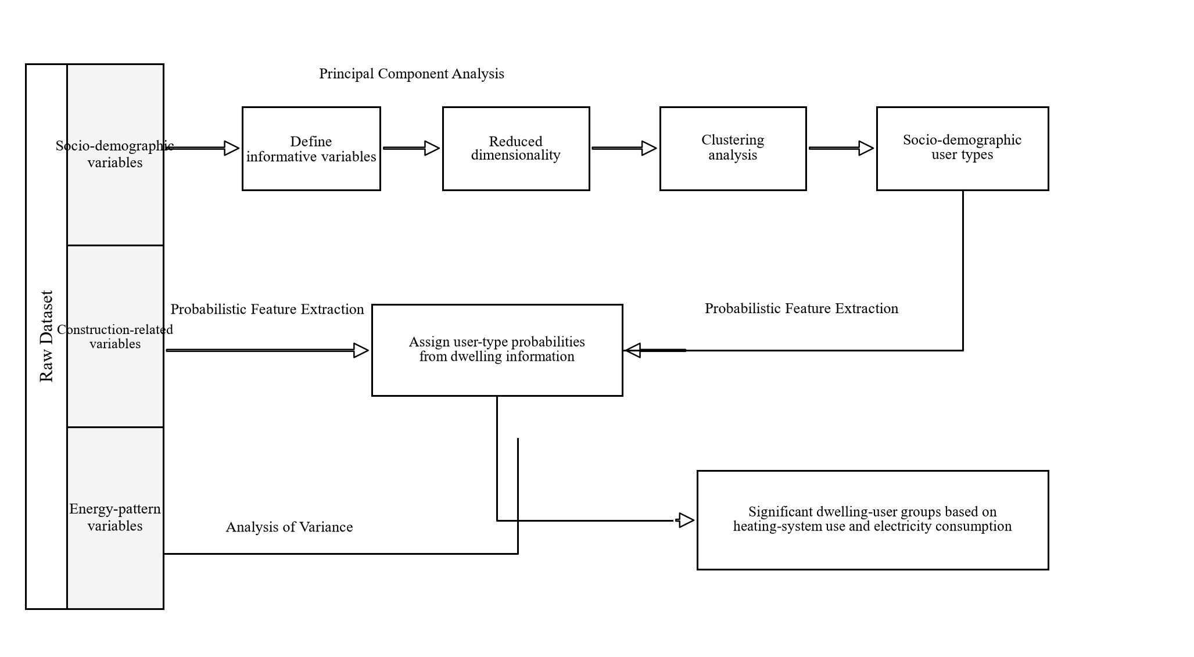
Figure 1. Process flow of the study.

2. Household archetypes

2.1 Feature construction and clustering
Household member ages, household size, and the education index are used to construct two published PCA components. The three normalized clustering features are PCA component 1, PCA component 2, and the education index. Four clusters are estimated with seeded k-means++ initialization and Lloyd iteration.
PC1 = -0.25 x minimum age - 0.75 x maximum age + 10 x household members
PC2 = (1/3) x minimum age + (2/3) x maximum age + 10 x household members
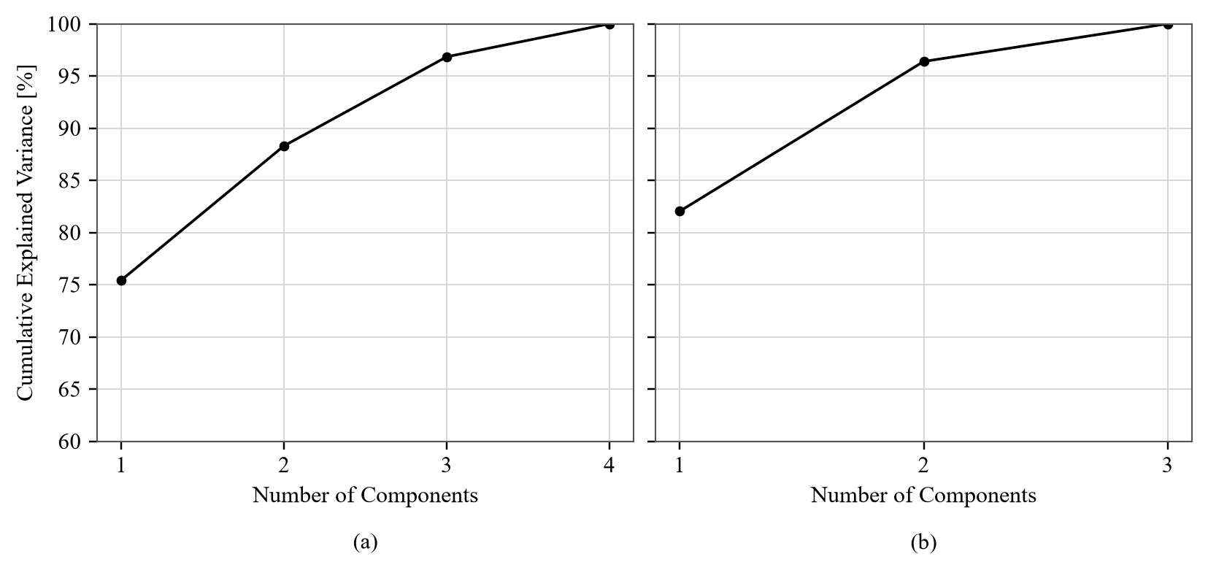
Figure 2. Explained variance of principal components considering (a) all variables and (b) excluding education.
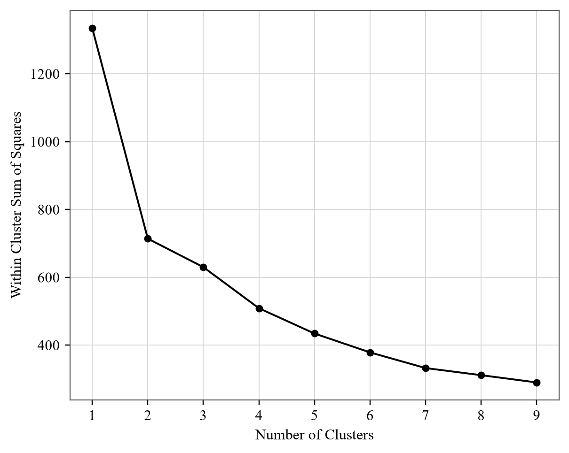
Figure 3. Within Cluster Sum of Squares as a function of the number of clusters.
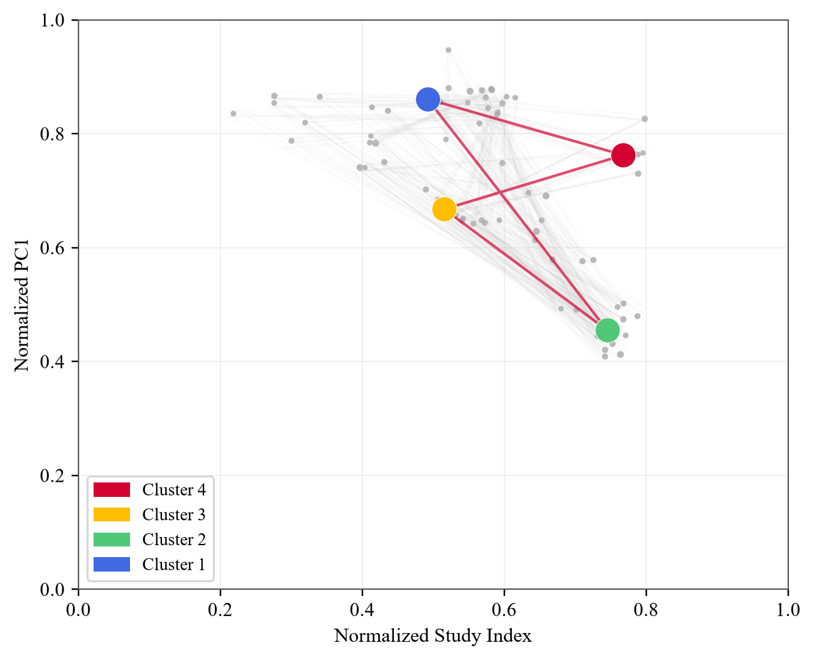
Figure 4. Cluster centroids for individual Italian regions and the complete dataset. Gray polygons represent regional solutions; colored points and the red polygon represent the complete dataset.
Table 2. Restored four-archetype household statistics. Values in parentheses are standard deviations.
Archetype | Households | Household share (%) | People share (%) | Minimum age | Maximum age | Members | Education index
1 | 7165 | 40.1 | 29.9 | 70.3 (11.1) | 78.3 (5.0) | 1.8 (0.7) | 0.49 (0.12)
2 | 4781 | 26.8 | 40.0 | 21.1 (7.6) | 57.2 (8.5) | 3.7 (0.9) | 0.74 (0.09)
3 | 4065 | 22.8 | 21.2 | 45.9 (12.8) | 63.1 (8.0) | 2.3 (0.8) | 0.52 (0.09)
4 | 1844 | 10.3 | 8.9 | 55.2 (17.4) | 72.2 (8.9) | 2.1 (0.8) | 0.77 (0.08)

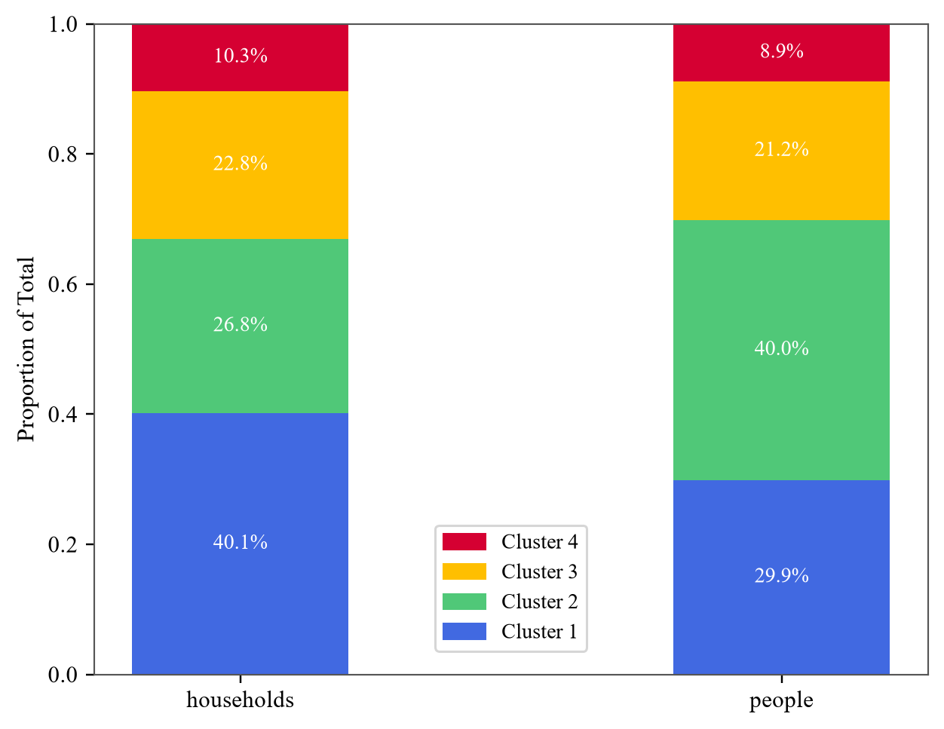
Figure 5. Proportion of each cluster among households and people.

3. Dwelling-to-archetype probabilities

3.1 Windowed probabilistic feature extraction
Building-age and dwelling-area classes are expanded with the configured dwelling seed. Archetype counts are calculated in centered age and area windows. Each probability equals the archetype count divided by the total sample count in its window.
Table 3. Windowed dwelling probability dataset summary.
Item | Value
Configured windows | 63
Building-age centers | 7
Dwelling-area centers | 9
Minimum sample count | 2
Maximum sample count | 775
Maximum probability-sum error | 0

Table 4. Windowed probability regression coefficients and goodness-of-fit statistics.
Term | Prob. 1 | Prob. 2 | Prob. 3 | Prob. 4
intercept | 0.434 | 0.276 | 0.393 | -0.103
age / 100 | 0.851 | -0.670 | -0.275 | 0.093
area / 100 | -0.327 | 0.241 | -0.105 | 0.190
age squared / 10,000 | -0.480 | 0.412 | 0.132 | -0.064
area squared / 10,000 | 0.065 | -0.036 | 0.013 | -0.042
age x area / 10,000 | -0.011 | -0.081 | 0.039 | 0.052
Adjusted R squared | 0.216 | 0.123 | 0.020 | 0.166
RMSE | 0.165 | 0.160 | 0.139 | 0.145

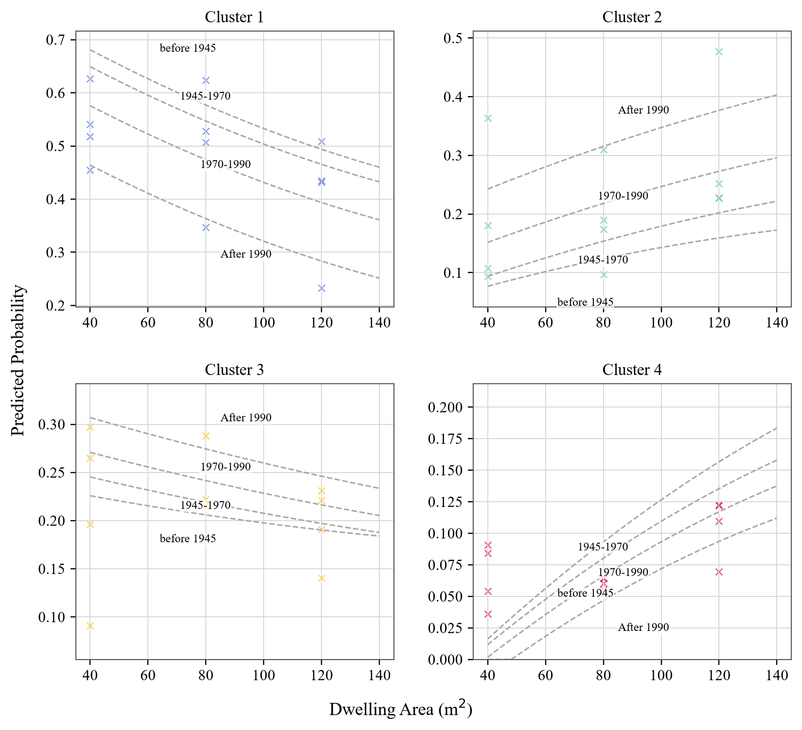
Figure 6. Probability of each cluster as dwelling age and area change. Points are calculated proportions; dashed lines are regression-model predictions for different construction-age classes.
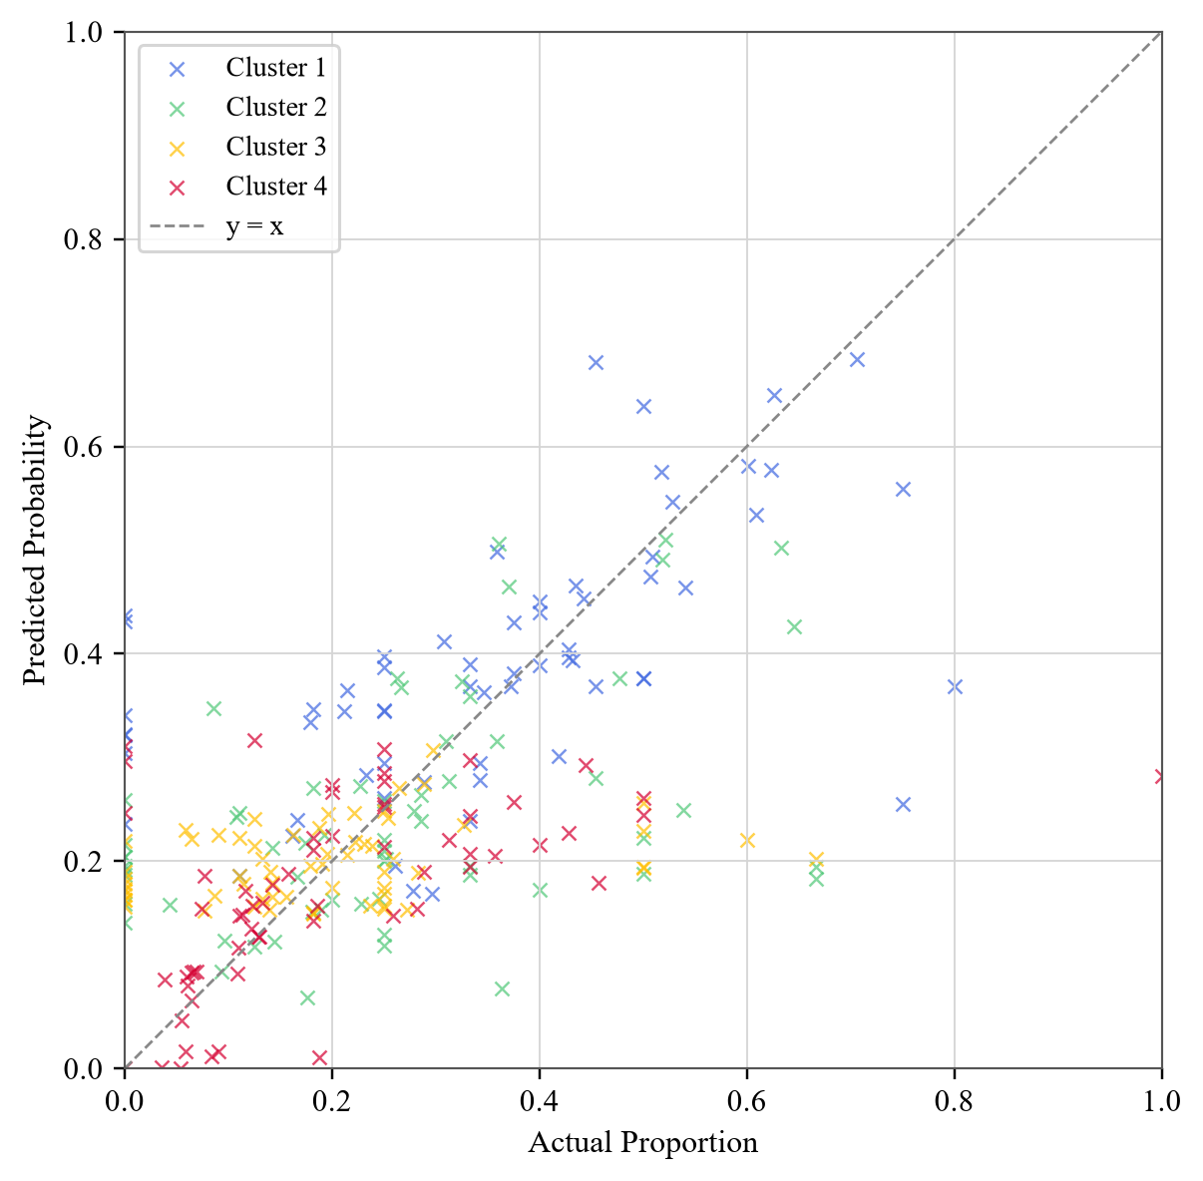
Figure 7. Alignment between predicted and actual values across clusters.

4. Energy analysis

4.1 Response and explanatory variables
Daily heating-system on-time is the sum of q_3_11A, q_3_11B, and q_3_11C. Annual electricity consumption is appliances_el_kWh. Explanatory variables are user archetype, dwelling type, location, insulation level, building age, dwelling area, and cooling-system use.

4.2 Type-II ANOVA
Table 5. Type-II ANOVA results for daily heating-system on-time and annual electricity consumption.
Variable or interaction | Heating F | Heating p | Electricity F | Electricity p
Usercluster | 12.80 | <0.001 | 158.56 | <0.001
Dwellingtype | 59.13 | <0.001 | 5.61 | <0.001
Location | 550.07 | <0.001 | 6.13 | <0.001
Insulationlevel | 10.30 | <0.001 | 4.37 | 0.004
Age_dwel | 14.88 | <0.001 | 55.86 | <0.001
Area_dwel | 35.25 | <0.001 | 245.92 | <0.001
CoolingSystemUse | 0.22 | 0.638 | 18.15 | <0.001
Usercluster x Dwellingtype | 2.35 | 0.005 | 0.96 | 0.482
Usercluster x Location | 2.14 | 0.023 | 2.77 | 0.003
Usercluster x InsulationLevel | 1.26 | 0.255 | 1.72 | 0.079
InsulationLevel x Location | 1.07 | 0.382 | 0.43 | 0.918
Dwellingtype x Location | 10.06 | <0.001 | 1.44 | 0.141
Dwellingtype x InsulationLevel | 0.78 | 0.670 | 0.97 | 0.472
Age_dwel x Area_dwel | 0.21 | 0.644 | 0.03 | 0.866

4.3 Iterative Tukey-Kramer groups

Heating-system on-time groups
Table 6. Heating-system on-time groups: generated and published summary statistics.
Group | n | Generated mean | Generated SD | Paper mean | Paper SD
H1 | 630 | 4.69 | 3.01 | 4.67 | 3.54
H2 | 2431 | 5.42 | 3.76 | 5.25 | 3.77
H3 | 1651 | 6.75 | 3.80 | 6.91 | 4.43
H4 | 2745 | 7.17 | 4.67 | 7.53 | 4.41
H5 | 2142 | 7.63 | 4.40 | 8.53 | 4.00
H6 | 1606 | 8.33 | 4.03 | 9.14 | 4.17
H7 | 2782 | 8.99 | 4.27 | 9.67 | 4.28
H8 | 3618 | 9.64 | 4.38

Annual electricity groups
Table 7. Annual electricity groups: generated and published summary statistics.
Group | n | Generated mean | Generated SD | Paper mean | Paper SD
E1 | 1063 | 2010.14 | 1451.01 | 1801.00 | 1502.00
E2 | 5190 | 2179.67 | 1656.73 | 2023.00 | 1631.00
E3 | 5859 | 2317.45 | 1848.34 | 2320.00 | 1502.00
E4 | 5493 | 2453.13 | 1847.13 | 2646.00 | 1844.00

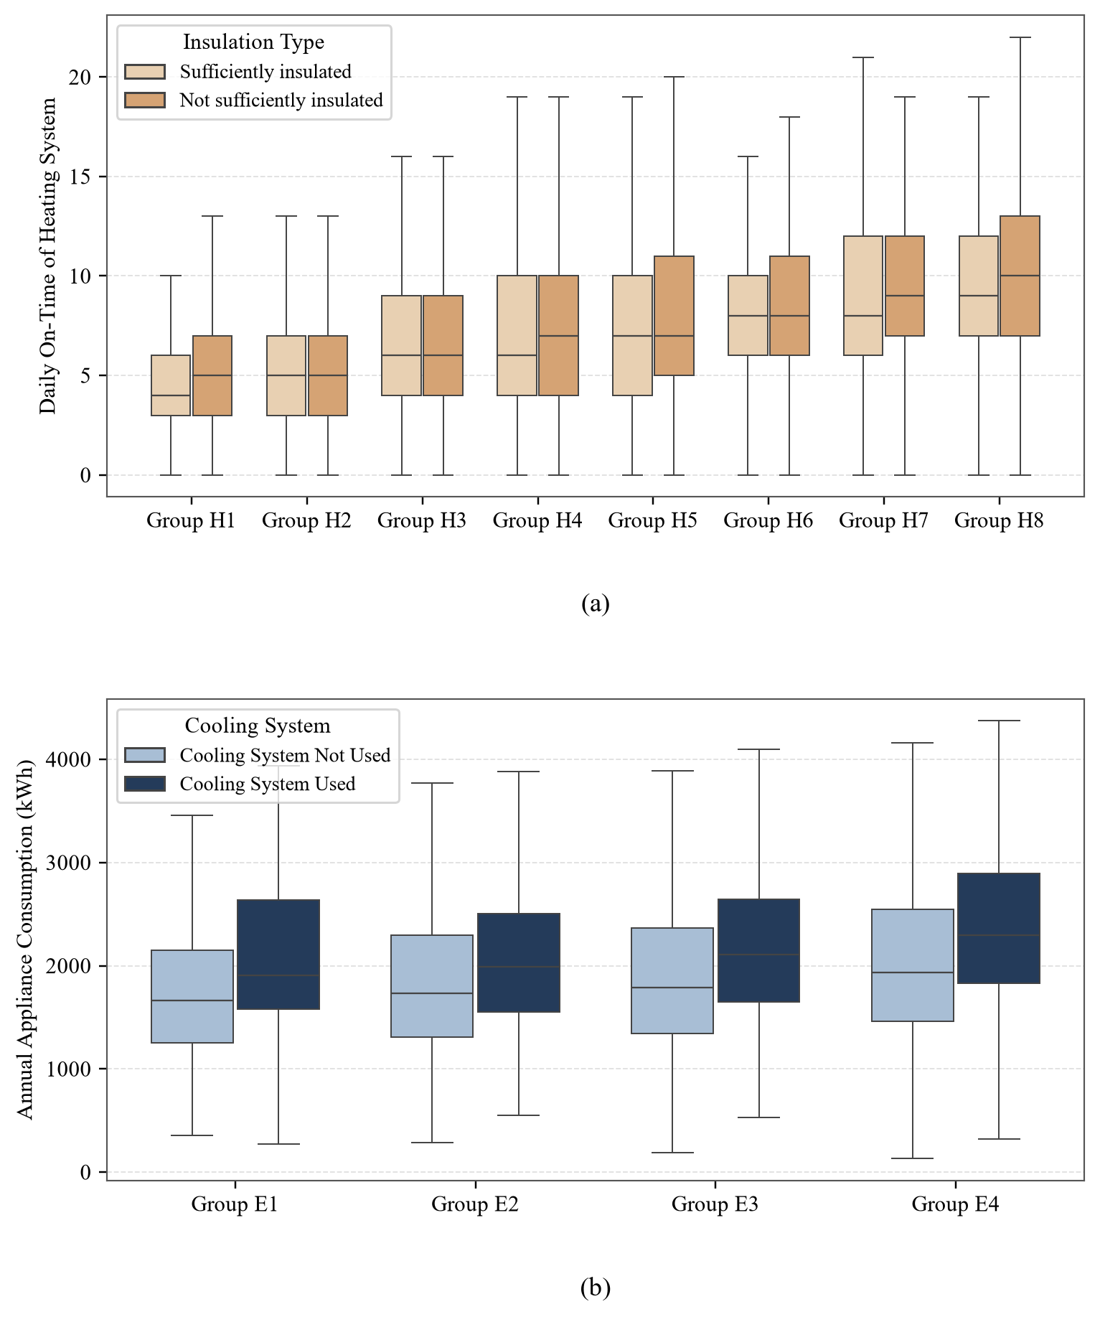
Figure 8. Variation of (a) daily heating-system operating hours and (b) annual electricity consumption across the generated significant groups. Box plots are drawn without outliers; boxes span the second and third quartiles and the internal line is the median.
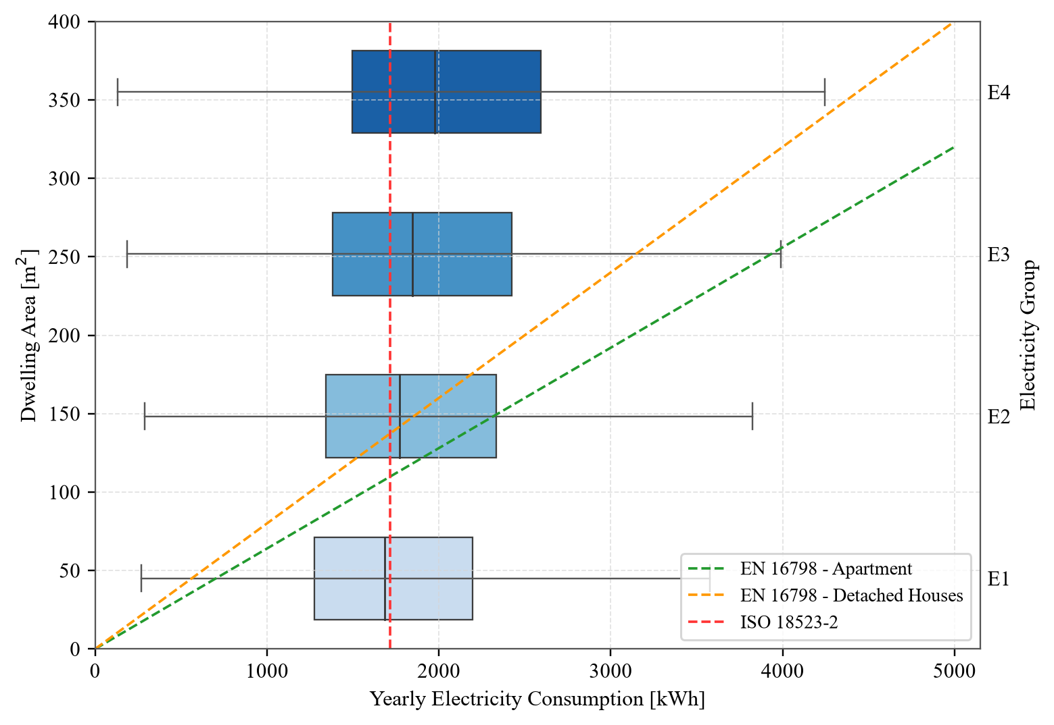
Figure 9. Yearly electricity consumption, dwelling area, generated electricity groups, and the reference assignments from EN 16798 and ISO 18523-2.
Table 8. Separate categorical factor summaries retained by the paper methodology.
Response | Factor | Level | n | Mean | SD
heating_daily_hours | insulation_level | none_or_slight | 4507 | 7.89 | 4.51
heating_daily_hours | insulation_level | sufficient_or_high | 13098 | 7.71 | 4.44
electricity_annual_kwh | archetype | 1 | 7047 | 1956.49 | 1680.70
electricity_annual_kwh | archetype | 2 | 4728 | 2809.40 | 1760.95
electricity_annual_kwh | archetype | 3 | 4010 | 2249.58 | 1758.55
electricity_annual_kwh | archetype | 4 | 1820 | 2423.77 | 1885.81
electricity_annual_kwh | cooling_system_use | absent_or_unused | 15059 | 2261.21 | 1778.65
electricity_annual_kwh | cooling_system_use | present_or_used | 2546 | 2533.68 | 1742.28

5. Workflow validation
Table 9. Automated workflow and paper-alignment validation record.
Check | Result
Four-archetype paper-tolerance checks | PASS
Probability checks | PASS
Energy structural checks | PASS
ANOVA significance matches | 25 of 28
Generated heating groups / paper count | 8 / 7
Generated electricity groups / paper text / Table 6 | 4 / 6 / 5

Appendix A. Assignment of user groups by dwelling type, location, and archetype
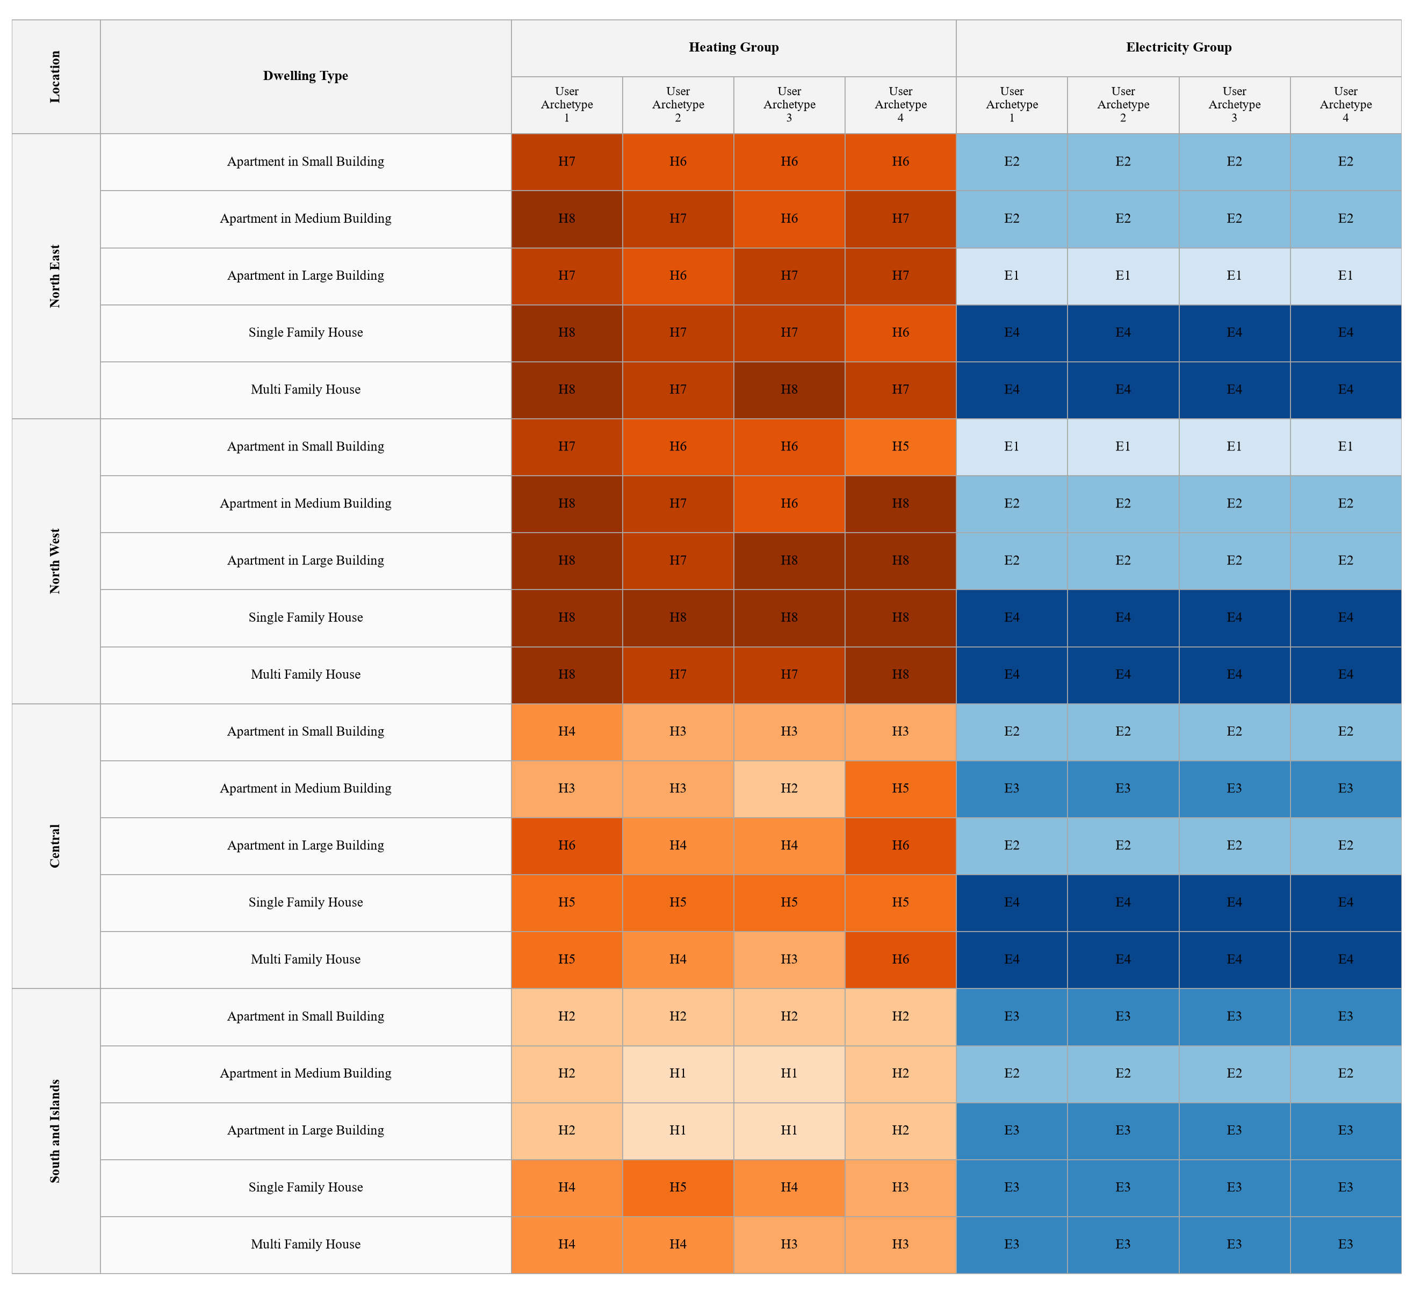
Figure A.1. Assignment of generated heating and electricity groups by dwelling type, location, and user archetype.

Appendix B. Windowed archetype probabilities
Table 10. Complete building-age and dwelling-area probability grid.
Age | Area | n | P(A1) | P(A2) | P(A3) | P(A4)
20 | 40 | 37 | 0.541 | 0.108 | 0.297 | 0.054
40 | 40 | 83 | 0.518 | 0.181 | 0.265 | 0.036
60 | 40 | 107 | 0.626 | 0.093 | 0.196 | 0.084
80 | 40 | 17 | 0.706 | 0.176 | 0.059 | 0.059
100 | 40 | 11 | 0.455 | 0.364 | 0.091 | 0.091
120 | 40 | 16 | 0.500 | 0.125 | 0.188 | 0.188
140 | 40 | 12 | 0.750 | 0.000 | 0.250 | 0.000
20 | 80 | 326 | 0.347 | 0.310 | 0.288 | 0.055
40 | 80 | 747 | 0.507 | 0.174 | 0.254 | 0.064
60 | 80 | 464 | 0.528 | 0.190 | 0.222 | 0.060
80 | 80 | 118 | 0.602 | 0.144 | 0.195 | 0.059
100 | 80 | 93 | 0.624 | 0.097 | 0.215 | 0.065
120 | 80 | 46 | 0.609 | 0.043 | 0.239 | 0.109
140 | 80 | 52 | 0.442 | 0.192 | 0.327 | 0.038
20 | 120 | 430 | 0.233 | 0.477 | 0.221 | 0.070
40 | 120 | 775 | 0.432 | 0.227 | 0.231 | 0.110
60 | 120 | 246 | 0.435 | 0.252 | 0.191 | 0.122
80 | 120 | 53 | 0.358 | 0.245 | 0.283 | 0.113
100 | 120 | 57 | 0.509 | 0.228 | 0.140 | 0.123
120 | 120 | 30 | 0.400 | 0.333 | 0.133 | 0.133
140 | 120 | 43 | 0.372 | 0.279 | 0.163 | 0.186
20 | 160 | 31 | 0.161 | 0.645 | 0.065 | 0.129
40 | 160 | 39 | 0.179 | 0.359 | 0.179 | 0.282
60 | 160 | 14 | 0.429 | 0.286 | 0.143 | 0.143
80 | 160 | 3 | 0.000 | 0.667 | 0.000 | 0.333
100 | 160 | 3 | 0.000 | 0.667 | 0.000 | 0.333
120 | 160 | 4 | 0.250 | 0.000 | 0.500 | 0.250
140 | 160 | 5 | 0.000 | 0.000 | 0.600 | 0.400
20 | 200 | 27 | 0.111 | 0.370 | 0.259 | 0.259
40 | 200 | 35 | 0.343 | 0.086 | 0.114 | 0.457
60 | 200 | 14 | 0.214 | 0.286 | 0.143 | 0.357
80 | 200 | 7 | 0.429 | 0.143 | 0.000 | 0.429
100 | 200 | 6 | 0.333 | 0.333 | 0.000 | 0.333
120 | 200 | 8 | 0.250 | 0.250 | 0.250 | 0.250
140 | 200 | 4 | 0.250 | 0.250 | 0.000 | 0.500
20 | 240 | 27 | 0.296 | 0.519 | 0.111 | 0.074
40 | 240 | 45 | 0.289 | 0.267 | 0.156 | 0.289
60 | 240 | 16 | 0.250 | 0.312 | 0.125 | 0.312
80 | 240 | 4 | 0.500 | 0.250 | 0.250 | 0.000
100 | 240 | 5 | 0.800 | 0.000 | 0.000 | 0.200
120 | 240 | 2 | 0.000 | 0.000 | 0.000 | 1.000
140 | 240 | 9 | 0.333 | 0.111 | 0.111 | 0.444
20 | 280 | 36 | 0.278 | 0.361 | 0.250 | 0.111
40 | 280 | 38 | 0.342 | 0.263 | 0.237 | 0.158
60 | 280 | 11 | 0.182 | 0.455 | 0.182 | 0.182
80 | 280 | 4 | 0.500 | 0.000 | 0.250 | 0.250
100 | 280 | 12 | 0.333 | 0.167 | 0.250 | 0.250
120 | 280 | 2 | 0.000 | 0.500 | 0.500 | 0.000
140 | 280 | 2 | 0.000 | 0.500 | 0.500 | 0.000
20 | 320 | 23 | 0.261 | 0.522 | 0.087 | 0.130
40 | 320 | 43 | 0.419 | 0.326 | 0.140 | 0.116
60 | 320 | 11 | 0.455 | 0.182 | 0.182 | 0.182
80 | 320 | 4 | 0.250 | 0.250 | 0.000 | 0.500
100 | 320 | 5 | 0.400 | 0.200 | 0.200 | 0.200
120 | 320 | 3 | 0.000 | 0.000 | 0.667 | 0.333
140 | 320 | 8 | 0.750 | 0.000 | 0.125 | 0.125
20 | 360 | 30 | 0.167 | 0.633 | 0.133 | 0.067
40 | 360 | 33 | 0.212 | 0.333 | 0.273 | 0.182
60 | 360 | 13 | 0.308 | 0.538 | 0.077 | 0.077
80 | 360 | 5 | 0.400 | 0.400 | 0.000 | 0.200
100 | 360 | 8 | 0.375 | 0.250 | 0.000 | 0.375
120 | 360 | 8 | 0.375 | 0.250 | 0.125 | 0.250
140 | 360 | 4 | 0.250 | 0.000 | 0.500 | 0.250

Source
Khajedehi, M. H. et al. Identification of Italian user archetypes for building energy simulations based on a national survey. Energy & Buildings 344 (2025) 115924. https://doi.org/10.1016/j.enbuild.2025.115924

