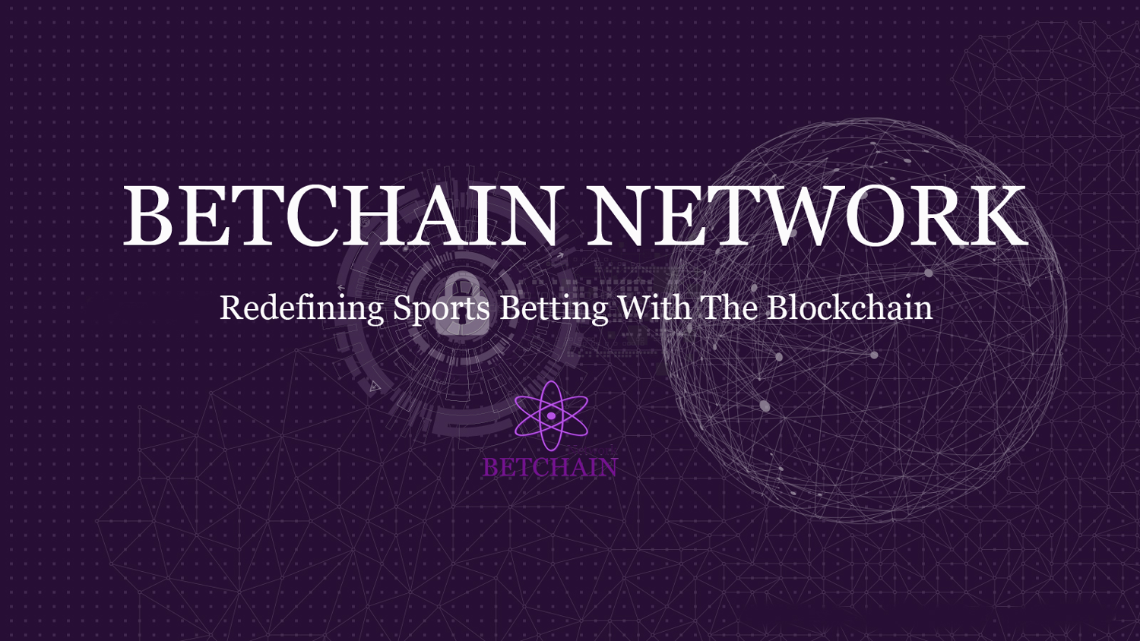

ABSTRACT

The BETCHAIN technology offers a sustainable solution to connect bettors (stackers) together for a common goal of getting instant cash outs without intermediaries like the traditional betting agencies. It creates a gaming ecosystem that empowers bettors by helping them reduce the risk of trust and fraud using the Blockchain Technology.

The lack of trust and transparency is a concern with the online sports betting industry. The BETCHAIN smart contract ensures that bet winners get instant cash out without delay making the process smart , automated and secure. Bettors tend to use reputable betting agencies instead of smaller sites, even if they offer more “interesting games”, because bettors naturally gravitate to betting agencies that they trust. BETCHAIN technology is a transparent Blockchain-based system, which will help improve trust in the sports betting industry. BETCHAIN technology enables users to play in a transparent and smart contract governed environment. This allows bettors and investors to have confidence in the fairness of the games. Through an innovative Bet Vault Technology (BVT), bettors will have tranquility that the games they play are fair and safe. Investors and businesses benefit from an ecosystem that provides liquidity sharing and fair compensation. By connecting investors, we aim for an optimal solution where all participants in the BETCHAIN network benefit.

INTRODUCTION

The Existing Sports Betting Industry

The existing sports betting ecosystem is largely mediators driven. Sports betting agencies stand as intermediaries between bettors and their cash outs. These traditional betting agencies also control the results of games played making it fraudulent with no transparency. They stand as a central authority and make all the decisions on the outcome of the games played. Cash outs are delayed and bettors have to go through a number of protocols to get make withdrawals.

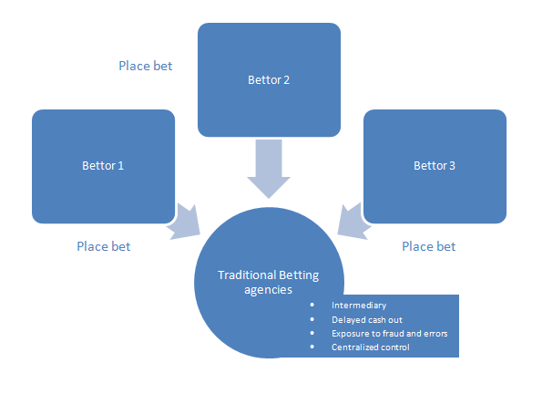

THE BETCHAIN TECHNOLOGY SOLUTION

BETCHAIN’s solution is Blockchain-based and it allows bettors to place bets on games that are run on its backend through a smart contract, rather than the traditional betting agency’s method. As all the results are recorded within the Blockchain, there is significantly lower fraud. Thus bettors can verify that their bets are running exactly on the Blockchain using the BETCHAIN smart contract technology.

Bettors place their bets from the App, the bet is processed by the BETCHAIN smart contract, saved in the BETCHAIN bet vault technology (BVT) and recorded on the Blockchain for transparency and accountability. After the game the BETCHAIN smart contract will cash out to the winners BETCHAIN token address without delay. This technology removes the need for a mediator like the traditional betting agencies, it is fraud free since every bet transaction is recorded on the Blockchain and funds withdrawal is instant without delay

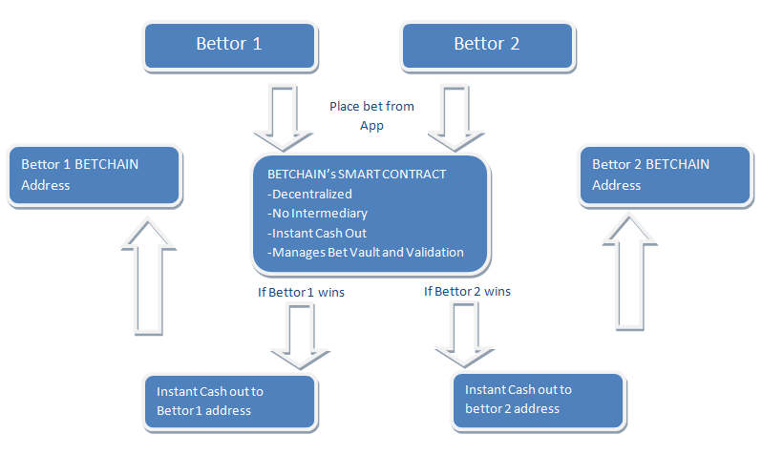

TECHNOLOGY

BETCHAIN Smart Contract

The BETCHAIN network relies on decentralized smart contracts to guarantee and record every bet transaction on the Blockchain. Through the Blockchain, we will be able to audit every transaction that occurs on BETCHAIN network. Users that play the games will be able to view, in real time, the outcomes and the rewards of the network. Unlike traditional betting agencies where cash deposits are made to the agency’s account, users will always have control over their bet (and withdrawals are simpler and conducted more quickly).

Our Platform will use the Ethereum network as a Blockchain based ecosystem. The Ethereum network is well-established, accepted, and used by the community with a full Turing language capability. While there are some latency issues, a middle-ground decentralized solution is proposed below that can significantly reduce this latency.

The usage of an Autonomous Agent (A Smart Contract) builds trust in the system because any conflict of interest between the gambler and the Platform is managed and audited in a decentralized manner. No third party needs to be involved since all the transactions are done via a Smart Contract, which guarantees everyone has access at all times and can verify the game’s fairness.

THE BETCHAIN STACK

Our technology stack is primarily composed of three main components: the Blockchain Layer, Mobile Applications (back/front end) and the Bet Vault Technology. The back/front end of the games will be running on databases, however all parts that could lead to any form of dispute between the bettor and the Platform will be decentralized and audited over the Blockchain using Smart Contracts.

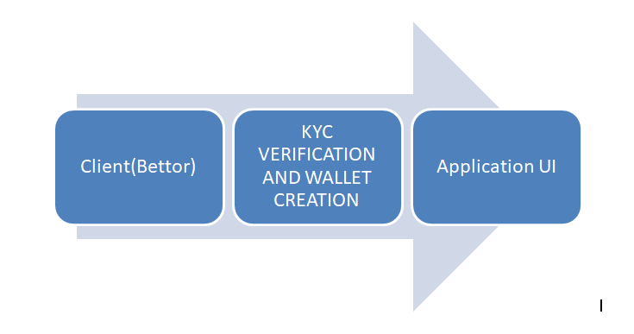

The above figure demonstrates the communication between approved game applications and the BETCHAIN Technology Random Number Generator.

THE BLOCKCHAIN LAYER

The Blockchain layer has three functions: token management, game outcome management, and providing auditing of the Random Number Generator.

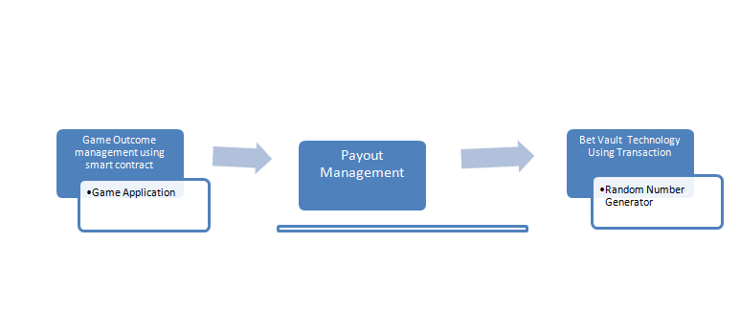

THE TOKEN MANAGEMENT

In a traditional online betting, Clients send money to the betting agencies in order to play its games. This creates the opportunity for potential fraud. BETCHAIN solves this problem by using Blockchain technology. All player funds will be stored in each player’s BETCHAIN token wallet address. When a player places a bet, the money will be sent to a Smart Contract which will manage the outcome of the bet in a decentralized manner. Using Blockchain means that the BETCHAIN Technology Team has no control over the player’s money at any time.

**To summarize:**

The player owns his/her money at all times.



The player is the only person who has management rights over their funds.



Wagers will be managed in a decentralized manner using Smart Contracts.



THE GAME OUTCOME MANAGEMENT

For each player’s wager, a Smart Contract will be used. The Smart Contract will manage the information provided by all parts of the system (Game code, BVT, player input). The Smart Contract will then verify the outcome of the play and automatically allocate funds to the right person according to the established contract rules.

**For example, Player A initiates a bet on the roulette.**

1. The fund will be automatically sent to the roulette contract
2. The random number generated for this turn of the roulette will be copied and recorded within a Smart Contract. (Note: everything critical (BVT and game history) to the game play that occurs will be recorded on a Smart Contract).
3. Utilizing the BVT, the Game code will send the outcome to the Smart Contract
4. The winner will then be automatically credited. If the player loses.
5. Finally, the player can decide to restart the process and continue play or end their gaming session

DEMO CODE FOR INITIALLY REGISTERING A BET ON THE NETWORK

The BETCHAIN smart contract code on github demonstrates registration of a bet on the BETCHAIN network. The registration is done fully through the Ethereum network, so participants can easily verify that the contract has been officially approved by the network. Through this demo, we see that registration can be called through the BetRegistry() function whereby the game will be registered on the BETCHAIN network.

View the code on github here

THE RANDOM NUMBER GENERATOR (RNG) AUDITABILITY

A key part of the betting industry is the verifiability of a RNG. In the traditional sense, RNG generators are usually administered by the company hosting the bet. However, in our case, this will be decentralised and demonstrably fair because every game will run on a custom built algorithm that relies on the RNG generator linked to the Ethereum network smart contract. This is described in more detail in the Wrapping Phase and Pay- out Process.

BET MOBILE APPLICATION (BACK & FRONT-END MANAGEMENT)

The BETCHAIN mobile application code will be hosted on our servers or hosted through the IPFS/Sia/Storj network. Bet outcome will then be communicated to the Smart Contract. Thereafter, the bet servers will provide the state of the bet to Blockchain using JSON RPC via IPC. The user experience won’t be impacted by the usage/availability of the Blockchain because all bet outcomes will be available immediately. This feature ensures that user experience is close to traditional bet, while ensuring that the process is also fully transparent and decentralized. Every bet code will be accessible on the Blockchain along with full auditability on the random number generated from the BVT.

RANDOMNESS BASED ON BLOCKCHAIN INFORMATION

The key is finding a decentralized RNG generation technique that a bettor’s bet can utilize based on the blockchain. The current solution utilizes the usage of Block generation information (such as timestamp, Nonce, Hash of the current block, and so on) to generate random numbers. Although those numbers are generated by miners, it is highly unlikely a miner could successfully change the outcome of the game on the Ethereum Public Network, because the miner would have to possess enough mining power to mine the Block several times within the public environment competition (around 14 seconds), as follows:

1. The miner is competing in the mining process of the Public Ethereum Blockchain environment
2. The miner finds the nounce and is now able to get the reward
3. The miner checks the nounce and Block information generated against the winning requirement of the bet

If it matches, the miner populates the result

1. Otherwise, the miner restarts the mining process to find another nounce that fits, forgetting about the previous mining reward

Even though this method would be highly reliable, we rejected it because we were seeking a model that did not allow any room for potential manipulation.

RANDAO (a decentralised autonomous organisation which aims to generate fully decentralised random numbers) is a very interesting possibility, but it is not mature enough to be implemented at this time. BETCHAIN Technology supports the development of fully decentralised random numbers and we will invest time studying RANDAO because, if fully mature and reliable, it is wholly aligned with our development plan.

GENERATING DECENTRALIZED RNG NUMBERS - AGILE APPROACH

**The random generator must solve the following challenges:**

Time and delays from the Blockchain ecosystem, such as mining block time



Decentralization and fully auditability



Licensing and legally compliant



THE PROPOSED SOLUTION:

The randomness of numbers will be introduced through a congruential generator algorithm that generates pseudo random sequences of numbers, which will change by adding input of data from the outside world (e.g. player movements over the platform, Forex and cryptocurrency exchange data, etc.). These datasets are used because they have both unexpected behaviour and are always available. This solution is compliant with licensing requirements because it can provide all the needed random numbers in a short amount of time, without impacting user experience. In order to strengthen our RNG model, we will initiate a double verification using the Blockchain technology by mining each number over a transaction. It will then be impossible for BETCHAIN Technology to manipulate the numbers in any way.

BETCHAIN TECHNOLOGY:

Blockchain-based back-end and development stack.



Auditability and transparency over betting codes - all contracts are accessible by players at all times.



Smart Contract implemented and connected to the Game back-end through APIs.



Security provided by the Ethereum Public Network.



A bet registry system connecting game developers to liquidity providers.Random number generation systems that allow games to be publicly verifiable and easily

accessed by game developers.

GAME OPERATIONS

Ecosystem benefits and structure

By operating on the blockchain, users can easily identify where their money is going and whether the results are fairly generated. User experience is our top priority and we will offer a wide variety of games, strong security, and reliability.

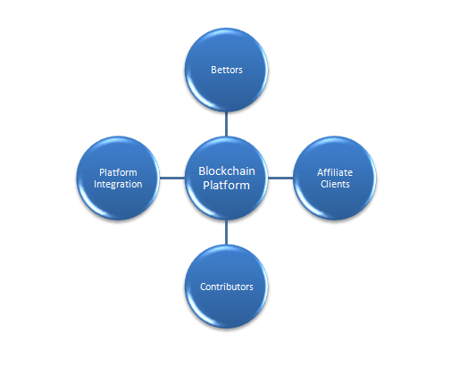

In addition to user benefits, developers benefit from the large liquidity pool and additional reputation provided by operating on the BETCHAIN Technology network. Developers will be able to easily “prove” the games that the user plays because it is transparent and on the blockchain.

The Developers are crucial in the betting industry. We at BETCHAIN understand them and will work to provide the best experience in terms of fair reward, full support on the marketing process, and greater capacity of players.

To ensure the success of bets, BETCHAIN provides support to the developers within the BETCHAIN ecosystem.

**Support to developers is provided on:**

Client acquisition by providing Marketing and direct access to our client base



Compliance from a legal and licensing perspective



Blockchain integration



*Developers only need to worry about the game development, BETCHAIN will do the rest.*

FINDING THE BALANCE WITHIN THE BLOCKCHAIN

User experience is crucial when it comes to working on an online betting initiative. BETCHAIN has worked hard to find the right balance between the speed of the gaming experience and the decentralization that comes with use of a Blockchain for the online betting industry.

POSSIBLE ISSUES THAT ETHEREUM FACES IN IT’S CURRENT STATE

The Ethereum Blockchain is not an optimal system to process data quickly because the Proof of Work mining process happens every 14 seconds. Furthermore, the Ethereum is not made to store huge amounts of data, given that the Blockchain is copied on every participating node of the network. Therefore, a fully decentralized system at every point - from the RNG to the game itself - would not be the best option because there would be a significant time delay and players do not want to wait minutes to get the play results. Further, Smart Contracts managing large amounts of data and processing non-linear logic are expensive.

GAS PRICE

The Ethereum introduced GAS price mainly to avoid “DDoS like attacks”, where a rogue person could create a large number of contracts to impact the efficiency of the public network itself. This way, GAS frequently changes its cost with the aim of an accurate usage of Smart contract demand.

SUMMARY**:**

The BETCHAIN platform is a realistic balance between speed and decentralization in to provide the optimal player experience. Every bet populated on the platform will comply with the following requirements of decentralization:

The speed of the user experience won’t be impacted - i.e. the bet outcome needs to be available within a few seconds.



No third party, developers, or the Platform have rights over the tokens or the money spent in the bets.



According to the bet result, Pay-out will then be automatically processed to the winners or the actors involved in its development.



Although every game will be offered by different developers, there will be a bet acceptance process (see section 6.5) where the BETCHAIN team will ensure the bettors comply with our speed and decentralisation requirements. No bet will be populated on the platform if it does not comply with those requirements. We may include an additional player KYC process, whereby only BETCHAIN verified players are permitted to use the platform so that we ensure a higher level of fair play and legal compliance.

ARCHITECTURE OF BLOCKCHAIN INTEGRATION AND SCENARIOS

As explained earlier, the technical features of all bet need to match two requirements:

Minimize the delays caused by the use of Blockchain and utilize its decentralization.

The following overall Bet Architecture matches the BETCHAIN Platform requirements in terms of security, decentralization and speed. There are four main components:

The Client - The BETTOR manages their money at all times.



The Blockchain - the smart contract controls the pay-out according to the game outcome.



The GS (Bet server) - represents the databases where the game runs.



The WS (Wallet server or BVT) - the Platform actor’s wallet will be updated according to final play outcome.



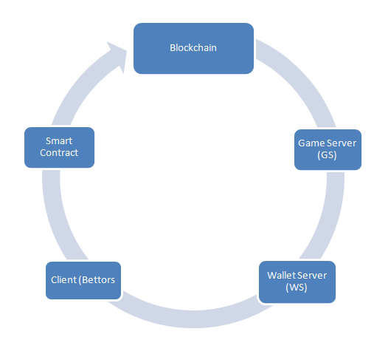

THE PROCESS IS DIVIDED INTO SEVERAL PHASES:

THE LOADING PHASE

We aim to avoid the verification transaction time on every bet during the Loading phase because that will minimize the delays caused by the Blockchain and will considerably impact the speed of the user experience.

In order to meet this requirement, the user will be asked to send money to the selected Game Smart Contract while the game is loading and configuring.

This Process requires fifteen seconds to load the game and set up the Blockchain smart contract. This process is allowed if, and only if, the user has been checked and verified through the KYC process. It will be impossible for non-verified bettors to send money to the smart contract and an automatic error message will guide him to go through the KYC Process (more details in section 15).

GAME INITIATION PROCESS

The coin amount moved into the smart contract will be populated onto the WS (Wallet Server) as the initial client’s wallet value. The GS (Game Server) can be seen as a cache- like system, where the value of the Platform actor’s (client) money will increase or decrease depending on the gameplay outcome.

Each bettor’s bet will be communicated to the GS (Game server) to determine outcomes.

1. WS sets up the temporary wallets - the amount of the client’s wallet will be the one invested during the loading phase. A double check is performed onto the smart contract to make sure the initial amount assigned to the client’s wallet is the one invested to the client during the loading phase.
2. The user places a bet (for example, 5 BETCHAINTOKENS are placed on RED in a roulette game).
3. The bet will be communicated to the GS and processed using the RNG (that is audited within the Blockchain). Depending on the game’s outcome, the WS’s wallets (Client, Platform and Developer) will be updated accordingly.
4. This process will be repeated as long as the user has funds and does not wish to stop playing.

WRAPPING PHASE AND PAY-OUT PROCESS

The user is able to stop the game session and start the wrapping phase at any time using a straightforward process facilitated by the friendly game front- end. The wrapping process consists of:

1. The user’s stop request will be populated onto the GS and WS.
2. The GS will create a history file of the session, the file will then be Hashed.
3. The last updated amount of the WS wallets along with the Hash will be sent to the smart contract.
4. According to the information sent, the smart contract will change its state and process the pay-out on the Blockchain.

GAME ACCEPTANCE PROCESS

We believe that our approach will attract a number of developers and game propositions.

In order to make the game acceptance process efficient and relevant to our platform, all new

game propositions will be processed as follows:

1. Auditing the code - our experts will make sure everything matches our security and legal requirements.
2. Testing the game based on various metrics - time, security, costs, blockchain integration, user experience, etc. If the results from Steps I and II are successful, then the proposed game will go through to the integration process.
3. Smart Contract development.
4. Test and security audit of the developed Smart Contract.
5. Game Launch over the platform.

Once the game is populated within the BETCHAIN Technology network, everything will integrate from within the system. If the developer requires additional liquidity, he/she will easily be able to access the pool of investors that are willing to participate in offering the games. If there are other technical issues, our team will support the developer to find a prompt resolution.

BLOCKCHAIN INTEGRATION PROCESS EXAMPLE - ICY CASH SPLASH

The code will be commented to give full visibility and understanding of our approach from a development perspective. If you have any questions, please contact our team over the communication channel at any time.

BLOCKCHAIN TECHNOLOGY BEYOND ETHEREUM

Ethereum is not market ready for gaming technology because there are still issues with speed and scalability that need to be solved. In this section, we will present two additional technologies that could add value to our initiative and may be integrated into our development plan.

IOTA: DECENTRALIZATION USING DAGS (DIRECTED ACYCLIC GRAPHS)

IOTA is a new innovative decentralized approach. It is not a Blockchain ecosystem; rather it introduces the concept of tangle. A tangle is literally a Blockchain without blocks and it makes the consensus process an intrinsic part of the system.

**This innovation introduces bet changing features for the Sports Betting Industry:**

In order to perform a transaction, you have to participate in the system and be part of 2 other transaction validation processes. This aspect makes transactions free of charge, which could introduce a considerable cut in the infrastructure cost for an online betting agency while still providing the necessary validation.



The system has been built for Smartphone or tablet and is extremely scalable and currently tending towards completion (at the time of the production of this whitepaper, this software is still in Beta phase).



The negative for the betting business would be the transaction validation time. However, the transaction time is directly impacted by the number of active participants (since you must participate in two other validations in order to make your own transaction validated). Thus, a

larger number of users will decrease the transaction time (which is currently between 2-3 minutes). Notably, the IOTA network is still on a beta version and the free transaction feature will likely attract large amounts of users and thereby resolve the transaction validation time. The potential of this ecosystem has no limit, and we are following its development and hoping to test game integration in the near future. [1]

DECENTRALIZATION OF STORAGE AND HOSTING

Decentralized storage is an open market since the Blockchain technology is not made to store data. Sia [2], IPFS [2], and Storj [3] are the main competitors for this market. The general idea is to allow users to store data or rent available storage capabilities managed over a decentralized environment.

For example, many people in the world possess unused storage capabilities. The competitors mentioned above propose to store data with a high level of security across a network of participants that are looking to be rewarded for their hard drive rental. If a person wants to store a 1 gigabit document, then the document will be split into many pieces and each piece will be encrypted. Then, those encrypted pieces are copied and spread over each participant’s hard drive.

The power of this model is that the only way to access the file is to possess the private key of the document holder, since it is impossible to find all the encrypted pieces of all the participants in the network. It provides strong security for a very attractive price and is just a little more expensive than common centralized systems. This technology allows storage of very sensitive data over any user’s computer because everything managed between the renter and user is via a cryptocurrency payment.

As presented in section 11.3, we chose to store a hash of a client’s Bet session over the Blockchain environment to make available a full traceability of the user’s journey. Using the decentralized storage in our model would provide security of the history and a strong reliability because the system no longer has a central point of failure.

BETCHAIN Technology is looking into using this solution for potential integration in its further development.

AFFILIATE ENGAGEMENT

New betting agency operators often struggle with player liquidity. Also, large affiliates do not want to deal with small start-up bets by developers because they often have poor conversion and low retention rates with players. Therefore, large affiliates are hesitant to deal with small developers until they have some trading history. As these small developers are paid on a periodic basis and not in real time, they often suffer cash-out delay issues. BETCHAIN easily solves this through our pay-per-game model. Each time customers play on the game, the payments are made to the respective participants in the game. This ensures an agile ecosystem with a small feedback loop that will even further encourage new and innovative operations by developers.

THE GAME ACCESS, KYC MANAGEMENT AND REQUIREMENTS

KYC will be implemented after all sales in order to comply with regulatory bodies. In this case, in order to be able to access the game, every Client has to successfully go through the KYC process. Following each successful KYC check, the Public Key of the Client’s Wallet will be added to our system. Once the client’s public key is added, then the client can use our ecosystem. Players will then be easily able to see their status and review their play history on the public Blockchain.

TOKEN SALE

BETCHAIN Tokens will be available for purchase on the Ethereum network as an ERC20 token. There is a current challenge with the ERC20 token: if you send your token to a Smart Contract, you have to use the “approve + transfer form” function to make the transfer. But, if you send your token to an externally owned address, you have to use the “transfer” function. Unfortunately, if you make a mistake using those functions, then the money is lost.

We are aware of this challenge and are working to ensure it will not happen to our Clients. We plan to upgrade to the new and under-development ERC223 standard (after it is fully developed). The ERC223 has a new feature that triggers, in the case of a scenario explained above, and the money is automatically sent back to the client.

UTILITY

BETCHAINTOKENS have many different uses. In the most basic sense, BETCHAINTOKENS can be used to by bettors to place bets on games via the BETCHAIN App on the BETCHAIN network. The network provides a frictionless rewards system, guaranteed pay-outs, attraction of otherwise unobtainable affiliates, eliminates potential fraud and reduces payment processing fees.

For investors and game developers, the tokens can be used to secure payment for running games and for receiving payment from players. Investors can guarantee real-time affiliate payments, thereby affording new investors the same highly lucrative affiliate deals that are currently available only to the largest brands.

For the smaller game developers that rely on bigger game developers to “back” the games, tokens can be used to receive commissions that provide the reputation and the working capital to offer the game.

All legitimate parties are afforded the security of knowing the immutable smart contracts, coupled with the tokens, eliminates fraud on the network.

Overall, tokens will have a value based on what users are willing to pay in order to use the services on the BETCHAIN Technology Network.

TOKEN SALE STRUCTURE

**Cryptocurrency accepted:** ETH

**Hard-cap:** BETCHAINTOKEN sale has a hard-cap of 449525.641 USD.

**Soft-cap:** BETCHAINTOKEN sale has a soft-cap of 64102.5641 USD. If the total amount raised is belowthe soft-cap, the offering is considered failed.

**Timescale:** Starting approximately on 4th of April 2018 and lasting for up to 30 days before all the tokens are distributed.

**Oversubscription:** When BETCHAINTOKEN offering raises more than 449525.641 USD, the Presalewill be closed immediately. There is a chance of oversubscription. In such an event, the exceeding amount of fund will be returned within 30 days after the close of the Crowdsale. Please note that no interest will be paid in such case.

**Failure:** If the token sale does not hit the soft-cap, then it will be considered a failed tokensale. The offering will be terminated and any funds sent will be returned within 15 days after the close of the token sale. Please note that no interest will be paid in such case.

**Other risks:** The sale of the tokens involves a number of other risks that are explained in thePrivate Placement Memorandum (PPM) that accompanies the token sale documents. Those risks include, without limitation, the SEC’s current position that similar tokens were considered securities and required registration or an exemption, potential loss of value in the tokens, inability to resell the tokens, failure to develop the BETCHAIN Sports Betting Network, and viability of technology risks. The reader is urged to read the PPM for a fuller explanation of the risks and to obtain proper counsel before proceeding with any investment.

Token Distribution

|  |  |  |  |
| --- | --- | --- | --- |
| Presale |  | 30% | 701,260,000 |
|  |  |  |  |
|  |  | |  |
| Sold during ICO* |  | 20% | 210,000,000 |
|  |  |  |  |
|  |  | |  |
| Rewards pool (VIP etc) |  | 10% | 70,000,000 |
|  |  |  |  |
|  |  | |  |
| Sold on the platform |  | 23% | 161,000,000 |
|  |  |  |  |
|  |  | |  |
| Founding team, vested for 24 months |  | 12% | 84,000,000 |
|  |  |  |  |
|  |  | |  |
| Ambassadors, Fund Raising Fees |  | 3% | 21,000,000 |
|  |  |  |  |
|  |  | |  |
| ICO bounties |  | 2% | 14,000,000 |
|  |  |  |  |
| **Total** |  | **100%** | **1,261,260,000** |
|  |  |  |  |

*Unsold tokens will be burnt.

THE TEAM

CEO

Pavel Sokolovas

Pavel has worked as a Commercial Director for several successful international companies. For the last five years, he has been working in an enterprise providing business solutions for banks and casinos

CPO

Kasparas Stundžius

He has more than 10 years of professional experience in advertising, communication, betting and project management of various work streams and business fields. Here at BETCHAIN NETWORK., he is responsible for varied product-related activities.

CTO

Jevgenij Simonait

Jevgenij has a great deal of experience and knowledge in the implementation of big systems from scratch and, as a full-stack developer; he is familiar with all layers of computer software development and the Blockchain Technology

SENIOR BLOCKCHAIN DEVELOPER

Tomas Navickas

With his BA in Financial Informatics and a Master’s in Business Informatics, he is the perfect addition to the BETCHAIN NETWORK.

UI/UX ARCHITECT

Jelena Klovienė

Jelena has degrees in mathematics (BA) and statistics (MA). With five years of working experience in the banking sector, she is an excellent addition to our developers' team and is responsible for the user interface as a front-end developer.

ANDROID DEVELOPER

Michail Ostryj

Michail is the Android whizz who aims to contribute to the development of the modern, ever-changing world.

ADVISORS

CHIEF SCIENTIST

Prof. Tomas Krilavičius

Prof. Tomas Krilavičius is an expert on application of Artificial Intelligence. He is a head of Applied Informatics Department at Vytautas Magnus University.

PROJECT MANAGER

Erik Obuchovič

He works in close collaboration with the development team, and together they are trying to create the most convenient betting and cryptographic account management system in the world.

UI/UX ARCHITECT

Artur Obuchovič

Artur has more than nine years of professional experience in the fields of project management, procurement, graphic design/web design, front-end development, product presentation.

OUR ROADMAP

MARCH 2016

**OP:** Ideation

OCTOBER 2017

**OP:** Proof of concept at Paris Microsoft Experience

NOVEMBER 2017

**OP:** Feasibility analysis and licensing

JANUARY 2018

**OP:** Casting the Development Team

MARCH 2018

**OP:** BETCHAIN ICO token sale

MAY 2018

**OP:** Wallet Exchange | Android-IOS Wallet Development

JULY 2018

**OP:** Listing | Listing on CoinMarketCap , External Exchange

AUGUST 2018

**OP:** Blockchain Scaling |The new Blockchain Infrastructure Based On Proof of Involvement and Integrity

SEPTEMBER 2018

**OP:** Rewarding Investors and Contributors

OCTOBER 2018

**OP:** App and Web Scaling on the Blockchain

NOVEMBER 2018

**OP:** LAUNCHING | Launching of the BETCHAIN Bet Vault and Wallet to the public

NOVEMBER 2018

**OP:** Marketing Campaign | continuous aggressive advertising campaign

References

1. http://www.betchain.network/wp-content/uploads/2018/03/betchain-whitepaper.docx

1. <https://github.com/ethereum/wiki/wiki/White-Paper>