- Explain regression in detail and give example of in real life situation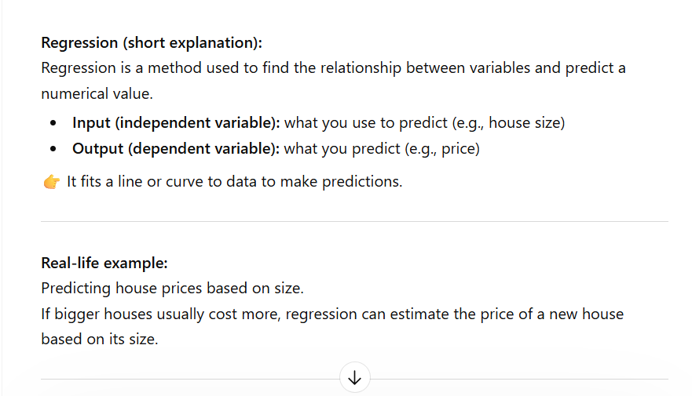
- This is the screen shot from chat gpt
- This promote gives more explanation about regression and it gives example

B) help me understand sql as beginner friendly with simple terms and application areas as new data analyst?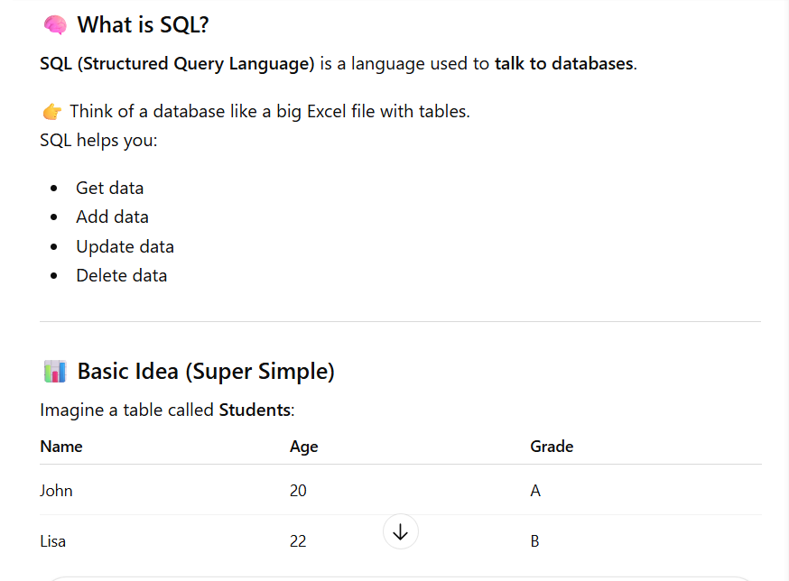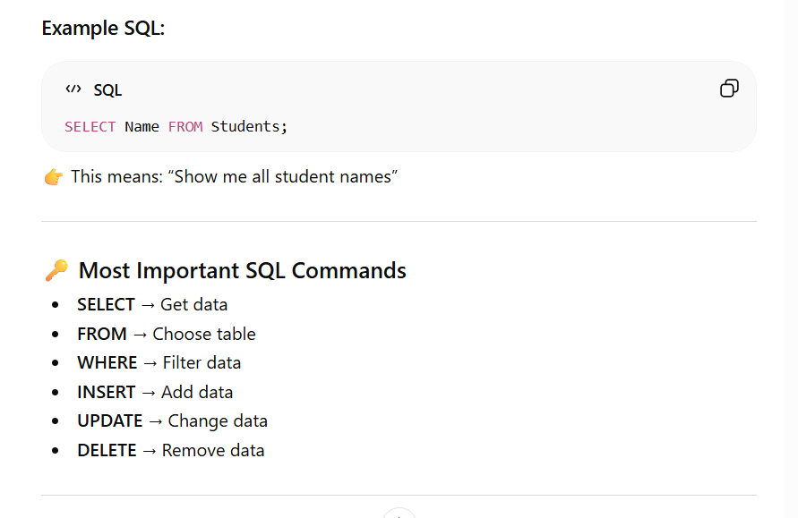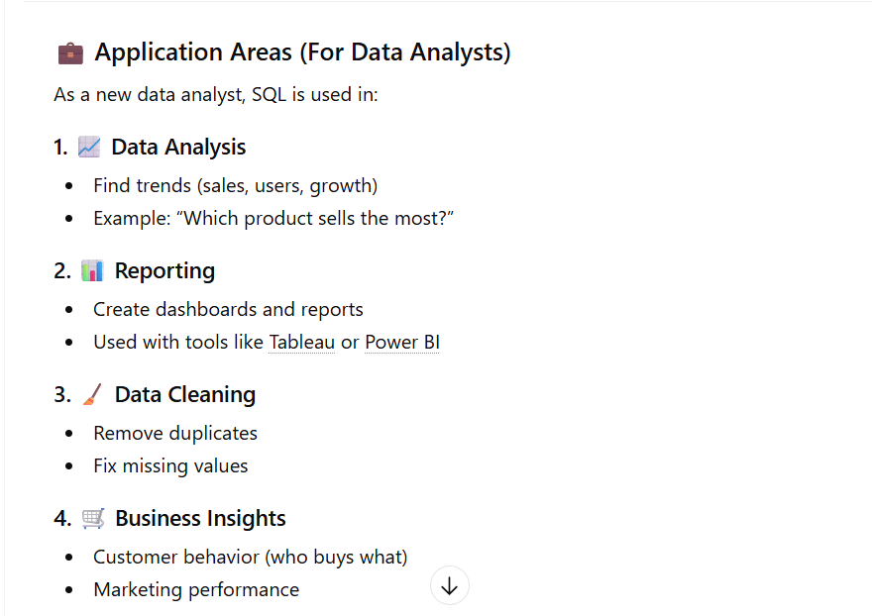
c) this breaks it to simplified small terms and application areas as new data analyst
c) create data sheets that has categorical and numerical data that can be processed?
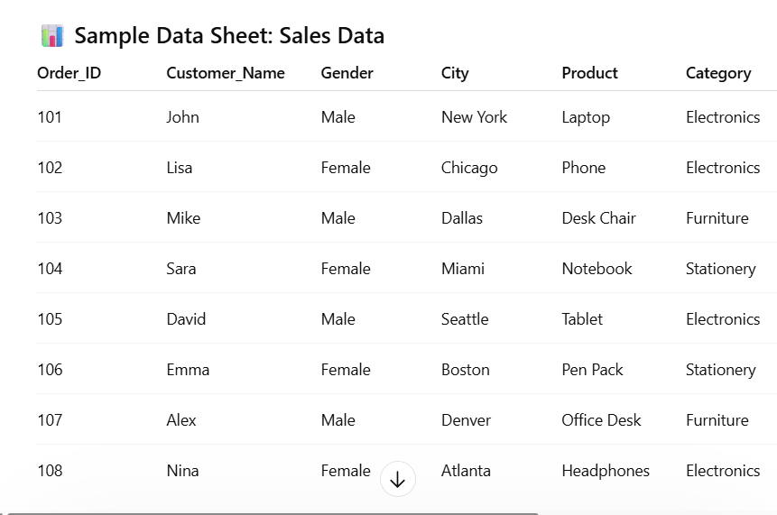
C) this prompt shows more specific data needed with categories with specific data needed

