Socioeconomic Impacts of Terrestrial Protected Areas: Evidence from Large-Scale National Surveys in Madagascar
Abstract
Protected areas are the most widely used instrument for biodiversity conservation, yet their socioeconomic effects on nearby populations remain contested, particularly in low income contexts where livelihoods depend heavily on natural resources. This paper evaluates the impact of terrestrial protected areas on rural household well being in Madagascar, exploiting geolocated socio-demographic surveys covering the period of rapid protected area expansion between 2008 and 2021. To support identification, we draw on an earlier survey wave from 1997 to assess the plausibility of parallel trends prior to treatment. We combine spatially derived socio environmental indicators with genetic matching and difference in difference to construct a credible counterfactual. The study follows a pre analysis plan registered before any outcome analysis, including an ex ante power calculation indicating the ability to detect effects of approximately 7.5 wealth percentiles. We find no statistically significant average effect of protected area creation on the wealth index of households located within 10 km of protected areas established after 2008. A series of robustness checks using alternative data sources and specifications supports this result. The absence of an average effect may reflect offsetting positive and negative mechanisms, heterogeneous impacts across households or sites, or limited implementation capacity in a context of weak governance and chronic underfunding of protected areas.
Keywords: Biodiversity Conservation, Well-being, Demographic and Health surveys, Genetic matching, difference-in-difference, Madagascar
JEL classification: Q57, I31, C31, Q56, O55

Introduction
The reconciliation between conservation and economic development has long debated in the scientific literature (Adams et al. 2004), but the issue has gained renewed prominence over the past decade with the rapid glocal expansion of protected areas (PA). This debate is particularly salient in the context of the Kunming–Montreal Global Biodiversity Framework, under which 195 signatory states committed to protecting 30 percent of terrestrial land by 2030.
In theory, PAs can affect local livelihoods through multiple and potentially opposing channels. While they are a central instrument for biodiversity conservation (Maxwell et al. 2020), their establishment may restrict access to land and natural resources that support income generating activities such as agriculture, hunting, fishing, or forest product collection. At the same time, protected areas may generate benefits through compensation schemes, employment opportunities linked to conservation or tourism, and the provision of ecosystem services such as water regulation, erosion control, or fire prevention (Kandel et al. 2022).
Despite these ambivalent mechanisms, rigorous quantitative evidence on the socioeconomic impacts of PAs remains limited, in particular in poor and fragile governance contexts. Among the 1,043 studies reviewed across 104 countries by McKinnon et al. ((2016)), only 19 used quantitative methods to assess effects on material living conditions or economic well being. More recent syntheses confirm substantial heterogeneity in estimated impacts across contexts and methodologies. Focusing on 30 quantitative evaluations of household income, Kandel et al. ((2022)) find that protected areas are associated with modest average gains, with effects that depend strongly on local conditions. This heterogeneity underscores the need for context specific evaluations using transparent and robust empirical strategies.
Madagascar provides a particularly relevant setting for such an analysis. It ranks among the poorest countries globally under SDG 1.1, with the highest share of the population living below the international poverty line (Conceição 2024, 298–99). During the study period, terrestrial PA coverage expanded from 3.6 percent of national territory in 2008 to 10.8 percent in 2021, while the share of the population living within 10 km of a PA rose from 9 to 28 percent. At the same time, Madagascar exhibits low state capacity (Hanson and Sigman 2021), which constrains the implementation of conservation policies and associated social measures. Combined with high rural dependence on natural resources, these features suggest that the socioeconomic impacts of protected areas may differ from those observed in less precarious institutional contexts.
Yet national scale impact evaluations remain scarce. None of the quantitative studies reviewed by McKinnon et al. ((2016)) focus on Madagascar. The only study cited by Kandel et al. ((2022)) that includes the country relies on cross sectional municipality level data from the 1993 census (Mammides 2019), predates the major expansion of protected areas, and does not allow for before and after comparisons.
This article contributes to the literature in two ways. Empirically, it provides the first national level impact evaluation of terrestrial protected areas in Madagascar, covering 71 protected areas created between 2008 and 2021. Methodologically, it combines recent advances in matching and difference in differences methods with geolocated household survey data to construct a credible counterfactual. To enhance transparency and limit researcher discretion, the empirical strategy was fully specified in a pre analysis plan registered on the Open Science Framework prior to conducting any outcome analysis.Our analysis plan was submitted with a dated and verifiable certification on the OSF portal in November 2024 and updated in March 2025.
The remainder of the paper proceeds as follows (theoryofchange?), presents the conceptual framework and hypotheses. (data?) describes the data sources. (descriptivestatistics?) outlines the identification strategy and econometric methods. (studydesign?) presents the econometric approaches used to assess the effect of PA on household livelihoods, the effect of PA on inequalities between households, and the heterogeneity of effects according to the type of PA governance. (resultats?) presents our main results and proposes a series of robustness tests. (discussionandconclusion?) concludes.

Theory of change
Our evaluation model is based on a theory of change that links the implementation of PA(the treatment) to local household well-being (outcome) through multiple possible channels, summarised in (Figure 1) The objective here is to determine the impact of PA implementation on observed changes in household living standards. Existing evidence suggests that average impacts are modest but highly context dependent. Kandel et al.((2022)) report a slightly positive average impact, alongside subtantial heterogeneity across settings. Building on this litterature, we represent potential mechanisms in the form of directed acyclic graph (Hünermund and Bareinboim 2023). If the mechanisms represented affect all residents of a locality in a convergent manner, they should translate into a significant average impact (positive or negative) on the average well being (Hypothesis 1). If, on contrary, they affect households in very different ways, the average effects may be close to zero, but inequalities within local communities may increase (Hypothesis 2).
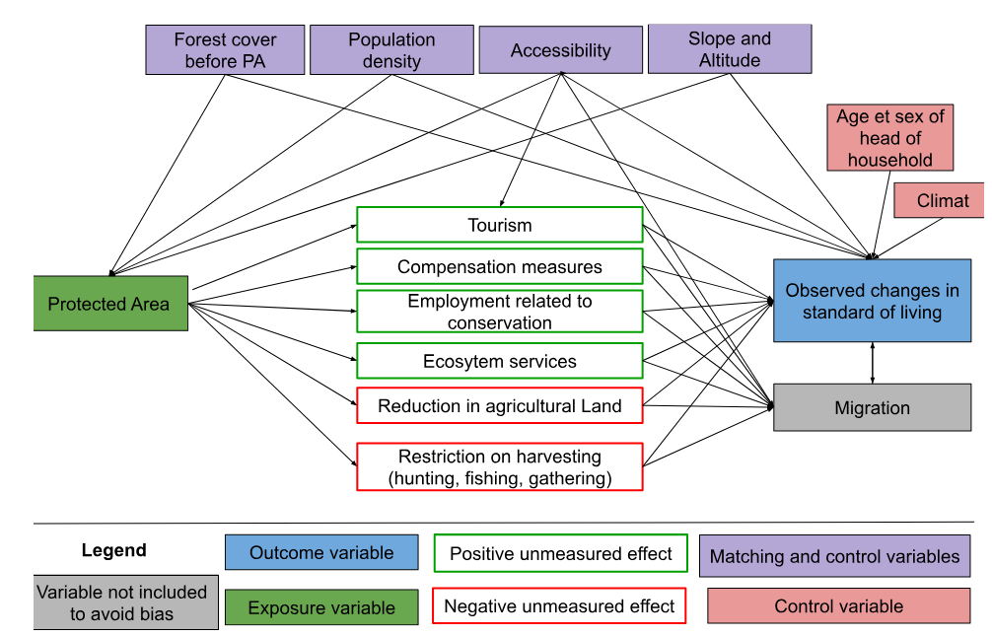
Figure 1: Logic diagram of the theory of change tested in the study
The factors likely to lead to a decline in well-being seem particularly significant in the Malagasy context, where the population is predominantly rural and living in extreme poverty (the last assessment was in 2012, with 80.7% of the population below the $2.15 a day threshold at 2017 PPP). Six studies conducted in Madagascar between 1995 and 2006 estimated the opportunity cost of restricted access to natural resources following the creation of PAs (slash-and-burn agriculture, hunting, gathering, timber, etc.) at between USD 39 and 177 per household per year (Neudert, Ganzhorn, and Waetzold 2017). Golden et al.((2014)) estimated that income from hunting accounted for 57% of household’s cash income in areas adjacent to the Makira and Masoala PA. Another survey of people living near Makira estimated the value of pharmaceutical use at USD 30-44 per year per household, based on the subsidized price of equivalent treatments in the Malagasy market (Golden et al. 2012).
Several factors that could help improve livelihoods through conservation appear to be fragile in Madagascar, starting with tourism. Naidoo et al. ((2019)) aggregate data from DHS surveys conducted between 2001 and 2011 in 34 developing countries. Their study is based on matching households near and far from PA, but with no pre-post conservation comparison. They highlight positive impacts , but only for a subset of PA ‘with documented tourism’. According to their study, households living near the PA ‘with tourism’ are 17% wealthier and 16% less likely to be poor than similar households living far from these areas. However, tourism in Madagascar’s PA remains low. According to data from Madagascar National Parks (MNP), only seven PA recorded more than 10,000 visitors in 2023 (with a maximum of 30,744 in Isalo), which is low compared to the average of 356,405 visitors per year and per PA recorded across 929 PAs worldwide in the global study by Chung et al. ((2018)).
When new PAs are created in Madagascar, compensation mechanisms for local populations remain rare, ineffective and insufficient (Rivière 2017; Bertrand et al. 2014). The most in-depth study on this subject, conducted by Poudyal et al. ((2018)) with support from the World Bank, focuses on the Ankeniheny Zahamena Corridor (CAZ), created in 2015 to connect several existing PAs. Five study sites were selected: two adjacent to the new CAZ PA (one eligible for compensation, the other not), two adjacent to long-established PA, and one far from the forest boundary. The median cost of the conservation restriction is estimated at USD 2,375 per household per year, representing between 27% and 84% of the average annual income. The amounts set aside to compensate beneficiary households were assessed to be insufficient relative to the losses incurred, and around 50% of households eligible for compensation received nothing (Poudyal, Jones, et al. 2018; Poudyal et al. 2016).
Our firt set of results therefore consists of determining whether PAs in Madagascar, by limiting access to natural resources, have negative impacts on the standard of living of households living nearby, potentially exceeding the benefits of compensation and ecosystem services, and whether these impacts are more adverse than those documented in other contexts (Hypothesis 1).
The impact mechanisms represented in Figure 1 are likely to affect households differently depending on their prior characteristics, which would increase inequality (hypothesis 2). Compensation measures are generally implemented in the form of projects to promote income-generating activities (agriculture, livestock, handicrafts) in surrounding communities (Poudyal, Rakotonarivo, et al. 2018). In the context of such development projects, individuals known as “development brokers” frequently emerge as intermediaries between local communities and implementing organizations. By mobilizing their social networks and specific skills, these brokers manage to capture a disproportionate share of the benefits of interventions, whether in form of income or priviledged access to opportunities. This dynamic can reinforce pre-existing inequalities within communities, limiting the access of the most vulnerable households to the expected benefits of compensation programs. Although tourism development is often presented as an opportunity for economic growth, it also tends to exacerbate socioeconomic inequalities, particularly in developing countries. Adeniyi et al. ((2024)) show that in Southern Africa, tourism can initially exacerbate inequalities by concentrating benefits in the most attractive regions, while leaving marginalized communities out of the economic benefits. According to Ghosh and Mitra ((2021)), the relationship between tourism and inequality follows an inverted Kuznets curve in developing countries: when tourism remains moderate, its growth reduces inequalities, but when tourism becomes massive, further expansion worsens inequalities. Finally, Xuanming et al.((2024)) point out that while tourism helps to improve certain socioeconomic indicators, it can also generate inflationary pressures and strain local resources, particularly affecting the most vulnerable households. Taken together, these mechanisms suggest that PAs may exacerbate economic inequalities within neighboring communities by creating opportunities that primarily benefit individuals with higher levels of education or dominant social positions, granting them access to rents and jobs related to tourism and associated activities (Hypothesis 2).
IUCN status of PAs are frequently used to explain differences in effectiveness between them. For example, Naidoo et al. ((2019)) show that multiple-use PAs (statuses V and VI) tend to have more beneficial effects than strict areas (statuses I to IV), partly due to greater flexibility in integrating local needs. Beyond status alone, governance plays a central role. Eklund et al. ((2017)) highlight the importance of transparent and inclusive structures to maximize the positive effects of PAs on conservation and social justice. They call for management approaches to be adapted to local contexts, with greater involvement of communities in decision-making processes, to better reconcile conservation and development objectives.
This diversity is particularly evident in Madagascar. Although governed by similar formal statuses, PAs follow different paths depending on the local context and the way in which they are implemented. Froger and Méral ((2009)) show that the early initiatives of shared governance, gradually introduced with in-depth mediation efforts, achieved encouraging results by strengthening local community support. However, from the 2000s onward, the accelerated deployment of management transfers, driven by quantitative targets, often led to hasty and less contextually adapted implementations, undermining the effectiveness of these mechanisms. These experiences demonstrate that, beyond the PA status, their establishment period, management approach, and level of community participation significantly influence their socioeconomic impacts. We therefore anticipate that the impacts of PAs on well-being and inequalities are heterogeneous, and that PAs with higher levels of local community participation are more likely to generate greater benefits and distribute them more equitably (Hypothesis 3).
Based on this theory of change, we define two main outcome variables to capture changes in living standards: household wealth index (the main outcome) and the standardized Z-score of the wealth index (the secondary outcome). Household wealth will be the outcome variable used to determine the overall impact of PAs, and the standardized Z-score of the wealth index will capture inequalities in living standards across localities. We also use variables that may be predictive of the outcome under study. The appropriate covariates for our model are variables that are likely to influence both the probability of treatment (whether a PA has been created near the household) and the outcome (household living standard and inequalities between households). The literature shows that PAs tend to be created in less dense, less accessible, higher and steeper regions (Joppa and Pfaff 2010). These variables may also affect living standards: areas that are more dense, flat, low-lying and accessible (in terms of travel time and geography) tend to be wealthier (Gallup, Sachs, and Mellinger 1999). We propose five covariates (forest cover in 2000, slope, elevation, population density in 2000, and accessibility in 2000).

Data
This study evaluates the impact of PA creation on rural household well-being between 2008 and 2021. These time frame was chosen on the basis of the availability of geolocalised data on household living conditions and coincides with a period of strong expansion of PAs in the country (Appendix). We use data from the World Database on Protected Areas (WDPA) for data on protected areas, particularly terrestrial protected areas. We use data from the mapme.biodiversity package (Görgen and Bhandari 2022) to automate the retrieval of large raster data sets on the geophysical environment of households, such as forest cover rates in 2000, slope and altitude, population density in 2000, and accessibility in 2000 (Appendix). Data on household socioeconomic conditions are mainly from the survey conducted by the ‘Institut National de la Statistique de Madagascar’ (INSTAT) as part of the Demographic and Health Surveys (DHS) (Appendix). This database is the source of our outcomes variables household living standards (primary outcome) and inequalities in living standards at the level of the localities studied (secondary outcome) (Appendix). These data also provide us with control variables: age and sex of the head of the household (Appendix).These characteristics determine the economic opportunities and resource management capacity of households (Lo Bue et al. 2022). These variables reduce the unexplained variability in the model and thus enable a more accurate estimate of the treatment effect.
In the case of Madagascar,three DHS surveys were conducted in 1997, 2008 and 2021, containing 650 clusters in 2021, 585 in 2008, and 268 in 1997. We use 2008 as the reference year. Accordingly, the population considered as treated encompasses households living in rural areas within 10 km of a PA created between 2008 and 2021, according to the GPS coordinates provided in the Demographic Health Surveys (DHS) data[^2]. Households in the control group are those living in a rural area more than 10 km away from a PA created between 2008 and 2021, and they exhibit very similar characteristics or share significant traits with households in the treatment group. We decided to exclude rural populations living within 10 km of PA created before 2008, as they are considered treated before the study period; as well as households located in urban areas.
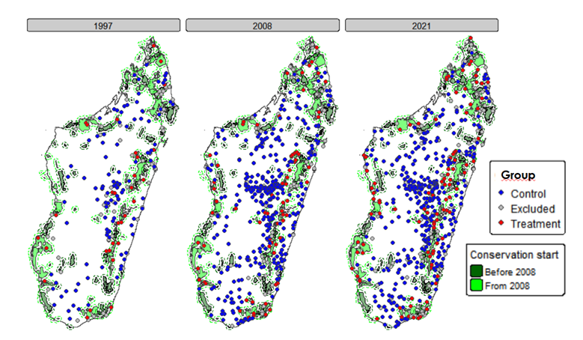
Figure 2: Classification of household clusters according their group affiliation
Notes: Households in the treatment group are those located in clusters less than 10 km from PAs created since 2008 in rural areas (shown in red) and households are those located in clusters more than 10 km from PA created since 2008 in rural areas (shown in blue). Rural populations living within 10 km of PA created before 2008 or located in urban areas are excluded from the study (shown in black). The GPS data used comes from DHS clusters.

Descriptive statistics
The unit of analysis in our study is the household. It is at this level that a significant proportion of individual resources are pooled, and it is at this level that data on living standards - the outcome variable in our study - are available in national surveys (Deaton 1997). Two outcome variables are taken into account: hosuehold living standards (primary outcome) and inequalities in living standards at the level of the localities studied (secondary outcome). Household living standards are estimated using the wealth index, calculated specifically for rural areas. We will translate this wealth index into an integer between 1 and 100, corresponding to the household’s wealth percentile relative to the distribution of the entire sample. In addition to the impact of PAs on hosuehold living standards, we seek to understand their influence on socioeconomic inequalities within the populations concerned. To do this, we propose using a standardized Z-score of the wealth index, which allows us to compare the relative distribution of wealth around the mean within the study population at the level of each survey group.
Figure 3 shows that the control and treatment groups have very similar wealth profiles, with averages between 47 and 50, and medians ranging from 46 to 51. In contrast, the excluded group is at the top of the national distribution of wealth, with an average above 50 and a median between 63 and 77. Its distribution is generally shifted upwards with higher values across the distribution. This suggests that there is no difference between the control and treatment groups; however, the standard deviations of the two groups indicate a high degree of heterogeneity in household living standards.
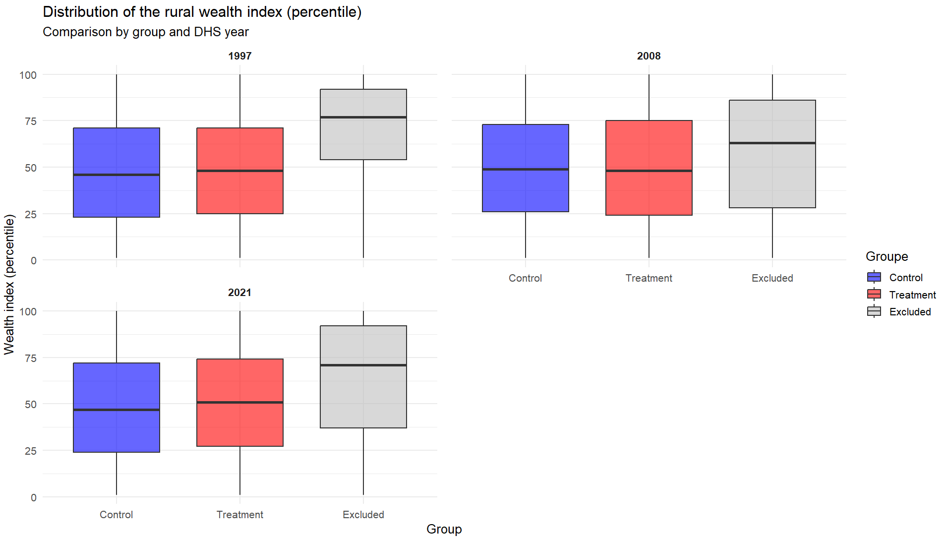
Figure 3: Distribution of the rural wealth index (percentile)
Notes: The graph shows boxplots of the wealth index distribution in percentiles (blue for the control group, red for the treatment group, and grey for the excluded groups). Across all surveys, for all years of the study, the wealth index odistributions of the treatment and control groups are roughly similar.
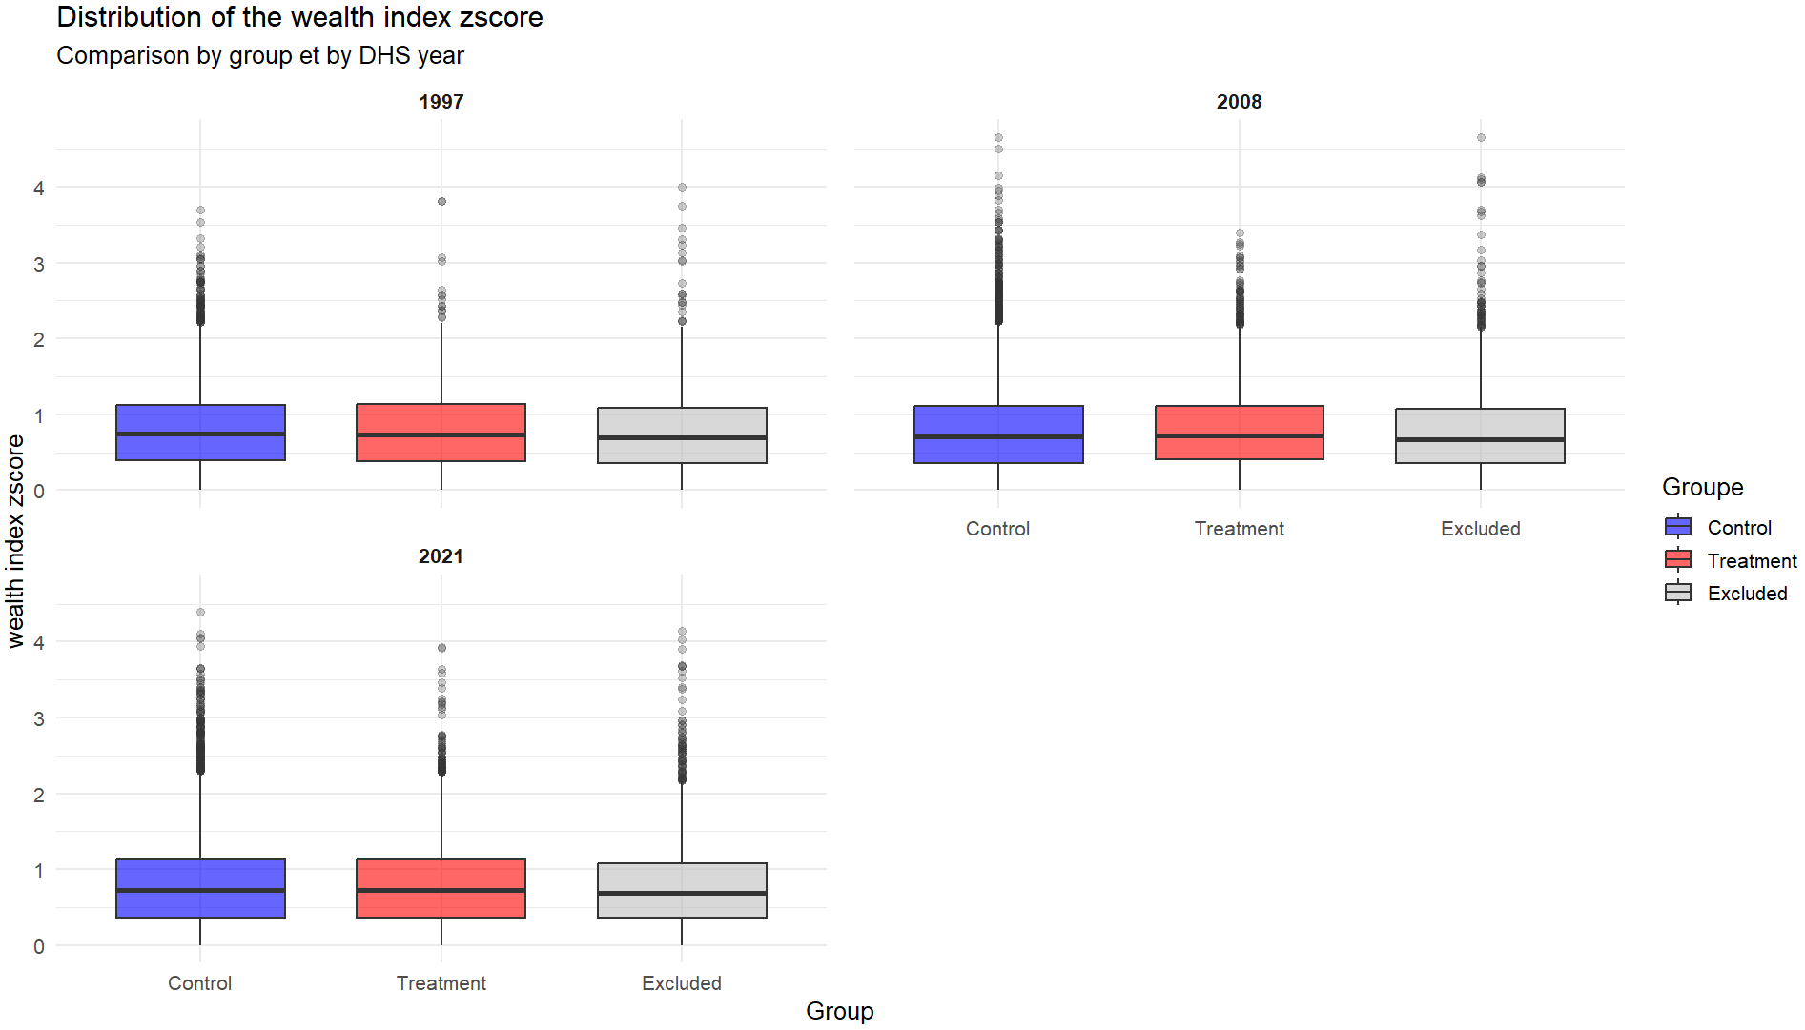
Figure 4: Distribution of the Zscore of the rural wealth index (percentile)
Notes: The graph shows boxplots of the zscore wealth index distribution in percentiles (blue for the control group, red for the treatment group, and grey for the excluded groups).Across all survey years, the wealth index Z scores of the treatment and control group is roughly similar.

Study design
To assess the impact of PA surrounding the well-being of households, it is essentials to identify the counterfactual scenario, that is, what would have occurred in the absence of protection. We therefore applied genetic matching combined with Mahalanobis distance matching and a caliper of 0.25 to reduce observable differences between treated and control units and to quantify the similarly between matched observations. This matching procedure enhances the robustness and credibility of the empirical results (Appendix). The underlying assumption is that, after matching, treated and control units would exhibit identical expected outcomes in the absence of PAs. Post-matching, we employed a difference-in-difference (DID) approach to estimate the causal effect associated with the PAs creation. This method consists in comparing the wealth index of households in treated and control groups before and after the PA creation(Appendix). The DID strategy relies on the parallel tyrends assumption, which posits that treated and untreated areas followed similar trajectories prior to the intervention.
The simplified equation for the difference-in-difference (Daw and Hatfield 2018) is as follows:
$$Y_{it}=α_{0}+β_{1}{\text{Treatment}}_{i}+β_{2}{\text{Post}}_{t}+δD_{it}+ε_{it}$$
(2)
With the parameters defined as:
$Y_{it}$: Wealth index for household $i$ in year $t$ (1997, 2008 or 2021) $α_{0}$: Intercept, representing the baseline wealth index $β_{1}$: Coefficient associated with the variable $Treatment_{i}$
$Treatment_{i}$: Binary variable that takes the value of 1 for households $i$ affected by a PA (treatment households) and 0 for households $i$ not affected by PA (control households)
$β_{2}$: : Coefficient associated with the variable $Post_{t}$
$Post_{t}$: Binary variable that takes the value of 1 for the post-treatment year 2021 and 0 for the pre-treatment year 2008
$δ$: Coefficient of interest representing the effect of PA creation on household living standards $i$ in year $t$
$D_{it}$: Interaction term between $Treatment_{i}$ and $Post_{t}$; It is equal to 1 for treatment households $i$ after the treatment year $t$ and 0 for the other households.
$ε_{it}$: Error term for household $i$ in year $t$

Robustness and sensitivity tests
We implement a series of robustness tests predefined in the pre-analysis plan published prior to the results(published on OSF in March 2025:https://osf.io/bgu5n/).We re-estimate all effects using distances thresholds 5 km and 15 km to assess the robustness of our results th the choice of the treatment radius. While condifence intervals may widen when restricting the study area to 5 km, comparing coefficients across specifications allows us to assess the consistency of the estimated effects.
We apply Benjamini-Hochber’s (Benjamini and Hochberg 1995) False Discovery Rate method to test Hypothesis 2 (PA impact on inequalities between households) and Hypothesis 3 the role of PA governance model). These tests are performed to mitigate the risk of incorrectly inferring significant effects by controlling the average proportion of false positives among the results reported as significant. Hypothesis 2 is evaluated using the Z-score outcome of the wealth index, and Hypothesis 3 is evaluated using PA governance categories based on IUCN status of PAs.
In the analysis, the outcome variable may be correlated with unobserved factors or shocks at the household level. Fixed effects methods can correct for many of these factors, but only repeated cross-sectional data are available.
Genetic matching and Doubly Robust DID estimation on a cross-section do not fully control for unobserved characteristics that may simultaneously affect PA and the outcome variable (wealth index). To assess the robustness of the results in the face of these potential biases resulting from unobserved confounding variables, we perform a sensitivity analysis using Rosenbaum’s method ((2002, ~105–170)).

Resultats

Matching between treatment and control
The distribution analysis of covariates prior to matching shows a substantial imbalance between the treatment and control groups (2008 case in the Table 1). After matching,the SMDs improve for all variables in each year. However, the population density in 2000 remains the most difficult variable to balance. This reflects the fact PAs are not randomly distributed. The graph Figure 5 shows the difference in covariates between the two groups.
Table 1: Standardized Mean Difference of the Year 2008
Year Variable SMD_before SMD_after
1 2008 treecover_area_2000 0.7107238 0.027823690
2 2008 slope_2000 0.1143434 0.014154202
3 2008 elevation_2000 0.5078613 0.024878748
4 2008 population_count_2000 0.5385607 0.102696532
5 2008 traveltime_2000_2000 0.1476695 0.004431269

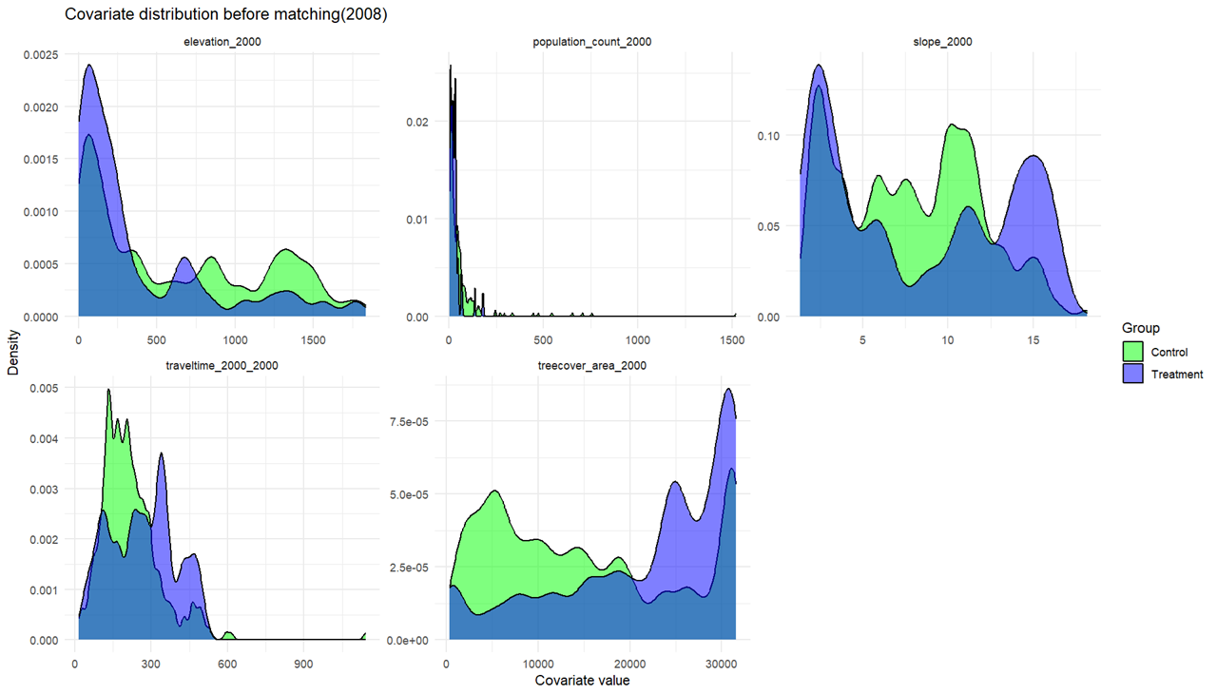
Figure 5: Covariate balance matching
Notes: These graphs show the distribution of covaraites before matching between clusters located near protected areas (purple) and those located far from them (green). Each panel illustrates the covaraites used in the matching, namely forest cover in 2000, slope and altitude, population density in 2000, slope and accessibility in 2000 (estimated travel time by car from households to the nearest towns).

Overall impact on livelihoods
In our DID estimation, we used robust standard errors. The results indicate no statistically significant difference at the 5% level between treated and control households. Figure 6 presents the results of the 2x2 DID estimation comparing the treatment groups (households living within 10 km of a PA) and the control groups (households more than 10 km away) prior to (1997-2008) and after (2008-2021) the PA establishment.
Table 2
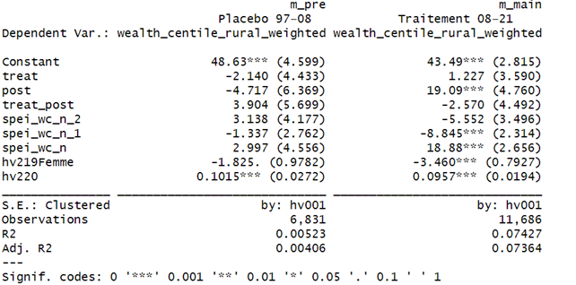
The placebo test for the treatment period (1997-2008 period) yields small and insignificant coefficient (+3.9 percentile) indicating that no differencial trend is detected prior to intervention (Table 3). The supports the parallell trends assumption as the wealth indices of the two groups vary similarly before PA creation.
Climatic conditions, as measured by the SPEI have no significant effect on rural wealth, and the effect of household characteristics appears to be minimal. On average, households headed by women are slightly poorer, while those with older members are tend to be wealthier.
For the treatment period (2008-2021), the estimated effect is negative but statistically insignificant (-2.5 wealth percentiles). Households living near PAs appear to have slightly lower living standards, but the confidence interval clearly includes zero. Given the study’s ex ante power calculation, which indicates that effects smaller than approximately 7.8 wealth percentiles cannot be reliably detected. This result that any true effect is either close to zero or below our detection threshold.
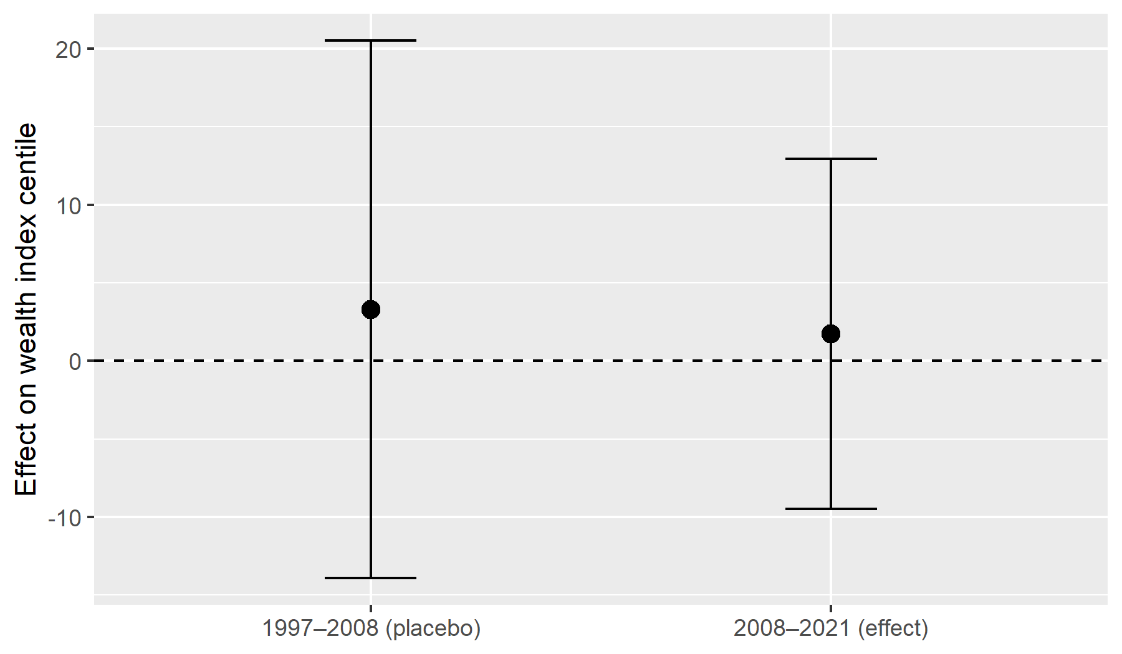
Figure 6: Impact on well-being: 2x2 DiD impact on local population (< 10km)
Notes: The vertical axis reports the estimated DID effect on the household wealth percentile (in points). Points indicate point estimates, and error bars represent cluster robust confidence intervals. The placebo estimate (1997-2008) and treatment period estimate (2008-2021) are both statistically insignificant, with the confidence interval crossing zero.

Event study estimation
The 2×2 DID estimates indicate no statistically significant average effect of PA creation on household living standards. Consistent with the pre analysis plan, our empirical design is powered to detect effects of approximately 7.5 wealth percentiles, and no such effect is detected. To further explore the possibility of heterogeneous effects over time, we therefore apply an estimator adapted to staggered treatment adoption and multiple periods, which allows treatment effects to vary dynamically (Borusyak, Jaravel, and Spiess 2024).
To increase temporal coverage before and after treatment, we integrate additional survey waves from the Malaria Indicator Surveys (MIS) (1997, 2011, and 2013) and MICS 2018, which follows a survey design comparable to DHS and MIS and includes 17,870 households. These additional surveys improve coverage of both pre treatment and post treatment periods.
• Staggered DiD: static
Table 3: Static treatment effect estimates on well-being
 | did2s (static)
treat_on = 1 | 4.519
 | (4.234)
Num.Obs. | 4246
R2 | 0.006
R2 Adj. | 0.006
AIC | 41025.8
BIC | 41032.2
RMSE | 30.32
Std.Errors | Corrected Clustered (cluster_uid)

The static staggered DID estimate suggests a positive but statistically insignificant association between treatment and household wealth (+4.5 wealth percentiles, standard error 4.23). Given the magnitude of uncertainty, this estimate does not allow us to reject the null hypothesis of no effect, motivating a dynamic event study analysis.
• Staggered DiD: dynamic event study
For the event study, each observation is indexed by its relative year to treatment, defined as the difference between the survey year and the year of PA establishment for treated locations. This transformation allows outcomes to be compared along a common event time dimension across cohorts. Because surveys are conducted at irregular intervals and some relative years are represented by very few observations, we group relative years into two-year bins. Observations occurring more than ten years before or after treatment are further aggregated into open-ended bins, as shown in Table 4. This binning strategy improves the stability and precision of the estimated dynamic effects.
Table 4: Binning of relative years-to-treatment for the event study
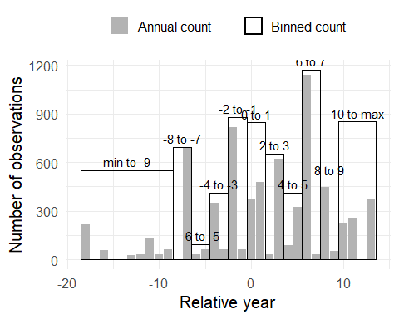
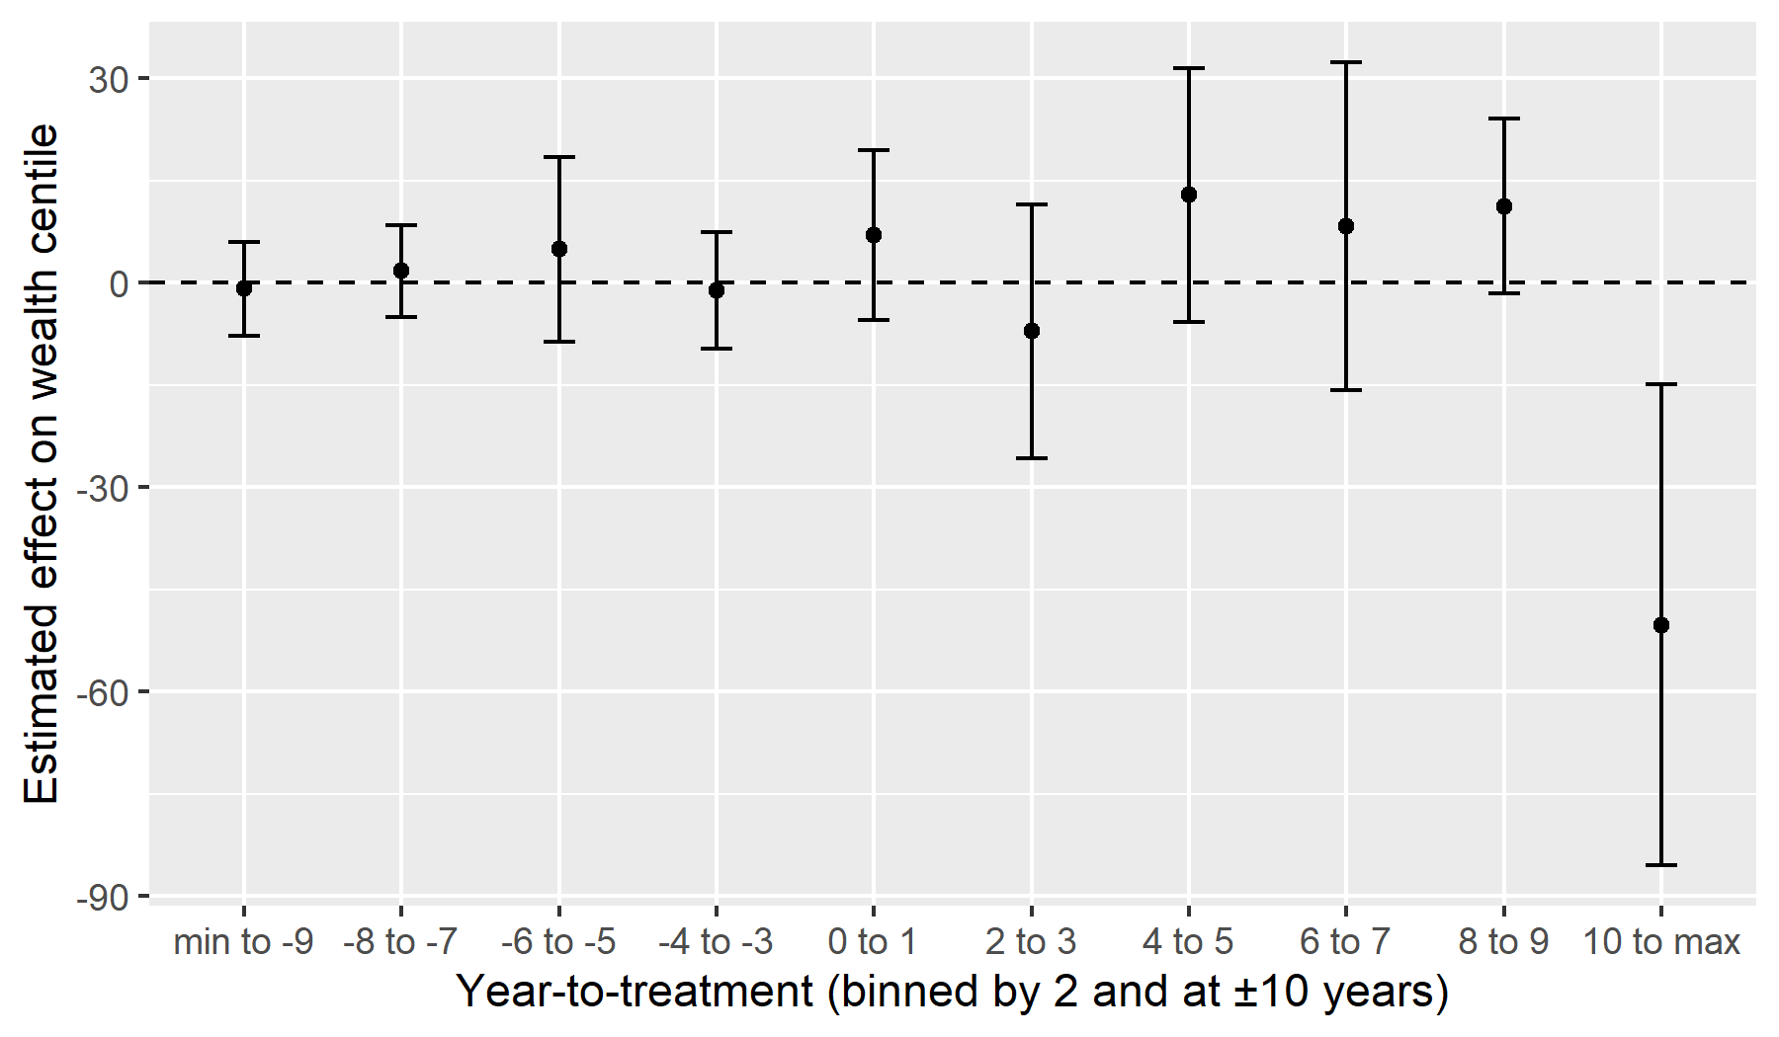
Figure 7: Impact on well-being: Event-study with 2-year bins
Figure 7 shows that the estimated event time coefficients are close to zero in the pre treatment period, and none of the pre treatment coefficients are statistically distinguishable from zero, supporting the plausibility of the parallel trends assumption. Following PA establishment, point estimates fluctuate across event time bins and are generally imprecise. However, the estimate for the longest horizon (more than 10 years after treatment) is large and negative, and its confidence interval lies entirely below zero. This pattern suggests a potential adverse effect emerging only at long horizons, while effects in the short and medium run remain statistically indistinguishable from zero. This long horizon estimate should nonetheless be interpreted cautiously, as it may reflect a specific subset of PAs. Although it includes 851 treated observations from 27 clusters, it primarily concerns PAs created at the beginning of the study period, which may differ systematically from later ones (for instance, lower tourism potential or other unobserved characteristics). Subject to further investigation, this estimate could reflect a genuine mechanism, such as a gradual decline in compensatory measures by PA managers or the cumulative effects of land use restrictions on younger farming generations.

Effect on inequalities

Estimation DID 2X2
The DID estimates indicate that PA creation does not have a statistically significant average effect on wealth inequalities, as measured by the Z score of the wealth index. The placebo estimation for the pre treatment period (1997–2008) yields a small and statistically insignificant treatment effect (treat × post = 0.038, s.e. 0.035), supporting the plausibility of the parallel trends assumption for inequality outcomes. For the treatment period (2008–2021), the estimated treatment effect is negative but small and statistically insignificant (treat × post = −0.011, s.e. 0.018). As shown in Figure 7, the clustered confidence interval clearly overlaps zero, indicating no detectable causal effect of PA creation on within-cluster wealth inequality. Hypothesis 2 is therefore not supported in terms of an average effect.
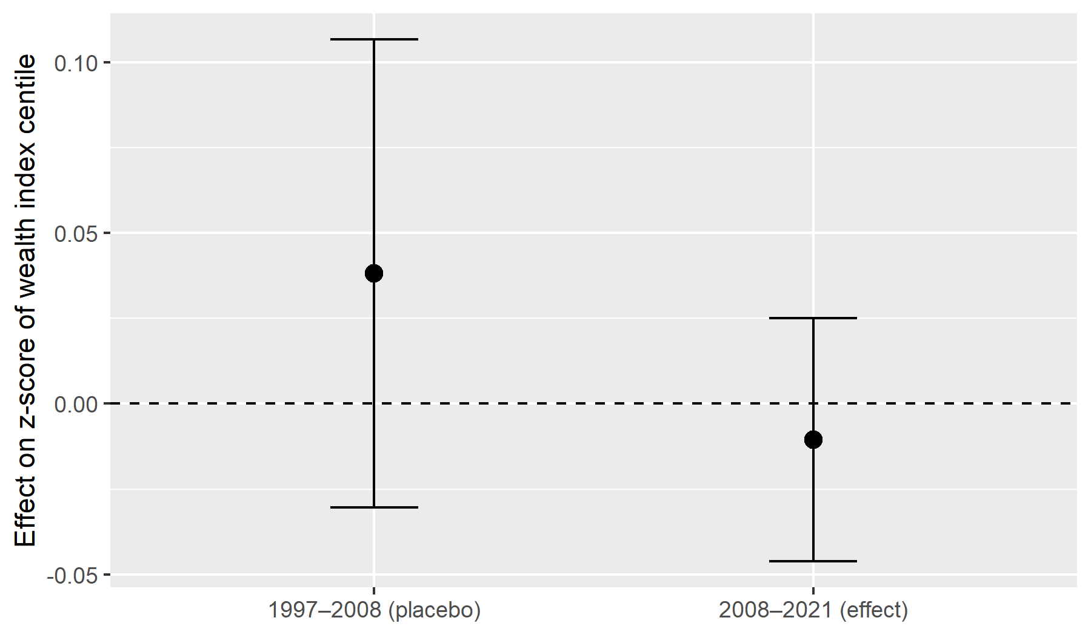
Figure 8: Impact on inequalities: 2x2 DiD impact on local population (< 10km)
Notes: The estimated average effect (black dot) is slightly positive for the placebo period, but still not significant (the error bar crosses the horizontal line). During treatment, the estimated average effect is slightly below 0, pointing to a negative effect, but as the clustered confidence interval overlaps 0, the effect is not significant
The coefficient on the post indicator is positive and statistically significant in the main specification (post = 0.055, p < 0.01), indicating a general increase in inequality over time between 2008 and 2021 that affects both treated and control clusters alike. This pattern reflects a time trend rather than a treatment effect, and should not be attributed to PA creation. Climatic conditions, as measured by the SPEI, exhibit statistically significant associations with inequality in the treatment period, suggesting that climatic shocks disproportionately affect poorer households and contribute to widening disparities. In contrast, household demographic characteristics play a limited role: households headed by women exhibit slightly lower relative wealth positions in the inequality distribution, while the age of the household head is positively associated with relative wealth. Finally, the very low values of R² and adjusted R² indicate that the model explains only a small share of the variation in inequality outcomes. This is expected in short panel DID specifications using repeated cross sections and does not undermine the identification of the treatment effect, but it cautions against interpreting the model as predictive
• Staggered DiD: static specification
Table 5 reports the static staggered DID estimates for inequality outcomes. The estimated treatment effect is negative but very small (−0.007), and not statistically significant. This indicates that, on average, exposure to PA creation is not associated with a detectable change in within cluster wealth inequality. The estimate is imprecise, and the null hypothesis of no effect should not be rejected
Table 5: Static treatment effect estimates on inequalities
 | did2s (static)
treat_on = 1 | -0.007
 | (0.019)
Num.Obs. | 4246
R2 | -0.000
R2 Adj. | -0.000
AIC | 7251.5
BIC | 7257.9
RMSE | 0.57
Std.Errors | Corrected Clustered (cluster_uid)

• Staggered DiD: dynamic event study
Figure 9 presents the dynamic event study estimates for inequality outcomes using two year bins. Pre treatment coefficients are close to zero and statistically insignificant, supporting the plausibility of the parallel trends assumption for inequality measures. Following PA creation, estimated effects remain small and statistically insignificant across all post treatment horizons.
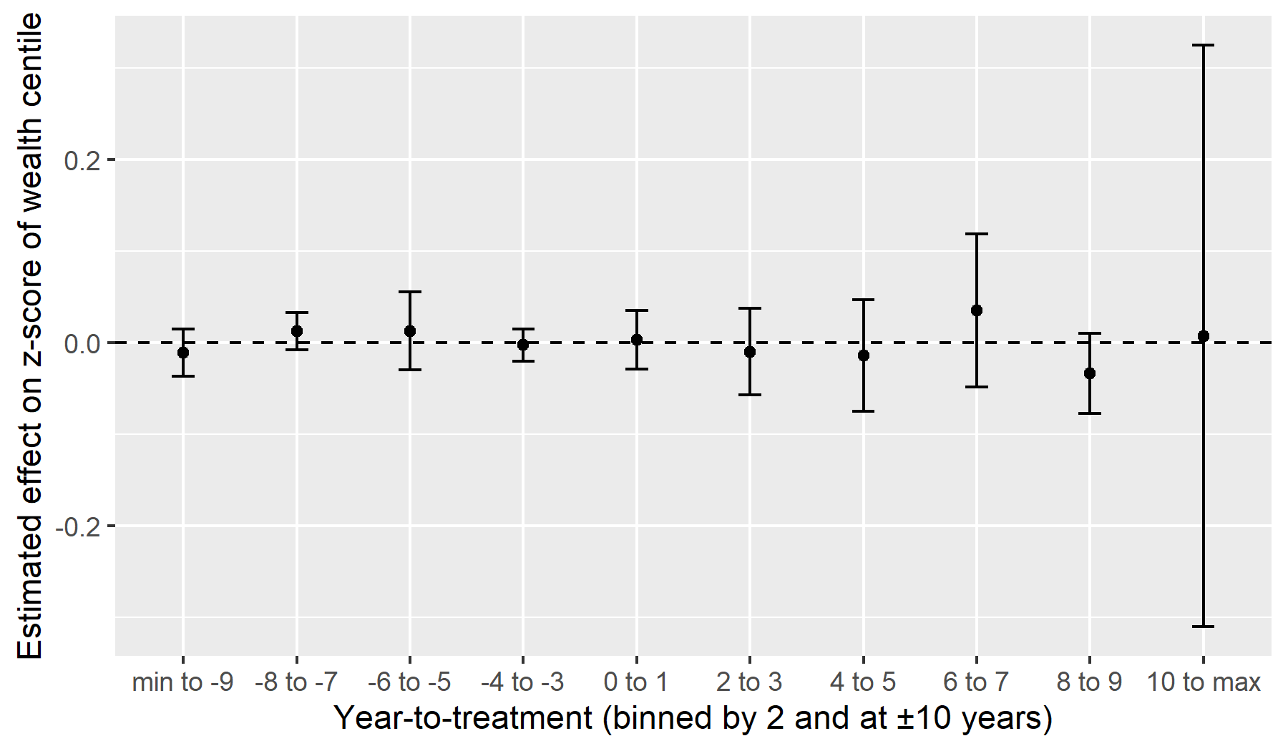
Figure 9: Impact on inequalities: Event-study with 2-year bins

Heterogeneity

Estimation DID 2X2
We assess whether the average effect of PA creation on household living standards differs by governance regime, distinguishing between strict PAs and multi use PAs (Appendix). The 2×2 DID estimates indicate no statistically significant effect for either governance type, both in the placebo period (1997–2008) and in the treatment period (2008–2021). Point estimates differ in sign across regimes, but confidence intervals are wide and overlap zero, providing no evidence of systematic heterogeneity in average impacts by PA governance
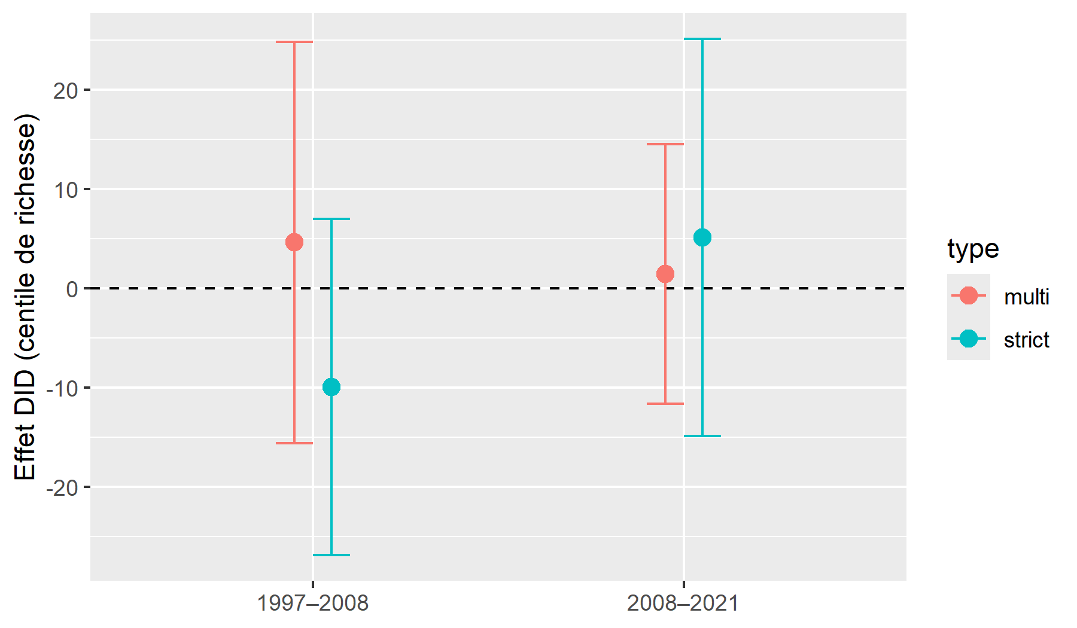
Figure 10: Heterogeneity of impact on well-being
Notes: The graph highlights the change in household living standards before and after the PA implementation, by governance type of PA. Point estimates differ slightly between multi use and strict PAs in both periods, but confidence intervals overlap zero throughout, indicating no statistically significant differences.
staggered DID and event study specifications that allow for dynamic and cohort specific effects lead to consistent conclusions. While some coefficients are statistically significant at specific horizons, they are not stable across specifications or governance types, and do not alter the overall finding of no detectable average differential effect by PA governance regime.

Robustness
In this section, we discuss the sensitivity analyses and robustness checks that suppport our main results. First, to verify the robustness of our conclusions, we performed additional analyses using distances of 5 km and 15 km from the AP to define the treated group. We find that the creation of PA did not lead to significant changes in household wealth percentiles for iether distance. In neither cas is the interaction coefficient significant. Conversely, the temporal effect is consistently positive and significant, reflecting a general increase in wealth after 2008, regardless of the distance considered. Climatic variables are also statistically significant, and socio-demographic indicators consistently show that female-headed households have lower wealth and that wealth levels are positively correlated with the age of the household head. The stability of these results across the three distance thresholds suggests that climatic and socio-demographic dynamics largely dominate the effect of proximity to PA. These tests showed that our conclusions are robust to the definition of treated households.
Benjamini’s (Benjamini and Hochberg 1995) False Discovery rate (FDR) method showed that, prior to multiple tetsing, the coefficients did not show a stable trend of improvement or deterioration in the wealth index. After controlling for the risk of false positives, only a marked negative effect on the wealth index remains statistically significant. This suggests a transient effect of impoverishment.
The pseudo panel approach shows that the average wealth index of household cohorts is influenced by environmental factors. The results indicate that households located at high altitudes and in densely populated areas have a higher wealth index. Forest cover has a positive and significnat effect, while slope and accessibility have a negative effect on the wealth index. In contrast, socioe-demograohic variables have a weakly significant effect, suggesting that spatial and environmental conditions play a more decisive role than individual househol characteristics.
Rosenbaum’s sensitivity test (Rosenbaum 1983) shows that the results are not robust in the face of unobserved assignment biases. In 1997, the absence of any systematic difference between households close to and far from PA before the introduction of PA confirms the hypothesis of parallel trends. In 2008, the test suggest a significant effect when assuming no bias ($Γ=1$), but this quickly disappears as soon as a small unmeasured imbalance is introduced ($Γ>1$). The Hodges-Lehmann intervals include zero and the p-value bounds exceed the 0.05 threshold. In 2021, the estimated effect is small and marginally significant, but it is not robust to hidden bias assumptions. Limiting ourselves to these three years, the observed wealth inequalities cannot be causally and robustly attributed to proximity to PA.
The DID estimates revealed that, on average, female-headed households have a lower wealth percentile (-2.307) than male-headed households (+0.7440). However, the interaction between the treatment and the gender of the household head does not reveal a signifcicant difference between men and women. In other words, living near PA has no particular effect on gender inequality among household heads. Similarly, no interaction between the treatment and the age of the household head was evident, even though households headed by people aged 45-59 appeared to be significantly wealthier (2.920) than others.

Discussion and conclusion
This study assesses the potentially contradictory effects of PAs on the household living standards and socioeconomic inequalities among rural households in Madagascar. By relying on a pre analysis plan and combining matching with difference in difference approaches.
Hypothesis 1 posits that, on average, PAs reduce the living standardsof rural households. Our results do not support this hypothesis. Across multiple specifications, we do not detect a statistically significant average effect of PA creation on the household wealth index. Point estimates are generally negative, but confidence intervals are wide and include zero, implying that any true effect is either close to zero or below our detection capacity. A plausible explanation is that losses associated with restrictions on access to natural resources are offset, at least partially, by compensatory mechanisms, ecosystem services, or adaptation strategies, even if these mechanisms remain limited or uneven. From a policy perspective, these findings underline the importance of strengthening inclusive measures, such as transparent revenue sharing from tourism or targeted transfers, to reduce the risk of vulnerability among households located near PAs
Hypothesis 2 concerns the effect of PA creation on within cluster wealth inequalities. The results show no statistically significant average impact of PAs on inequality, as measured by the Z score of the wealth index. Instead, observed changes in inequality are primarily associated with broader socio demographic and climatic dynamics. In particular, climatic shocks, as captured by drought indicators, are associated with increased inequality, suggesting that poorer households are less able to buffer adverse shocks. Household characteristics also matter: households headed by women tend to occupy lower relative positions in the wealth distribution, while those headed by older individuals tend to be better off, likely reflecting accumulated assets and social capital. These patterns point to structural drivers of inequality that operate largely independently of PA creation. In the absence of inclusive policies, conservation interventions may nonetheless interact with these dynamics by reinforcing existing asymmetries in access to opportunities, which calls for governance arrangements that explicitly address equity concerns.
Hypothesis 3 examines whether the effects of PA creation differ by governance regime. The 2x2 DID estimates do not provide evidence of statistically significant heterogeneity between strict and multi use PAs. While point estimates differ in sign across governance types, confidence intervals are wide and overlap zero, preventing any firm conclusion regarding differential average impacts. staggered DID and event study analyses lead to consistent conclusions: although some coefficients are significant at specific horizons, they are not stable across specifications and do not alter the overall finding of no detectable systematic heterogeneity by governance type. These results suggest that, in the Malagasy context, formal governance categories alone are insufficient to explain variation in socioeconomic outcomes, and that implementation quality, timing, and local context likely play a more important role
Overall, our results do not allow us to rule out that protected areas have socioeconomic impacts on rural households. However, they suggest that the widespread concern, notably in Madagascar, that PA creation substantially undermines rural living conditions is not supported at the temporal and spatial scale of our analysis. At the same time, these findings do not preclude the existence of longer term effects, nor of important sources of heterogeneity that are not captured by the dichotomous classifications used in this study. In particular, the negative effects observed at long horizons in the dynamic analysis may point to delayed or cumulative mechanisms, or to differentiated impacts across specific subsets of PAs. This calls for further work to better document long term trajectories and to move beyond coarse governance typologies in order to understand how conservation policies interact with local socioeconomic dynamics over time.

CRediT authorship contribution statement
Iriana Razafimahenina: conceptualization - formal analysis - Methodology - writing - original draft
Florent Bédécarrats: conceptualization - Data curation - formal analysis - Funding acquisition - investigation -Methodology - Project administration - Resources - Software - Supervision - Validation - writing - original draft -
Ingrid Dallmann:conceptualization - Methodology - Supervision - Validation - Writing - review & editing
Holimalala Randriamanampisoa: conceptualization - formal analysis - Project administration -supervision - Validation- Writing - review & editing

Financement
The study is performed in the framework of the BETSAKA project. The BETSAKA project is cofunded by the Development Impact Lab of the German KfW Development Bank; the Agence Française de Développement (AFD), through the PAIRES program, the French National Research Agency (ANR), and the French Research Institute for Sustainable Development (IRD).

Declaration of interest
One of the authors is an evaluation officer at AFD, and the BETSAKA project is funded by the Evaluation department of both AFD and KfW. While the operational departments of AFD and KfW also fund conservation projects in Madagascar and other countries, the Evaluation departments operate independently. They are committed to rigorous, unbiased studies and are supervised by independent entities within both institutions.

Appendix A. Supplementary data
Supplementary material related to this article can be found at

Adams, William. M., Ros Aveling, Dan Brockington, Barney Dickson, Jo Elliott, Jon Hutton, Dilys Roe, Bhaskar Vira, and William Wolmer. 2004. “Biodiversity Conservation and the Eradication of Poverty.” Science 306 (5699): 1146–49. https://doi.org/10.1126/science.1097920.
Adeniyi, Oluwatosin, Wasiu Adekunle, Joshua Afolabi, and Terver T. Kumeka. 2024. “Tourism-Income Inequality Nexus in Africa: Evidence from SADC Countries.” Current Issues in Tourism 27 (18): 2899–2917. https://doi.org/10.1080/13683500.2023.2227377.
Benjamini, Yoav, and Yosef Hochberg. 1995. “Controlling the False Discovery Rate: A Practical and Powerful Approach to Multiple Testing.” Journal of the Royal Statistical Society: Series B (Methodological) 57 (1): 289–300. https://doi.org/10.1111/j.2517-6161.1995.tb02031.x.
Bertrand, Alain, Sigrid Aubert, Pierre Montagne, Alexio Clovis Lohanivo, and Manitra Harison Razafintsalama. 2014. “Madagascar, Politique Forestière: Bilan 1990–2013 Et Propositions.” Madagascar Conservation & Development 9 (1): 20–30. https://www.ajol.info/index.php/mcd/article/view/104817.
Borusyak, Kirill, Xavier Jaravel, and Jann Spiess. 2024. “Revisiting Event-Study Designs: Robust and Efficient Estimation.” The Review of Economic Studies, February, rdae007. https://doi.org/10.1093/restud/rdae007.
Chung, Min Gon, Thomas Dietz, and Jianguo Liu. 2018. “Global Relationships Between Biodiversity and Nature-Based Tourism in Protected Areas.” Ecosystem Services 34 (December): 11–23. https://doi.org/10.1016/j.ecoser.2018.09.004.
Conceição, Pedro, ed. 2024. Breaking the Gridlock: Reimagining Cooperation in a Polarized World. Human Development Report 2023/2024. New York: UNDP.
Daw, Jamie R., and Laura A. Hatfield. 2018. “Matching and Regression to the Mean in Difference-in-Differences Analysis.” Health Services Research 53 (6): 4138–56. https://doi.org/10.1111/1475-6773.12993.
Deaton, Angus. 1997. The Analysis of Household Surveys: A Microeconometric Approach to Development Policy. Baltimore, MD: World Bank Publications.
Eklund, Johanna, and Mar Cabeza. 2017. “Quality of Governance and Effectiveness of Protected Areas: Crucial Concepts for Conservation Planning.” Annals of the New York Academy of Sciences 1399 (1): 27–41. https://doi.org/10.1111/nyas.13284.
Froger, Géraldine, Vincent Géronimi, Philippe Méral, and Patrick Schembri, eds. 2009. Diversité Des Politiques de Développement Durable : Temporalités Et Durabilités En Conflit à Madagascar, Au Mali Et Au Mexique. Economie Et Développement. Paris (FRA) ; Paris: Karthala ; GEMDEV. https://www.documentation.ird.fr/hor/fdi:010048701.
Gallup, John Luke, Jeffrey D. Sachs, and Andrew D. Mellinger. 1999. “Geography and Economic Development.” International Regional Science Review 22 (2): 179–232. https://doi.org/10.1177/016001799761012334.
Ghosh, Sudeshna, and Subrata Kumar Mitra. 2021. “Tourism and Inequality: A Relook on the Kuznets Curve.” Tourism Management 83 (April): 104255. https://doi.org/10.1016/j.tourman.2020.104255.
Golden, Christopher D., Matthew H. Bonds, Justin S. Brashares, B. J. Rodolph Rasolofoniaina, and Claire Kremen. 2014. “Economic Valuation of Subsistence Harvest of Wildlife in Madagascar.” Conservation Biology 28 (1): 234–43. https://doi.org/https://doi.org/10.1111/cobi.12174.
Golden, Christopher D., BJ Rodolph Rasolofoniaina, EJ Gasta Anjaranirina, Lilien Nicolas, Laurent Ravaoliny, and Claire Kremen. 2012. “Rainforest Pharmacopeia in Madagascar Provides High Value for Current Local and Prospective Global Uses.”
Görgen, Darius A., and Om Prakash Bhandari. 2022. “Efficient Monitoring of Global Biodiversity Portfolios.” https://doi.org/10.32614/CRAN.package.mapme.biodiversity.
Hanson, Jonathan K., and Rachel Sigman. 2021. “Leviathan’s Latent Dimensions: Measuring State Capacity for Comparative Political Research.” The Journal of Politics 83 (4): 1495–1510. https://doi.org/10.1086/715066.
Hünermund, Paul, and Elias Bareinboim. 2023. “Causal Inference and Data Fusion in Econometrics.” The Econometrics Journal, utad008.
Joppa, Lucas, and Alexander Pfaff. 2010. “Reassessing the Forest Impacts of Protection: The Challenge of Nonrandom Location and a Corrective Method.” Annals of the New York Academy of Sciences 1185 (1): 135–49. https://doi.org/10.1111/j.1749-6632.2009.05162.x.
Kandel, Pratikshya, Ram Pandit, Benedict White, and Maksym Polyakov. 2022. “Do Protected Areas Increase Household Income? Evidence from a Meta-Analysis.” World Development 159 (November): 106024. https://doi.org/10.1016/j.worlddev.2022.106024.
Lo Bue, Maria C., Tu Thi Ngoc Le, Manuel Santos Silva, and Kunal Sen. 2022. “Gender and Vulnerable Employment in the Developing World: Evidence from Global Microdata.” World Development 159 (November): 106010. https://doi.org/10.1016/j.worlddev.2022.106010.
Mammides, Christos. 2019. “Evidence from Eleven Countries in Four Continents Suggests That Protected Areas Are Not Associated with Higher Poverty Rates.” Biological Conservation 241 (November): 108353. https://doi.org/10.1016/j.biocon.2019.108353.
Maxwell, Sean L., Victor Cazalis, Nigel Dudley, Michael Hoffmann, Ana SL Rodrigues, Sue Stolton, Piero Visconti, Stephen Woodley, Naomi Kingston, and Edward Lewis. 2020. “Area-Based Conservation in the Twenty-First Century.” Nature 586 (7828): 217–27.
McKinnon, Madeleine C., Samantha H. Cheng, Samuel Dupre, Janet Edmond, Ruth Garside, Louise Glew, Margaret B. Holland, et al. 2016. “What Are the Effects of Nature Conservation on Human Well-Being? A Systematic Map of Empirical Evidence from Developing Countries.” Environ Evid 5 (1): 8. https://doi.org/10.1186/s13750-016-0058-7.
Naidoo, R., D. Gerkey, D. Hole, A. Pfaff, A. M. Ellis, C. D. Golden, D. Herrera, et al. 2019. “Evaluating the Impacts of Protected Areas on Human Well-Being Across the Developing World.” Science Advances 5 (4): eaav3006. https://doi.org/10.1126/sciadv.aav3006.
Neudert, Regina, Joerg U. Ganzhorn, and Frank Waetzold. 2017. “Global Benefits and Local Costs–The Dilemma of Tropical Forest Conservation: A Review of the Situation in Madagascar.” Environmental Conservation 44 (1): 82–96.
Poudyal, Mahesh, Julia PG Jones, O. Sarobidy Rakotonarivo, Neal Hockley, James M. Gibbons, Rina Mandimbiniaina, Alexandra Rasoamanana, Nilsen S. Andrianantenaina, and Bruno S. Ramamonjisoa. 2018. “Who Bears the Cost of Forest Conservation?” PeerJ 6: e5106. https://doi.org/10.7717/peerj.5106.
Poudyal, Mahesh, O. Sarobidy Rakotonarivo, Julie H. Razafimanahaka, Neal Hockley, and Julia P. G. Jones. 2018. “Household Economy, Forest Dependency & Opportunity Costs of Conservation in Eastern Rainforests of Madagascar.” Sci Data 5 (1): 180225. https://doi.org/10.1038/sdata.2018.225.
Poudyal, Mahesh, Bruno S. Ramamonjisoa, Neal Hockley, O. Sarobidy Rakotonarivo, James M. Gibbons, Rina Mandimbiniaina, Alexandra Rasoamanana, and Julia PG Jones. 2016. “Can REDD+ Social Safeguards Reach the ‘Right’people? Lessons from Madagascar.” Global Environmental Change 37: 31–42. https://www.sciencedirect.com/science/article/pii/S095937801630005X.
Rivière, Mylène. 2017. “Les (Dé)connexions Du Développement : Ethno-Géographie Systémique de l’aide Au Développement Et à La Conservation Forestière à Amindrabe, Madagascar.” PhD thesis, Université Michel de Montaigne - Bordeaux III. https://theses.hal.science/tel-01720849.
Rosenbaum, Paul. 1983. “The Central Role of the Propensity Score in Observational Studies for Causal Effects.”
———. 2002. Observational Studies.
Skiles, Martha Priedeman, Clara R. Burgert, Siân L. Curtis, and John Spencer. 2013. “Geographically Linking Population and Facility Surveys: Methodological Considerations.” Population Health Metrics 11 (1): 14. http://www.biomedcentral.com/content/pdf/1478-7954-11-14.pdf.
Xuanming, Pan, Toyo Amègnonna Marcel Dossou, Kouessi Pascal Dossou, and Alastaire Sèna Alinsato. 2024. “The Impact of Tourism Development on Social Welfare in Africa: Quantile Regression Analysis.” Current Issues in Tourism 27 (7): 1159–72. https://doi.org/10.1080/13683500.2023.2214351.

These GPS coordinates correspond to the centroids of the enumeration areas surveyed. To protect respondent confidentiality, these coordinates are first randomly shifted using the following procedure: An offset angle between 0 and 360 is randomly drawn, and then an offset distance is randomly drawn, between 0 and 2 km in urban areas and between 0 and 5 km in rural areas. For 1% of rural clusters, the distance drawn is between 0 and 10 km (Skiles et al. 2013)
These GPS coordinates correspond to the centroids of the enumeration areas surveyed. To protect respondent confidentiality, these coordinates are first randomly shifted using the following procedure: An offset angle between 0 and 360 is randomly drawn, and then an offset distance is randomly drawn, between 0 and 2 km in urban areas and between 0 and 5 km in rural areas. For 1% of rural clusters, the distance drawn is between 0 and 10 km (Skiles et al. 2013)

