Supplementary Materials

Section A. Data processing and variable definitions

Protected area data
Protected area boundaries and attributes are drawn from the World Database on Protected Areas (WDPA), May 2021 release (UNEP-WCMC and IUCN 2023). The following WDPA fields are used, with definitions drawn from the WDPA User Manual (UNEP-WCMC 2024):
- STATUS: The legal or established status of a protected area. We retain only sites with STATUS equal to “Designated”, “Established”, or “Inscribed”, which correspond to sites that have been formally recognized through legal or other effective means.
- STATUS_YR: The year in which the protected area was designated or established. A value of 0 indicates that the designation year was not reported by the data provider. It does not mean the PA was created in year zero, nor that its existence is uncertain – it simply reflects missing temporal metadata. In the May 2021 WDPA release, a non-negligible number of PAs carry STATUS_YR = 0.
- IUCN_CAT: The IUCN management category assigned to the protected area. Categories Ia, Ib, II, and III correspond to strict protection regimes (nature reserves, wilderness areas, national parks). Categories IV, V, and VI correspond to less restrictive management (habitat management areas, protected landscapes, sustainable-use areas). Many PAs in the WDPA carry a category of “Not Reported”, “Not Applicable”, or “Not Assigned” – we group these as “unknown IUCN category”.
- DESIG_ENG: The designation type in English. UNESCO-MAB Biosphere Reserves are excluded, as is standard practice, because they often encompass large areas with minimal legal protection (Hanson 2022).
- MARINE: Indicates whether the PA is terrestrial, coastal, or marine. We exclude purely marine PAs (MARINE = "2").

Temporal classification of protected areas
Because STATUS_YR = 0 is common in the WDPA, we distinguish two sets of PAs:
- PAs with recorded designation year: used for the 2000–2020 comparison. For 2000, we retain PAs with 1 ≤ STATUS_YR ≤ 2000. For 2020, we retain PAs with 1 ≤ STATUS_YR ≤ 2020.
- All PAs in 2020: includes all PAs from set (1) above plus those with STATUS_YR = 0. These PAs are known to exist because they appear in the May 2021 WDPA release – their designation year is simply not recorded. This is the set used for the main 2020 cross-section (Table 1, Figure 1).
The 2000–2020 comparison is restricted to set (1) because PAs with missing designation year cannot be reliably assigned to the 2000 period.

Spatial processing in R
Population counts inside and near protected areas were computed in R (R Core Team 2023) for each country and each first-level administrative unit (ADM1) from geoBoundaries v6.0.0 (Runfola et al. 2020), using the terra (Hijmans 2025) and exactextractr (Baston 2023) packages for raster extraction and sf (Pebesma 2018) for vector operations, run on the SSP Cloud data-science platform (Avouac et al. 2025). All geometries were processed in an equal-area projection (EPSG:6933), and protected areas were filtered to each country by ISO3 code so that PAs in neighbouring countries are not attributed across borders. For each administrative unit, the following steps were performed:
- Classification: PAs were assigned to one of three IUCN groups (strict, non-strict, unknown) and dissolved into one geometry per group.
- Hierarchical assignment: Where PA categories overlap spatially, area was assigned to the highest-priority category using an exclusive hierarchy: strict > non-strict > unknown. Each location belongs to at most one category.
- Buffer construction: For each category, a 10 km buffer was computed and reduced to the ring lying within 10 km of the PA boundary but outside any PA interior. Buffer rings are also assigned exclusively – an area already claimed by a higher-priority PA interior or buffer is not counted again. Combined with a single joint treatment of PAs with and without a recorded designation year, this exclusive construction avoids double counting of overlapping buffer zones.
- Zonal aggregation: Population (from GHSL or WorldPop) and land area were summed within each interior and ring, clipped to national boundaries. Buffer zones are truncated at international borders.
We also computed total PA boundary length by IUCN category from the same filtered WDPA polygons. Multipart geometries belonging to the same WDPAID were dissolved in EPSG:6933, and their perimeters were summed by category. This provides a category-level measure of potential boundary exposure that complements the area-based standardization reported in the main text.

Output dataset structure
The R computation produces one CSV file per country and population source (GHSL or WorldPop), with one row per ADM1 unit and temporal subset. Key variables in the output:
Variable | Definition | Unit
pop_total | Total population within the administrative unit | persons
pop_strict | Population inside strict PAs (IUCN Ia-III) | persons
pop_nonstrict | Population inside non-strict PAs (IUCN IV-VI) | persons
pop_unknowncat | Population inside PAs of unknown IUCN category | persons
pop_strict10 | Population in the 10 km buffer ring around strict PAs (exclusive of inside) | persons
pop_nonstrict10 | Population in the 10 km buffer ring around non-strict PAs (exclusive) | persons
pop_unknowncat10 | Population in the 10 km buffer ring around unknown-category PAs (exclusive) | persons
area_strict | Land area inside strict PAs | km²
area_nonstrict | Land area inside non-strict PAs | km²
area_unknowncat | Land area inside unknown-category PAs | km²
scenario | Temporal subset: Confirmed_2000, Confirmed_2020, Unknown_Year, or All_2020 | –
source | Population dataset: GHSL or WP (WorldPop) | –
The All_2020 subset (PAs with 1 ≤ STATUS_YR ≤ 2020 or STATUS_YR = 0) is computed directly with a single joint mask, rather than by summing Confirmed_2020 and Unknown_Year; this is what removes the double counting of overlapping buffer zones. A separate national-level aggregation file per country provides total PA area and distinct PA counts (all categories, All_2020 set).
In the R analysis, “inside or within 10 km” is computed as the sum of the inside population and the buffer-ring population (e.g., pop_strict + pop_strict10). Percentage shares are computed relative to pop_total, which represents the total national population from the same gridded dataset.
For the reviewer-requested 2020 standardization table by PA category, PA counts are the number of distinct WDPAID in the May 2021 WDPA snapshot after the filters above (the count basis requested by the reviewer), while inside-PA areas are taken from the per-country national aggregation files (National_PA_Totals_Refactored_<ISO3>.csv). Inside and 10 km ring populations and ring areas come from the reviewed ADM-based GHSL outputs described above. Country land-area denominators are taken from the geoBoundaries-based country areas to express PA area as a share of the combined land area of the 75-country sample.

References
Avouac, Romain, Thomas Faria, and Frédéric Comte. 2025. “A Cloud-Native Data Science Platform for Official Statistics.” In Foundations and Advances of Machine Learning in Official Statistics, edited by Florian Dumpert. Springer Nature Switzerland. https://doi.org/10.1007/978-3-032-10004-7_8.
Baston, Daniel. 2023. Exactextractr: Fast Extraction from Raster Datasets Using Polygons. https://isciences.gitlab.io/exactextractr/.
Hanson, Jeffrey O. 2022. “Wdpar: Interface to the World Database on Protected Areas.” Journal of Open Source Software 7 (78): 4594. https://doi.org/10.21105/joss.04594.
Hijmans, Robert J. 2025. Terra: Spatial Data Analysis. https://rspatial.org/.
Pebesma, Edzer. 2018. “Simple Features for R: Standardized Support for Spatial Vector Data.” The R Journal 10 (1): 439–46. https://doi.org/10.32614/RJ-2018-009.
R Core Team. 2023. R: A Language and Environment for Statistical Computing. R Foundation for Statistical Computing. https://www.R-project.org/.
Runfola, Daniel, Austin Anderson, Heather Baier, et al. 2020. “geoBoundaries: A Global Database of Political Administrative Boundaries.” PLOS ONE 15 (4): e0231866. https://doi.org/10.1371/journal.pone.0231866.
UNEP-WCMC. 2024. World Database on Protected Areas (WDPA) [WDOECM] User Manual 1.6. UNEP World Conservation Monitoring Centre. https://wdpa.s3.amazonaws.com/WDPA_Manual/English/WDPA_WDOECM_Manual_1_6.pdf.
UNEP-WCMC, and IUCN. 2023. Protected Planet: The World Database on Protected Areas (WDPA). UNEP-WCMC and IUCN. Cambridge, UK. www.protectedplanet.net.

Section B. Country-level detail
Table S1: Protected area coverage and population proximity (2000–2020)
Warning: package 'dplyr' was built under R version 4.5.3
 | PA area (km²) |  | % pop. inside PAs |  | % pop. inside or within 10 km
Country | 2000 | 2020 | 2000 | 2020 | 2000 | 2020
Afghanistan | 0 | 21,798 | 0.0 | 1.0 | 0.0 | 13.3
Angola | 82,206 | 82,206 | 1.5 | 1.7 | 2.4 | 3.1
Bangladesh | 4,120 | 3,857 | 0.3 | 0.4 | 3.8 | 9.3
Benin | 24,730 | 24,730 | 1.6 | 1.7 | 15.2 | 15.8
Bhutan | 12,959 | 17,123 | 2.8 | 3.0 | 43.8 | 45.9
Bolivia | 212,372 | 236,250 | 7.1 | 13.5 | 47.7 | 52.1
Burkina Faso | 34,942 | 39,973 | 3.1 | 3.7 | 27.0 | 38.7
Burundi | 1,172 | 1,174 | 0.1 | 0.1 | 25.4 | 28.0
Cabo Verde | 0 | 21 | 0.0 | 0.1 | 0.0 | 39.5
Cambodia | 24,745 | 62,639 | 1.9 | 4.5 | 10.8 | 27.6
Cameroon | 23,657 | 48,085 | 0.1 | 2.1 | 3.9 | 21.6
Central African Republic | 67,995 | 67,995 | 0.2 | 0.3 | 13.1 | 14.2
Chad | 143,131 | 173,459 | 3.7 | 3.6 | 10.8 | 10.6
Comoros | 12 | 529 | 0.5 | 11.8 | 33.6 | 98.6
Congo, Dem. Rep. | 161,685 | 282,122 | 1.5 | 4.7 | 18.3 | 22.4
Congo, Rep. | 31,032 | 117,639 | 0.5 | 12.1 | 48.0 | 70.0
Côte d'Ivoire | 20,929 | 21,171 | 0.1 | 0.3 | 21.8 | 26.4
Djibouti | 0 | 201 | 0.0 | 0.0 | 0.0 | 1.3
Egypt, Arab Rep. | 59,135 | 126,749 | 0.3 | 0.4 | 10.4 | 10.8
El Salvador | 14 | 1,402 | 0.0 | 2.5 | 1.0 | 81.5
Eritrea | 5,807 | 5,807 | 1.1 | 1.4 | 7.5 | 5.3
Eswatini | 695 | 715 | 0.2 | 0.1 | 26.9 | 34.1
Ethiopia | 103,155 | 165,408 | 2.7 | 6.4 | 6.6 | 12.5
Gambia, The | 313 | 462 | 0.1 | 0.4 | 51.0 | 73.2
Ghana | 28,703 | 29,074 | 0.9 | 0.8 | 62.8 | 63.8
Guinea | 11,087 | 54,567 | 2.0 | 14.1 | 40.7 | 52.5
Guinea-Bissau | 3,251 | 5,535 | 1.8 | 4.9 | 9.3 | 15.0
Haiti | 548 | 1,761 | 0.8 | 2.8 | 8.5 | 43.8
Honduras | 21,586 | 23,726 | 3.2 | 4.1 | 60.0 | 68.9
Indonesia | 41,090 | 64,140 | 0.1 | 0.3 | 2.6 | 4.5
Kenya | 54,913 | 55,891 | 3.0 | 3.2 | 47.8 | 47.9
Kiribati | 0 | 0 | 0.0 | 0.0 | 0.0 | 0.0
Korea, Dem. Rep. | 0 | 0 | 0.0 | 0.0 | 0.0 | 0.0
Kyrgyz Republic | 5,332 | 5,332 | 0.4 | 0.4 | 16.3 | 15.8
Lao PDR | 25,375 | 41,418 | 1.6 | 3.3 | 20.8 | 29.3
Lesotho | 69 | 69 | 0.0 | 0.0 | 0.2 | 0.3
Liberia | 1,551 | 3,413 | 0.0 | 0.9 | 0.8 | 6.1
Madagascar | 30,133 | 42,528 | 1.0 | 3.8 | 8.2 | 24.8
Malawi | 16,530 | 17,114 | 1.3 | 1.4 | 42.9 | 42.0
Mali | 41,179 | 82,426 | 3.2 | 9.3 | 32.6 | 45.4
Mauritania | 6,014 | 6,014 | 0.4 | 0.1 | 0.7 | 0.2
Micronesia, Fed. Sts. | 0 | 0 | 0.0 | 0.0 | 0.0 | 0.0
Moldova | 0 | 0 | 0.0 | 0.0 | 0.0 | 0.0
Mongolia | 219,208 | 286,375 | 1.6 | 1.9 | 37.7 | 56.8
Morocco | 11,474 | 17,548 | 0.5 | 1.2 | 30.4 | 38.4
Mozambique | 74,133 | 137,400 | 0.8 | 5.2 | 2.5 | 20.4
Myanmar | 10,544 | 42,542 | 0.2 | 0.4 | 7.6 | 10.9
Nepal | 23,738 | 28,745 | 0.7 | 3.0 | 20.3 | 32.9
Nicaragua | 15,659 | 23,454 | 2.3 | 4.1 | 62.1 | 67.4
Niger | 80,125 | 192,502 | 1.9 | 4.5 | 3.2 | 8.2
Nigeria | 32,942 | 41,860 | 0.2 | 0.5 | 1.9 | 3.7
Pakistan | 80,228 | 80,228 | 2.9 | 2.9 | 19.2 | 19.2
Palestine (West Bank and Gaza) | 0 | 0 | 0.0 | 0.0 | 0.0 | 0.0
Papua New Guinea | 12,950 | 16,674 | 0.9 | 1.0 | 8.6 | 9.4
Philippines | 22,795 | 39,240 | 3.0 | 3.2 | 33.9 | 49.7
Rwanda | 2,019 | 2,120 | 0.0 | 0.1 | 15.5 | 21.7
Senegal | 21,853 | 23,063 | 1.2 | 1.3 | 12.9 | 30.9
Sierra Leone | 2,473 | 3,386 | 0.5 | 0.9 | 24.8 | 29.6
Solomon Islands | 122 | 247 | 0.2 | 0.3 | 0.9 | 4.2
Somalia | 0 | 0 | 0.0 | 0.0 | 0.0 | 0.0
Sudan | 8,334 | 8,751 | 0.1 | 0.1 | 0.2 | 0.2
Syrian Arab Republic | 0 | 0 | 0.0 | 0.0 | 0.0 | 0.0
São Tomé and Príncipe | 0 | 314 | 0.0 | 0.0 | 0.0 | 37.8
Tajikistan | 25,313 | 25,705 | 0.6 | 0.6 | 10.5 | 10.7
Tanzania | 192,871 | 226,066 | 2.0 | 3.2 | 37.5 | 38.9
Togo | 6,289 | 6,264 | 2.5 | 2.8 | 45.9 | 58.5
Tunisia | 7,469 | 11,581 | 0.1 | 0.2 | 25.9 | 55.7
Uganda | 27,642 | 30,414 | 1.7 | 2.1 | 80.5 | 81.1
Ukraine | 15,866 | 17,937 | 1.1 | 1.1 | 45.4 | 46.4
Uzbekistan | 12,307 | 19,245 | 0.1 | 0.3 | 2.9 | 6.6
Vanuatu | 54 | 54 | 0.1 | 0.1 | 12.5 | 15.8
Viet Nam | 5,674 | 21,180 | 0.6 | 1.0 | 8.4 | 17.7
Yemen, Rep. | 0 | 2,801 | 0.0 | 0.0 | 0.0 | 0.2
Zambia | 239,426 | 243,563 | 8.2 | 8.2 | 66.0 | 64.5
Zimbabwe | 49,208 | 78,860 | 0.6 | 4.2 | 12.3 | 31.2
Source: WDPA May 2021, GHSL.

Section C. Net change in population near protected areas, 2000–2020
Figure S1 shows the net change (2020 minus 2000) in population inside protected areas and within 10 km of their boundaries, for the 75 LMICs combined, decomposed by IUCN management category. This figure is restricted to protected areas with recorded designation years in the WDPA.
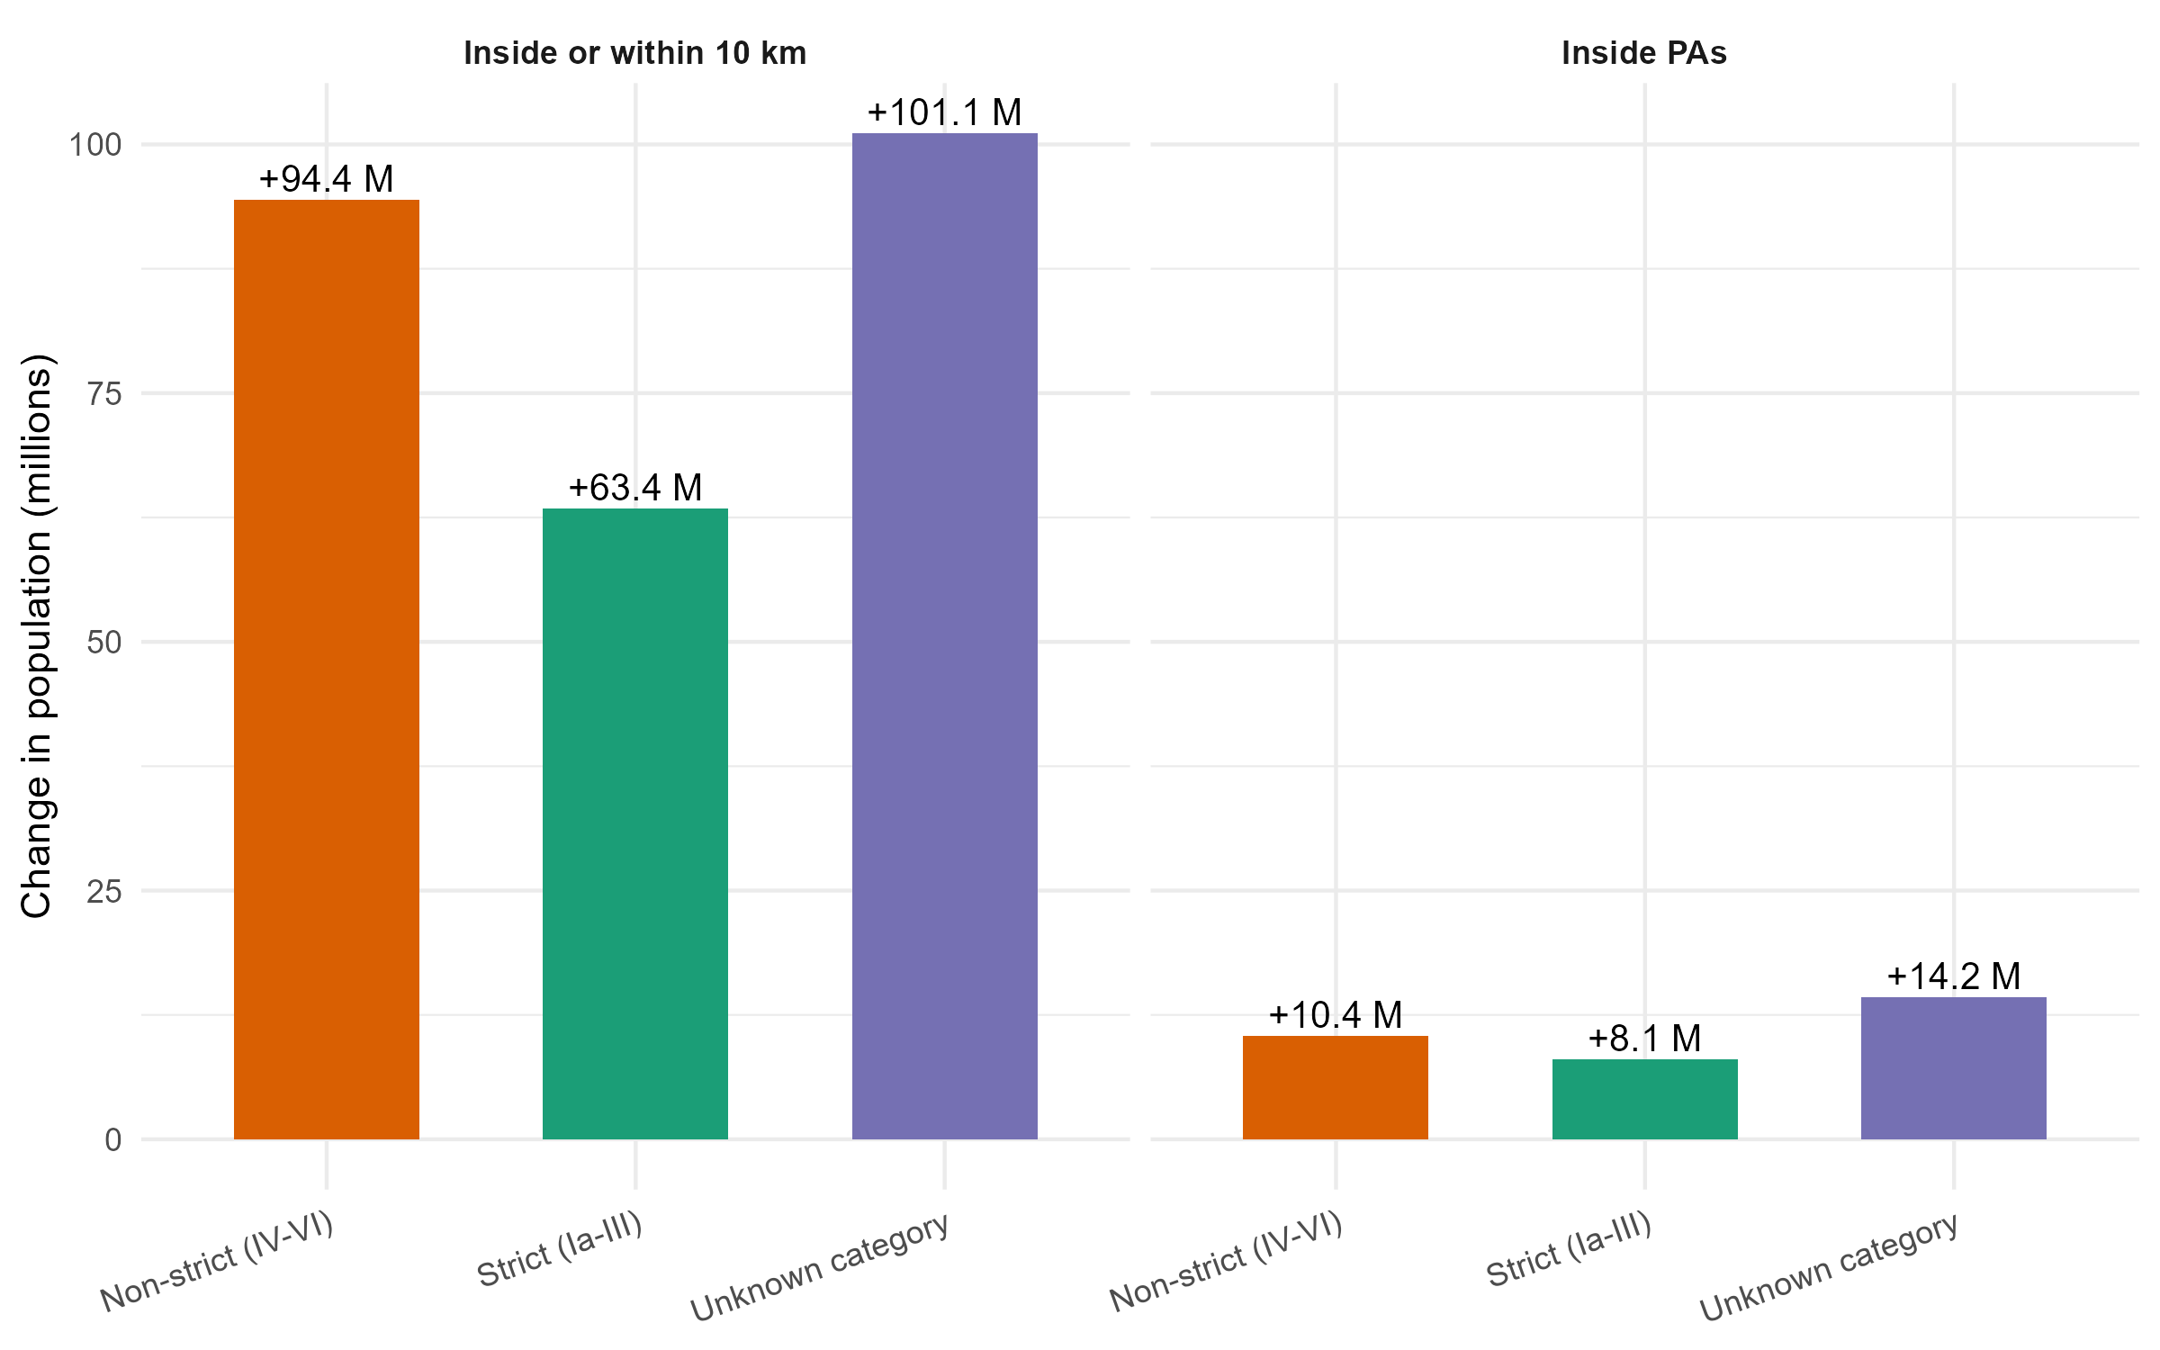
Figure S1: Net change in population inside protected areas and inside or within 10 km of their boundaries, 2000 to 2020, for the 75 low- and lower-middle-income countries combined, decomposed by IUCN management category. Estimates are restricted to protected areas with recorded designation years in the WDPA.

Section D. Effect of including PAs with missing designation year
Figure S2 displays, for each country, the share of the national population residing inside PAs or within 10 km under two counts: one restricted to PAs whose designation year is recorded as falling on or before 2020 (“Recorded year”), and one that also includes PAs with missing designation year (“Incl. missing year”). The gap between the two bars represents the uncertainty attributable to incomplete temporal metadata in the WDPA.
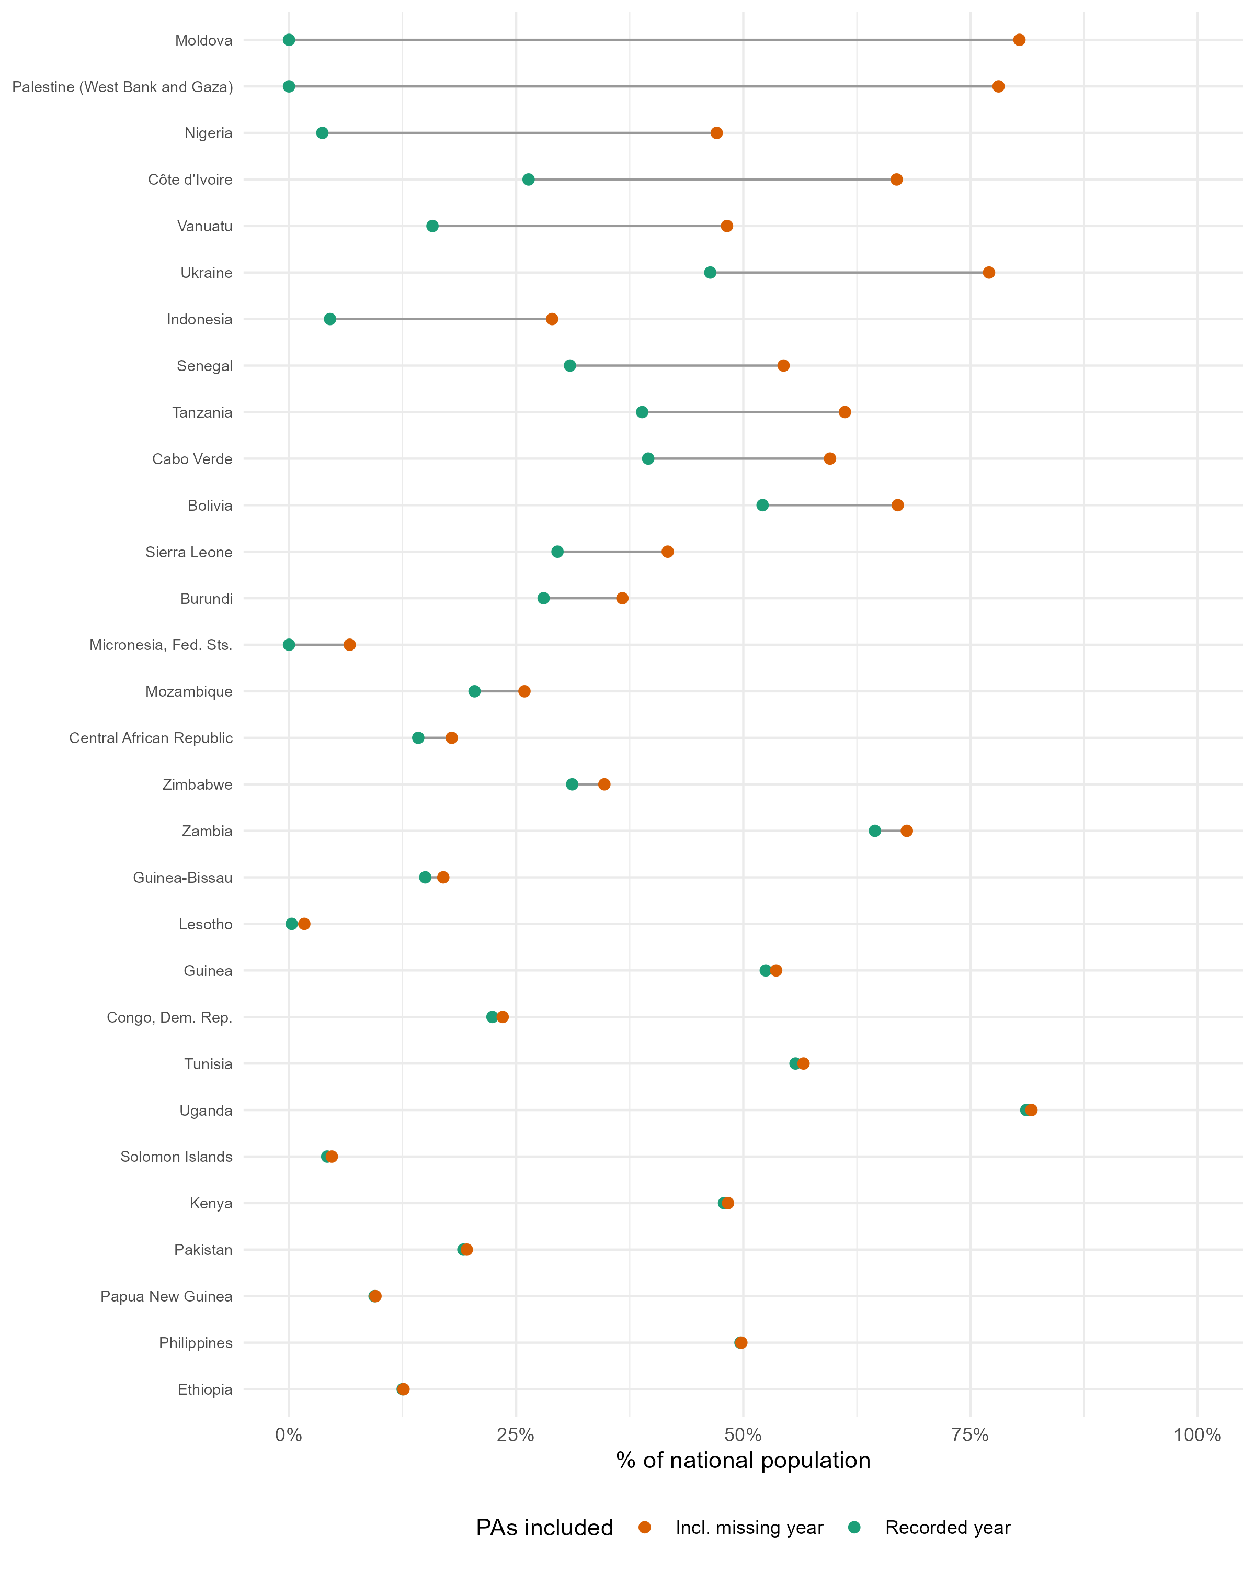
Figure S2: Effect of including protected areas with missing designation year on the estimated share of the national population living inside protected areas or within 10 km, by country. The figure compares counts based only on protected areas with recorded designation year with counts that also include protected areas whose designation year is missing.

Section E. Largest GHSL-WorldPop discrepancies
Figure 3 in the main text shows that the inside-PA comparison is systematically shifted upward, with most country estimates above the 1:1 line, whereas the broader inside-or-within-10-km perimeter is closer to parity. Table S2 lists the largest country-level discrepancies under the threshold rule used in the paper.
Table S2: Largest differences between GHSL and WorldPop estimates
Country | Perimeter | GHSL (%) | WorldPop (%) | Abs. diff. (pp) | Rel. diff.
São Tomé and Príncipe | Inside or within 10 km | 37.8 | 70.2 | 32.4 | 86%
Comoros | Inside PAs | 11.8 | 38.2 | 26.3 | 223%
Congo, Rep. | Inside PAs | 12.1 | 24.5 | 12.4 | 103%
São Tomé and Príncipe | Inside PAs | 0.0 | 8.7 | 8.6 | 17,346%
Bhutan | Inside or within 10 km | 45.9 | 53.8 | 7.9 | 17%
Nepal | Inside or within 10 km | 32.9 | 40.3 | 7.3 | 22%
Bhutan | Inside PAs | 3.0 | 9.2 | 6.2 | 204%
Guinea-Bissau | Inside or within 10 km | 21.0 | 27.0 | 6.0 | 29%
Bolivia | Inside PAs | 30.6 | 25.1 | 5.4 | 18%
Djibouti | Inside or within 10 km | 1.3 | 6.7 | 5.4 | 426%
Zambia | Inside PAs | 8.8 | 14.2 | 5.4 | 61%
Haiti | Inside or within 10 km | 43.8 | 48.9 | 5.1 | 12%
Senegal | Inside PAs | 2.8 | 7.8 | 5.0 | 180%
Source: WDPA May 2021, GHSL & WorldPop 2020.

