<https://stackoverflow.com/questions/21944895/running-powershell-script-within-python-script-how-to-make-python-print-the-pow>

<https://www.delftstack.com/howto/powershell/python-powershell/>

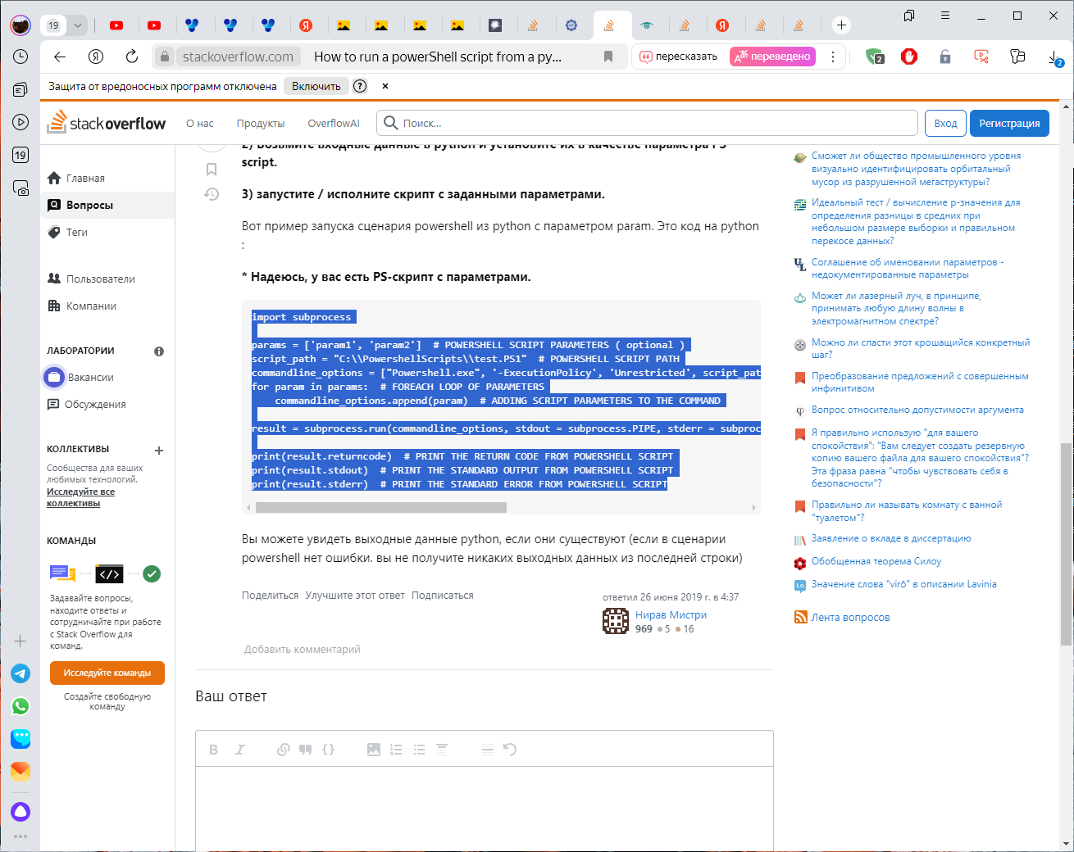

<https://stackoverflow.com/questions/56761404/how-to-run-a-powershell-script-from-a-python-file>

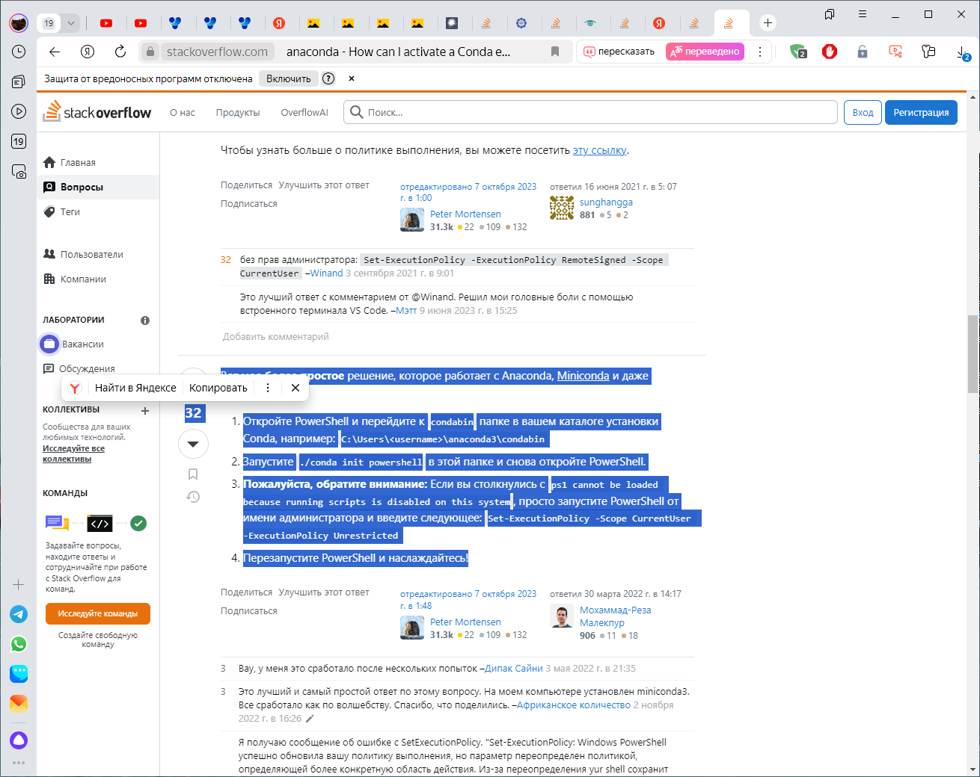

<https://stackoverflow.com/questions/64149680/how-can-i-activate-a-conda-environment-from-powershell>

https://www.youtube.com/watch?v=1quKqf47V6s&t=1928s&ab_channel=ХаудиХо™-ПростоомиреIT%21

<https://www.youtube.com/watch?v=RpiWnPNTeww&list=PL0lO_mIqDDFUev1gp9yEwmwcy8SicqKbt&index=3&ab_channel=ГошаДударь>