



# Artificial Intelligence

**Coursework 01**

**Mind Map Drawing**

**Student Name :** Santhakumar Ajith

**LMU ID :** 22086653

**Date Submitted** **:** 25th May 2023

**Table of Contents**

Artificial Intelligence 1

Introduction to artificial intelligence 5

Introduction to Mind Maps 7

Week 01 : Introduction to Artificial Intelligence 9

Week 02 : Agents 10

Week 03 : Reflex and Goal-based Agents 11

Week 04 : Pathfinding algorithms 12

Week 05 : Knowledge Based Agents (KBA) - Multi-Agent Environments 14

Week 06 : Adversarial search 15

Week 07 : Natural Language Processing (NLP) 16

Week 08 : Uncertainty – Probability & Markov Chain. 17

Week 09 : Human Augmentation. 18

Week 10 : Game Theory 19

# Introduction to artificial intelligence

AI, or artificial intelligence, is like having a computer or a robot that can do smart things. It's all about making machines do tasks that usually require human intelligence, like learning, solving problems, understanding language, or recognizing images.

There are two types of AI:

1. **Narrow AI**, which is designed to do specific tasks really well. For example, you might have seen voice assistants like Siri or Alexa, which can answer your questions or play your favorite songs. Or there are image recognition systems that can identify objects in pictures.
2. **General AI**, which is like having a machine that can be as smart as a human. It can understand things, learn new stuff, and do a wide range of tasks just like we can. But right now, we don't have this type of AI fully developed yet. It's more like a goal for the future.

AI is used in many different areas, like healthcare, finance, transportation, and even entertainment. For example, in healthcare, AI can help doctors analyze medical images or predict diseases. In transportation, AI is used to develop self-driving cars. So, it's a technology that can be really helpful in many ways.

Here are some of the advantages of AI:

1. AI can help us to solve problems that are too difficult or dangerous for humans to solve on their own. For example, AI can be used to diagnose diseases, find new planets, and even design new drugs.
2. AI can make our lives easier and more efficient. For example, AI can be used to automate tasks like booking appointments, making travel arrangements, and even shopping for groceries.
3. AI can help us to learn and grow. For example, AI can be used to personalize our learning experiences, provide us with feedback, and even help us to develop new skills.

Here are some of the disadvantages of AI:

1. AI can be used to create harmful or dangerous technologies. For example, AI can be used to create autonomous weapons that can kill without human intervention.
2. AI can lead to job losses. As AI becomes more sophisticated, it is likely to automate many jobs that are currently done by humans.
3. AI can be used to invade our privacy. AI systems can collect and store vast amounts of data about us, which could be used to track our movements, monitor our online activity, and even predict our future behavior.

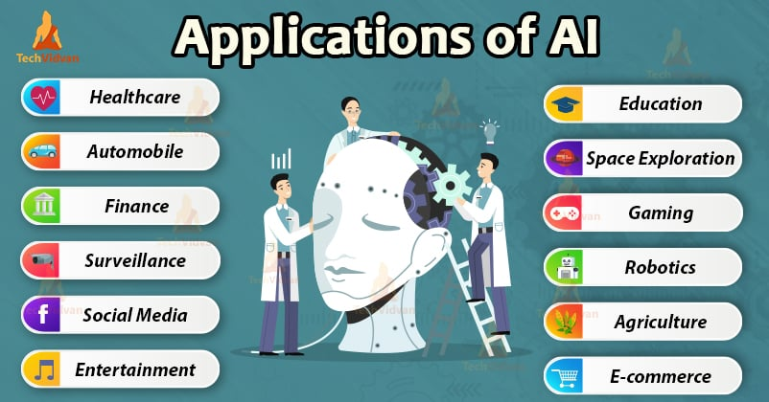

Figure 01 – Applications of AI

(https://www.google.com/url?sa=i&url=https%3A%2F%2Fwww.aitimejournal.com%2Fwhat-is-artificial-intelligence-ai%2F29625%2F&psig=AOvVaw396m0RRZvjw1BMyd2KBrN4&ust=1685025213739000&source=images&cd=vfe&ved=0CBEQjRxqFwoTCKDMrp6Wjv8CFQAAAAAdAAAAABAJ

# Introduction to Mind Maps

A mind map is a visual tool that helps you organize and connect your thoughts and ideas. It is like a diagram that starts with a central topic or main idea, and then branches out into related subtopics or concepts. Imagine your central topic as the trunk of a tree, and the branches as the different ideas or aspects connected to that topic. Each branch can then have its own smaller branches, forming a tree-like structure.

The main purpose of a mind map is to capture and represent information in a way that is easy to understand and remember. It allows you to see the relationships between different ideas and how they connect to the main topic.

The beauty of a mind map is that it is flexible and non-linear. You can add or rearrange ideas easily, and you can see the big picture while also focusing on specific details. It helps you to brainstorm, organize information, solve problems, plan projects, and study for exams.

In summary, a mind map is a visual diagram that helps you organize and connect your thoughts and ideas. It starts with a central topic and branches out into related subtopics, allowing you to see the relationships and structure of your thoughts in a clear and visual way.

Creating a mind map involves several steps. First, start with a central idea, which serves as the main concept or topic. Next, add branches that radiate out from the central idea, representing major subtopics or related categories. Then, expand each subtopic by adding sub-branches to capture specific details, ideas, or associations. Instead of using full sentences, use concise keywords or phrases to represent each idea and consider incorporating relevant images or symbols for visual appeal. Connect and organize the branches by identifying connections and relationships between different ideas, using lines or arrows to establish links. Finally, review and refine the mind map, adjusting the structure, adding or removing ideas, and ensuring clarity and coherence in the layout.

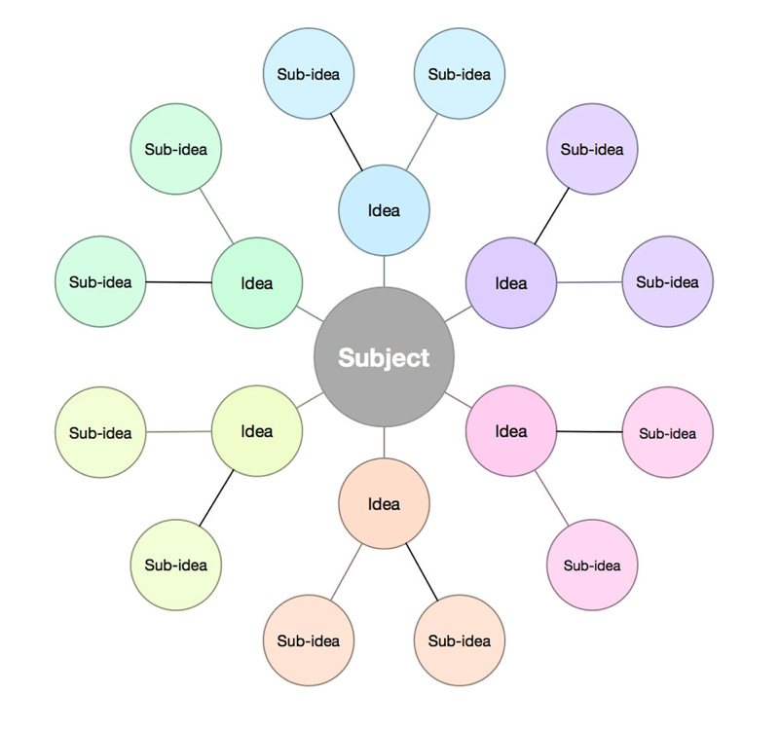

Figure 01 – Mind Map Example

(https://thesweetsetup.com/wp-content/uploads/2018/03/4-basicmindmap.jpg)

# Week 01 : : Introduction to Artificial Intelligence

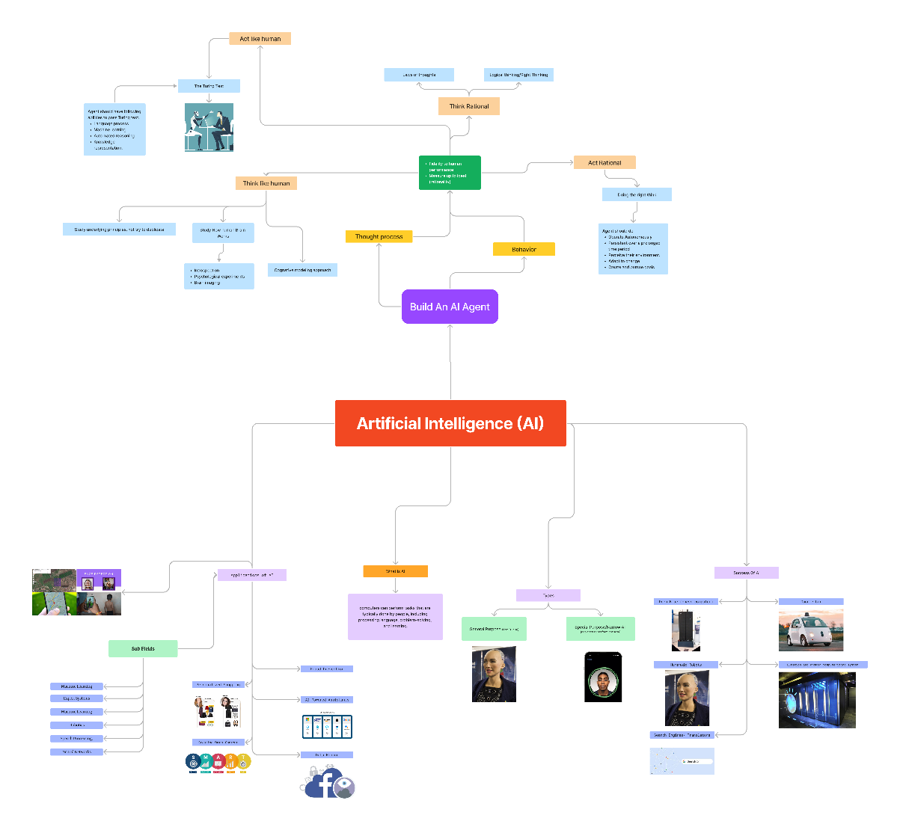

## Explanation

Artificial intelligence refers to the development of computer systems that can perform tasks that typically require human intelligence, such as learning, reasoning, and problem-solving. It involves the creation of algorithms and models that enable machines to process and interpret information, make decisions, and adapt to new circumstances. This topic provides a simple and clear understanding of artificial intelligence (AI), including its definition and its close relationship with other fields and technologies. Additionally, it touches upon philosophical concepts such as the Turing test and the Chinese room, which are often associated with AI.

# Week 02 : Agents

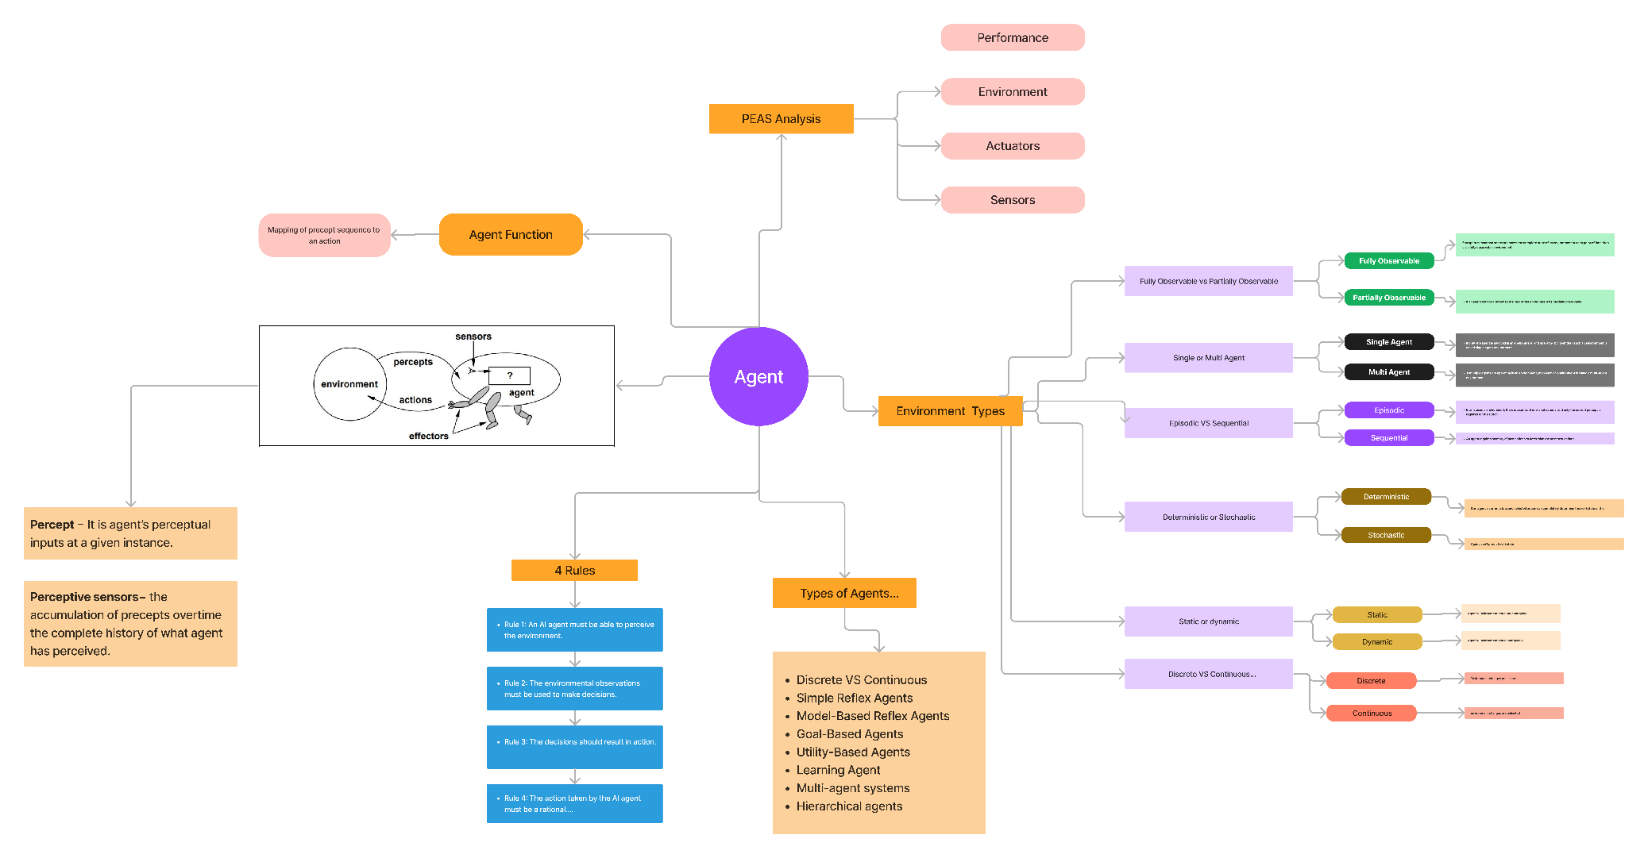

## Explanation

An AI agent is a system or entity designed to achieve specific goals by perceiving its environment, making decisions, and taking actions. It can be a software program or a robot that operates autonomously or with some human guidance. The main purpose of an AI agent is to act intelligently and effectively within its environment, adapting its behavior to achieve its objectives.

The functioning of an AI agent involves three key components: perception, decision-making, and action. Perception refers to the agent's ability to gather information about its environment using sensors or data inputs. It processes this information to understand the current state of the environment and identify relevant patterns or features.

Based on its perception, the AI agent employs various algorithms and techniques to make decisions. It may use rule-based systems, machine learning models, or other approaches to analyze the available information and determine the best course of action. The decision-making process leverages the intelligence of the agent, enabling it to reason, learn from data, and make informed choices.

Once a decision is made, the AI agent takes action in the environment. This could involve physical actions performed by a robot or virtual actions executed by a software program. The agent's actions aim to modify the environment in a way that aligns with its goals and improves its chances of success. The AI agent continually perceives the environment, makes decisions based on its current understanding, and adapts its actions accordingly.

Evaluating the performance of an AI agent is crucial to assess its effectiveness. Performance measurement involves using various metrics and criteria depending on the specific application or domain. For example, in a game-playing AI agent, performance can be measured by factors such as win rate, average score, or speed of decision-making. In customer service chatbots, performance may be evaluated based on customer satisfaction ratings or the accuracy of responses. By measuring performance, developers and researchers can identify areas for improvement, refine the AI agent's capabilities, and enhance its overall effectiveness in achieving its goals

# Week 03 : Reflex and Goal-based Agents

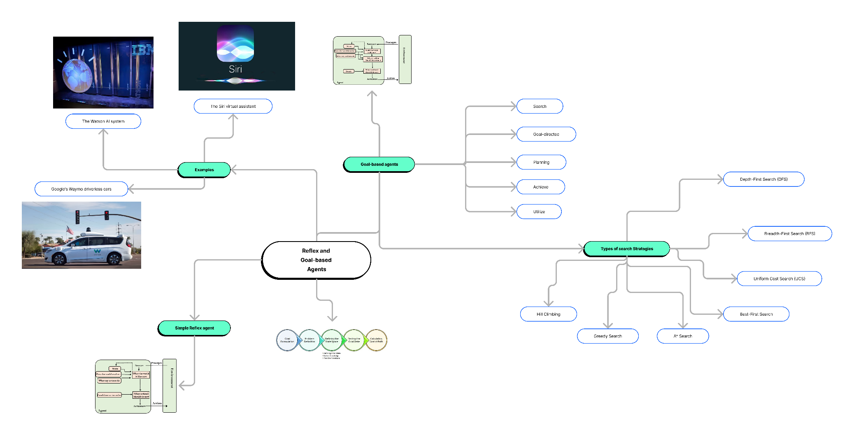

## Explanation

# Reflex agents make decisions based on predefined rules and immediate observations, while goal-based agents have explicit goals and maintain a model of the world to plan actions and achieve those goals. Reflex agents are simpler and reactive, whereas goal-based agents are more sophisticated and capable of handling complex scenarios.

# Week 04 : Pathfinding algorithms

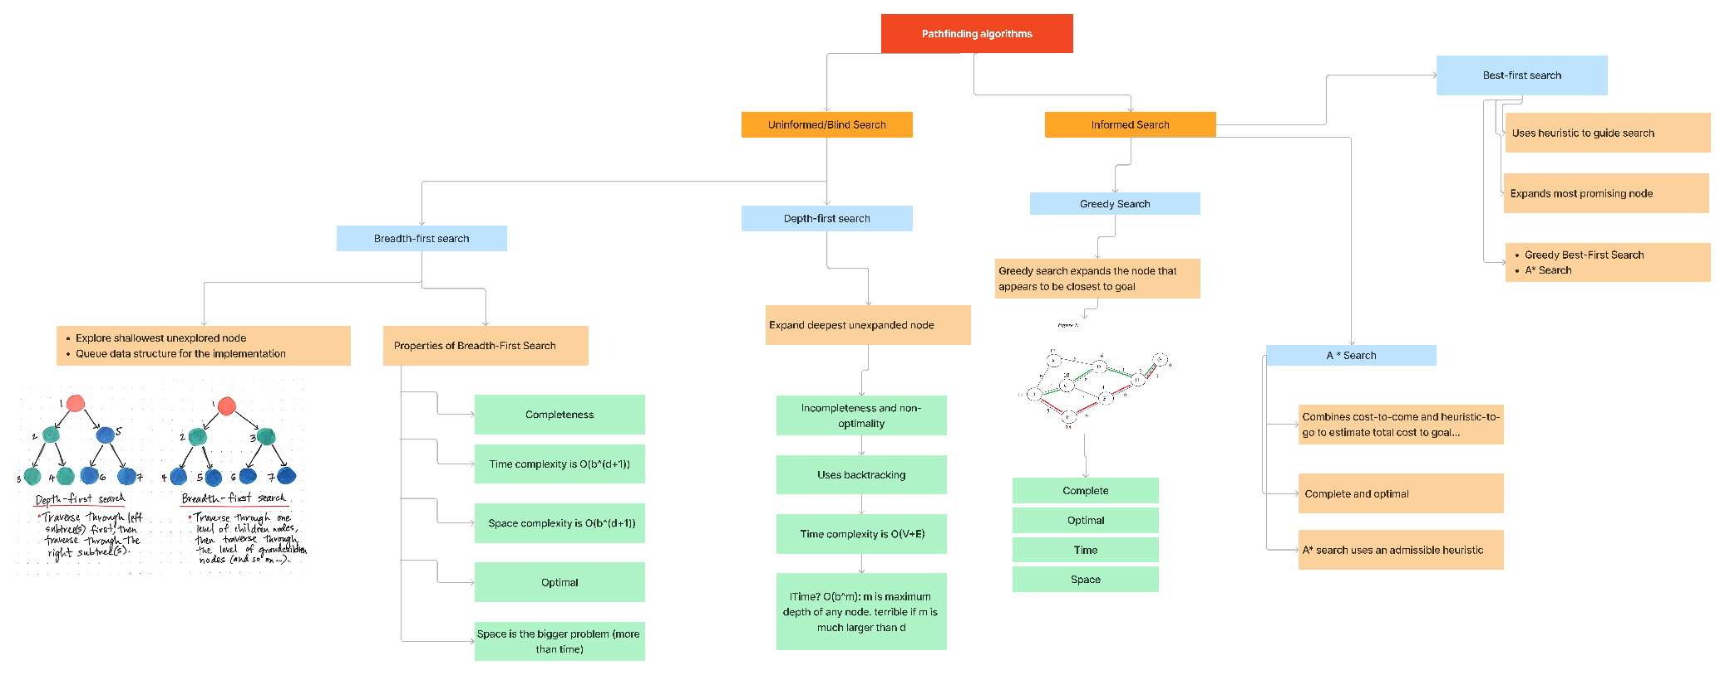

## Explanation

Pathfinding algorithms are like treasure maps for computers! Imagine you're in a maze and you want to find the quickest way to a treasure. Pathfinding algorithms help computers find the best route from one place to another. They use special rules and tricks to explore different paths, compare them, and choose the one that gets you to your destination the fastest. These algorithms are like little helpers for computers to navigate through complex mazes or maps, just like you would with a treasure map to find the hidden loot.

# Week 05 : Knowledge Based Agents (KBA) - Multi-Agent Environments

# 

## Explanation

# In a knowledge-based agent (KBA) system, multiple agents with specialized knowledge and expertise collaborate in a multi-agent environment. Each agent represents a distinct area of knowledge and possesses specific skills. These agents communicate and share information to collectively solve complex problems and make informed decisions.

# Drawing an analogy to a group of friends, imagine each friend excelling in a particular field of expertise. One friend is knowledgeable about animals, another friend is skilled in mathematics, and yet another friend is well-versed in history. In a multi-agent environment, these friends collaborate as a team, leveraging their individual expertise to tackle challenges efficiently.

# Similarly, in a multi-agent system, KBAs work in concert, utilizing their unique knowledge and capabilities to collectively address intricate tasks. Through effective communication and information sharing, these agents pool their expertise to achieve remarkable results. This collaborative approach fosters synergy and maximizes the potential of the agents, similar to how a team of skilled individuals can accomplish more together than they could individually.

# Week 06 : Adversarial search

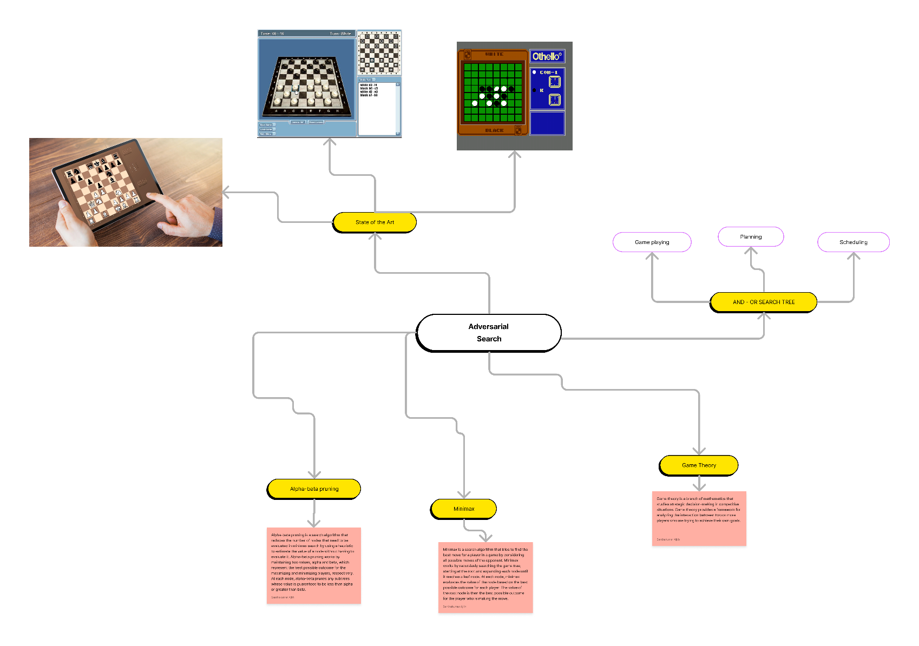

## Explanation

Adversarial search, is a strategy used in games where two opponents compete against each other. The goal is to find the best moves by considering both the player's own choices and the potential actions of the opponent. The minimax algorithm evaluates different game states, envisioning the opponent's moves and selecting moves that maximize the player's gain or minimize their loss. It helps in making strategic decisions in competitive games and finding optimal strategies to outsmart the opponent.

The minimax algorithm, used in adversarial search, works by exploring the game tree and assigning values to different positions. It assumes that the opponent will play optimally and aims to minimize the maximum possible loss. The algorithm recursively evaluates each possible move, creating a tree of game states. It alternates between maximizing the player's gain and minimizing the opponent's gain until it reaches a terminal state or a specified depth. By considering all possible moves and anticipating the opponent's actions, the minimax algorithm enables players to make informed decisions and strive for the best possible outcome in competitive games.

Game theory is a mathematical approach to analyze strategic decision-making in competitive situations. It helps determine optimal strategies by considering the choices of all players and their potential outcomes, leading to better decision-making in games and other competitive scenarios.

Alpha-beta pruning is a technique used in minimax algorithms to reduce the number of explored game states. By ignoring irrelevant branches, it speeds up the search process by pruning away paths that are guaranteed to be worse than other options, resulting in more efficient and effective decision-making in games.

# Week 07 : Natural Language Processing (NLP)

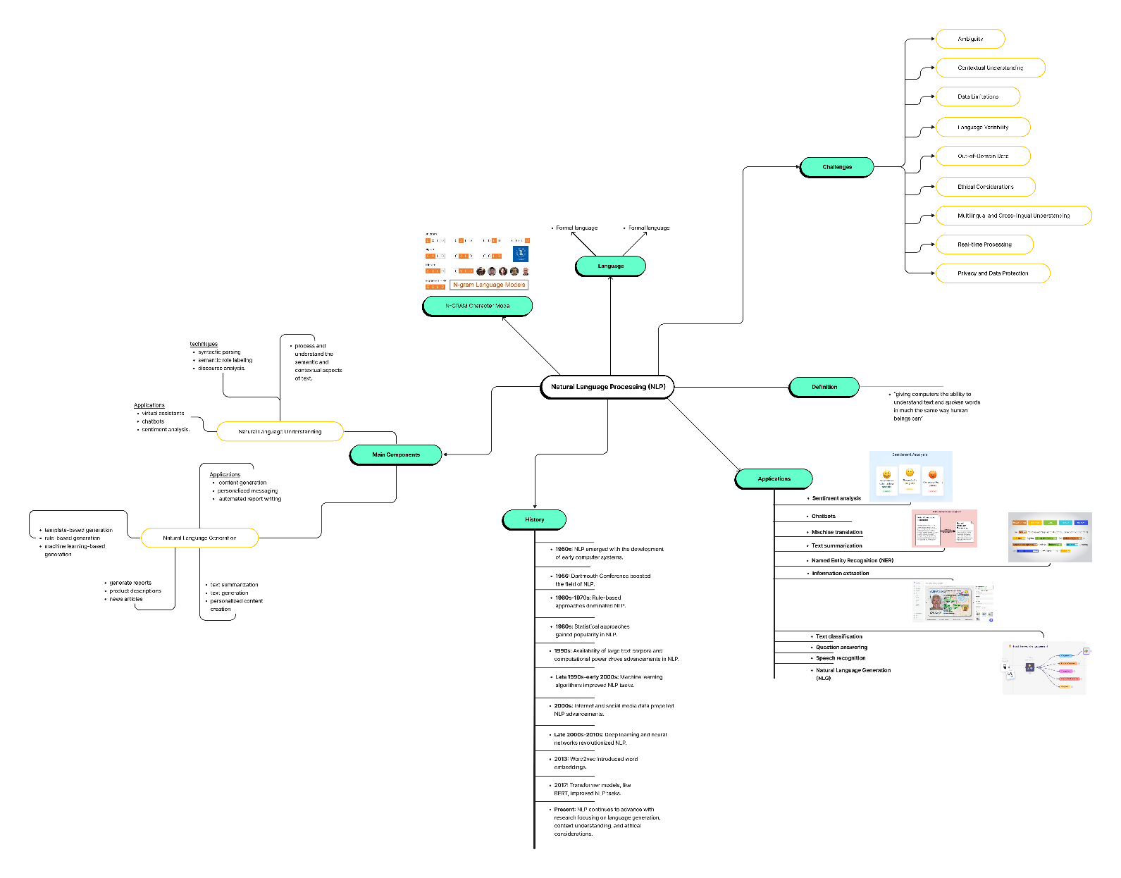

## Explanation

Natural Language Processing (NLP) is a field of study that focuses on enabling computers to understand and interact with human language. It involves using algorithms and techniques to process and analyze written or spoken text. NLP has two main components: Natural Language Understanding (NLU) and Natural Language Generation (NLG). NLU helps computers comprehend and interpret human language by tasks like part-of-speech tagging, named entity recognition, and sentiment analysis. NLG, on the other hand, focuses on generating human-like language and includes tasks like machine translation, text summarization, and text generation. Together, NLU and NLG form the foundation of NLP, empowering computers to understand and generate meaningful language, bridging the gap between humans and machines.

# Week 08 : Uncertainty – Probability & Markov Chain.

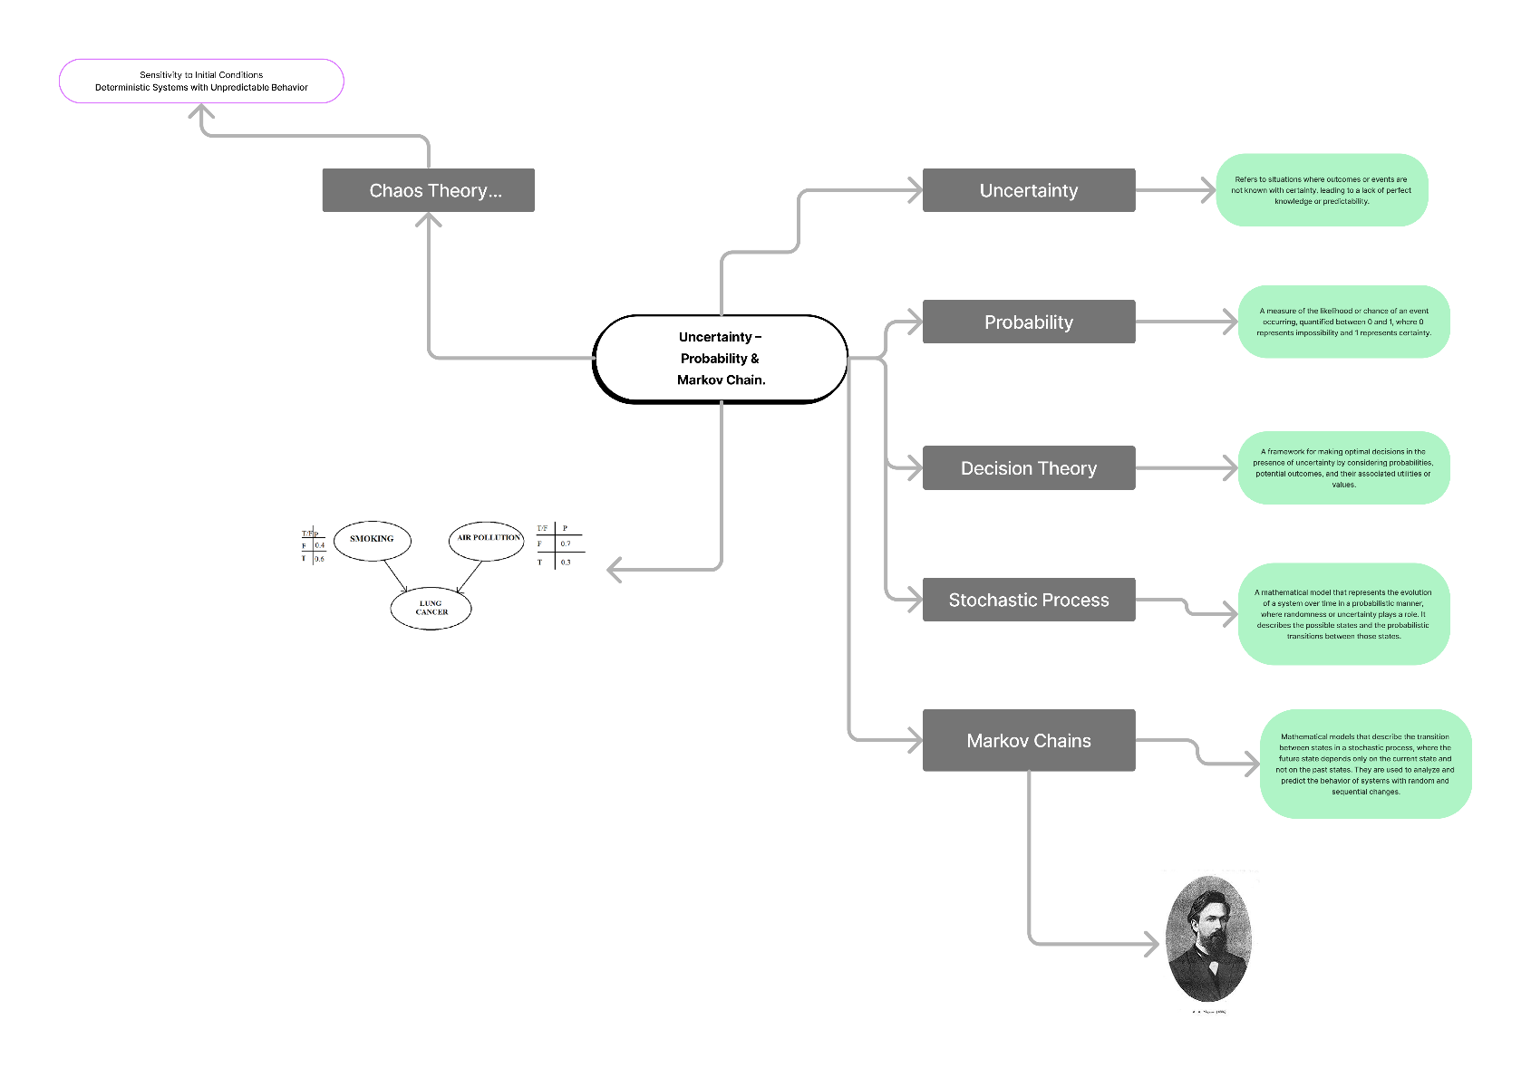

## Explanation

Markov chains are used to model probabilities based on data that represents different states. These states transition from one to another in a semi-random or stochastic manner. By encoding this information into a matrix and vector, known as a column matrix, and iterating through the process, we can create a collection of probability vectors called Markov chains. To determine the transition probabilities, we train the Markov chain using an input corpus.

Markov models are particularly useful when provided with a substantial amount of input data. For example, if a machine analyzes a large amount of English text, it can learn the likelihood of certain words following others. Similarly, by examining someone's travel history, it can predict their likely next location based on their current location. By continuously updating the input corpus with new data, the machine can refine the transition probabilities for all state changes.

On the other hand, genetic algorithms are different. They create functions by rearranging parts and evaluating their suitability for specific tasks. While a child algorithm depends on its parents in genetic algorithms, Markov models focus on predicting the next item in a sequence rather than generating new sections of code.

# Week 09 : Human Augmentation.

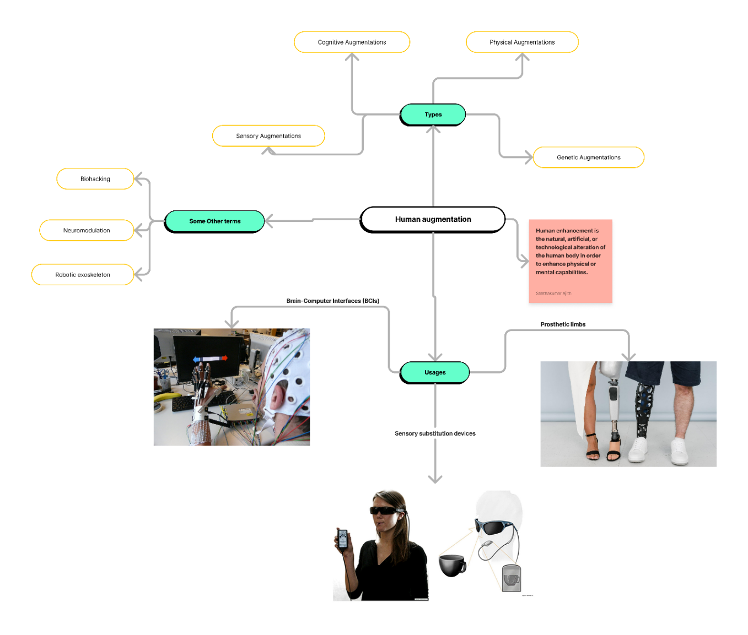

## Explanation

Human Augmentation is a field that involves enhancing or extending human capabilities through the integration of technology. It aims to improve physical, cognitive, or sensory abilities, enabling individuals to perform tasks more efficiently or overcome limitations.

For instance, prosthetic limbs can augment the physical abilities of individuals who have lost a limb, allowing them to regain mobility and perform daily activities. Cognitive augmentation involves using technologies like brain-computer interfaces to enhance memory, attention, or problem-solving skills. Sensory augmentation includes devices that enhance hearing or vision, such as cochlear implants or smart glasses.

By combining technology with the human body, human augmentation empowers individuals to overcome physical disabilities, enhance cognitive abilities, or experience new sensory perceptions. It opens up possibilities for individuals to achieve higher levels of performance, improve quality of life, and expand the boundaries of human potential.

# Week 10 : Game Theory

## Explanation

Game Theory is a field that explores strategic decision-making in competitive situations. It involves studying how individuals or entities interact with each other, considering their choices and potential outcomes. Game Theory helps analyze and predict behaviors in situations where the outcome of one participant's decision depends on the decisions of others.

For example, in a game like chess, players strategize and make moves based on anticipating their opponent's actions. Game Theory provides a framework to understand how players think, make choices, and seek to maximize their gains or minimize their losses. It explores concepts such as Nash equilibrium, where each player's strategy is optimal given the strategies of others.

By studying and applying Game Theory, we gain insights into complex interactions across various fields, including economics, politics, and biology. It helps us understand how individuals or entities make decisions in competitive scenarios, leading to better strategies, negotiation tactics, and decision-making processes.

# References

1. Kumar Abhishek. 2023. Introduction to artificial intelligence - Simple Talk. [ONLINE] Available at: <https://www.red-gate.com/simple-talk/development/data-science-development/introduction-to-artificial-intelligence/>. [Accessed 20 May 2023].
2. Simplilearn.com. 2023. What is Artificial Intelligence? Types, History, and Future [2023 Edition] | Simplilearn. [ONLINE] Available at: <https://www.simplilearn.com/tutorials/artificial-intelligence-tutorial/what-is-artificial-intelligence>. [Accessed 15 May 2023].
3. Educative: Interactive Courses for Software Developers. 2023. What are agents in Artificial Intelligence?. [ONLINE] Available at: <https://www.educative.io/answers/what-are-agents-in-artificial-intelligence>. [Accessed 05 May 2023].
4. Unstop - Competitions, Quizzes, Hackathons, Scholarships and Internships for Students and Corporates. 2023. Unstop - Competitions, Quizzes, Hackathons, Scholarships and Internships for Students and Corporates. [ONLINE] Available at: <https://unstop.com/blog/types-of-agents-in-artificial-intelligence>. [Accessed 25 April 2023].
5. Code Envato Tuts+. 2023. Artificial Intelligence Series - Part 1: Path Finding. [ONLINE] Available at: <https://code.tutsplus.com/tutorials/artificial-intelligence-series-part-1-path-finding--active-4439>. [Accessed 25 May 2023].
6. GeeksforGeeks. 2023. A* Search Algorithm - GeeksforGeeks. [ONLINE] Available at: <https://www.geeksforgeeks.org/a-search-algorithm/>. [Accessed 20 April 2023].
7. AI - Agents & Environments. 2023. AI - Agents & Environments. [ONLINE] Available at: <https://www.tutorialspoint.com/artificial_intelligence/artificial_intelligence_agents_and_environments.htm>. [Accessed 25 April 2023].
8. What is Natural Language Processing? | IBM. 2023. What is Natural Language Processing? | IBM. [ONLINE] Available at: <https://www.ibm.com/topics/natural-language-processing>. [Accessed 15 April 2023].