**Final Project Report**

Student Name: MinHyuk Kim

Student ID: 2020315666

**1. Briefly describe the project purpose:**

At the beginning of each semester, we fill our minds and register for courses. Even if we try with enthusiasm, we often fail because of competition.

So, I wanted to experience a course registration without competition, so I chose it as a project topic. Course registration is implemented from student registration to selecting the desired course.

**2. Draw the logic flow of the program (with flowchart):**

At the login window, you create ID and PW. In the process, you will be asked to enter your personal information. And when you login with that information, you can move next window(Course registration). At last, you can check information about course you registered.

**3. Provide screenshots for each screen with brief description:**

<LoginGUI>

In LoginGUI, you can login program, but you don't have ID/PW then you should sign up through SIGN UP button.

<SignupDialog>

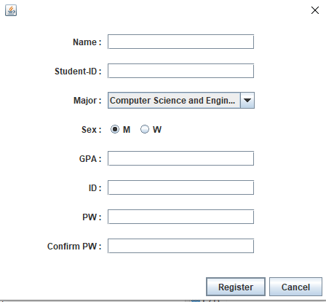

So you can register your personal information.

[Exception Handling]

1. You should enter letter length more than 0 and less than 20 in Name
2. You should enter 10 digits in Student ID
3. You should enter the GPA more than 0 and less than 4.5
4. You should enter ID length more than0 and less than 15
5. You should enter Password length more than0 and less than 15
6. You should enter the same value in PW, Confirm PW

If you entered information successfully, again go to the login window, and then input ID and PW you signed up.

<RegisterGUI>

In register window, you can check your available credit and so on

(available credit is different according to major, GPA) and you can add courses into the empty list. You can't add the same course(duplicate), and you can't add or delete course out of available credit.

You finished course registration, then enter 'REGISTRATION' button.

Then pop up this message and program is ended.

<CheckDialog>

**4. Explain the code of the main functionalities**

User information was saved and used in a text file through file input/output. And

The most challenging part is course registration,

Here, moving between data is made possible through arrays to store, add, and delete values.

In other parts of exception handling, regular expressions are used.

In addition, polymorphism was used in the credit calculation process.

**5. Explain what is included in your project and why it is used (Polymorphism, Inheritance, File I/O, etc)**

I used File I/O for storing user info and using it at log-in. In sign-up window, output the file retaining user information and in log-in window, input the file to compare user information with user input value.

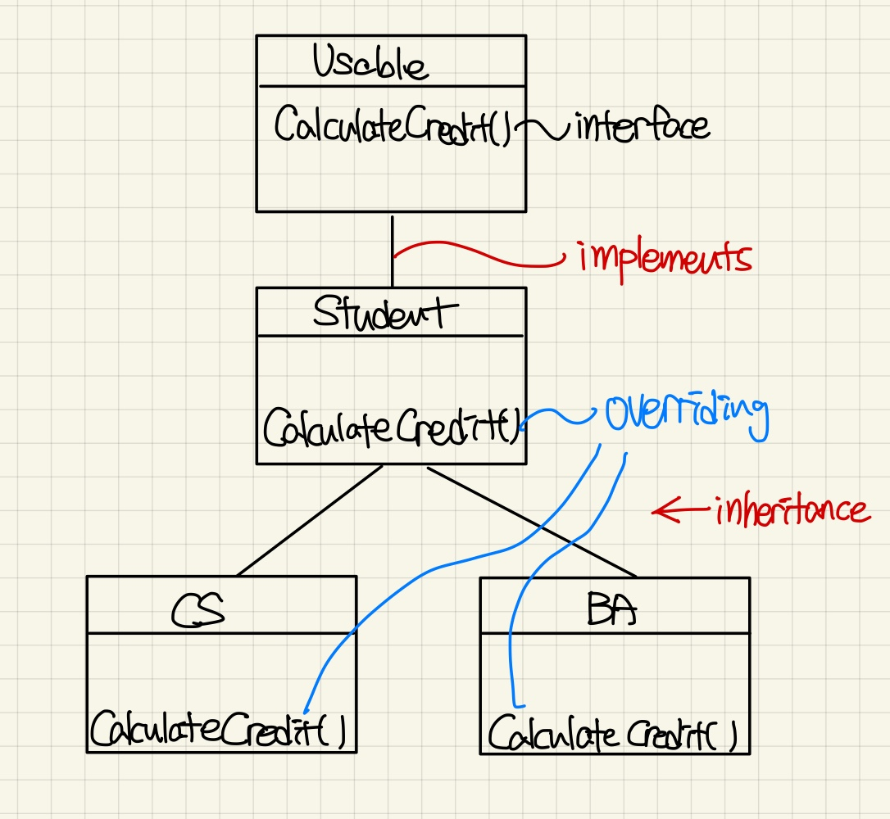

And I used inheritance and polymorphism because depending on the student's major and grades, calculate available credit each other. In particular, because the function was absolutely necessary, I used interface.

<Thank you professor and TA during half year !>