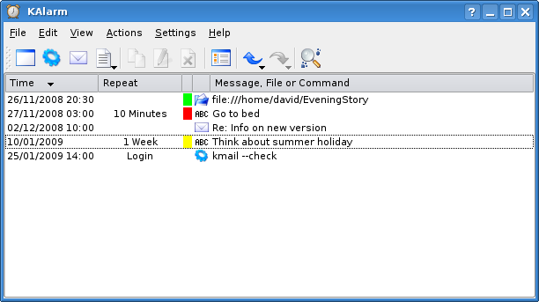
Requirements Projekt
«ClockAlarm»

Autor

Projektteam 05b

Samuel Gauthier
Loïc Charrière

Version und Datum

Version X0.2
17.03.2017
Berner Fachhochschule
Departement für Technik und Informatik
Medizininformatik

Inhaltsverzeichnis

1 Zweck des Dokuments 2
2 Kurzbeschreibung 2
3 Projektziele 2
4 Systemabgrenzung 2
4.1 Prozessumfeld 2
4.2 Systemumfeld 2
4.3 Randbedingungen 2
5 Anforderungen 2
5.1 Quellen und Vorgehen 2
5.2 Funktionale Anforderungen 2
5.3 Technische Anforderungen 2
5.4 Qualitätsanforderungen 2
6 Glossar 2
7 Abbildungsverzeichnis 2
8 Tabellenverzeichnis 2
9 Literaturverzeichnis 2
10 Anhang 2
10.1 Abstimmung der Anforderungen 2
10.2 Definition of Ready - Checklist 2
11 Versionskontrolle 2

Zweck des Dokuments
Dieses Dokument beschreibt die Ziele und Anforderungen für das Projekt ClockAlarm.

Kurzbeschreibung / Projekt-Vision
The ClockAlarm project is an application allowing the user to manage alarms which will
alert him at specified times. The user can create new alarms and assign them to categories
in order to stay organised. The project is thought to replace in the long run an existing
application named KAlarm.

Projektziele
- Improve the overall life organisation of the user
- No more missed events

Requirements
- The application has to be cross platform (Windows, Linux, macOS)
- The database must not be stored in a binary format
- The con_guration has to be easily transferable to another computer
- Customisable alerts
- Classi_able alerts
- Recurrent alerts
- Alerts can be scheduled
- Delay alerts
- Snooze alerts

Systemabgrenzung

Stakeholder
1. kAlarm users
Users who previously used kAlarm on linux, and wishing to find a similar but remastered
and cross-platform software.
2. Computer users
Those who tend to forget many things.
3. Investors
Investors in the project. For example advertisers looking for visibility in the software.
4. The GNU Project
The GNU Project collective could be pleased to see that an updated version of kAlarm
is proposed.

Actors
1. Software User (Primary Actor)
The peoples who will use the software. They are the
rst concerned by the product.
2. Administrator (Primary Actor)
Super users with special authorizations. May be able to manipulate the data and the
other users.
It is likely that the software does not need an administrator.
3. System Time (Supporting Actor)
The service specific to the OS and providing the exact international time.
4. Messaging Software (Supporting Actor)
Allows ClockAlarm to send Emails.
5. OS Notification Services (Supporting Actor)
OS specific notification center or notification service.

System context
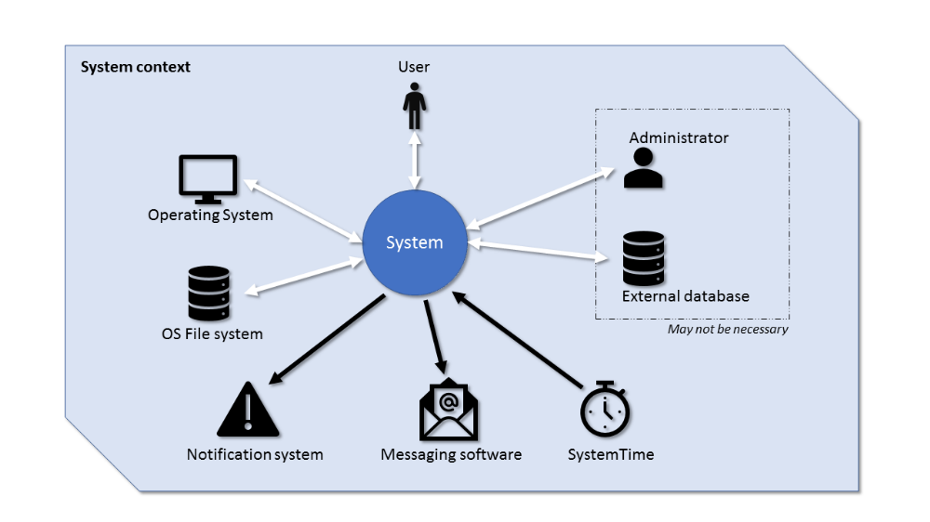

System boundary
In addition to the elements above, special attention should be given to the following points.
¤ The must-have goal isn't to add functionality to the existing software kAlarm, but to
create a similar and cross-platform product.
¤ The existence of a database and an administrator could be dropped and go out of
context.
¤ The software isn't meant to be an alternative to an agenda. It behaves like a list of
tasks and reminders.

Context boundary
In addition to the logical considerations and those stated above, the following points should
be taken into account.
¤ The software is responsible for asking the messaging software to send to emails. This
means that the way emails are sent isn't part of the environment.
¤ The software bases its alarms on the internal time. The accuracy of the time and of
the time zone with respect to the geographical position of the machine is not part of
the environment.

Anforderungen

Quellen und Vorgehen
[1] Patrick Thomson. Git vs. Mercurial: Please Relax. Aug. 2008. url: https://importantshock.
wordpress.com/2008/08/07/git-vs-mercurial/ (visited on 03/12/2017).
[2] Klaus Pohl and Chris Rupp. Requirements Engineering Fundamentals: A Study Guide
for the Certified Professional for Requirements Engineering Exam - Foundation Level -
IREB compliant. English. 1 edition. Santa Barbara, CA : Sebastopol, CA: Rocky Nook,
Apr. 2011. isbn: 978-1-933952-81-9.
[3] mpm. ZipdocExtension - Mercurial. Nov. 2012. url: https://www.mercurial-scm.
org/wiki/ZipdocExtension (visited on 03/12/2017).
[4] William von Hagen. Open source desktop publishing with Scribus. Apr. 2013. url: http:
//www.ibm.com/developerworks/library/os- scribus/index.html (visited on
03/12/2017).
[5] Levels of TeX - TeX Users Group. Jan. 2017. url: http://tug.org/levels.html
(visited on 03/12/2017).
[6] Version Control Systems Popularity in 2016. url: https://rhodecode.com/insights/
version-control-systems-2016 (visited on 03/12/2017).

Funktionale Anforderungen

Domain model

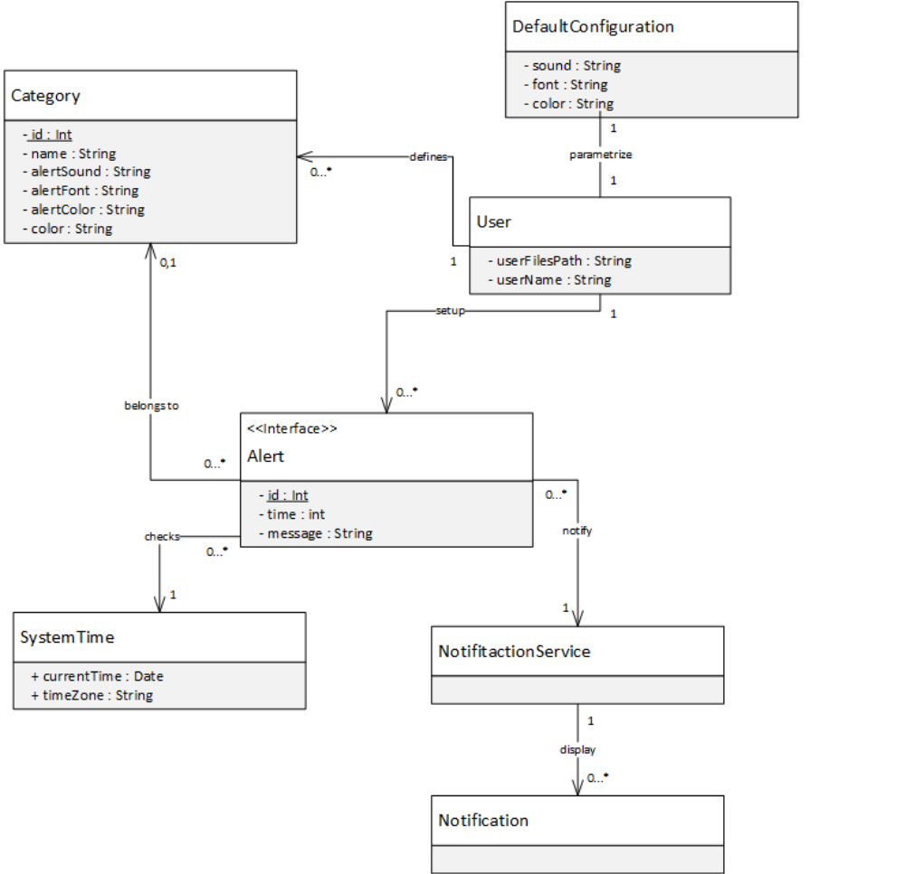

User Stories

As a User
Alerts functionality
¤ i want to registrate some alerts so that the software warns me when they occure
¤ i want to be able to choose a di
ente color, font and sound for every alert
¤ i want to edit the existing alerts when needed
¤ i want to delete the existing alerts when needed
¤ i want to postpone an alarm so that i'm notified again later (snooze)
¤ i want to mute an alert so that i'm not notified
Managing alerts
¤ i want to create categories of alerts, so that I can sort my alerts
¤ i want to edit my categories, in a way my alerts remain categorised
¤ i want to delete categories of alerts, so that my list of categories stay concise
¤ i want to assign color identity to my di
erent categories, some that I can easily find
them
¤ i want to personalize the default color, font and sound of my alarms in the software
configurations
¤ i want to mute an alert catogory so that i'm not notified by any alert in this category
Persistence
¤ i want to retrieve the correct state of my alerts after turning my computer down and
back on
¤ i want to be alerted at any times, as soon as I'm loged on my computer session
Exportability
¤ i want to export my alerts so that I can't import then on an others computer with
ClockAlarm installed
¤ i want to import an alerts file, so that I can retrieve previously exported alerts
¤ i want to load configuration files, so that I can use predifined color and sound themes
Pivacy
¤ i want my alerts to remain private, so that nobody except me knows about them

Use cases
See attached full documentation in the pdf.

Technische Anforderungen

ID | Statua | Prio | Beschreibung
T1.1 | Entwurf | M

Qualitätsanforderungen

ID | Statua | Prio | Beschreibung
Q1.1 | Entwurf | M

- Anforderungen sollten zur besseren Übersichtlichkeit zu Themen zusammengefasst werden
- Jeweils auch mit NICHT-Anforderungen
- Projektziel(e) benennen, zu deren Erreichen die Anforderungen beitragen

Glossar

Abbildungsverzeichnis
Abbildung 1: Et ut aut isti repuditis qui ium Error! Bookmark not defined.

Tabellenverzeichnis
Tabelle 1: Et ut aut isti repuditis qui ium Error! Bookmark not defined.

Literaturverzeichnis
Literatureintrag
Autorname, Autorvorname, Buchtitel, Verlag, Ort, Ausgabe, Jahr 7
Literatureintrag
Autorname, Autorvorname, Buchtitel, Verlag, Ort, Ausgabe, Jahr 9
Literatureintrag
Autorname, Autorvorname, Buchtitel, Verlag, Ort, Ausgabe, Jahr 11

Anhang

Abstimmung der Anforderungen
Eventuell aufgetretene Konflikte und die gewählte Lösung dafür werden kurz dokumentiert

Definition of Ready - Checklist

Versionskontrolle
Version | Datum | Beschreibung | Autor
X0.1 | 26.02.2017 | Dokument erstellt | S.G.
X0.2 | 13.03.2017 | Dokument überarbeitet | L.C.
X1.0 | 21.05.2013 | Dokument bereit zum Review | N.N.
V1.0 | 21.05.2013 | Dokument freigegeben | N.N.

