**User Manual for Basic Pizzeria App**

**Brent Lewis, SDEV 140-51P**

**Introduction:**

This program is made for Basic Pizzeria to have users order pizza.

**Starting the Program:**

Locate the file BasicPizzeria.py, and open it in the PyCharm interface

**Opening Screen:**

You will see a prompt saying thanks for using the text-based pizza ordering app, available pizzas, and a prompt that says please choose a pizza.

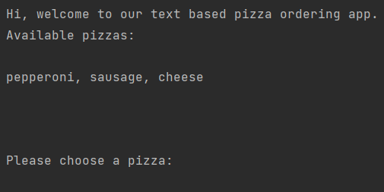

**User selection:**

You type in what pizza you want, from the choices given. It will ask if you want to order again. If yes, then you go through it again until you don’t want to order any pizza. If no, then it will give you a total and prompt you to input your information for delivery.

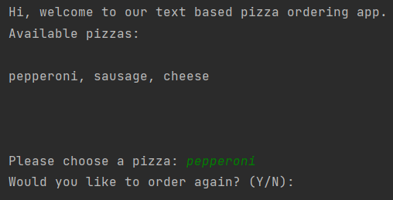

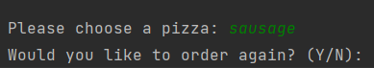



**Customer Information:**

After it prompts you to enter your information for delivery. It will ask you to enter your name. Next, it will ask you to enter your address. Then, it will ask you to enter your phone number. Finally, it will display your info and prompt you saying we’ll get the order out on delivery ASAP and thanks for using the app, if there’s any trouble, we’ll contact you with the number provided.

