**Validation Testing**

**Brent Lewis, SDEV 140-51P**

**DATA TESTED:** Entered a pizza called works

**RESULTS:** Program crashed

**CHANGES MADE:** Added error message

**SCREEN SHOT:**

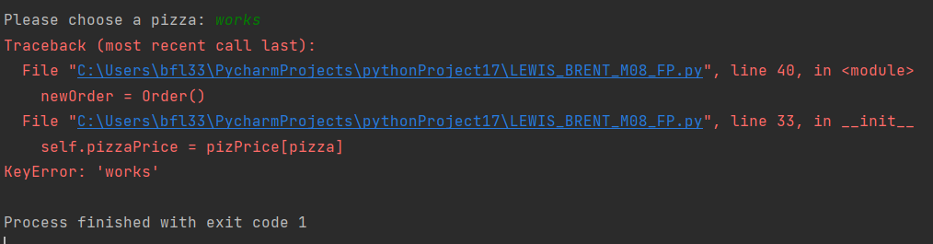

**DATA TESTED:** Entered pizza called supreme

**RESULTS:** ERROR. Program ran like it should (with added ERROR message)

**CHANGES MADE:** None

**SCREEN SHOT:**

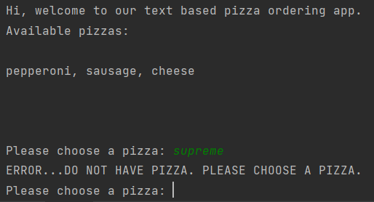

**DATA TESTED:** Entered a pizza called pepperoni

**RESULTS:** Program ran like it should

**CHANGES MADE:** None

**SCREEN SHOT:**

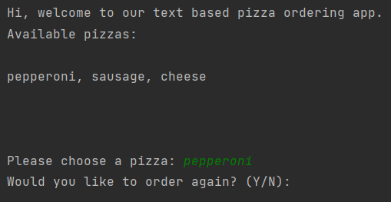

**DATA TESTED:** Entered a pizza called sausage

**RESULTS:** Program ran like it should

**CHANGES MADE:** None

**SCREEN SHOT:**

