Oxygen monitors - Report

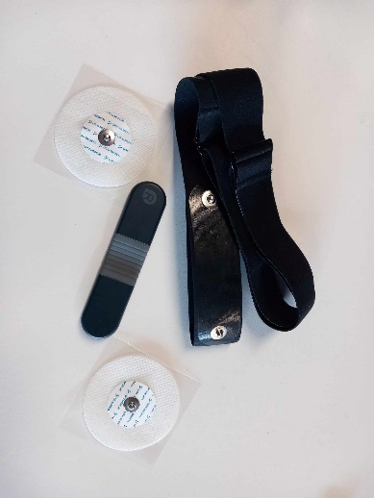

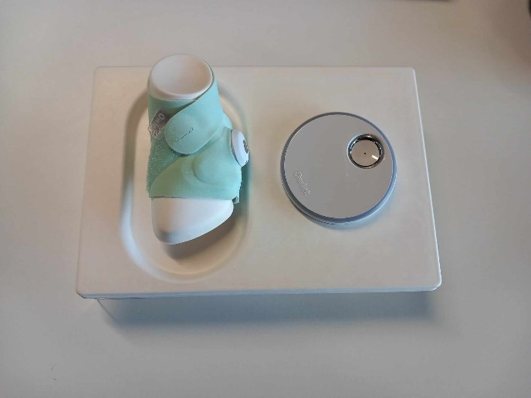

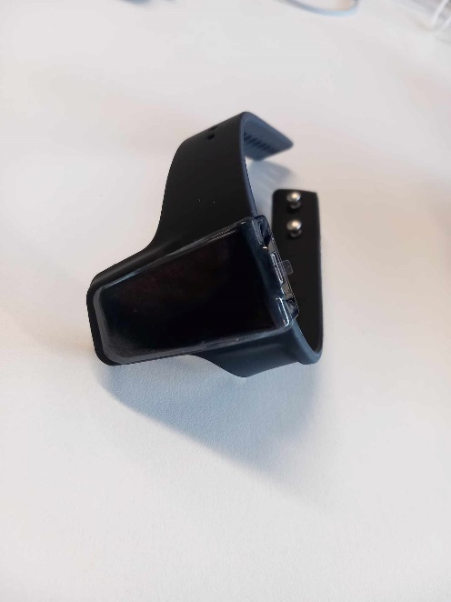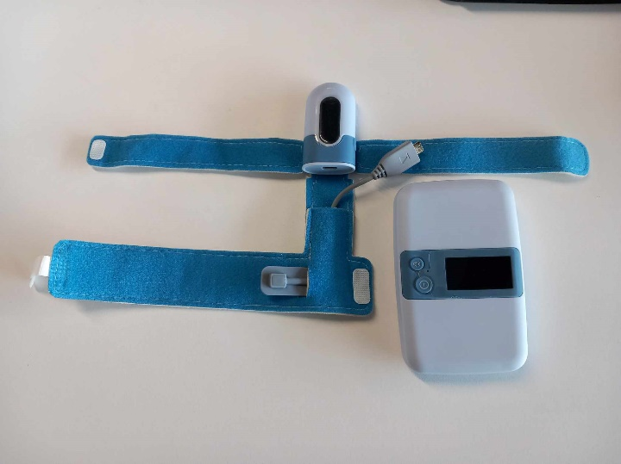

Fannie BICHEMIN

INTERN AT ULSTER UNIVERSITY & STUDENT AT ECOLE NATIONALE SUPERIEURE DE L’ELECTRONIQUE ET DE SES APPLICATIONS

**Contents**

**Smart Wrist Pulse Oximeter :** 3

**Characteristics of smart wrist :** 3

**Owlet smart sock:** 5

**Characteristics of owlet smart sock :** 5

**BabyO2 S2 – Oxygen Monitor :** 6

**Characteristics of BabyO2 S2 :** 6

**ECG recorder – Heart Health monitor :** 7

**Characteristics of Heart Health monitor :** 7

**Conclusion** 13

**List of figures**

**Figure 1 :** Smart wrist pulse oximeter 3

**Figure 2** : Oxygen level and pulse rate while standing still (left screenshot) and in motion (right screenshot) 4

**Figure 3 :** Measurement History 4

**Figure 4 :** Smart sock 5

**Figure 5 :** Oxygen monitor & base station 6

**Figure 6** : Oxygen level and pulse rate 6

**Figure 7 :** Hear Health Monitor – ECG recorder, electrodes & chest strap 7

**Figure 8 :** User interface with measurement details 7

**Figure 9 :** ECG report – using chest strap 8

**Figure 10** **:** ECG report – using electrodes (beginning) 8

**Figure 11** : ECG report – using electrodes (data at the end of the experiment) 9

# **Smart Wrist Pulse Oximeter**

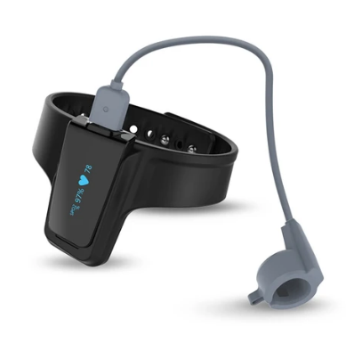

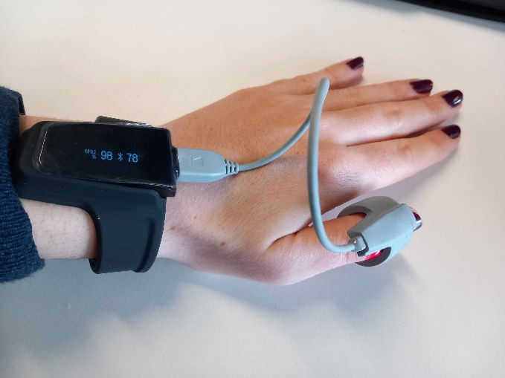This device is useful to monitor heart pulse and blood oxygen.

**Figure 1 :** Smart wrist pulse oximeter

Website link : [Viatom Checkme O2 Pulse Oximeter | Viatom (viatomtech.com)](https://www.viatomtech.com/checkme-o2)

## **Characteristics of smart wrist**

|  |  |
| --- | --- |
| **Is it easy to use ?** | YES ( thanks to user manual ) |
| **Is the mobile app easy to use ?** | YES ( thanks to user guide ) |
| **Are the data consistent ?** | YES |

Tanks to the mobile app (Mobile App link : [ViHealth - Apps on Google Play](https://play.google.com/store/apps/details?id=com.viatom.vihealth&hl=en_US)), we can monitor our pulse rate and our oxygen level :

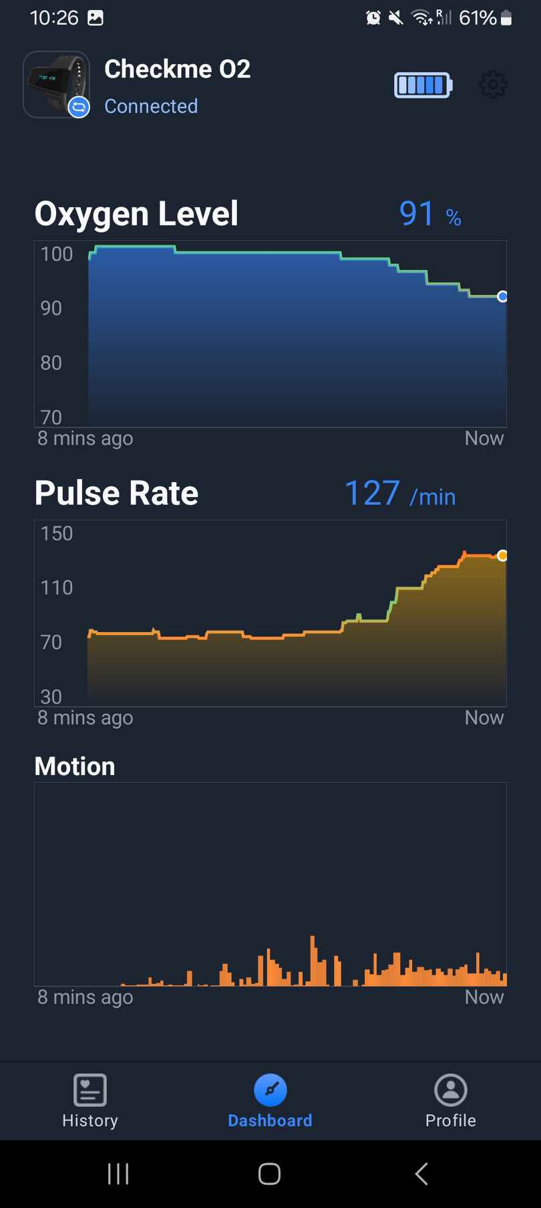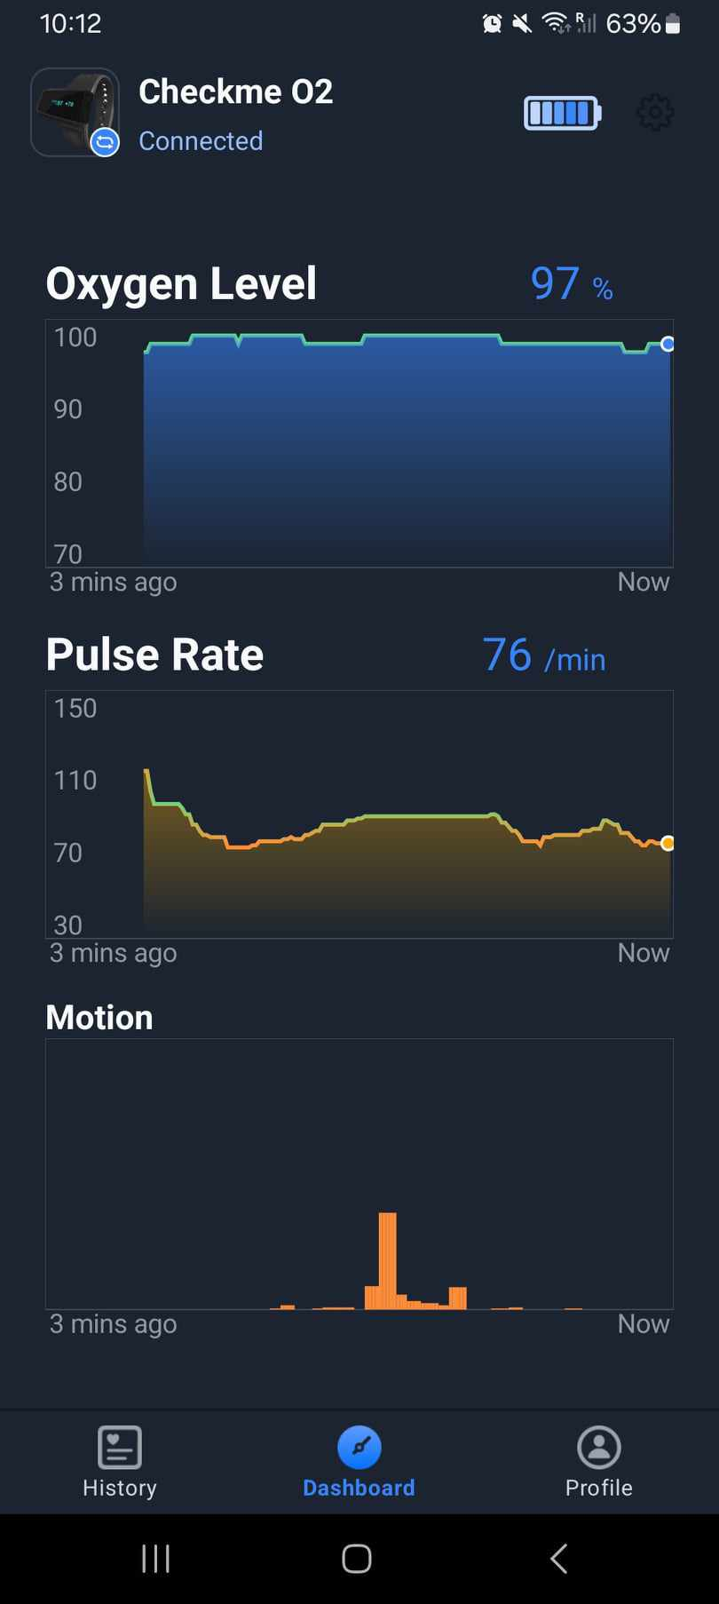

**Figure 2** : Oxygen level and pulse rate while standing still (left screenshot) and in motion (right screenshot)

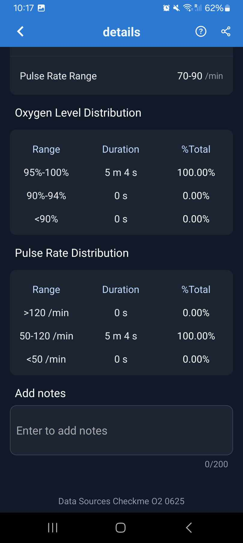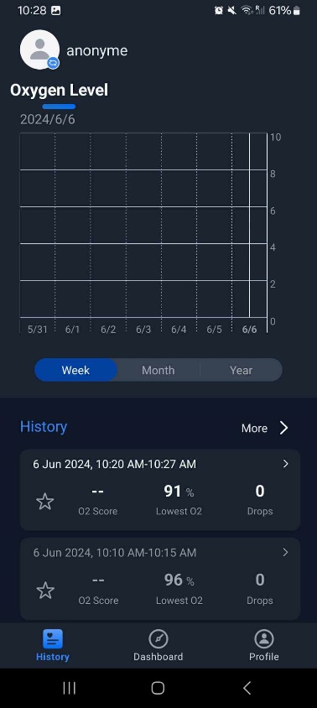This is also possible to display measurement history :

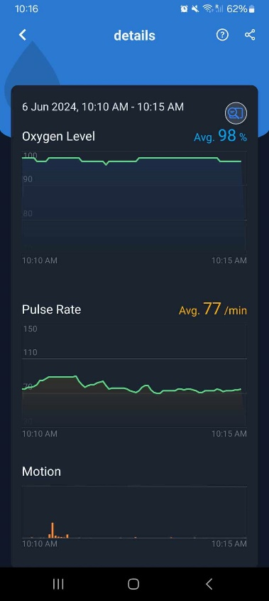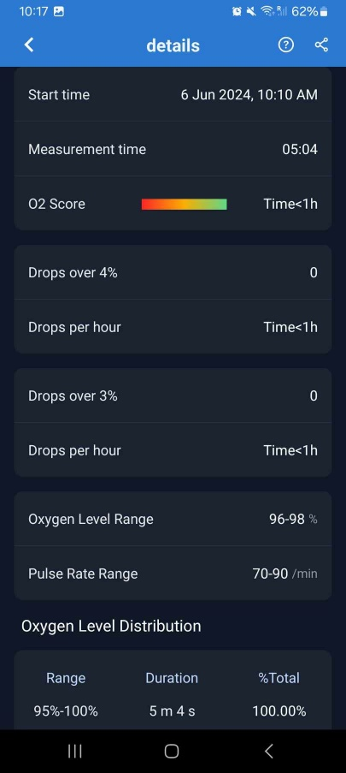

**Distribution**

**Charts**

**Measurement details**

**Data**

**Figure 3 :** Measurement History

# **Owlet smart sock**



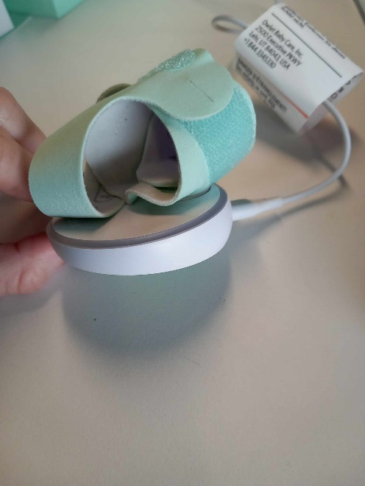This device is useful to monitor heart rate and oxygen level while babies are sleeping.

Website link : [Owlet Smart Sock 3 Baby Monitor – Owlet UK (owletbabycare.co.uk)](https://owletbabycare.co.uk/products/owlet-smart-sock)

**Figure 4 :** Smart sock

## **Characteristics of owlet smart sock**

|  |  |
| --- | --- |
| **Is it easy to use ?** | YES (Explanatory diagram) |
| **Is the mobile app easy to use ?** | YES ( User guide ) |
| **Are the data consistent ?** | No test performed |

Tanks to the mobile app (Mobile App link : [Owlet - Apps on Google Play](https://play.google.com/store/apps/details/Owlet?id=com.owletcare.owletcare&hl=en_US)), we can monitor pulse rate and oxygen level of babies.



This device was created to enable parents to monitor heart pulse and oxygen level of their children. The datasheet of this product explains that we need to connect to a WIFI-network. It was not possible to do so in the University because the mobile app used for this device is not programmed for such a network.

# **BabyO2 S2 – Oxygen Monitor**

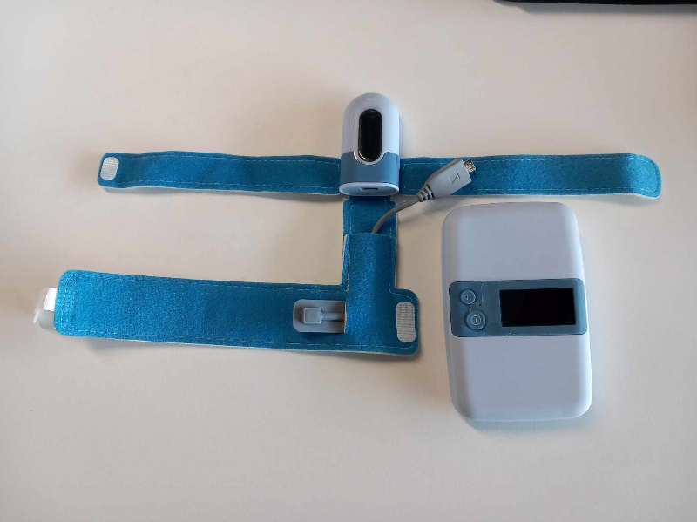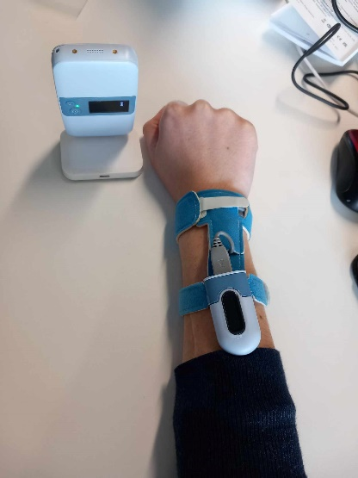

This device is useful to monitor oxygen level while babies are sleeping.

**Figure 5 :** Oxygen monitor & base station

Website link : [Baby Sleep Monitor with Base Station, Track Baby's Average Oxygen Level, Heart Rate & Movement, with Free APP, Fit Babies 0-3 Years Old – Wellue (getwellue.com)](https://getwellue.com/products/babyo2-s2-baby-oxygen-monitor?_pos=1&_sid=e19589c13&_ss=r)

## **Characteristics of BabyO2 S2** Avertissement

This device is supposed to be used on a foot of a child. It was used on an arm of an adult because we needed to test it.

|  |  |
| --- | --- |
| **Is the main device easy to use ?** | YES ( thanks to explanatory diagram ) |
| **Is the mobile app easy to use ?** | YES ( thanks to user guide ) |
| **Are the data consistent ?** | YES (but it was not possible to do lots of test) |
| **Is the base station easy to use ?** | YES (thanks to user guide) |

We can use base station to easily monitor data (oxygen level).

Thanks to the following mobile app : [ViHealth - Apps on Google Play](https://play.google.com/store/apps/details?id=com.viatom.vihealth&hl=en_US) , we can also monitor oxygen level and pulse rate with charts.

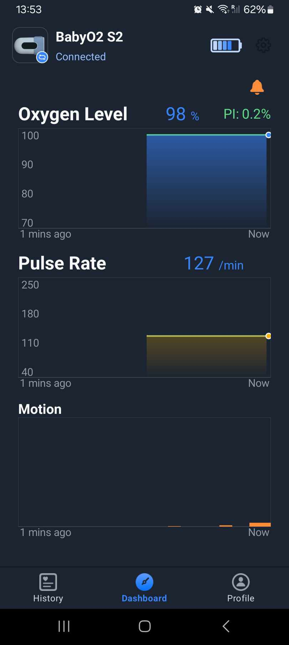

**Figure 6** : Oxygen level and pulse rate

# 

# **ECG recorder – Heart Health monitor**

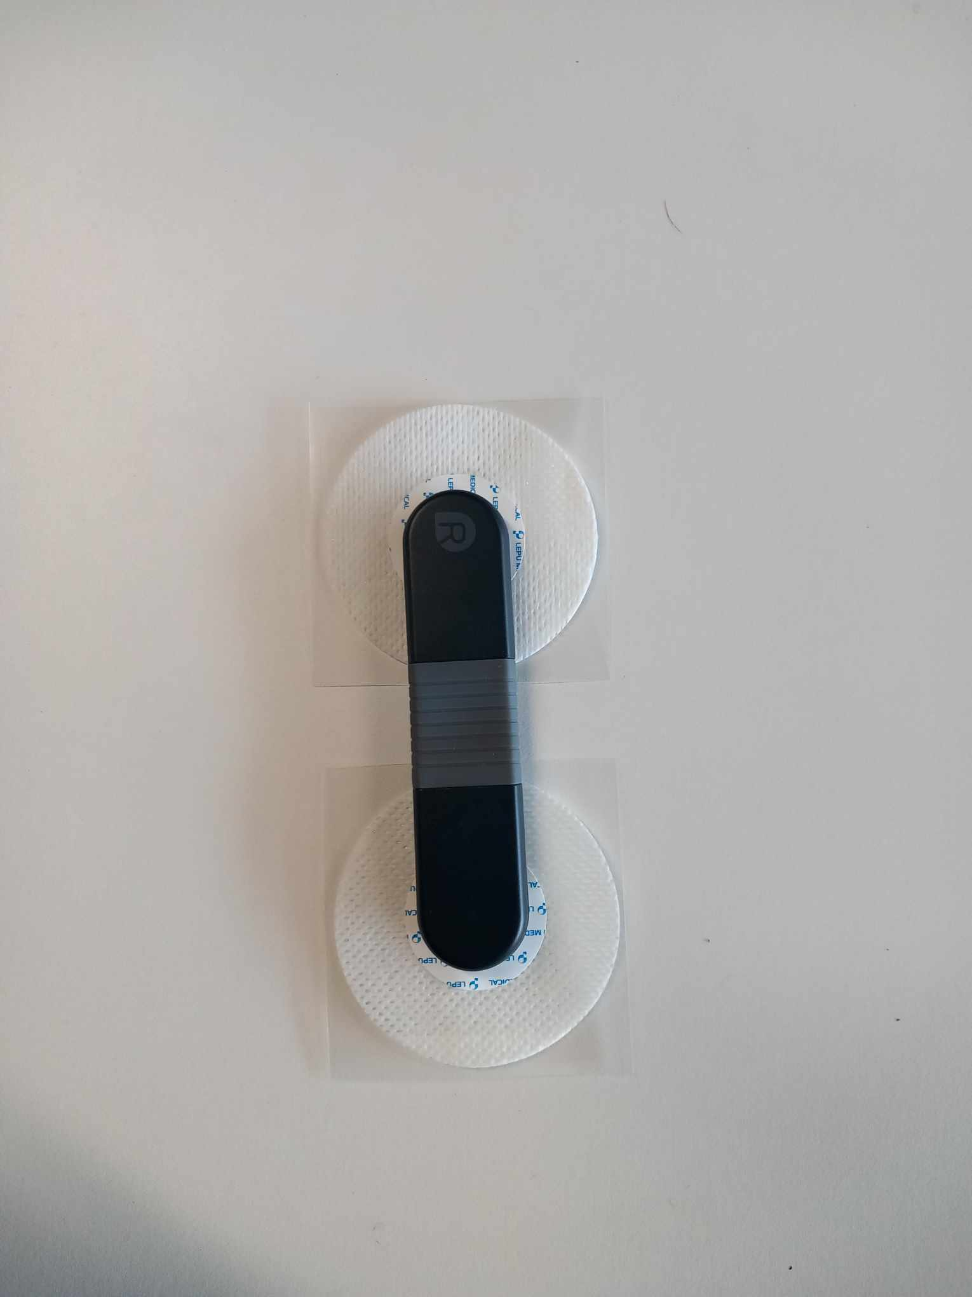

This device is useful to monitor ECG. There are two option to record ECG : with electrodes or with chest chest strap.

**Figure 7 :** Hear Health Monitor – ECG recorder, electrodes & chest strap

Website link : [24-Hour ECG Monitor with AI Analysis, Continuous ECG/EKG Monitoring at Home – Wellue (getwellue.com)](https://getwellue.com/products/heart-health-monitor?variant=40752050438186)

## **Characteristics of Heart Health monitor**

|  |  |
| --- | --- |
| **Is the main device easy to use ?** | YES ( thanks to explanatory diagram ) |
| **Is the computer app easy to use ?** | YES ( thanks to user guide ) |
| **Are the data consistent ?** | YES |

Tanks to the computer app (the software is available thanks to a USB key included in the ECG recorder packaging), we can monitor our pulse rate and read a medical report :

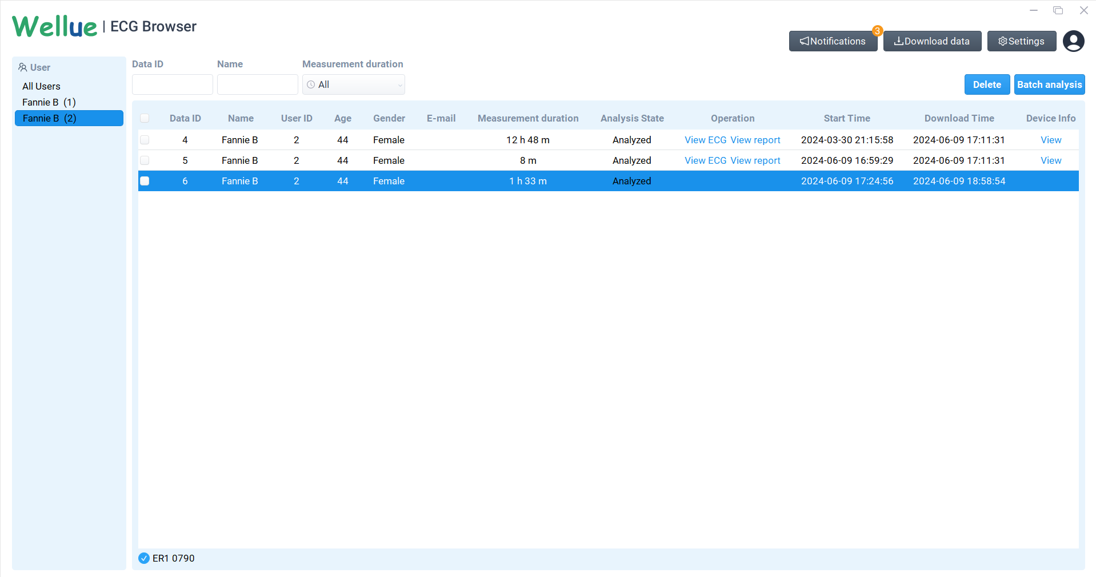

**Figure 8 :** User interface with measurement details

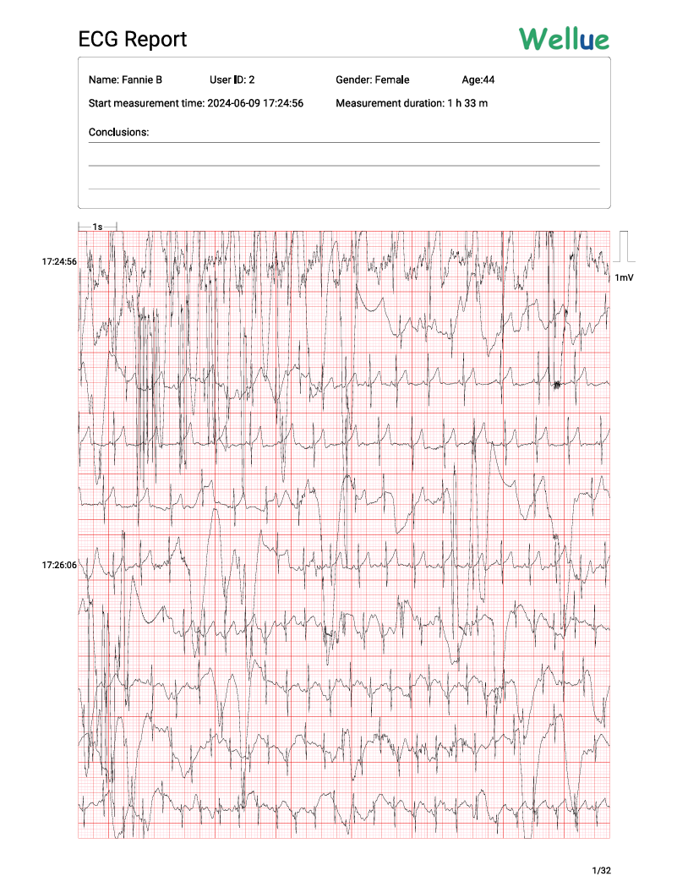The first test was to use ECG recorder with chest strap. The following document shows the ECG report of this experiment :

**Figure 9 :** ECG report – using chest strap

The second test was to use ECG recorder with electrodes. The following documents shows two ECG report of this experiment :

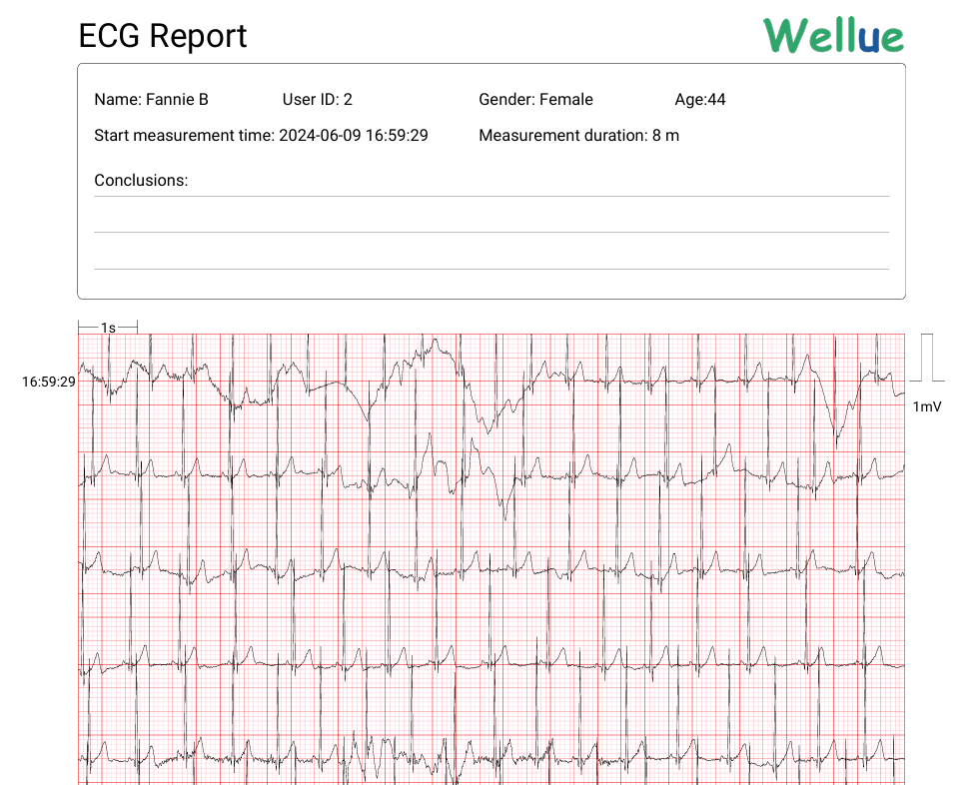

**Figure 10** **:** ECG report – using electrodes (beginning)

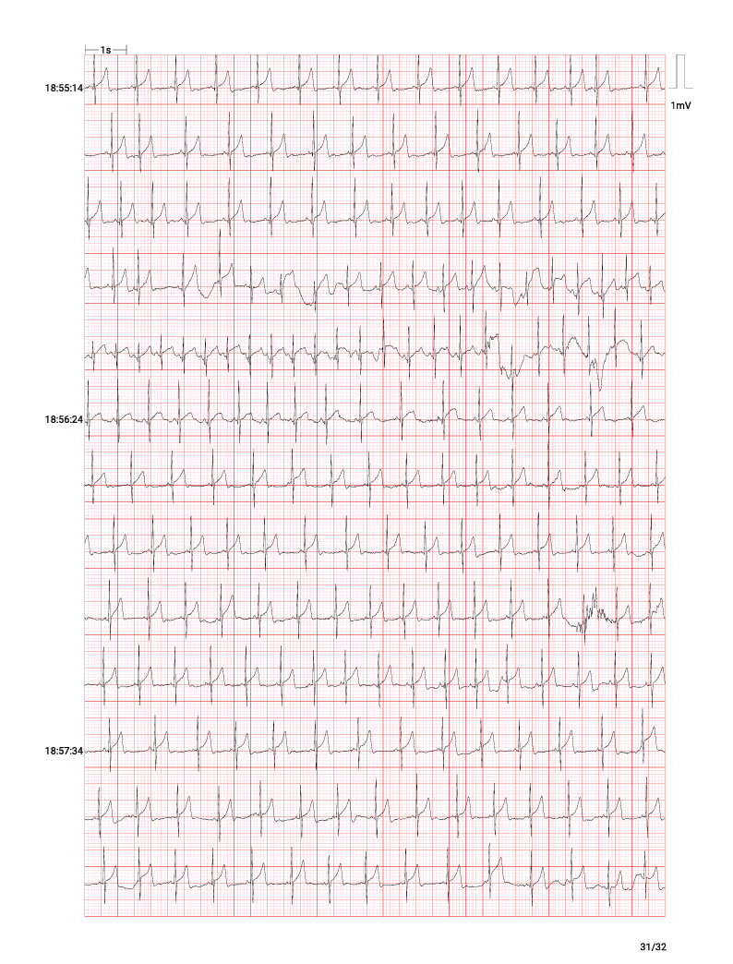

**Figure 11** : ECG report – using electrodes (data at the end of the experiment)

* The following three pages show the report created by the software. It allows us to discover overall min and max pulse rate, ventricular and supraventricular rhythm.

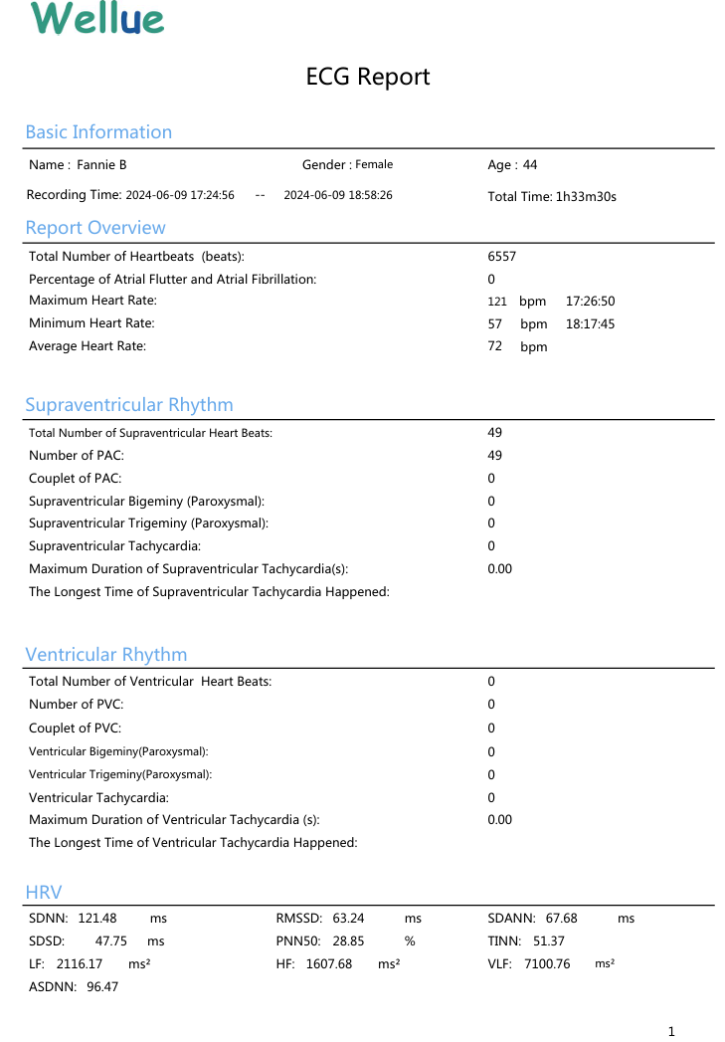

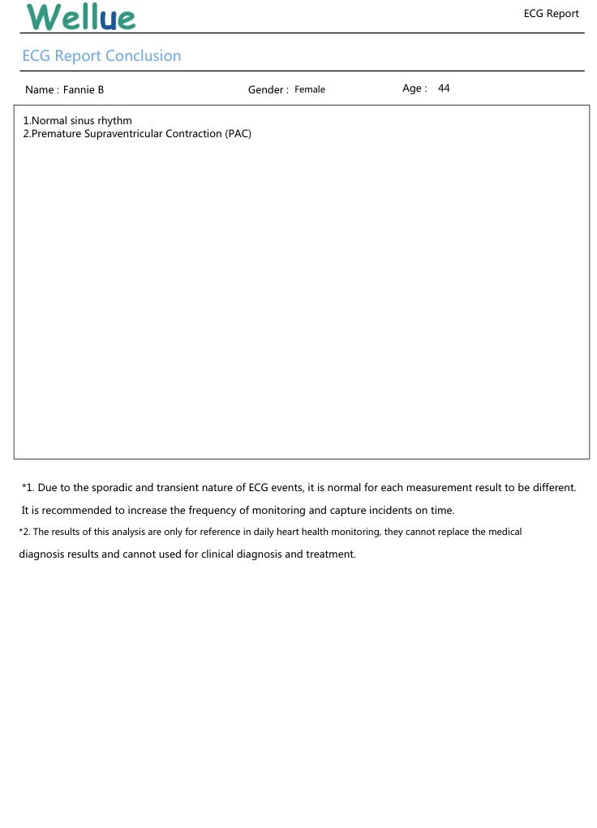

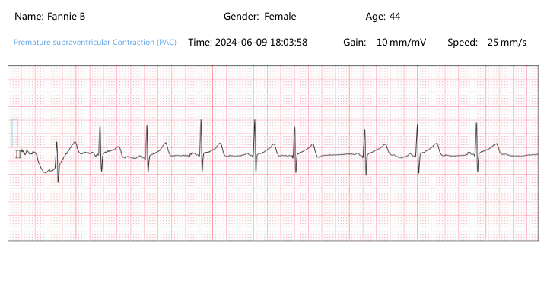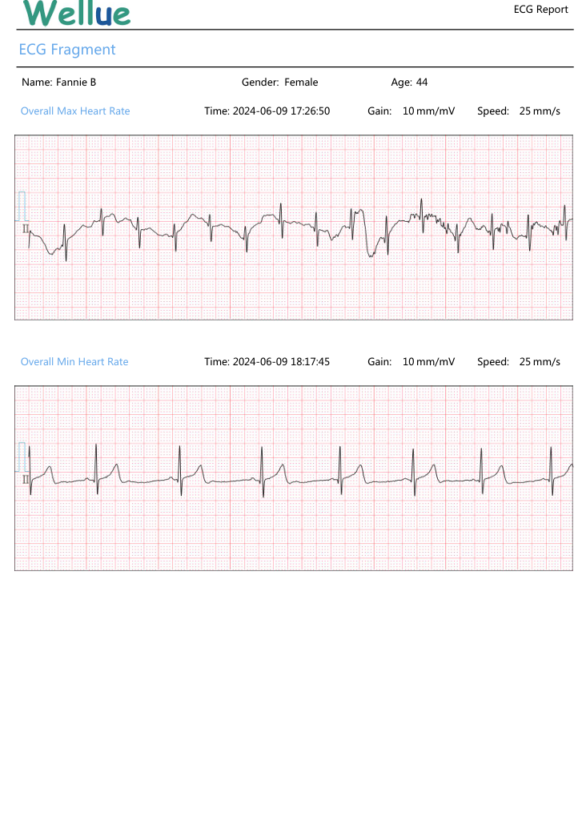

# **Conclusion**

|  |  |  |
| --- | --- | --- |
|  | **APPLICATION** | **Features** |
| **BabyO2 S2** | On a child’s feet | Base station for parents |
| **Checkme 02** | On an adult’s wrist | Bluetooth & charts |
| **Smart Sock** | On a child’s ankles | WIFI connexion |
| **Heart Health monitor** | On an adult’s chest | Accuracy & Report |